Lab 2 Assignment

YingTa Lin (ytl287)

Saturday 25th September, 2015

**Assignment 4:**

10. Describe how to design two second-order filters (with same resonant frequency f1) so that the rise-time and decay-time of the impulse response can be specified? (The two filters will have different pole radii.) Given an example of the design in Matlab and its real-time implementation in Python/PyAudio

The system is two second order filter in cascade and radius is what influence the shape of envelope that generated according to the input. However, it is very hard to find the coefficient of the two system given which specified sample is its peak amplitude. So I think of it from another approach.

1. Derive the rise time:

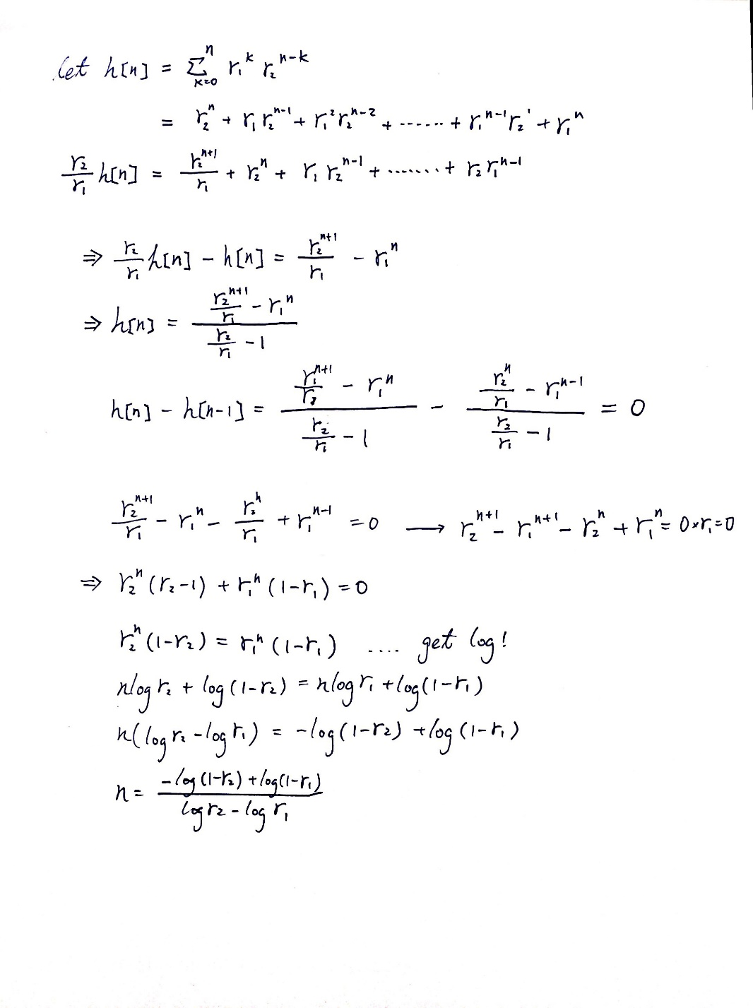

From here we have the relationship formula $\frac{n =\log\left(\frac{r2-r1}{r1-1}\right)}{\log\left(\frac{r2}{r1}\right)}$ where r1 and r2 are radius of the first and second filter, n is the index of the sample which represent the maximum amplitude.

For radius is derive from the Ta and Tb where I assign Ta = 0.4, Tb = 0.9 I have n = 1.013785738774196 * 103. It I divide n by sampling frequency Fs = 8000, I get 0.1267 (sec) which is the peak located.

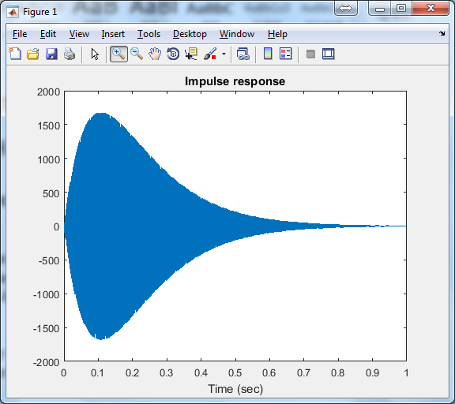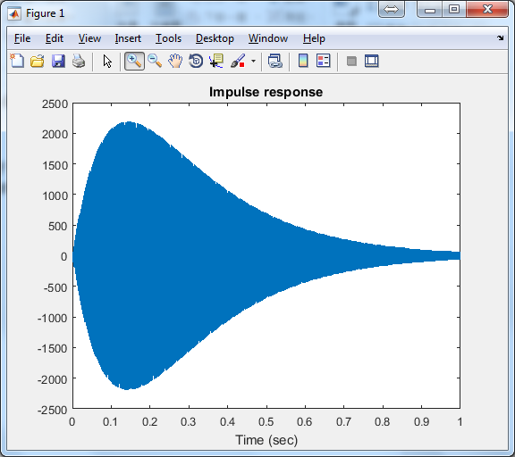

1. Falling time:

The falling time is influence by the Ta and Tb directly, when Ta and Tb are 0.5, the decay duration is specified by 0.5. It is calculated from the peak to the point that amplitude is smaller than 1% of the peak amplitude.