Lab 3 Assignment

YingTa Lin (ytl287)

Sunday 27h September, 2015

**Exercise 1:**

See “play_wav_any_channel.py”

Given command “play_wav_any_channel.py vivalavida_mono.wav” or “play_wav_any_channel.py vivalavida_stereo.wav” to verify that the program will determine how to play the music by its number of channel.

**Exercise 2:**

There are three amplifiers (gain) in this system, feedback, direct-path, and feed forward which we can draw the system diagram as follow.



If the feedback gain greater than 1, value for delay buffer is going to diverse which makes the system unstable.

If the delay is N samples, the system can be written as the equation below where x(n) is input and y(n) is output.

$$y\left(n\right)=x\left(n\right)+y\left(n-N\right)$$

Where we can find out the number of poles is related to N, and the poles will locate evenly around the circle as the figure below. (Take N = 8)

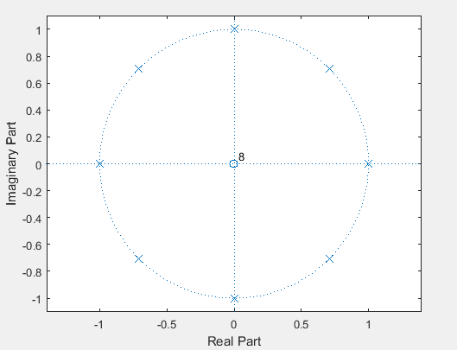

The modified version of feedforward delay system python script is “feedbackdelay_circbuffer1_finalecho” which the remaining echo that store in the buffer is played after no more inputs. (Not include the echo that comes from the echo)

**Exercise 3:**

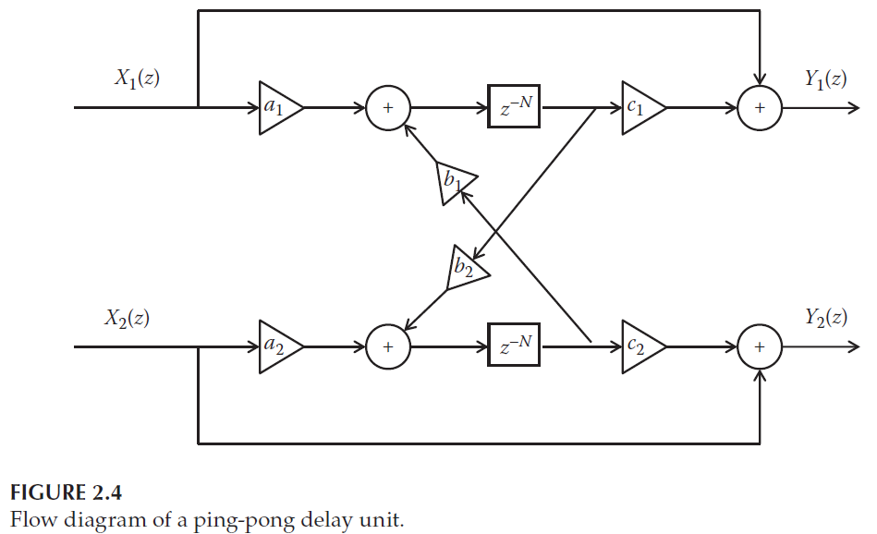

Flow diagram of a ping-pong delay unit.