**DSP Lab Project Report**

**“Guitar Effecter”**

NYU Tandon School of Engineering

Direct by Professor Ivan Selensnick

Present by Cheng-Hsun Lee, Ying-Ta Lin

About:

This report explain what is audio effect unit and a simple implementation via pyaudio module based on python.

An effect unit is an electronic device that alters how a musical instrument or other audio source sounds. Some effects subtly "color" a sound, while others transform it dramatically. Musicians use effects units during live performances or in the studio, typically with electric guitar, keyboard, or bass. While most frequently used with electric or electronic instruments, effects can also be used with acoustic instruments, drums and vocals.

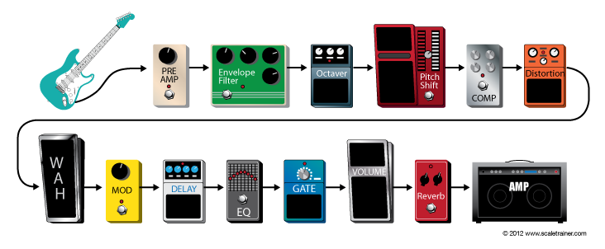

Equipment used in this project:

Focusrite Scarlett 2i2:

<http://us.focusrite.com/usb-audio-interfaces/scarlett-2i2>

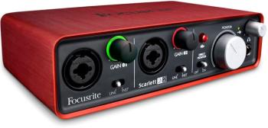

Epiphone LP Junior Solid-Body Electric Guitar, Vintage Sunburst

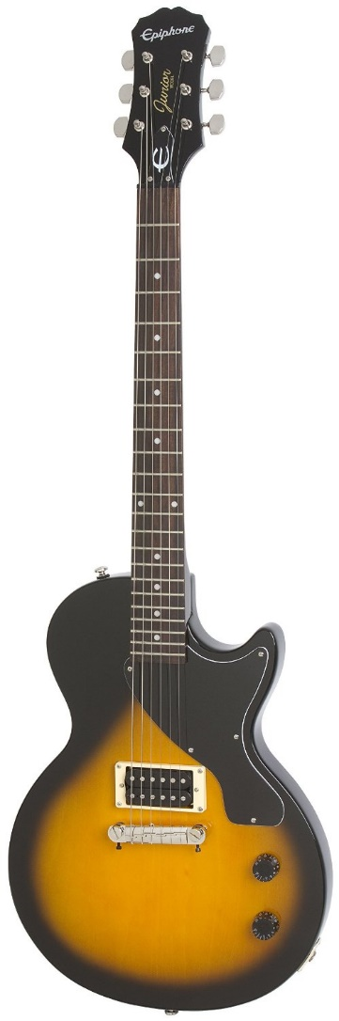

Windows 7 x64 ultimate machine

Mac Air iOS X Yosemite 10.10.5

* Tkinter 8.5 on python 2.7
* To work on Mac OS X, install and update “ActiveTcl”

Effect implemented:

**Flanging:**

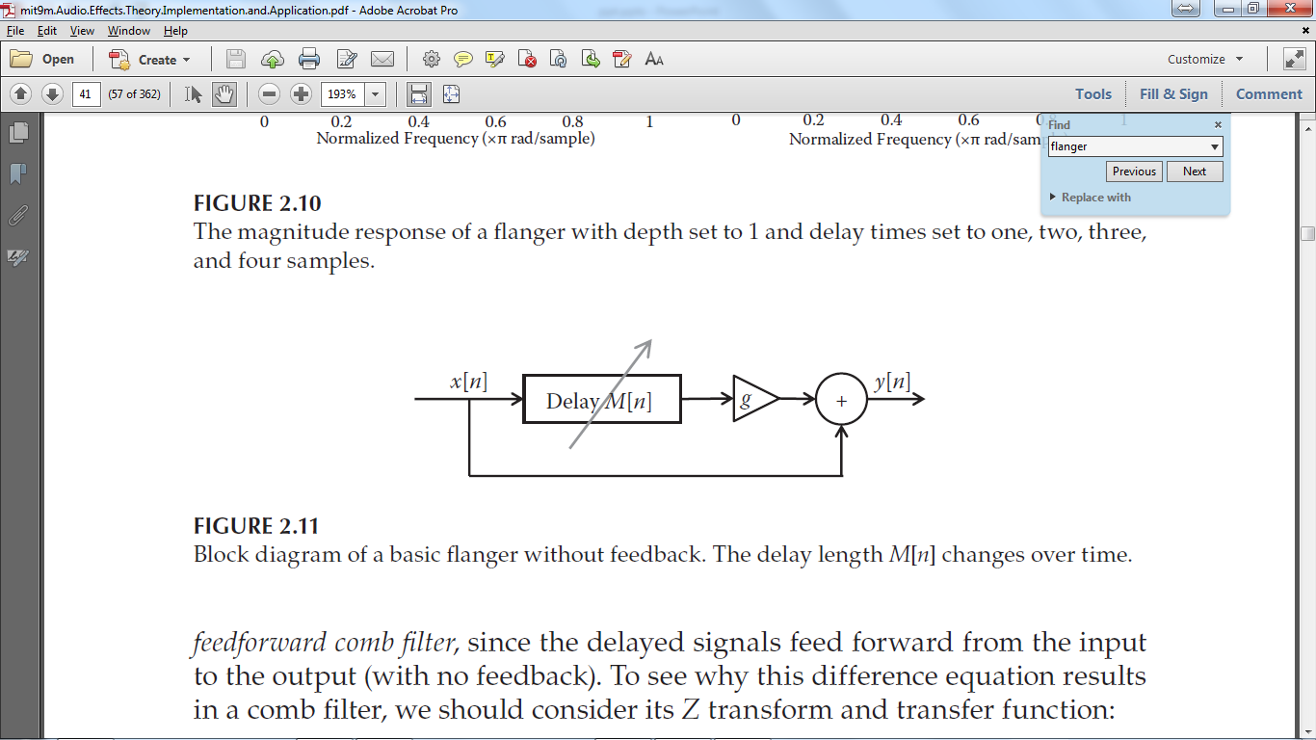

There are several type of flanging, the one that is implemented is a feed-forward system. Without adding the direct path to the output, the system is known as a vibrato filter. The delay block is a low-frequency oscillator (LFO) that represent as a circular buffer with index that steps in various rate which is a sinusoid fluctuation in this case.

**Auto-Wah:**

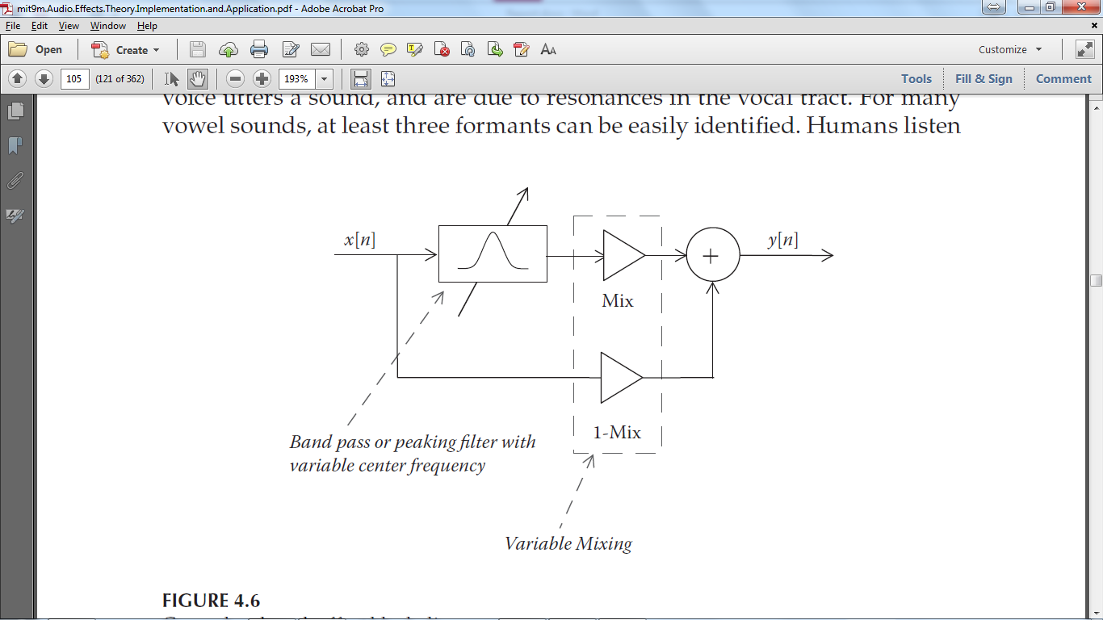

Wah-Wah effect creates additional frequency fluctuation sounds based on vowel “a” or “u” so human ear would perceive frequency drifting that sounds like “wah-wah”. Usually, a commercial guitar effect product use foot pedal for player to tilt on. When the pedal is tilt ups and downs, we have the wah-wah effect. However, for simplicity, an Auto-Wah design is more popular in guitar effect software because it replace the pedal with a LFO.

Echo: (Delay with feedback)

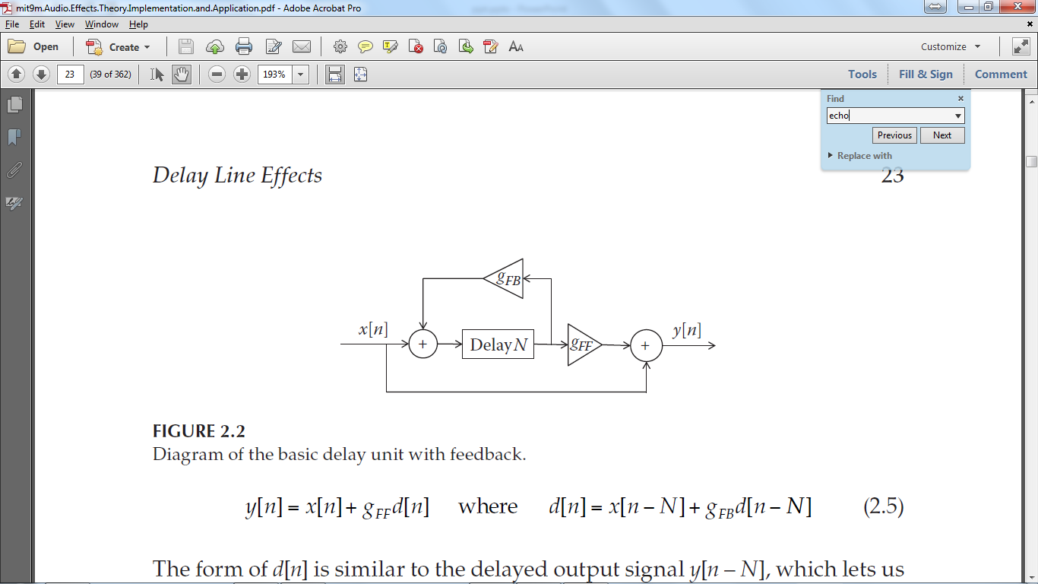

The delay effect we made is an echo effect. Input signal will loopback with a total gain less than 1 and dies out gradually. The parameters of the designed system allows us to modify the period between first sample and its delayed version, also how many times a sample is being repeated.

**Fuzzy:**

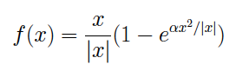

Fuzzy effect is clipping signal input and adding overtones. We implement the effect using a differential equation exactly according to the formula given above.

Graphic User Interface and code structure design:

The GUI is implemented on python with built in module Tkinter, which is easy to code. The interface is running as a thread and a public class so the parameters can be read from the primary thread. The primary thread is running a state machine that loop through audio input blocks with different effect as states. Therefore, to ensure each block is process properly, state only changes before any block is being processed. Luckily, the computation is fast enough for human not to perceive the delay between state changes.

References:

Amazon.com

Reiss, Joshua D., and Andrew P. McPherson. Audio Effects: Theory, Implementation, and Application. Boca Raton: CRC, 2014. Print.

Focusrite.com: http://us.focusrite.com

Wikipedia: https://en.wikipedia.org/wiki/Effects_unit

Global Guitar Network: http://globalguitarnetwork.com/guitar-effects/