DSP Lab

Project “Guitar Effecter” Report

Direct by Professor Ivan Selensnick

Present by Cheng-Hsun Lee, Ying-Ta Lin

NYU Tandon School of Engineering

About:

This report explain what is audio effector and a sample implementation via pyaudio module based on python.

Equipment used in this project:

Focusrite Scarlett 2i2:

<http://us.focusrite.com/usb-audio-interfaces/scarlett-2i2>

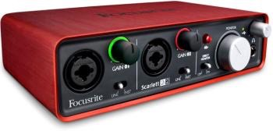

Epiphone LP Junior Solid-Body Electric Guitar, Vintage Sunburst

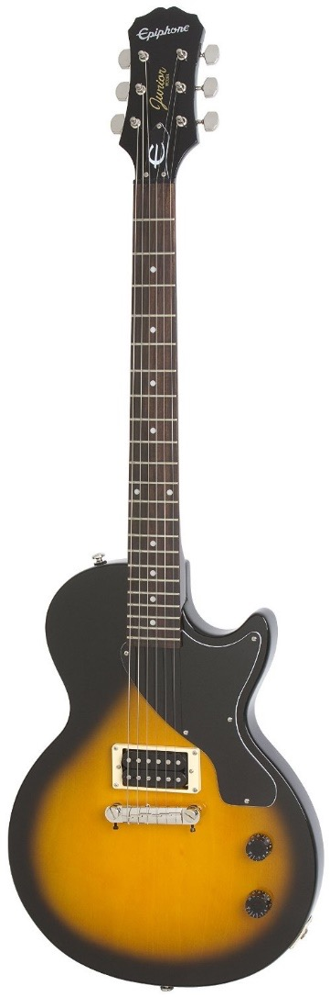

Windows 7 x64 ultimate machine

Mac Air iOS X Yosemite 10.10.5

* Tkinter 8.5 on python 2.7
* To work on Mac OS X, install and update “ActiveTcl”

Effect Unit:

An Effects unit (effect box,stomp box, stompbox, pedal) is an electronic device that alters how a musical instrument or other audio source sounds. Some effects subtly "color" a sound, while others transform it dramatically. Musicians use effects units during live performances or in the studio, typically with electric guitar, keyboard, or bass. While most frequently used with electric or electronic instruments, effects can also be used with acoustic instruments, drums and vocals. Examples of common effects units include wah-wah pedals, fuzzboxes and reverb units.

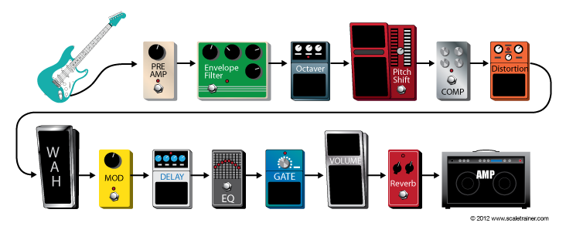

Effects units processing：

In DSP view of these effects, we implement them with different filters, LFO(low frequency oscillator), and mathematic equation, to make the sound change in frequency or amplitude…etc.

Some of them are:

Basic Filtering — Low-pass, Band-pass, High-pass filter, Equalizer, etc.

Time Varying Filters — Wah-wah, Phasor

Delays — Vibrato, Flanger, Chorus, Echo

Modulators — Ring modulation, Tremolo, Vibrato

Non-linear Processing — Compression, Limiters, Distortion, Exciters/Enhancers

Spatial Effects — Panning, Reverberation, Surround Sound

Effect implemented:

Flanger:

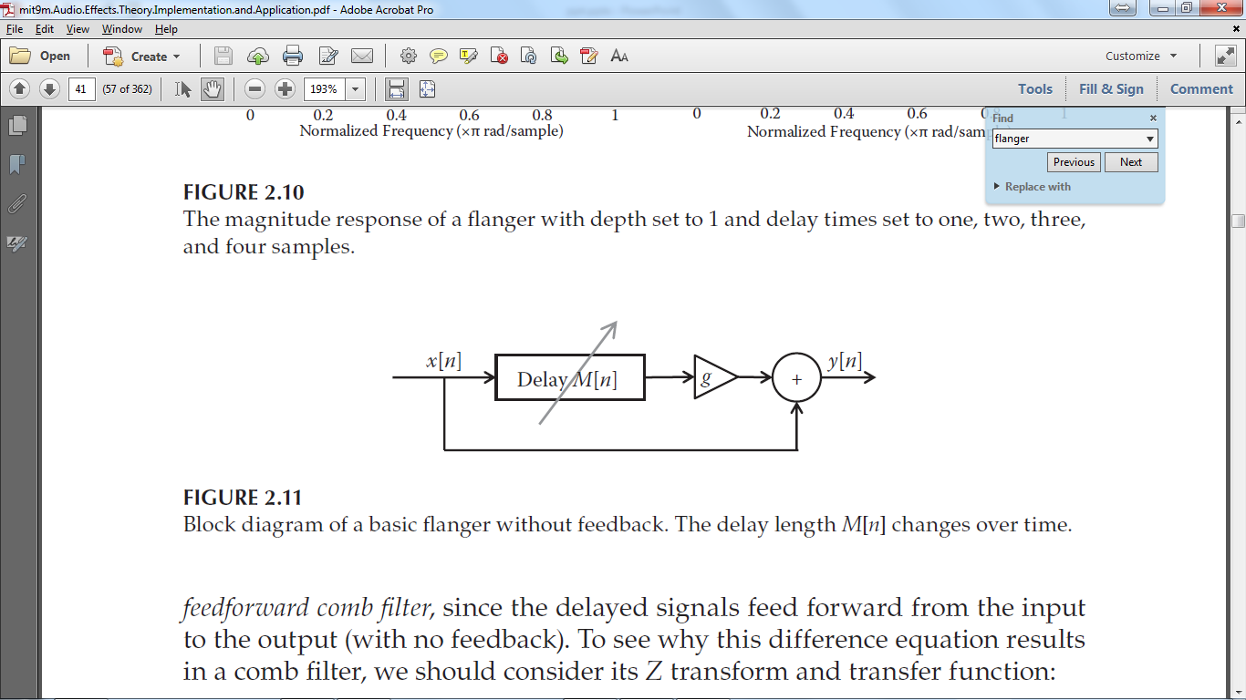

There are several type of flanging, the one that is implemented is a feed-forward system. Without adding the direct path to the output, the system is known as a vibrato filter. The delay block is a low-frequency oscillator (LFO) that represent as a circular buffer with index that steps in various rate which is a sinusoid fluctuation in this case.

Auto-Wah:

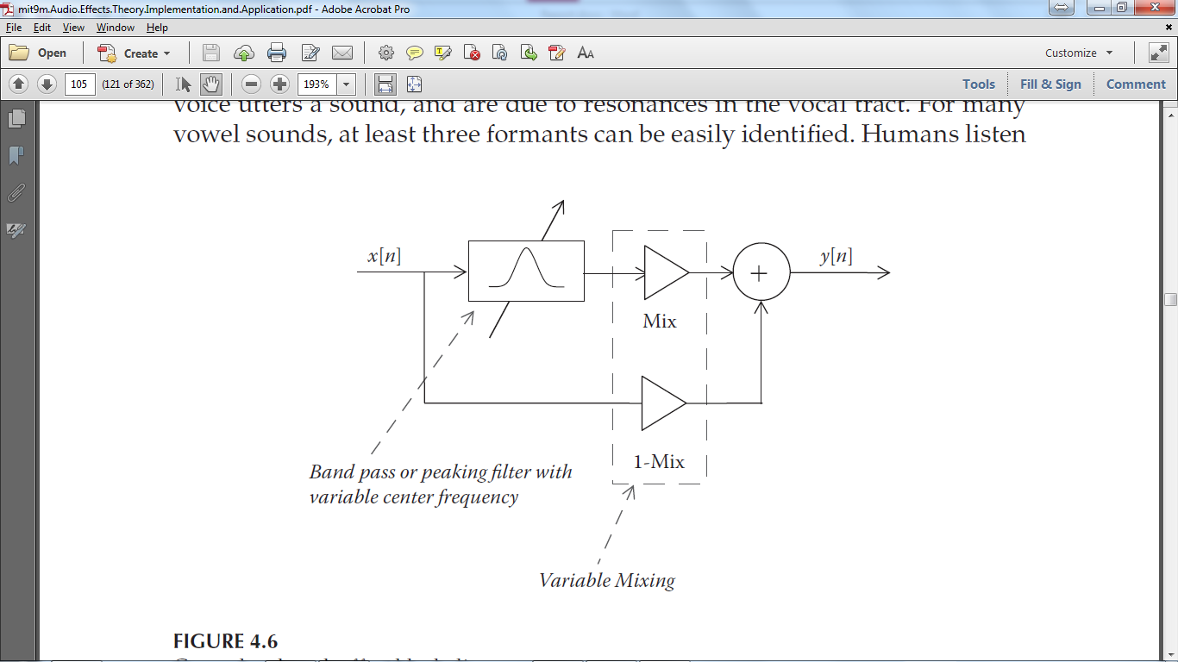

Wah-Wah effect creates additional frequency fluctuation sounds based on vowel “a” or “u” so human ear would perceive frequency drifting that sounds like “wah-wah”. Usually, a commercial guitar effect product use foot pedal for player to tilt on. When the pedal is tilt ups and downs, we have the wah-wah effect. However, for simplicity, an Auto-Wah design is more popular in guitar effect software because it replace the pedal with a LFO.

Echo: (Delay with feedback)

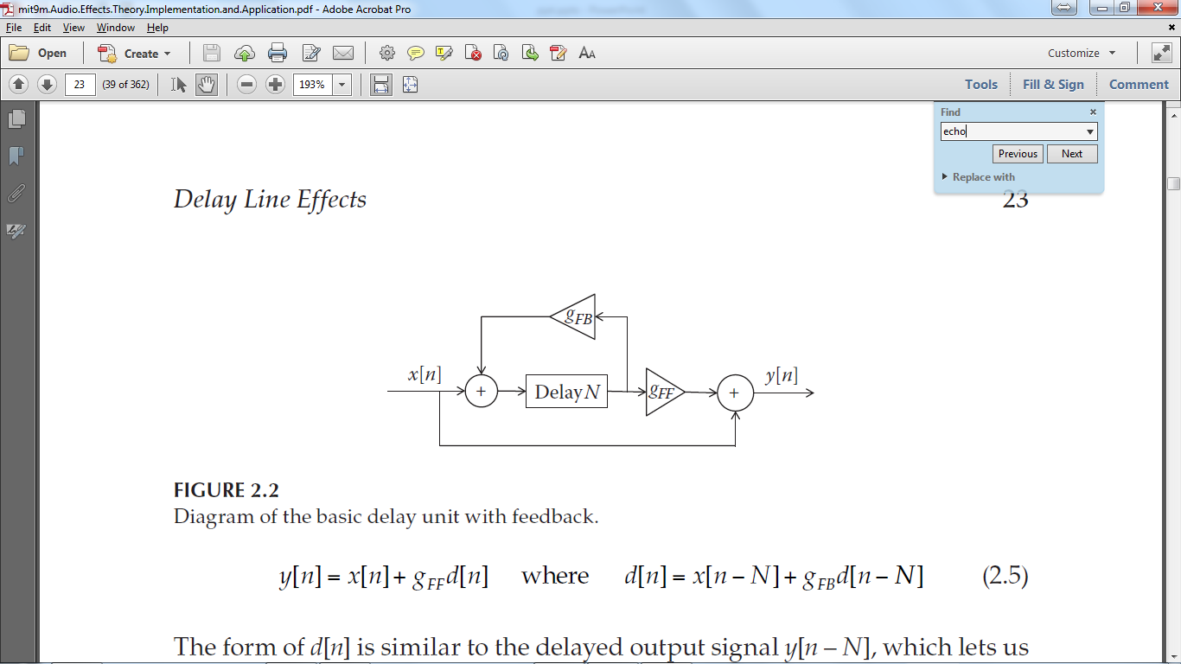

The delay effect we made is an echo effect. Input signal will loopback with a total gain less than 1 and dies out gradually. The parameters of the designed system allows us to modify the period between first sample and its delayed version, also how many times a sample is being repeated.

Fuzzy:

