**Quotes app**

1. **Task Description**

Create a quotes application using React that fetches random quotes from a public API and displays them to users. The app will feature a simple and intuitive interface where users can view a new quote with the click of a button. Each quote will include the author's name, and users will have the option to copy quotes to their clipboard for easy sharing. The application will also incorporate a favorites feature, allowing users to save their favorite quotes for quick access later. Additionally, it will utilize responsive design principles to ensure a seamless user experience across various devices.

1. **Task Output Screenshot:**

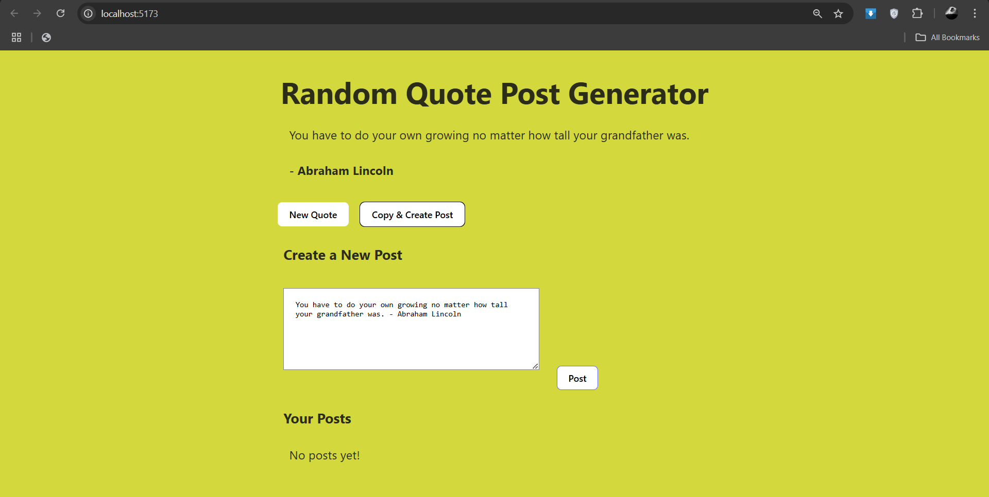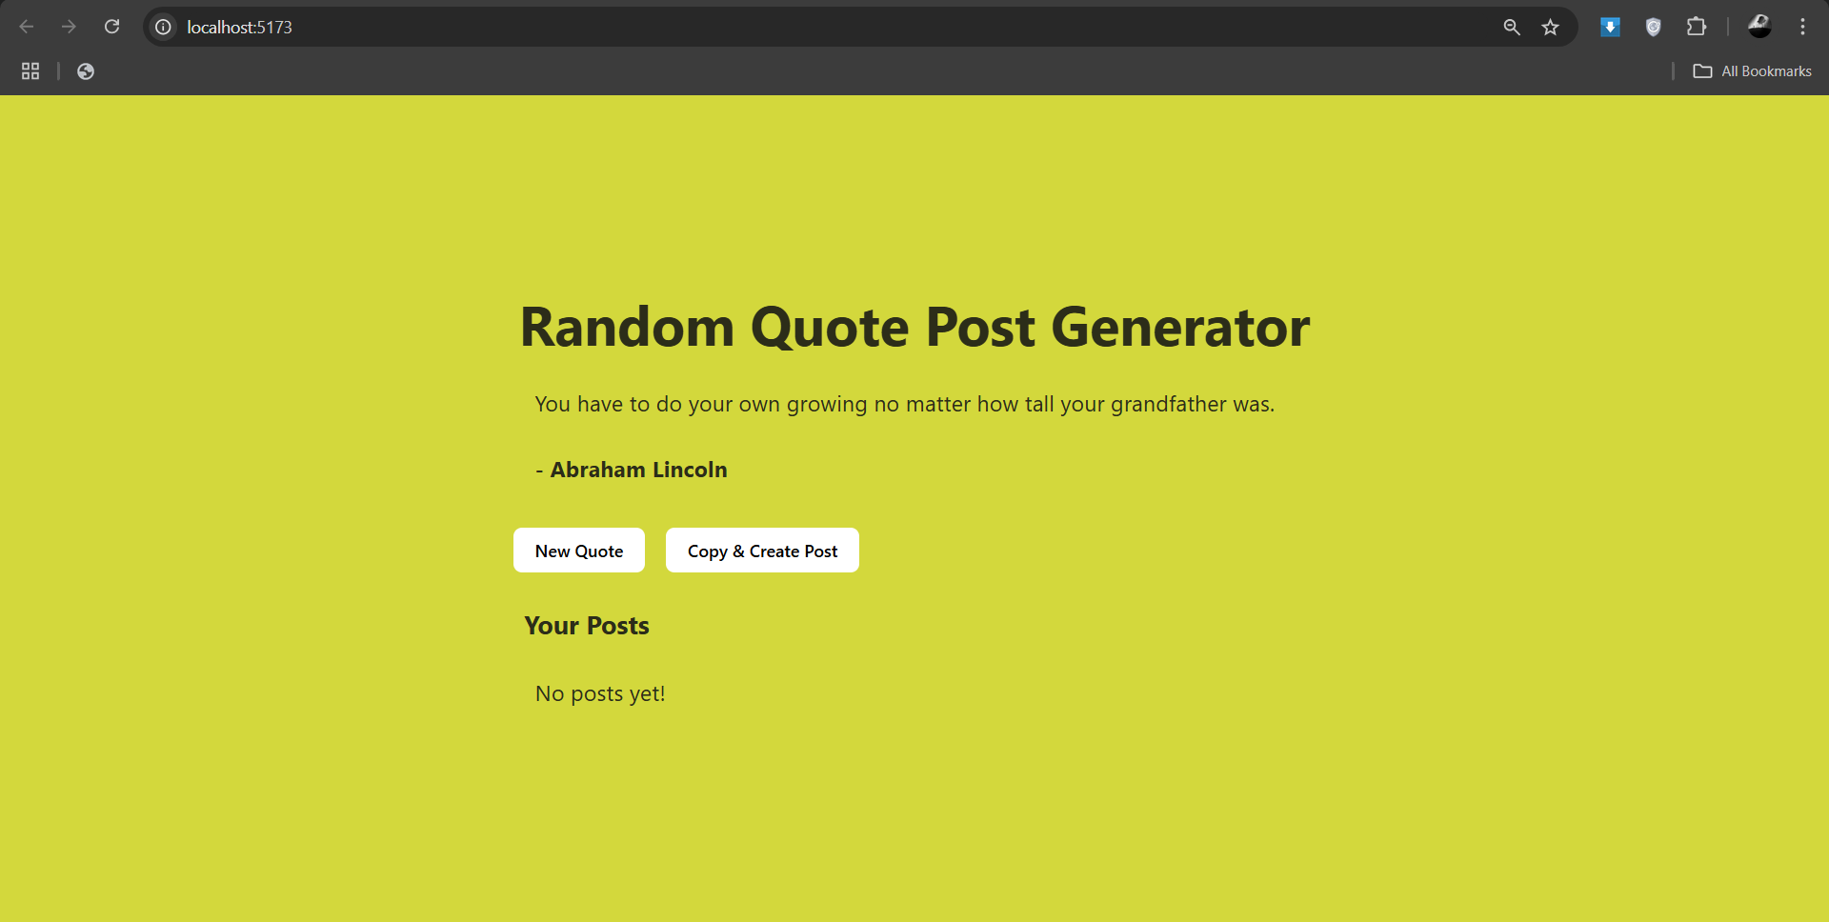

1. **Widget/Algorithm Used In Task**

* **API Integration**: The app fetches random quotes from a public API, utilizing asynchronous requests to retrieve and display data in real time.
* **Clipboard Functionality**: A built-in feature allows users to copy quotes to their clipboard with a single click, enhancing usability and sharing capabilities.
* **Favorites Management**: Users can save their favorite quotes using local state management, enabling easy access to selected quotes for future reference.