**Context**

1. **Task Description**

Build a React application using the Context API to manage and share state between components. The app should include an input component where a user can enter text and a display component that shows the entered text in real-time using context. This demonstrates effective data flow and state management between sibling components without direct prop drilling, ensuring clean and scalable code structure.

1. **Task Output Screenshot:**

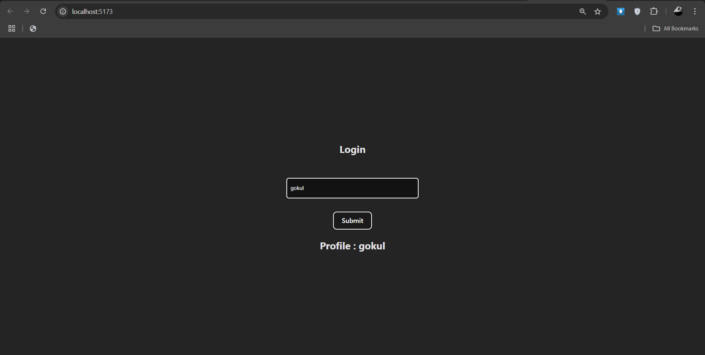

1. **Widget/Algorithm Used In Task**

* **React Context API: Provides a way to manage and share state across components without prop drilling.**
* **React Hooks (useContext and useState): Manages state (useState) and accesses context (useContext) to update and retrieve data efficiently.**
* **Component Composition: Separates concerns by capturing input in one component and displaying it in another, enhancing modularity and reusability.**