**Multi step form**

1. **Task Description**

Create a multi-step form using React that guides users through several sections of input with validation at each step. Each step will contain specific fields, and the form will only progress to the next step if the current step's inputs pass validation. Users can navigate between steps to review or edit information. The form includes a summary at the end for review before submission, and it uses state management to handle form data across steps, providing a seamless, interactive experience for complex data entry.

1. **Task Output Screenshot:**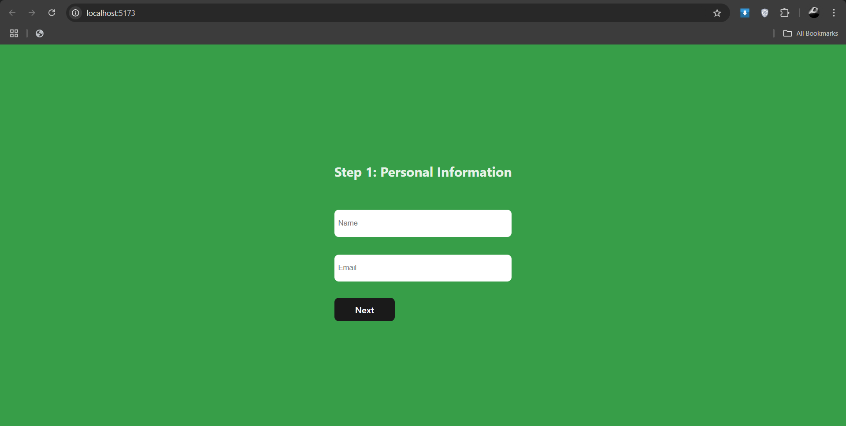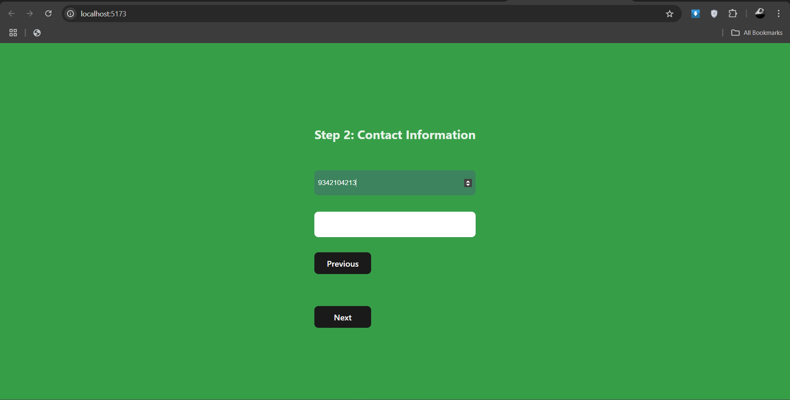
2. **Widget/Algorithm Used In Task**

* **Multi-Step Navigation**: The form utilizes state management to track the current step and control user navigation between steps, allowing for forward and backward movement.
* **Input Validation**: Each step implements validation logic to ensure that all required fields are correctly filled before allowing progression to the next step.
* **Data Aggregation**: The form collects and stores user inputs in a centralized state, enabling easy review and editing of all information before final submission.