**Password validator**

1. **Task Description**

Create a password strength validator as a React application that allows users to input a password and receive real-time feedback on its strength. The strength levels range from "Weak" to "Excellent," based on criteria such as password length, use of uppercase and lowercase letters, numbers, and special characters. The application will display the password strength below the input field, updating dynamically as the user types. The project includes a well-organized file structure, with separate components and styling, to ensure maintainability and a clean user interface.

1. **Task Output Screenshot**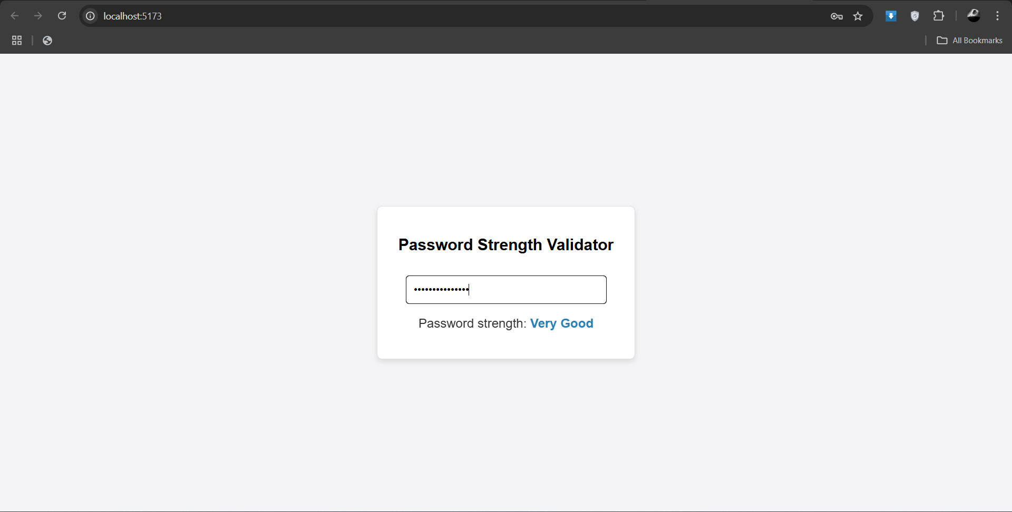

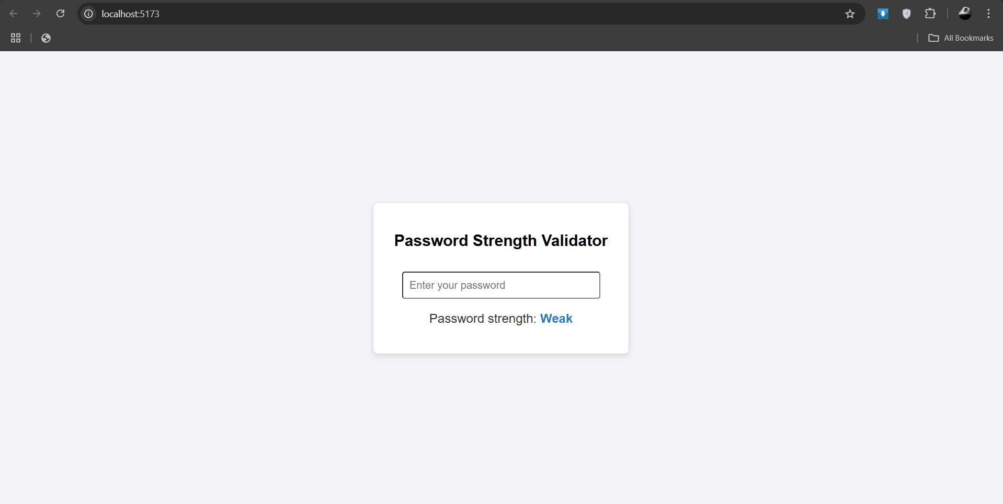

1. **Widget/Algorithm Used In Task**

* **Password Strength Scoring**: An algorithm evaluates password criteria like length, uppercase, lowercase, numbers, and special characters to determine strength.
* **Real-Time Feedback**: React’s useState updates the password strength label instantly as the user types, providing immediate feedback.
* **Dynamic Rendering**: The app conditionally displays the strength level (e.g., "Weak," "Good," "Excellent") based on the evaluated score.