**Social media dashboard**

1. **Task Description**

Develop a social media analytics dashboard using React that visualizes user engagement metrics and statistics from various social media platforms. The dashboard will display key performance indicators (KPIs) such as likes, shares, comments, and follower growth through interactive charts and graphs. Users will be able to filter data by date range and platform, providing insights into trends and performance over time. The application will feature a responsive design for optimal viewing on different devices and will utilize APIs to fetch real-time data, ensuring that users have access to the most up-to-date information.

1. **Task Output Screenshot:**

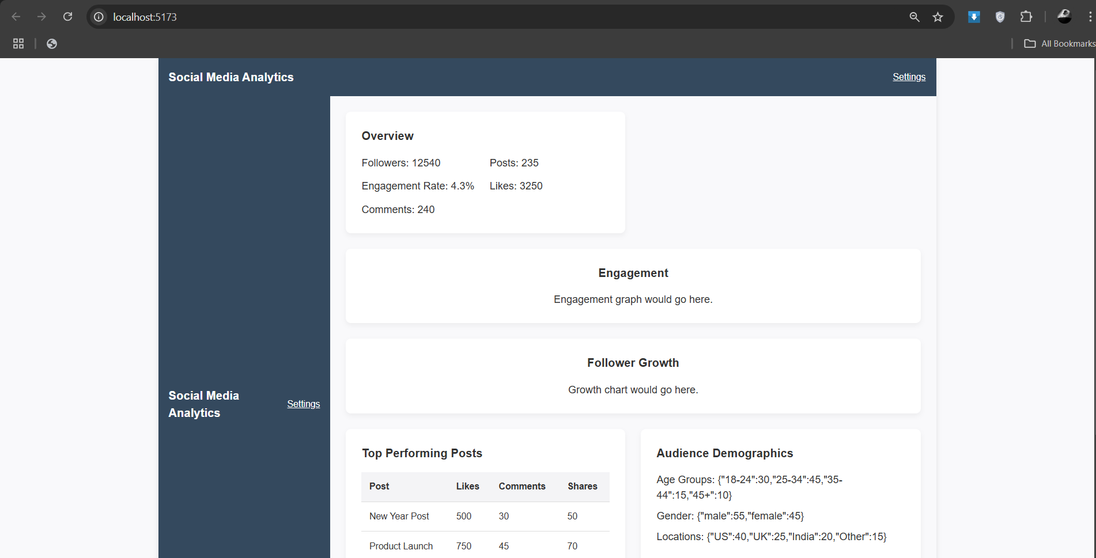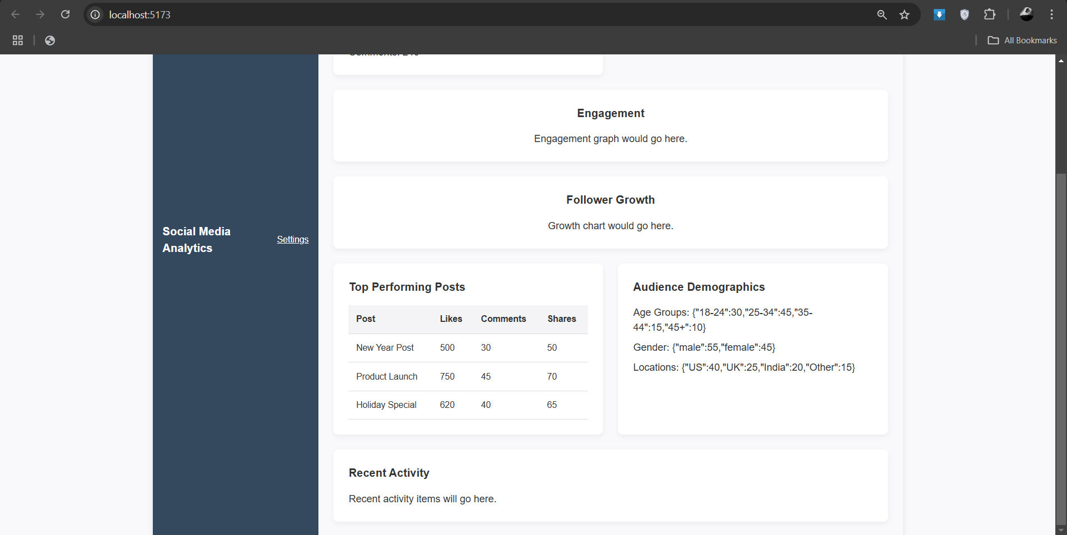

1. **Widget/Algorithm Used In Task**

* **Step Navigation Logic**: The form uses state management to track the current step and facilitate navigation between steps, ensuring a smooth user experience.
* **Input Validation**: Each step includes validation algorithms that check user inputs for completeness and correctness before allowing the user to proceed to the next step.
* **Data State Management**: The form aggregates and stores user inputs in a central state, enabling easy access and modification of data across multiple steps before final submission.