Exploration

Table of contents

## Load Libraries

library(tidyverse)  
library(lubridate)  
library(fs)  
library(tsibble)  
library(fpp3)

## Load and Clean Data

all_cases_collapsed_file <- dir_info("data", type = "file", regexp = "(?i)all_cases_collapsed.*\\.rds$") %>%  
 subset(subset = modification_time == max(modification_time), select = path, drop = TRUE)  
  
all_cases_collapsed <- readRDS(all_cases_collapsed_file) %>%  
 filter(year > 2007, year != 2025) %>%  
 as.data.frame()

##Aggregate by Month

cases_per_month <- all_cases_collapsed %>%  
 group_by(year_month) %>%  
 summarise(num_cases = n(), .groups = "drop") %>%  
 mutate(  
 year_month = as.Date(paste0(year_month, "-01")),  
 year = year(year_month),  
 month = month(year_month)  
 )

##General Trend of bTB Cases

ggplot(cases_per_month, aes(x = year_month, y = num_cases)) +  
 geom_line() +  
 geom_point() +  
 labs(title = "Trend of bTB Cases", x = "Month", y = "Number of cases") +  
 theme_minimal()

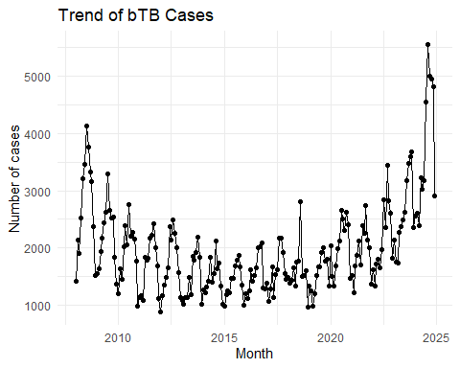

##Average Cases per Month

avg_per_month <- cases_per_month %>%  
 group_by(month) %>%  
 summarise(avg_cases = mean(num_cases), .groups = "drop")

##Monthly Seasonality Plot

ggplot(cases_per_month, aes(x = year, y = num_cases, group = 1)) +  
 geom_line() +  
 geom_point(size = 1) +  
 geom_hline(  
 data = avg_per_month,  
 aes(yintercept = avg_cases),  
 color = "blue",  
 linetype = "solid"  
 ) +  
 facet_grid(. ~ month, scales = "free_x", space = "free") +  
 labs(  
 title = glue::glue("Seasonality of bTB by month (2008-{max(cases_per_month$year)})"),  
 x = "Year",  
 y = "Number of cases"  
 ) +  
 theme_minimal() +  
 theme(  
 strip.background = element_rect(fill = "grey90", color = NA),  
 strip.text = element_text(size = 12, face = "bold"),  
 axis.text.x = element_text(angle = 90, hjust = 1, face = "bold")  
 )

