Sangres Trees Report 2024

2024-10-10

## Summary Stats

treatment_summary <- merged_summary %>%  
 group_by(TreatmentStatus)%>%  
 summarize(Tree_count = sum(Tree_count), MOG_count = sum(MOG_count), MOG_live_count = sum(MOG_live_count), Surveyed_ha = sum(PlotSize))  
library(knitr)  
kable(treatment_summary)

| TreatmentStatus | Tree_count | MOG_count | MOG_live_count | Surveyed_ha |
| --- | --- | --- | --- | --- |
| Treated | 1249 | 426 | 366 | 3 |
| Untreated | 4716 | 492 | 405 | 3 |

### Figures by Plot

grid.arrange(fig1,fig2)

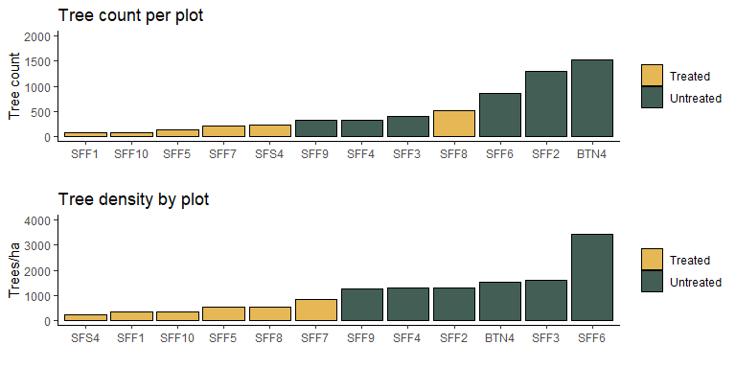

grid.arrange(fig3,fig4)

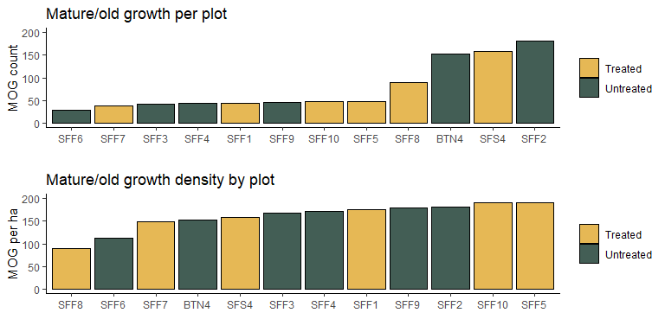

grid.arrange(fig5,fig6)

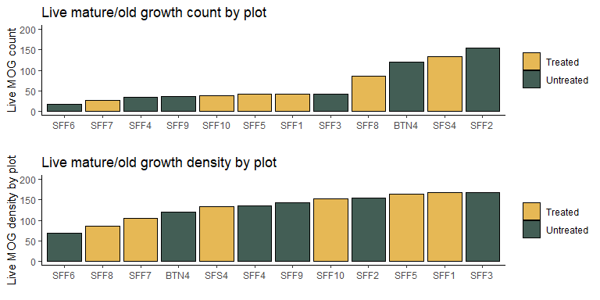

### Figures by Treatment

grid.arrange(fig7,fig10, fig8, fig9)

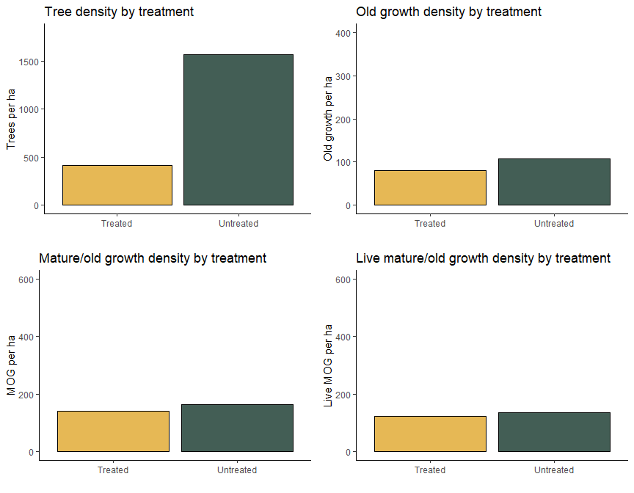

### DBH Histograms & Species Composition

plot1

## Warning: Removed 1 row containing non-finite outside the scale range  
## (`stat_bin()`).

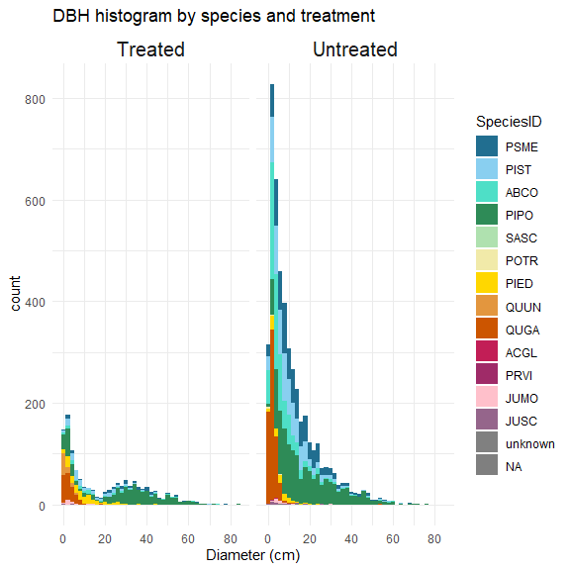

plot2

## Warning: Removed 1 row containing non-finite outside the scale range  
## (`stat_bin()`).

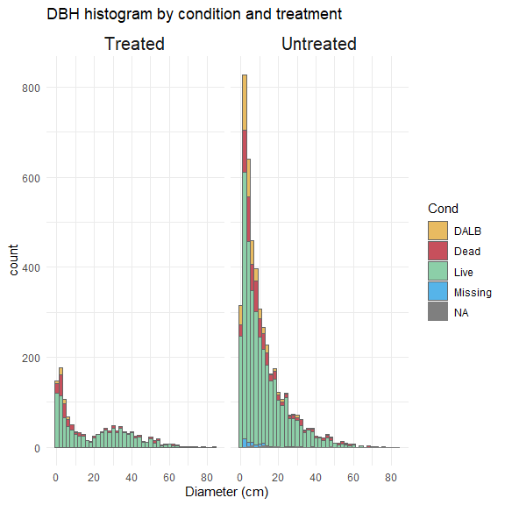

plot4

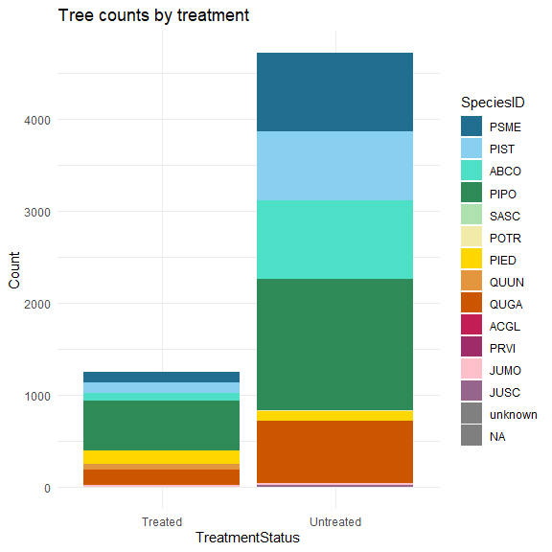

plot5

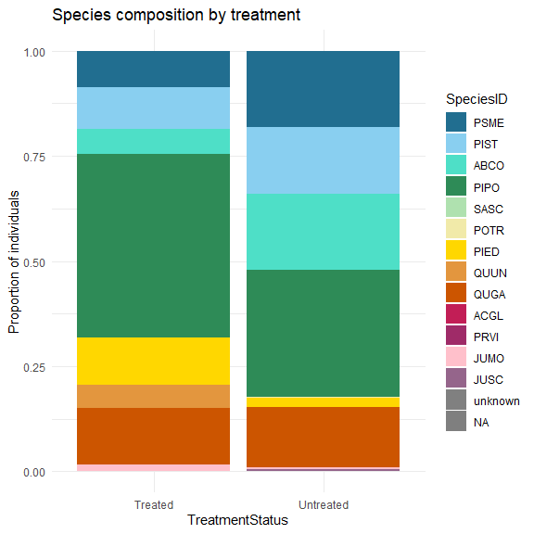

grid.arrange(plot6, plot7)

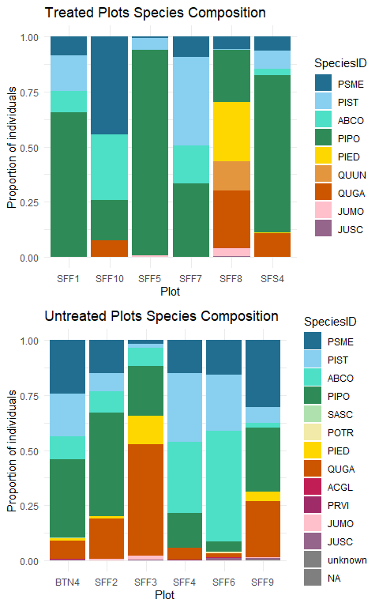

### Basal Area Figures

grid.arrange(plot9,plot8, ncol=2)

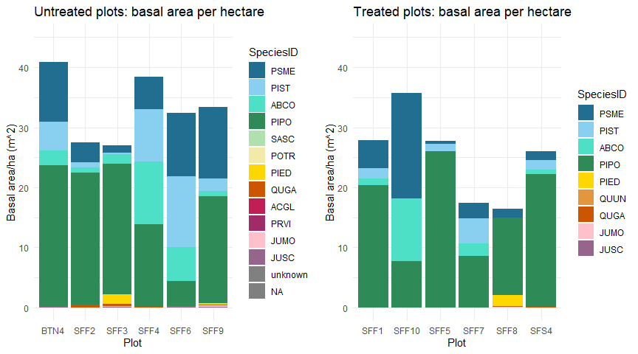

plot10

