|  |
| --- |
| DYNAMIC MEMORY: DELETES  If you have an array in a heap array, delete the array in the array before the heap array.  *In 2-D arrays 🡪 Delete all the arrays and then the outer array. |

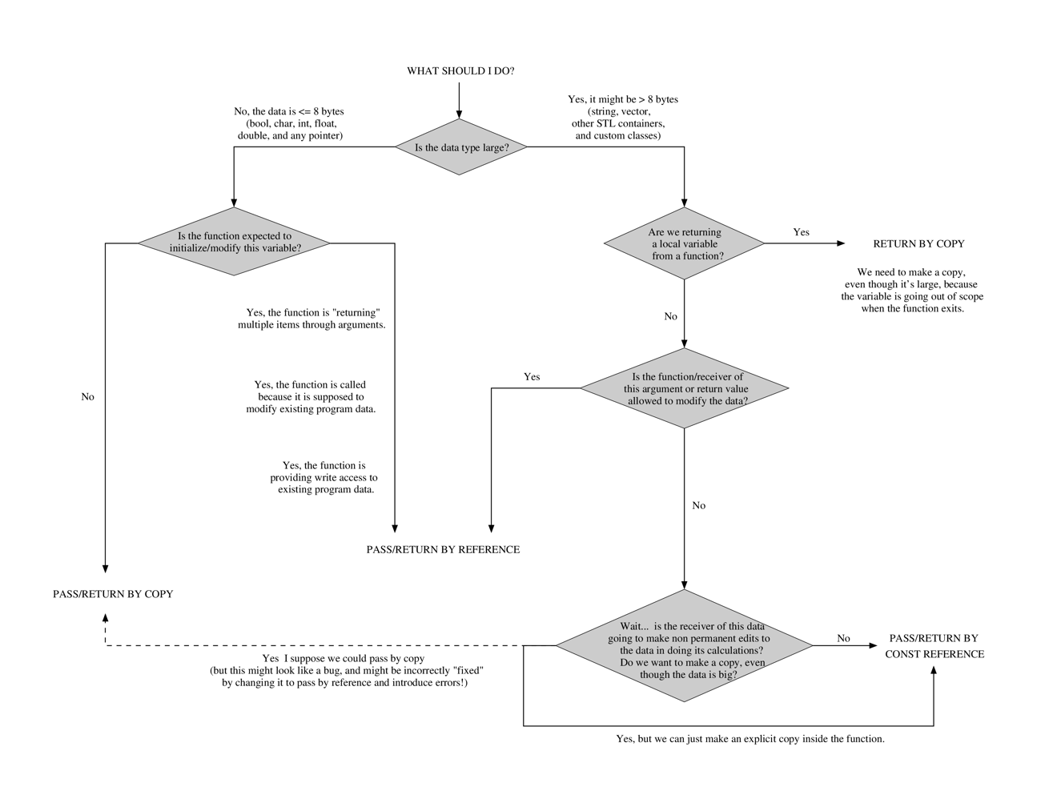🡪Declare the pointer before creating heap alloc:

|  |  |
| --- | --- |
| Float* oat[3];  Oat[1] = new float; *oat[1] = 3.14;  Oat[2] = new float; *oat[2] = 6.02;  Float rice;  Float *wheat;  Wheat = oat[2];  Float **barley = new float*;  *barley = oat[1]; |  |

Classes:

Implementation:

**Dynamic Memory (2-D)**

|  |
| --- |
| **Vectors:**  Declare: std::vector < double > vector_name;   * Vectors can only be copied to ones with the same type.   Vector_name.size(); //Capacity  Vector_name.begin(), vector_name.end(); //Iterator  Vector_name.push_back(value) //Modifiers  Vector_name[ ]; //Accessor |

|  |
| --- |
| **WHEN TO USE “const”:**  Declaring a function in .h file (and subsequentially in implementation file) 🡪 After function ( ).  Member functions that do not change member variables (passing by argument) 🡪 before the class name  Ex:  bool Date::isEqual (const Date &date2) const; |

**Memory Debugging**

|  |
| --- |
| **Creating a new object:**  Class object_name( argument ) |

**Memory Diagrams**

