Johanes L. Guibone | 09/22/2022
Science, Technology and Society | BSCS – IV

Document Digitized Archiving Solution for Law Office and Notary Public

Chapter 1
Introduction
Notary publics by law needs to follow the Supreme court’s ruling on Notarial Practice (2004, SC Rules on Notarial Practice). This ruling has laid out the procedures and proper practice for all Notary Public in the Philippines. In the Rules for Notary Procedures in Section VI, d. It clearly states that for all contract documents executed by the notary public, the notary public should keep an original copy of the said document for the Clerk of Court. Thus, it has produced a problem of law offices and notary public service, holding stacks of boxes with notary copies from clients (Images: Table 1). These legal documents at the end of every year are also presented to the Hall of Justice for archiving and renewal process of the notary commission.
This system hasn’t been updated until (2019 Proposed Amendment to the Revised Rules on Evidence, n.d.) in paragraph (a) and (b) of Section 4 of Rule 130 which state that “
(a) An “original” of a document is the document itself or any counterpart intended to have the same effect by a person executing or issuing it. An “original” of a photograph includes the negative or any print therefrom. If data is stored in a computer or similar device, any printout or other output readable by sight or other means, shown to reflect the data accurate “original.”

(b) A “duplicate” is a counterpart produced by the same impression as the original, or from the same matrix, or by means of photography, including enlargements and miniatures, or by mechanical or electronic re-recording, or by chemical reproduction, or by other equivalent techniques which accurately reproduce the original. “

Thus, now allowing Notary Public to free up space used in the past to store client duplicate of notary documents and case files. With this in mind, we propose to develop a system which handles the scanning and cataloging notary documents with text and feature extraction to be digitized and store in a computerized or electronic means.

  - Feature scope
- Development of solution for pulling data through a scanning device and processing it through an OCR Solution to extract text and information specifically for cataloging purposes.
- Develop a robust solution for archiving said digitized notary documents stored in a local or remote hosting site.
- Develop a system to sign in to the archiving solution to then be able to pull data for reproduction.

Chapter 2
Review of Related Literature

2.1 Convenience of a Digital Archive Solution
As stated in the book (Archives and Manuscripts, 2019), the advantage of a digitalized archiving solution and repositories has far reaching implication in storing and accessing needed information for later access. It also has the capacity for redundancy and security, given if the repository solution is robust and secure.

2.2 Changes in the Philippines legal proceedings
And this research is in part pursued by the relatively recent amendment in the Philippine Revised Rules on Evidence (2019 Proposed Amendment to the Revised Rules on Evidence, n.d.) stating that digital copies of documents can now be presented as evidence. And by the need for a better solution in safekeeping legal copies of contract document. (Image. Table 1).
2.3 Other Examples of Digital Arching Solution.
Medicine: the move to digitalize document archiving has started in the field of medicine as early as the 1990’s. The earliest record I can find is from the book “Methods of information in medicine” published in 1995 (Methods of information in medicine, 1995). It discusses the importance of storing and safekeeping patience medical records in a medium that would be easily accessed by doctors and staff in the field of medicine. And the importance of safekeeping medical records in emergency situations.
Banking: Perhaps one of the fields where Digital Archiving is most used. Banking establishments takes advantage of digital storing and retrieval of client information in their everyday operation these days. The normal operation of a client depositing and withdrawing funds from different established banks or participating vendors. Has been the norm since the 1960’s with the advent of the ATM and bank cards.(James Kelman, n.d.)

2.4 Optical Character Recognition (OCR)
Is an automated method for machines to recognize written patterns. It could be text, numbers and sometimes images in the English writing system. (Hamad & Kaya, 2016). It has been used extensively in the archiving and data entry industry. OCR is one of the fields of research using pattern recognition, artificial intelligence and computer vision. And thus would be invaluable in extracting data from the physical form to electronic representation for our use case.

Chapter3
Methods
Design and Methodology
This chapter contains methods, discussions, tools, and illustrations used in the study’s development.

3.1 Source document
The source document for the development of this software will come in two ways hardcopy and softcopy

- Hardcopy: are documents that have already been printed out and are in physical form. These documents are required for the legal counsel to fulfill the needed requirement in executing the type of contract they have been requested. This document could come from the client or by other means.
- Softcopy: are documents/files currently stored in the electronic device used by the legal office or notary service. This are any document that are needed or required by the legal council in executing the needed contract document. The document has to be in electronic form to qualify as a softcopy.

3.2 Developmental Tools and Material
The developer will inquire on the best approach for the development of this software. And thus, have not done an extensive selection process on ways to approach the development side of the problem.
But the team has laid out qualities in the search for the types of software or hardware needed in the selection.

Software:
- Mode of delivery: Is the keyword we use to describe the clients preferred way to access the program. Example. If they want a browser-based implantation then we would develop a way to implement access such the user may be able to use a browser to access and conduct the operation of archiving documents through a browser based method.
- Storage solution: for now, we are discussing if we want to make the software have a local repository or have an option of having an offsite backup. But this would be discussed in a later date.
- Types of Development Language: We are looking into using Python as the main mode of developing the OCR techniques we would be using in extracting information from hardcopy documents. We would be looking into ways and methods we can extract key information from softcopy documents in use as keywords for sorting and document retrieval from the archive.
Hardware:
The hardware specification would come in a later date after we have gathered our personal machines specification and our development environment. But we would be aiming for a lightweight system that a small legal office could easily accommodate.

3.3 Methods
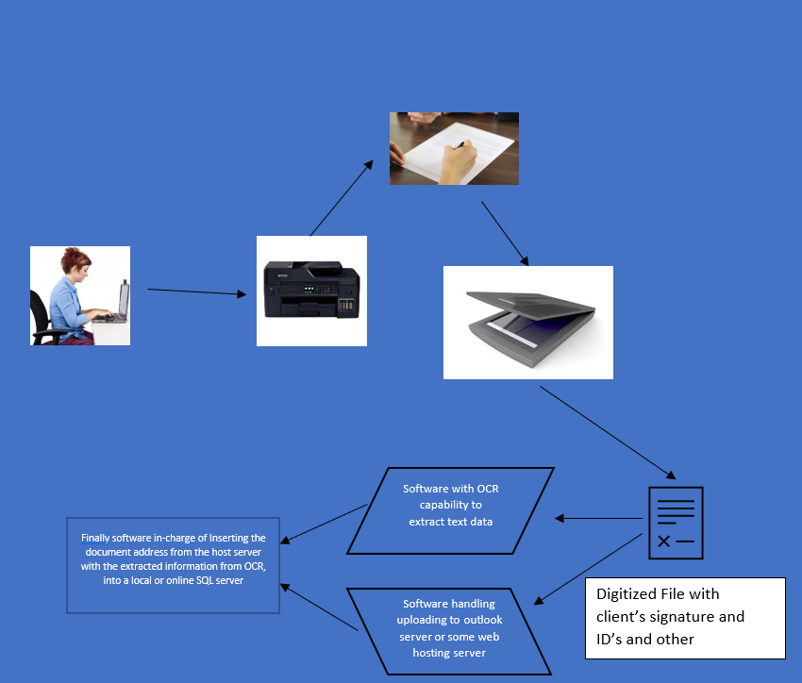

This is a very rough sketch of what our system’s flow would be. The main mode of data entry is by processing digital data from hardcopy or softcopy documents to extract keywords in preparation for archiving the said digital copy.

3.4 Evaluation
Evaluation would be done with a simple check if the OCR technology has successfully extracted key information from the digital copy of the document.
- Document Number Identification: All contract or notary document has a corresponding unique numerical sequence based on the book and year number. We would check if the OCR has successfully extracted that written information.
- Automated Data input: We would check if the system was successful in cataloging and organizing all the necessary document pertaining to the notary document. ID’s, supporting document. Etc.
- Automated Data Storage: The method in which all the document and supporting document would be stored locally or offsite.
Data Retrieval: the evaluation of retrieving the data or group of data base on user

Reference:

2019 Proposed Amendment to the Revised Rules on Evidence. (n.d.).
A.M. No. 02-8-13-SC 2004 Rules on Notarial Practice. (n.d.). Retrieved July 15, 2022, from https://sc.judiciary.gov.ph/files/rules-of-court/02-08-13-SC.pdf
Hamad, K., & Kaya, M. (2016). A Detailed Analysis of Optical Character Recognition Technology. International Journal of Applied Mathematics, Electronics and Computers, 4(Special Issue-1), 244–244. https://doi.org/10.18100/ijamec.270374
Jaillant, L. (2019). After the digital revolution: working with emails and born-digital records in literary and publishers’ archives. In Archives and Manuscripts (Vol. 47, Issue 3, pp. 285–304). Taylor and Francis. https://doi.org/10.1080/01576895.2019.1640555
James Kelman. (n.d.). The History of Banking: A Comprehensive Reference Source & Guide. CreateSpace Independent Publishing Platform, 2016.

Store Product and sales Management Solution

Chapter 1
Introduction

Store sails management solutions has been around for centuries. Since the time humans have introduce the concept of exchanging goods or services there was a need to better manage the information and data of said transaction.

Business Transaction and sales Accumulation Solution

Chapter 1
Introduction

Activity Number

