TUTORIAL

Installing and configuring python virtual environment

1. Installations:
   1. #sudo apt-get install python
   2. #sudo apt-get install pip
   3. #sudo pip install virtualenv
   4. #sudo pip install virtualenvwrapper
2. Setting environment variable:
   1. #sudo vim /etc/profile
   2. Add following lines:
      * export WORKON_HOME=$HOME/.virtualenvs
      * source /usr/local/bin/virtualenvwrapper.sh
   3. #source /etc/profile
3. Start new environment into project directory:
   * #mkvirtualenv <nameofve> -p python
4. Install necesary packages for the environment:
   1. #pip install numpy
   2. #pip install scipy h5py
   3. #pip install tensorflow # tensorflow-gpu for GPU machines
   4. #pip install keras
   5. #pip install flask gevent
   6. #pip install imutils requests
   7. #pip install redis
   8. #pip install Pillow //Image library

Project Plannification

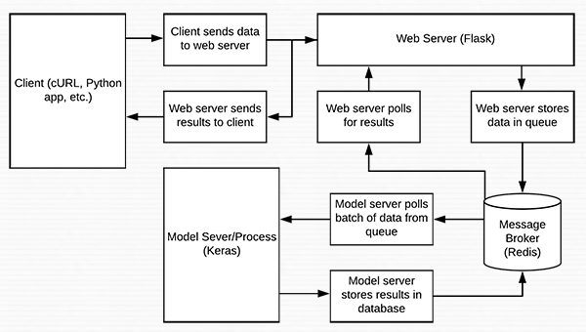

Server Script Building

Source

* https://www.pyimagesearch.com/2018/01/29/scalable-keras-deep-learning-rest-api/