Secondary Characters

The Vagabond
Name: Unknown
Age: Unknown
Race: Asian / Hispanic
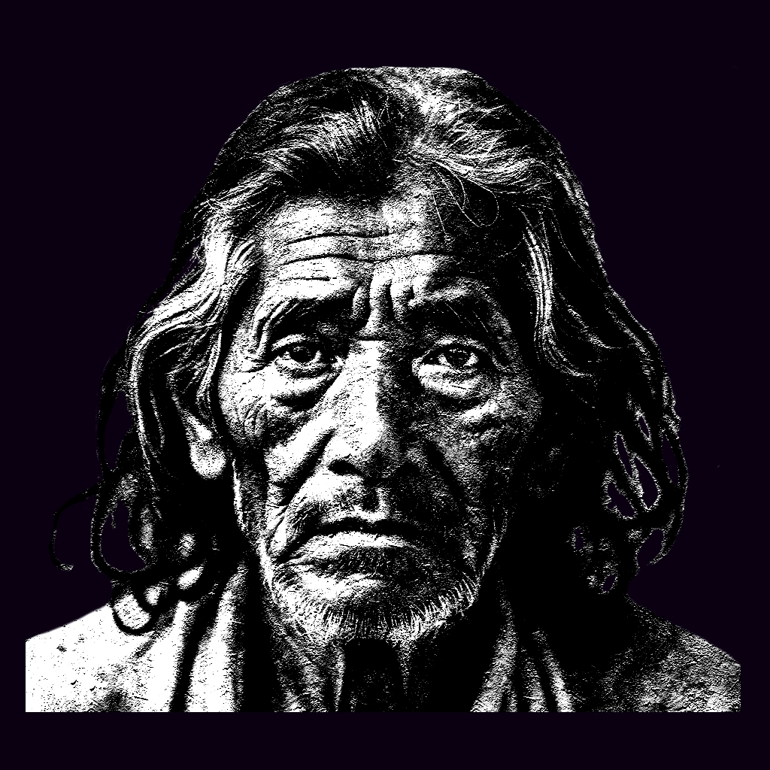
A vagabond roaming the city of Nueva Esperanza. He has seen the deterioration of the architecture and its people, nobody knows where he is from, where he used to work or if he has family around somewhere. It seems as if he has always been there, standing, watching, waiting. His reflections appear to criticize the way people tend to forget their humanity in order to keep on, and in the sake of comfort. He is one of the living among the ghosts that crawl in the darkest corners of Nueva Esperanza, also known as Los Olvidados. He therefore, is a symbol of the condition of the city. He lies at the core, he is everywhere.
He has both asian and hispanic features, his skin is dirty, his hair is gray and neglected. His eyes are sad and deep, but vivid. He is probably 50 or 60 years old, his voice is thick and low and he speaks coherently but meditative, sometimes speaking more to himself than you. His clothes are worn-out, darkened by mud, green, red and gray.

The Maid
Name: Soledad Fernandez
Age: 36
Race: Hispanic

A middle-aged hispanic woman living in the apartment building, she used to know Zhao family, her neighbors, she would portrait herself as a sweet woman, supportive and charismatic, but deep inside she was tormented by a heavy task. She immigrated to the south of the USA when she was only 19 years old with the promise of a better life for herself and a future family, girlfriend to an american soldier who convinced her even more to move. The idyllic life soon turned into nightmare once her boyfriend had an accident in the battlefield, the boyfriend had lost almost all senses and limps, left only with both his eyes. Deformed and crippled, left aside by his country that did not have the resources to compensate the soldier enough. Soledad had to take care of him, however she could. With not enough studies to get something better, she got a job as a maid in the richer side of the city, leaving Terrance (her boyfriend) alone for hours in the morning, and by the evening she would spend most of the time cleaning, feeding and taking care of his necessities. Saddened to her core, a modern martyr and one of the living among the ghosts of Nueva Esperanza. Eventually she will decide to commit suicide, unless you convince her otherwise.
Behind her worn-out face, you can see that she once was a beautiful young woman (still is), her black deep eyes display her accumulated fatigue, wrinkles in her forehead, dark shadows surrounding her eyes as a clear sign of weariness. Light brown skin and deep dark hair garnished by strings of white hair indicating a life full of stress.

The Father

The Mother

The Child

The Criminal
Name: Alan White
Age: 32
Race: White American
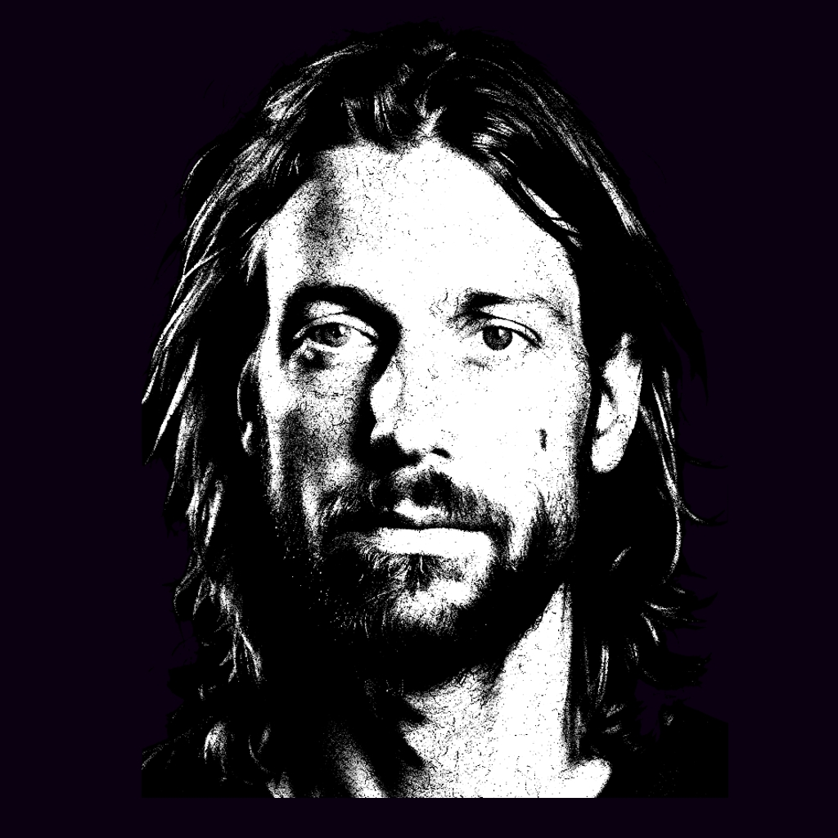
Alan is part of the lost youth in Nueva Esperanza. The middle class disappeared at the same time that crisis emerged, drug addiction and crime was the answer to many. Desperation and frustration led him to kidnap a child, without really being sure of how to ask for ransom or what to do with him, as if driven by a demon he took him from a family of other white people in the park. He then hid into an abandoned factory in the outskirts of the city to further plan his next moves.
Manuel is then called to investigate the same factory where a witness saw someone suspicious entering. The new detective then faces several decisions that may or may not save the boy from Alan claws, at the same time he is welcomed back by the city that once was his own home.
Alan is a white male, still young but the abuse of substances and the lack of nurishment has wasted his features. He looks old now, deprived and desperate, his green eyes reflect anxiety, his mouth plea for food and liquor, he can hardly formulate coherent thoughts, his voice is gritty and low. Light brown long hair and beard.

