Project Title: **To Supply Leftover Food to Poor**

Category: Salesforce

Skills Required: Salesforce Developer

1. Project Overview

a. Project Objectives and Goals

Objective: This project aims to develop a Salesforce-based application designed to manage and streamline the distribution of leftover food to underserved communities. The primary goal is to enhance the efficiency of food drop-offs, coordinate tasks, manage volunteers, and generate insightful reports.

2. Detailed Description of Implemented Features

a. Custom Objects

**1. Drop-OffPoint:**

* Purpose: The Drop-Off Point object captures essential details about locations where food is dropped off. This helps in tracking and managing food distribution points effectively.
* Fields:
  + Drop-OffPoint Name: A text field representing the name of the drop-off point
  + Location Details: A text field for additional details about the drop-off point location.
  + Distance: A number field that records the distance from the dropoff point to the delivery area.
  + Venue: A lookup relationship field linking to the Venue Object to provide a connection between drop-off points and venues.

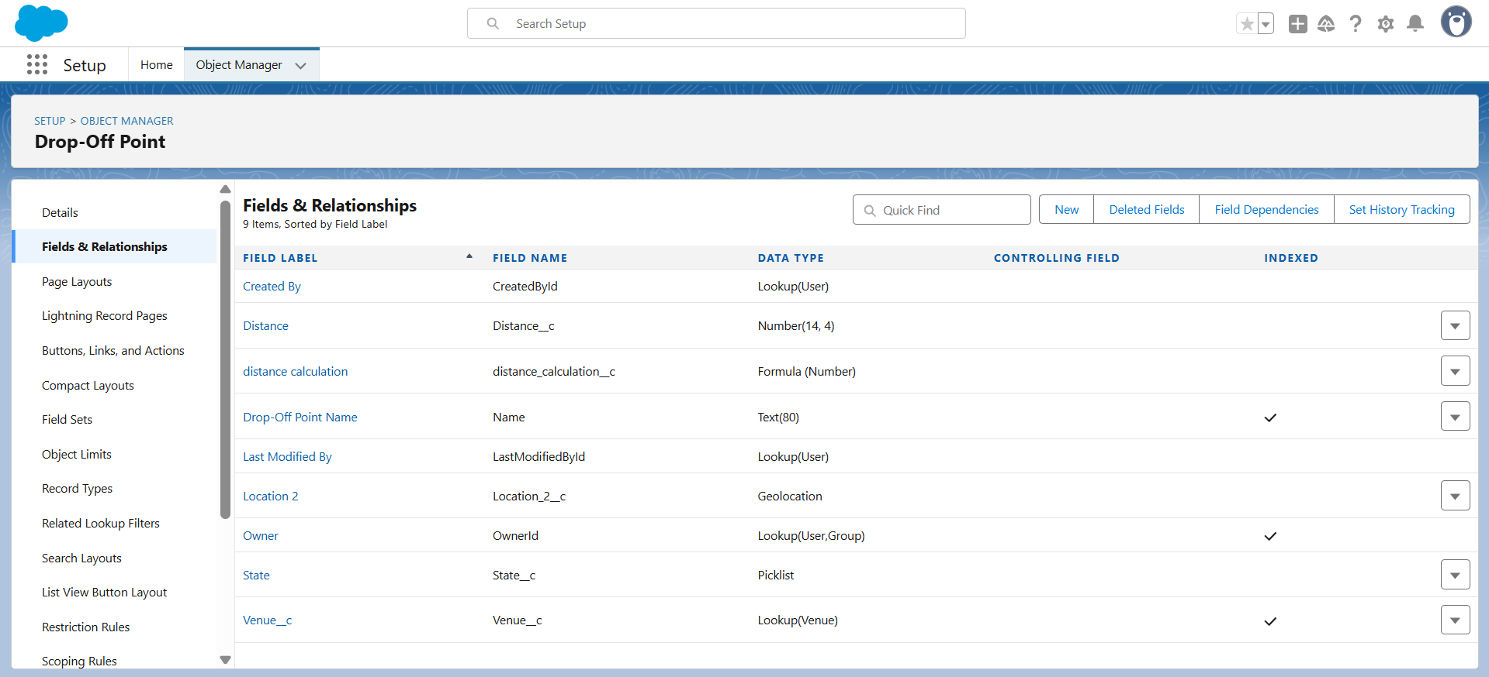

**2. Task:**

* Purpose: The Task Object is used to manage and track various tasks related to food distribution, including assigning tasks to volunteers and recording task details
* Fields:
  + Task Name: A text field representing the name of the task.
  + Date: A date field indicating when the task is scheduled or completed.
  + Rating: A numeric field used to rate the task performance.
  + Drop-Off Point: A lookup relationship field linking to the Drop-Off Point object to associate tasks with specific drop-off points.
  + Sponsored By: A lookup relationship field linking to the Drop-Off Point Object to indicate the sponsor of the task

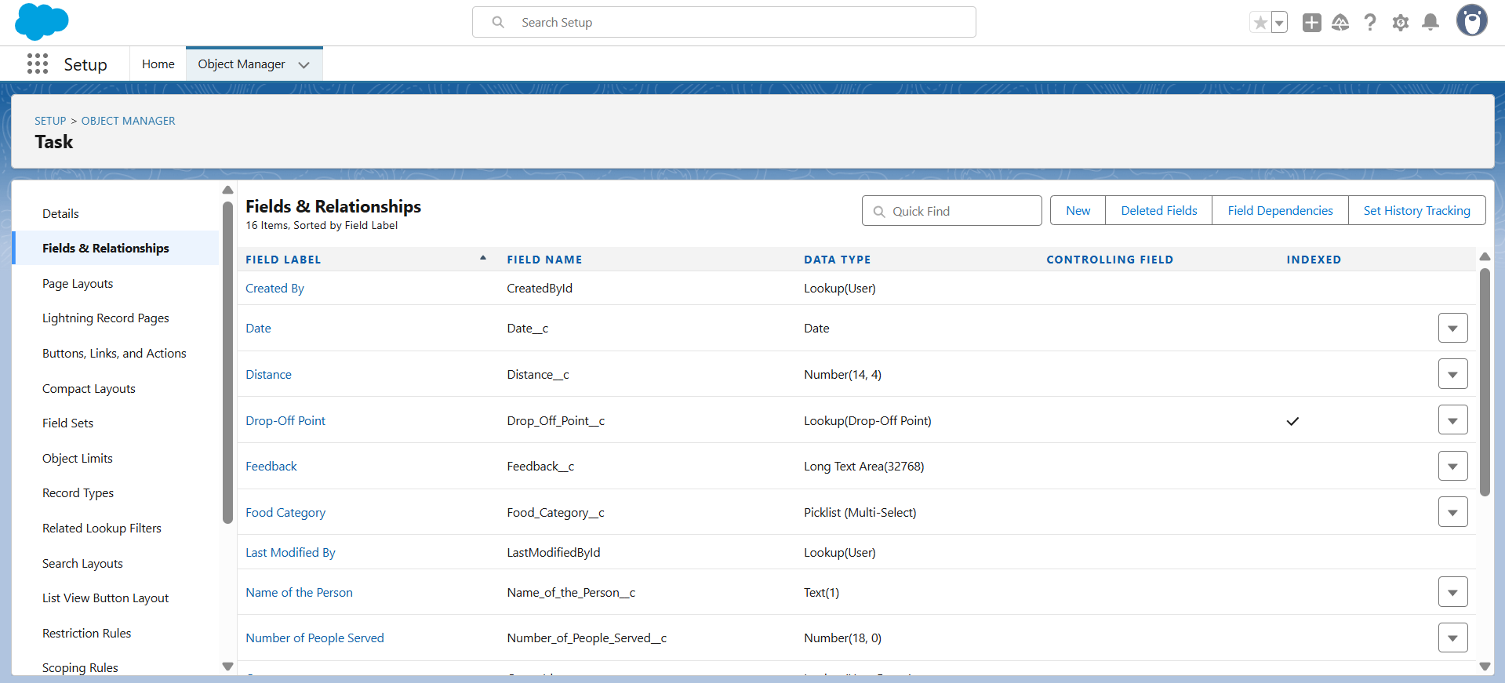**3. Volunteer:**

* Purpose: The Volunteer object keeps track of individuals who are involved in the food distribution process, including their contact information and assigned tasks
* Fields:
  + Volunteer Name: A text field for the name of the volunteer.
  + Contact Email: An email field for the volunteer's contact email.
  + Contact Phone: A phone field for the volunteer's contact number.
  + Assigned Tasks: A related list showing tasks assigned to the volunteer

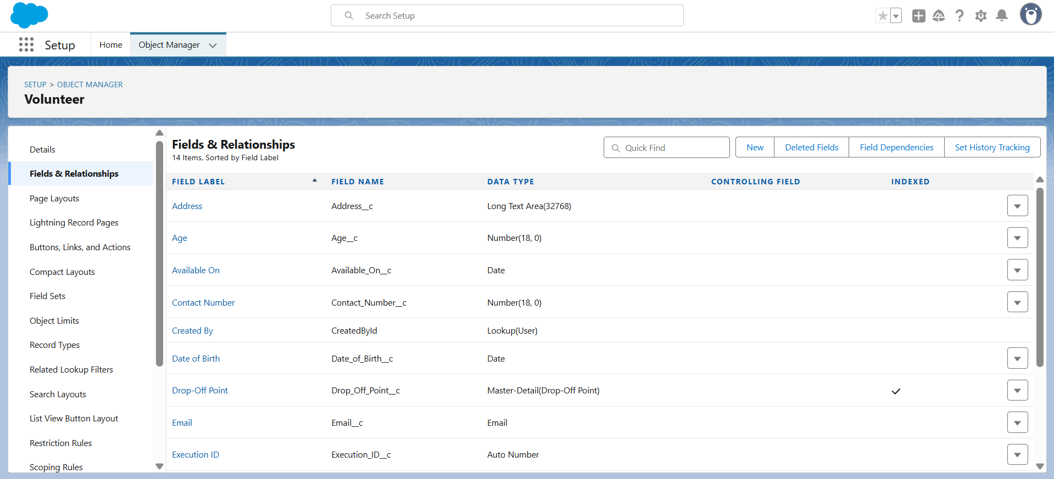

**4. Execution Detail:**

* Purpose: The Volunteer object keeps track of individuals who are involved in the food distribution process, including their contact information and assigned tasks
* Fields:
  + Execution Detail Name: A text field for naming the execution detail record.
  + Volunteer: A master-detail relationship field linking to the Volunteer object to associate execution details with a specific volunteer.
  + Task: A master-detail relationship field linking to the Task object to associate execution details with a specific task
  + Details: A text field for additional information about the execution.

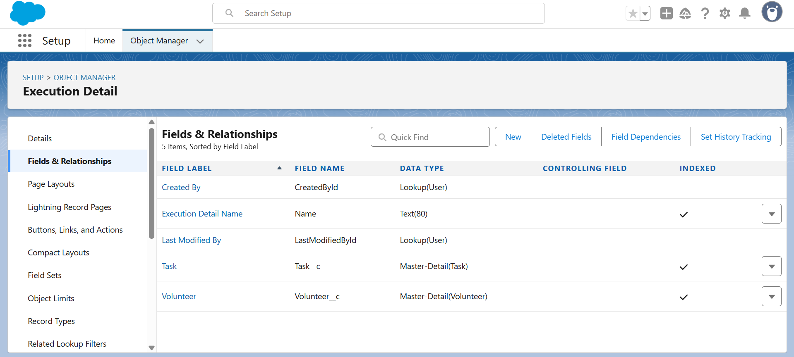

2.2 Object Relationships

* Master-Detail Relationships:
  + Execution Detail to Volunteer: Ensures that each execution detail record is linked to a volunteer, making volunteer information essential for each distribution record.
  + Execution Detail to Task: Ensures that each execution detail record is linked

to a task, making task information essential for each distribution record.

* Lookup Relationships:
  + Task to Drop-Off Point: Connects tasks to drop-off points, providing context on where each task is executed.
  + Task to Volunteer: Connects tasks to volunteers, enabling tracking of which

a volunteer is responsible for each task.

* + Drop-Off Point to Venue: Links drop-off points to venues, facilitating a detailed understanding Of where food is being dropped Off.

2.3 Sharing Rules

To ensure that records are shared appropriately based on distance criteria, the following sharing rules were set up:

* Rule 1:
  + Label: Rule 1
  + Criteria: Records where the distance is less than 15 km
  + Access: Shared with Public Group - Iksha
* Rule 2:
  + Label: Rule 2
  + Criteria: Records where the distance is between 15 km and 30 km
  + Access: Shared with Public Group - NSS

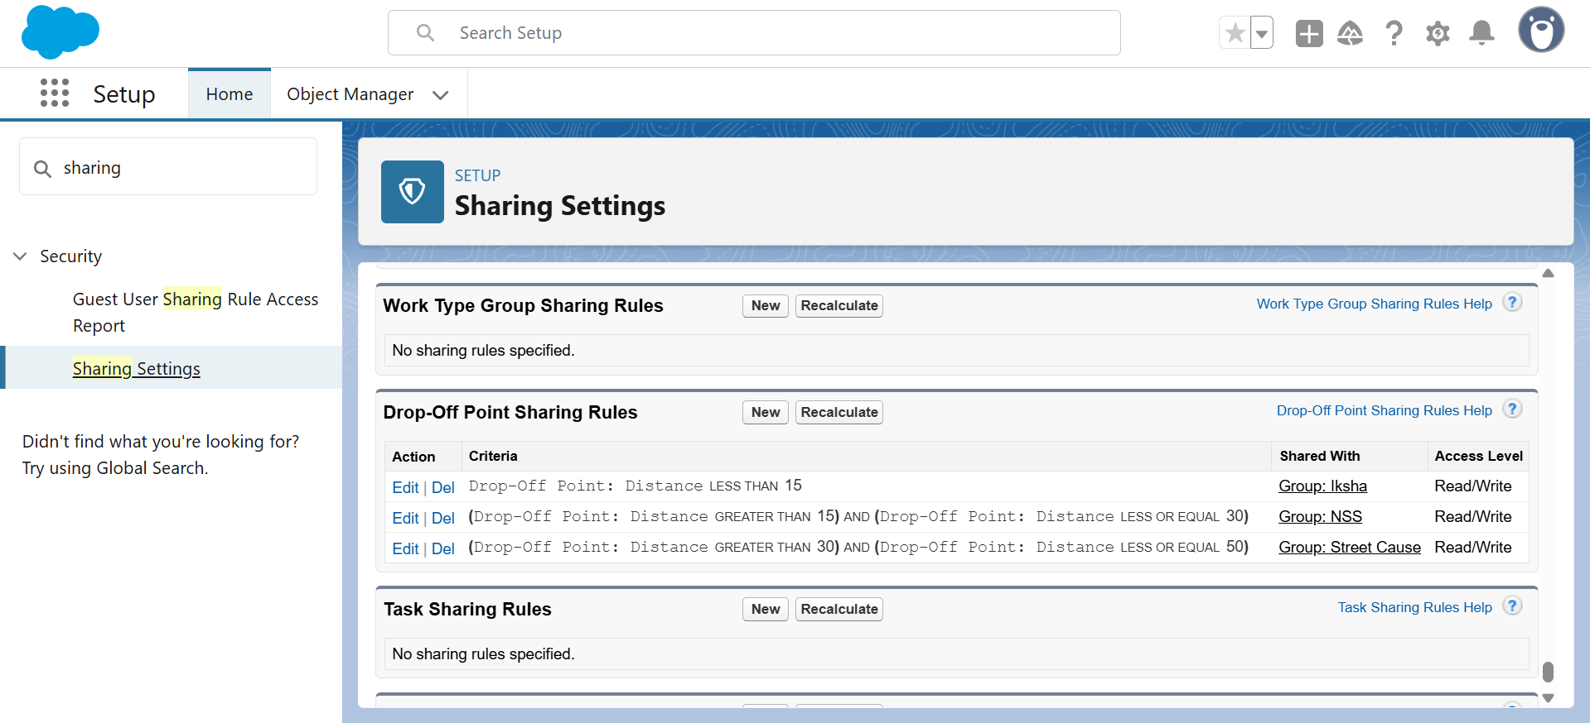

2.4 Flow and Dashboard

* Flow: Venue Flow
* Purpose: To manage and capture detailed information related to food drop-off points.
* Components:
  + Text Component: For entering the venue name.
  + Email Component: For entering the contact email of the venue.
  + Phone Component: For entering the contact phone number of the venue.
  + Text Component: For entering the venue location.
  + Number Components: For entering latitude and longitude values of the venue.

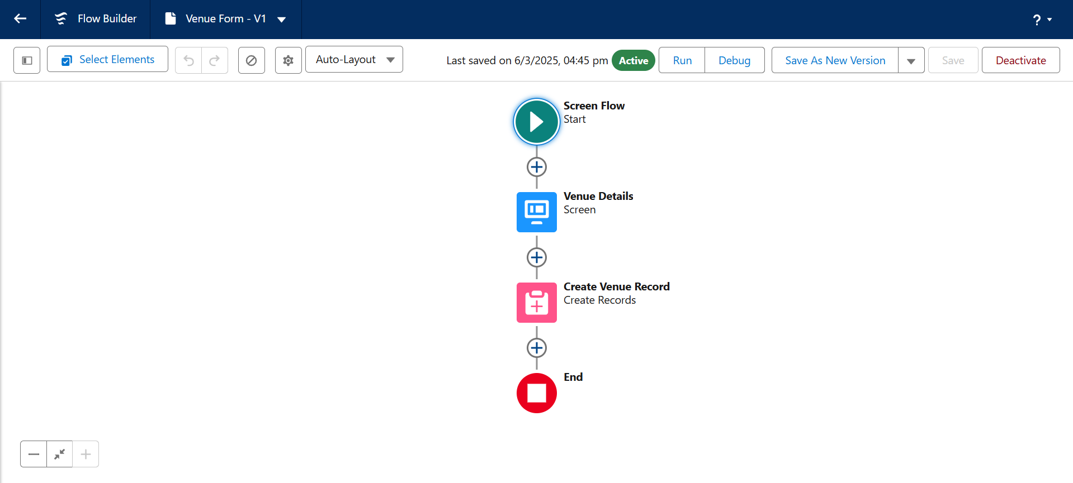

* **Dashboard:**
* Name: Organization Details
* Components:
  + Lightning Table: Displays detailed information about venues and drop-off points, facilitating a comprehensive view of the data.

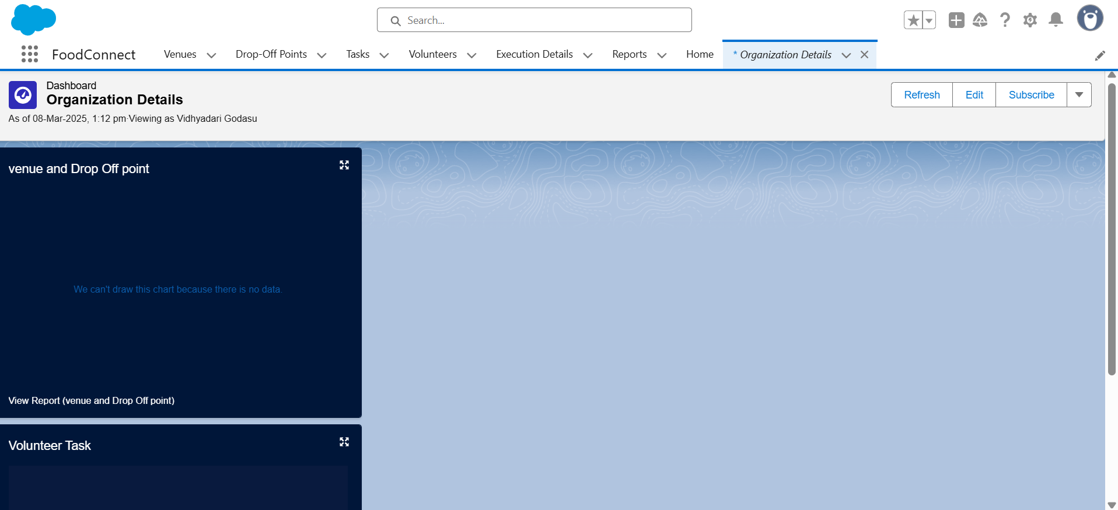

3. Configuration and Setup Instructions

3.1 Creating Custom Objects

1. Drop-Off Point:

* Navigate to Object Manager > Create > Custom Object.
* Enter details such as the label name, record name, and Other settings for Drop

2. Task:

* Navigate to Object Manager > Create > Custom Object.
* Enter details such as the label name, record name, and other settings for Task.

3. Volunteer:

* Navigate to Object Manager > Create > Custom Object.
* Enter details such as the label name, record name, and other settings for Volunteer.

4. Execution Detail:

* Navigate to Object Manager > Create > Custom Object.
* Enter details such as the label name, record name, and other settings for Execution Detail.

3.2 Sharing Rules Setup

* GO to Sharing Settings.
* Define new sharing rules for Drop-Off Point based on distance criteria, ensuring appropriate access for different public groups.

3.3 Lightning App Builder

1. Create Home Page:

* Go to Lightning App Builder > New
* Select Home Page and name it "HOME Page"
* Add Flow and Dashboard components to the page.

2. Save and Activate:

* Click on Save and Activation.
* Set the page as the default for the FoodConnect app.

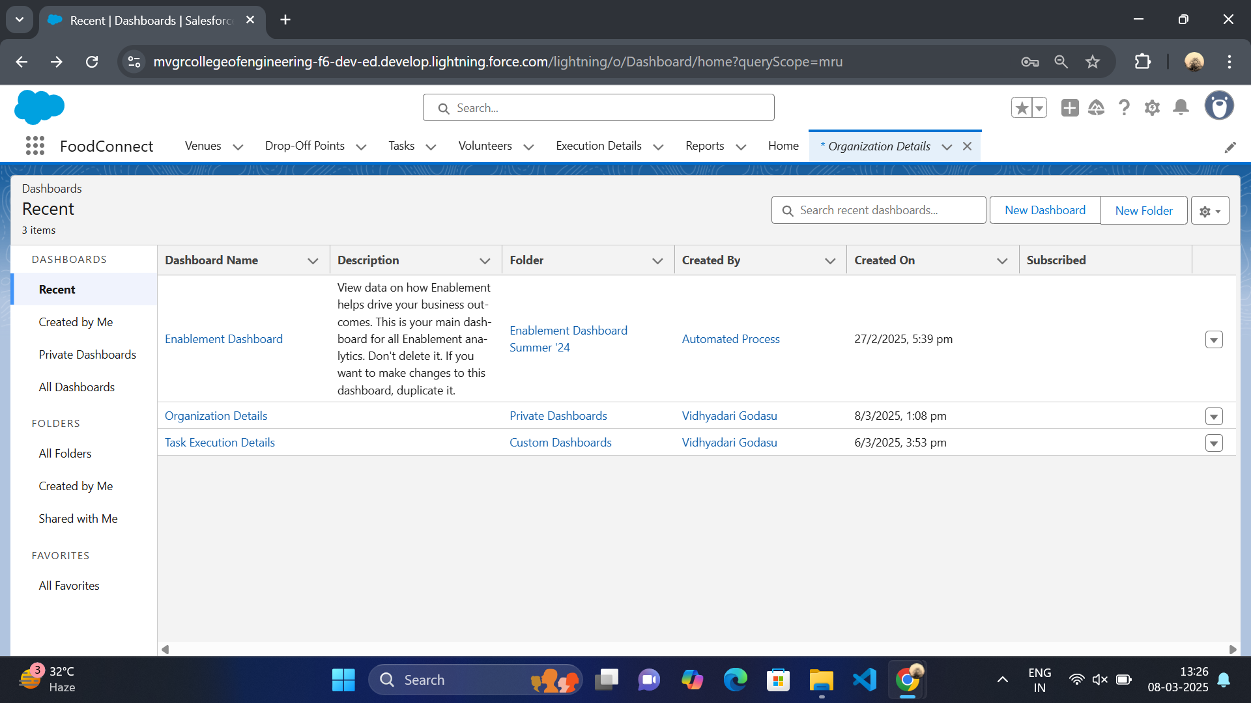

3.4 Report Types and Dashboards

1. Custom Report Types:

* Create report types for Venue with Drop-Off with Volunteer and Volunteers with Execution Details and Tasks.

2. Reports:

* Generate and configure reports using the custom report types to track and analyse relevant data.

3. Dashboards:

* Configure dashboards to visualise data from reports and other components, providing insights into the overall distribution process.

4. Deliverables:

* Code Files: Include Apex triggers and any other code implemented.
* Output Screenshots: Provide screenshots of custom objects, flows, dashboards, and reports to illustrate the setup.
* Project Documentation: Detailed descriptions of implemented features, configurations and setup instructions.
* Project Demonstration Video: A video showcasing the functionality of the application, including key features and processes.