Geometry-Aware Optimization of CNN Inference Energy for CPU-Based Edge Devices

(Abstract) CNN inference on edge devices is increasingly important, yet relatively few studies have examined how CNN architecture affects inference energy under constrained CPU resources. This study investigates the relationships between depth, channel distribution, pooling placement, and CPU inference energy, latency, and classification accuracy. We profiled 550 CNN architectures using ONNX Runtime and HWiNFO power logs, and evaluated 100 architectures on CIFAR-10. XGBoost surrogate models were trained to predict energy, latency, and accuracy, enabling the screening of 50,000 valid CNN candidates and identification of Energy-Accuracy Pareto candidates for empirical verification. Paired measurements were also conducted to assess whether untrained ONNX models preserved the relative energy and latency characteristics of trained models. In adjusted regression analyses, each additional pooling operation was associated with a 38.7% reduction in inference energy (95% CI: 37.0%–40.3%; HC3 p < .001) and, within the accuracy-measured subset, a 1.20 percentage-point increase in CIFAR-10 accuracy (95% CI: 0.76–1.65 pp; HC3 p < .001). Compared with a near-parameter-matched VGG-inspired reference, the selected Pareto candidate reduced trained CPU inference energy by 52.23% while changing accuracy by -0.11 pp. These results indicate that pooling placement and channel geometry can affect CPU inference energy beyond parameter count alone, supporting their consideration in energy-aware CNN design.

1. INTRODUCTION

As CNN-based image classification is increasingly used on edge device, reducing inference energy under constrained CPU environments has become an important challenge. Existing studies have mainly focused on reducing parameter count, computational cost, or training energy [1]. However, parameter-matched architectures can still exhibit different inference costs depending on how convolutional layers, channel widths, and pooling operations are arranged.
Prior work compared shallow-wide and deep-narrow neural networks under fixed parameter budgets, showing that deeper network does not necessarily improve performance [2]. However, that study was limited to accuracy in audio-event detection and did not quantify inference energy or latency.
This study extends the geometry perspective to CNN image classification by directly measuring CPU inference energy, latency, and accuracy across architectures with various depth, channel distribution, and pooling placement. Based on these measurements, we identify lower-energy configurations that maintain competitive classification performance.

2. METHODS

We generated CNN architectures with different depths, channel-distribution patterns, numbers of pooling operations, and pooling locations. To isolate the effects of architectural geometry, all models used CIFAR-10 inputs, 3×3 convolutions, and the same classifier structure. This allowed the architectures to be compared under a consistent experimental setup. In total, 550 architectures were profiled using ONNX Runtime for CPU inference. Net inference energy and latency were calculated from HWiNFO CPU Package Power logs after correcting for the idle-power baseline. Among these architectures, 100 were additionally evaluated for CIFAR-10 classification accuracy using the same training protocol. We also performed paired measurements on untrained and trained ONNX models to examine whether the initial measurements captured the relative computational costs of the trained architectures.
Across 27 paired architectures, untrained and trained measurements showed near-perfect correlations for energy (Pearson r = 0.999) and latency (r = 1.000). Paired TOST analyses further supported equivalence within pre-specified margins of ±5% for energy and ±3% for latency. These results support the use of untrained ONNX measurements as large-scale indicators of relative structural cost.

3. RESULTS AND DISCUSSION
3.1. SURROGATE PREDICTION AND PARETO LANDSCAPE

On the test set, the XGBoost models achieved R² values of .886, .976, and .902 for predicting Energy, Latency, and Accuracy, respectively. These results suggest that a large portion of both CPU inference cost and classification performance can be explained by architectural characteristics.
The Energy-Accuracy Pareto analysis further showed that jointly adjusting channel-growth patterns and pooling placement produced more favorable energy-accuracy trade-offs than reducing parameter count alone. In other words, architectures with similar parameter counts are able to differ considerably in their energy-accuracy characteristics depending on how their layers were arranged. Fig. 1(a) visualizes the final surrogate-based Energy-Accuracy Pareto landscape across the 50,000 generated candidates. The highlighted C002793 architecture lies on this final Pareto frontier and was selected for trained empirical comparison.
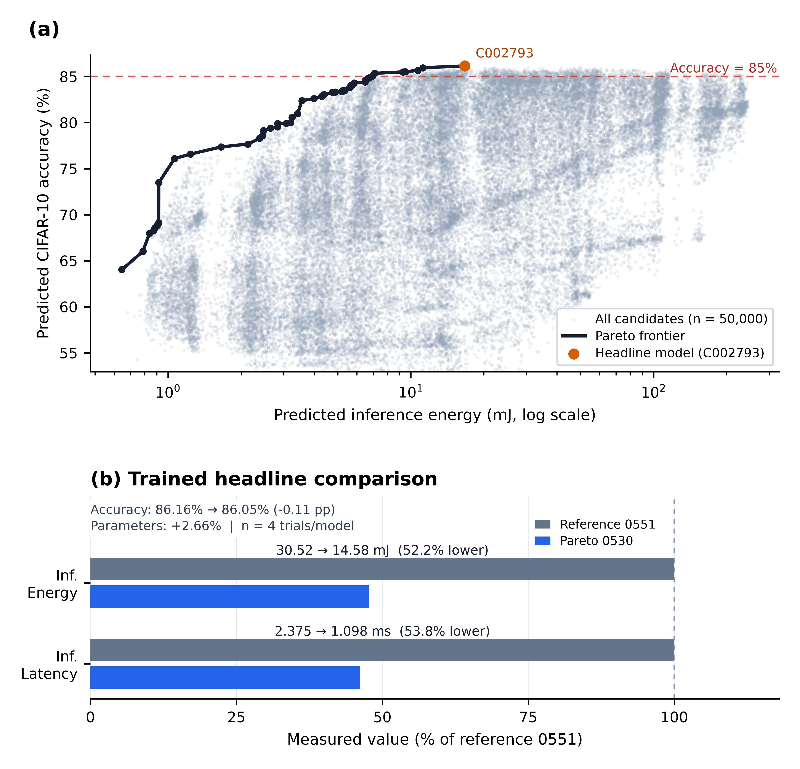
Fig 1. Final Pareto search and trained headline outcome.
(a) Energy–Accuracy Pareto landscape of 50,000 CNN candidates predicted by the surrogate; C002793 is highlighted and energy is log-scaled. (b) Trained ONNX comparison of VGG-inspired reference 0551 and C002793/0530, normalized to 0551 (four trials/model).

3.2. EFFECT OF POOLING GEOMETRY

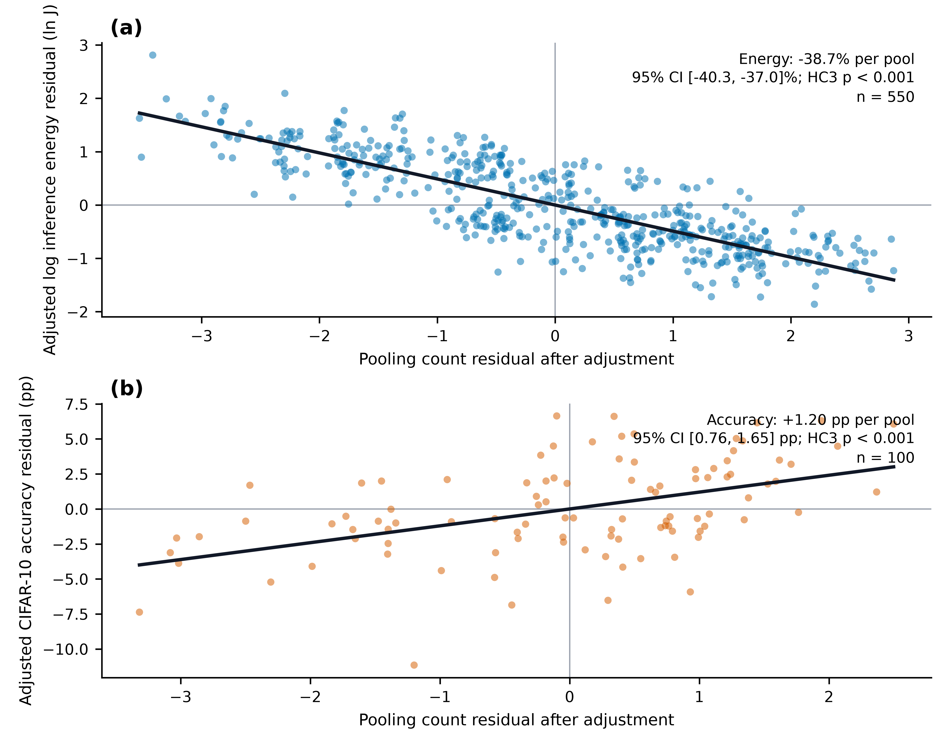

Fig 2. Association of pooling geometry with CNN inference energy and classification accuracy.
Regression estimates adjusted for model size, depth, and channel distribution. (a) Each additional pooling layer was associated with 38.7% lower inference energy across 550 architectures (95% CI: 37.0–40.3%; HC3 p < .001). (b) It was associated with +1.20 pp CIFAR-10 accuracy across 100 labeled architectures (95% CI: 0.76–1.65 pp; HC3 p < .001).

As shown in Fig 2, adjusted partial-residual analyses indicated that pooling count is significantly associated with both energy and accuracy after controlling for architectural covariates. After these adjustments, each additional pooling layer was associated with an average 38.7% reduction in inference energy (95% CI: 37.0% to 40.3% reduction; HC3 (p < .001)). Within the subset of 100 architectures with accuracy measurements, each additional pooling operation was also associated with a 1.20 pp increase in CIFAR-10 accuracy (95% CI: 0.76 to 1.65 pp; HC3 p < .001). These results should be interpreted as adjusted associations within the architecture space explored in this study rather than as evidence of a direct causal effect of pooling.

3.3 COMPARISON WITH THE VGG-INSPIRED REFERENCE

The paired validation across 27 architectures supported the use of untrained ONNX measurements as structural cost indicators: untrained and trained measurements showed near-perfect agreement for energy (Pearson r = .999) and latency (r = 1.000), and both satisfied the pre-specified TOST equivalence margins of ±5% and ±3%, respectively, indicating that the initial measurements provided a useful large-scale indicator of relative structural cost.
Then, we compared the selected Pareto candidate with a VGG-inspired reference architecture whose parameter count was within 3% of the candidate [3]. This comparison demonstrates that meaningful differences in actual inference energy can arise from model geometry even when two architectures have similar parameter counts. As shown in Fig 1(b), the candidate reduced trained CPU inference energy by 52.23% and latency by 53.77%, while changing classification accuracy by -0.11 percentage points.

4. CONCLUSION

This study combined CPU inference measurements from 550 CNN architectures with XGBoost-based surrogate modeling to investigate the relationship between CNN geometry and inference energy. The results showed that pooling geometry were associated with differences in inference energy that were not explained by parameter count alone. In addition, the Energy-Accuracy Pareto analysis identified architectures that could reduce energy consumption while retaining performance. Overall, these findings suggest that CNN architecture design for edge CPUs should consider channel and pooling geometry alongside conventional measures such as model size and parameter count.

References

[1] He, L., Li, D., Jiang, C., Liu, J., Xu, C. & Zhang, L. A predictive offline–online hybrid approach to DNN training energy optimization. Sustainable Computing: Informatics and Systems 51, 101415 (2026).
[2] Wang, J. & Li, S. Comparing the influence of depth and width of deep neural network based on fixed number of parameters for audio event detection. Proc. IEEE Int. Conf. Acoustics, Speech and Signal Processing 2681–2685 (2018).
[3] Simonyan, K. & Zisserman, A. Very deep convolutional networks for large-scale image recognition. arXiv:1409.1556 (2015)

