SMART HOME VOICE AGENT
Development Log

Project Overview
This project creates a voice-controlled smart home system. User speak commands, and the system controls lights and fans connected to an ESP32 microcontroller.
What it does:
- Listens to User voice through your computer microphone
- Converts speech to text using Whisper AI
- Understands User intent using Qwen AI
- Sends commands to ESP32 via MQTT
- ESP32 controls lights and fans
- Shows temperature and humidity on an LCD screen
- Interactive Web dashboard to control home appliances
- Accessible globally on any Wi-Fi using secure Cloudflare Tunnels

- Software Setup
1.1 Install Python 3.11
Whisper AI only works with Python 3.11. Other versions will not work.

1.2 Create Whisper Environment
• Open command prompt
• >> mkdir C:\Whisper311
• >> cd C:\Whisper311
• >> py -3.11 -m venv whisper_env
• >> whisper_env\Scripts\activate
• >> pip install faster-whisper
• >> pip install sounddevice
• >> pip install scipy
• >> pip install openai
• >> pip install paho-mqtt

1.3 MQTT Broker Setup (Mosquitto)
MQTT is a messaging system. It allows your Python program and ESP32 to talk to each other.
1.3.1 Download Mosquitto
- Go to mosquitto.org/download
- Download Windows x64 installer
- Open Command Prompt
- >> mosquitto -v
- If successful, you see:
mosquitto version 2.x starting
Opening ipv4 listen socket on port 1883.
Opening ipv6 listen socket on port 1883.
(IMPORTANT: Keep this Command Prompt window open. Do not close it.)

1.3.2 If occur:
- 'mosquitto' is not recognized as an internal or external command
(Means Mosquitto's folder m didn’t added to Windows PATH.)

- Open Command Prompt
- >> cd "C:\Program Files\mosquitto"
- >> cd mosquitto.exe -v
- You should see something similar to:
1750000000: mosquitto version 2.x starting
1750000000: Using default config.
1750000000: Starting in local only mode.
1750000000: Opening ipv4 listen socket on port 1883.
1750000000: Opening ipv6 listen socket on port 1883.
(Means The MQTT Broker is running successfully!)
IMPORTANT: Keep this Command Prompt window open. Do not close it.

1.3.3 Possible Errors (Mosquitto Running Error)
• In the command prompt you just opened, if you see: Only one usage of each socket address (protocol/network address/port) is normally permitted. Or later when running the project, if the Arduino IDE Serial Monitor shows an error:
Attempting connect to mqtt…………….. rc = -2…………… fail……….
• Which means: Another Mosquitto instance is already running on your laptop.
• Most likely, because you installed Mosquitto as a Windows Service, it automatically started in the background. So when you manually ran:
mosquitto.exe -v
you accidentally tried to start a second broker.
• TO FIX IT
• Press: Win+R then type: services.msc ENTER
• Find Mosquitto Broker or Mosquitto
• If it says Running, right-click it then choose STOP
• Wait until the status becomes blank.
• Because we want to restart Mosquitto with a custom configuration that allows the ESP32 to connect.
• Then open a new Notepad and create a file named my_mosquitto.conf (this file has been shared in the group)
• In this my_mosquitto.conf file, paste:
listener 1883
allow_anonymous true
• Then drag this file into the Mosquitto folder (the location should be:
C:\Program Files\mosquitto)
• Then go back to the command prompt
• >> cd "C:\Program Files\mosquitto"
• >> mosquitto.exe -c my_mosquitto.conf -v
• You should see the following:
mosquitto version 2.1.2 starting
Config loaded from mosquitto.conf.
Opening ipv4 listen socket on port 1883.
Opening ipv6 listen socket on port 1883.
mosquitto version 2.1.2 running
• You should NOT see: Only one usage of each socket address...

1.3.4 Download MQTT
- Open command prompt
- >> python -m pip install paho-mqtt
- Show (Successfully installed paho-mqtt-2.x.x) means successfully
- If fail, try >> py -m pip install paho-mqtt

1.4 Programming Setup
1.4.1 Drag file
Drag all the python file (record_test.py // smart_home_voice.py // speech_to_text.py // test_whisper.py) into whisper folder (location C:Whisper311)
Coding refers file (SHVA_code)
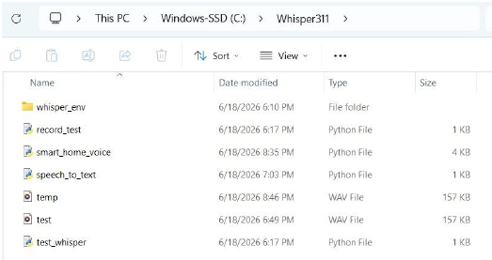

1.4.2 Check IP
Before running the project each time, check your computer's IP address because mine keeps changing. So before every run, you need to check it and then replace the IPv4 address in both of these codes:
• smart_home_voice.py
• sketch_jun13a_ESP32_SmartHome_Phase7A1.ino
To check the laptop IPv4 address:
Cmd >> ipconfig
Then look for:
IPv4 Address ............................................. 192.168.0.111
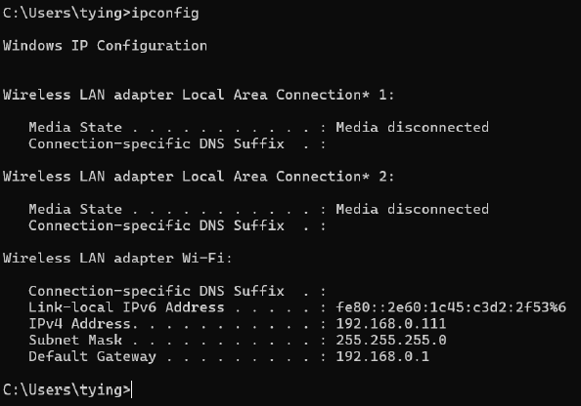

1.4.3 Arduino ide code
This is the Arduino IDE code for the ESP32.
Please change WiFi SSID & WiFi Password and your laptop's IPv4 address (the current one is 192.168.0.104)
Make sure the IPv4 address matches your laptop's current IP address before uploading and running the code.
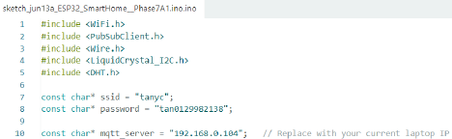

    - API Key Setup
For better security and speed, we are now using a dedicated Alibaba Cloud Workspace and a faster model (qwen3.7-plus). Update the Qwen client in smart_home_voice.py to this exact code:
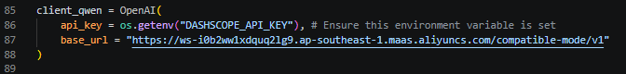Setting the API Key (Windows): Because we are using os.getenv, you must set your API key in your laptop's system variables once. Open Command Prompt and type:
Setx DASHSCOPE_API_KEY “your api key”
(Restart your computer or IDE after running this).

    - CMD
Once everything is set up and you are ready to run the project, you need to open two Command Prompt windows.
Window 1 (CMD)
>>cd "C:\Program Files\mosquitto"
>>mosquitto.exe -c my_mosquitto.conf -v
(Check whether it is using my_mosquitto.conf or mosquitto.conf.)
Window 2 (CMD)
>>cd C:\Whisper311
>>whisper_env\Scripts\activate
>>python smart_home_voice.py
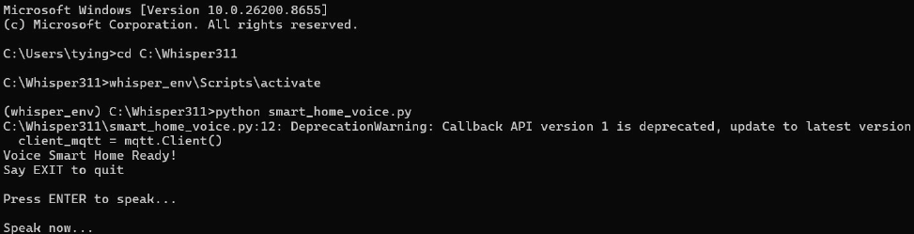
The Window 2 interface is our UI.
The Window 1 interface is the communication medium between the Python program and the ESP32.
The role of the AI in this project is:
User: "It's getting hot here."
The Qwen AI will interpret the meaning and think: "It is hot, so the fan should be turned on."
It will then generate the command: ON FAN
The Python program sends this command through MQTT (via Window 1) to communicate with the ESP32, and then the ESP32 turns on the fan.
The same logic applies to:
User: "It's getting dark here."
The AI will understand the intention and send the appropriate command to turn on the light.
Of course, users can also give direct commands such as: turn on light, turn off light, turn on fan, turn off fan…
In summary, the AI acts as an intelligent interpreter that converts natural language into device control commands, while MQTT serves as the communication bridge between the Python application and the ESP32.

    - Generate API Key
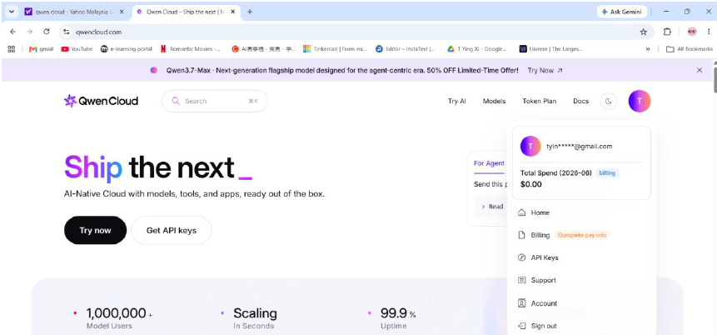
- Google search Qwen Cloud and login acc
- Press API Key at Acc sides
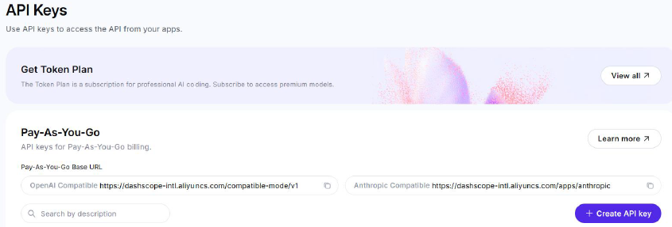
- Press Create API Key
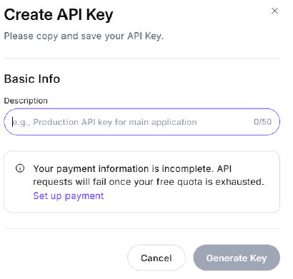
- Write any content at description and then press generate key

1.4.7 Arduino IDE Setup
- Install Arduino IDE
- Install ESP32 Board
- Install Required Libraries (PubSubClient, LiquidCrystal I2C, DHT sensor library)

    - Install Python dependencies
-open cmd
->>pip install numpy
->>pip install paho-mqtt
->>pip install pydub
->>pip install pyaudio
->>pip install faster-whisper
->>pip install scipy
->>pip install numpy paho-mqtt pydub pyaudio faster-whisper scipy
->>pip install pipwin
->>pipwin install pyaudio
->>pip install setuptools wheel Cython
->>pip install faster-whisper --prefer-binary

2.0 Hardware Setup
2.1 Hardware Components List
Component | Picture | Purpose
ESP32 Dev Board | 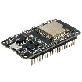 | Main controller
DHT22 Sensor | 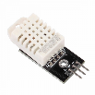 | Temperature & Humidity
I2C LCD (16x2) | 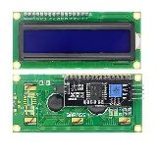 | Display screen
LED |  | Light output indicator
DC Fan (5V) | 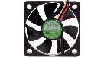 | Fan output
TIP31C Transistor | 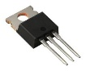 | Fan switch
Resistor | 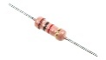 | Current limit
Jumper Wires | 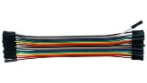 | Connections
Breadboard |  | Circuit assembly
INMP441 | 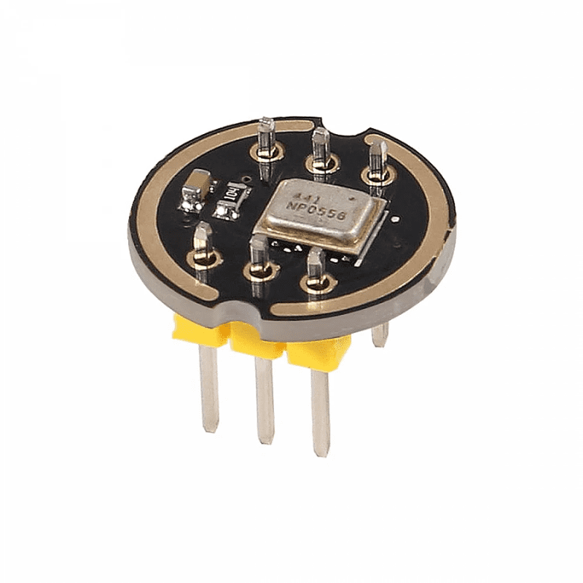 | Microphone
MAX98357 | 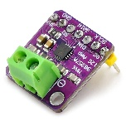 | I2S audio amplifier
Amplifier Speaker | 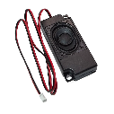 | Speaker
Relay Module | 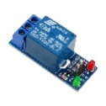 | Operate LED

2.2 Wiring Component
Component | Component Pin | Connect To | Purpose
DHT22 | VCC | ESP32 3.3V | Power
 | GND | ESP32 GND | Ground
 | DATA | ESP32 GPIO4 | Temperature & humidity data signal
I2C LCD | VCC | ESP32 5V | Power
 | GND | ESP32 GND | Ground
 | SDA | ESP32 GPIO21 | I2C data line
 | SCL | ESP32 GPIO22 | I2C clock line
TIP31C (Fan Control) | Base (via 2kΩ) | ESP32 GPIO19 | Fan ON/OFF control signal
 | Collector | Fan GND | Switch fan ground
 | Emitter | ESP32 GND | Common ground
Fan | VCC | ESP32 5V | Power
 | GND | TIP31C Collector | Controlled ground
INMP441 Microphone | VDD | ESP32 3.3V | Power
 | GND | ESP32 GND | Ground
 | SD | ESP32 GPIO35 | I2S data input
 | WS | ESP32 GPIO32 | I2S word select
 | SCK | ESP32 GPIO26 | I2S clock
 | L/R | ESP32 GND | Left channel selection
MAX98357 Amplifier | VIN | ESP32 5V | Power
 | GND | ESP32 GND | Ground
 | DIN | ESP32 GPIO23 | I2S audio data
 | LRC | ESP32 GPIO27 | I2S left/right clock
 | BCLK | ESP32 GPIO14 | I2S bit clock
 | SD | ESP32 GPIO33 | Shutdown control
 | GAIN | ESP32 GND | Gain setting
OLED Display (SSD1306) | GND | ESP32 GND | Ground
 | VCC | ESP32 3.3V | Power
 | SCL | ESP32 GPIO25 | I2C clock line
 | SDA | ESP32 GPIO17 | I2C data line
TIP31C (Relay Control) | Base (via 2kΩ) | ESP32 GPIO18 | Relay ON/OFF control signal
 | Collector | Relay IN | Switch relay control
 | Emitter | ESP32 GND | Common ground
Relay Module | VCC | 5V Power Supply | Relay power
 | GND | ESP32 GND | Ground
 | IN | TIP31C Collector | Receive transistor switching signal
 | COM | LED + | Relay output
 | NO | 5V Power Supply | Normally open power output
 | NC | Not connected | Normally closed (unused)
LED | Positive (+) | Relay COM | Controlled power input
 | Negative (-) | ESP32 GND | Ground return

3.0 UI Design
3.1 The Flask Dashboard (app.py) To control the hardware remotely, a Flask web application (app.py) was developed. It communicates with the Python background process to display:
- Live device states (ON/OFF).
- An Activity Log mapping out user voice text, intents, and system errors.
- A terminal injection text box for typed commands.
- Dynamic CSS theme switching (Sunrise, Dark, Light).
3.2 Global Remote Access (Cloudflare Tunnels) To allow the dashboard to be accessed from any phone (even on cellular data), we use a secure Cloudflare Tunnel.
- Installation: Open CMD and run: winget install Cloudflare.cloudflared
- Usage: While the system is running, open a new CMD and run: cloudflared tunnel --url http://localhost:5000
- Result: Cloudflare provides a public link (e.g., [https://random-words.trycloudflare.com](https://random-words.trycloudflare.com)) that routes securely to the local dashboard.

4.0 Prototype
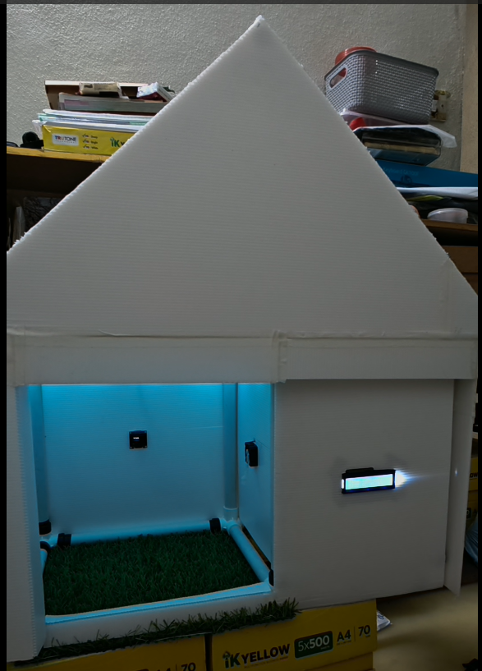

5.0 Running Complete System
5.1 Check Laptop IP Address
- open command prompt
- >>ipconfig
- Look for "IPv4 Address" (example: 192.168.0.104)
- Update in two places which is
(smart_home_voice_esp32_audio_fixed.py) – BROKER = “YOUR_IP”
(smart_home_voice_agent_esp32.ino) – mqtt_server = “YOUR_IP”

5.2 Start the System (One-Click Automation)
Instead of manually opening multiple command prompt windows, we have automated the startup and shutdown process using Windows Batch files.

Create Start - SHVA.bat inside C:\Whisper311:
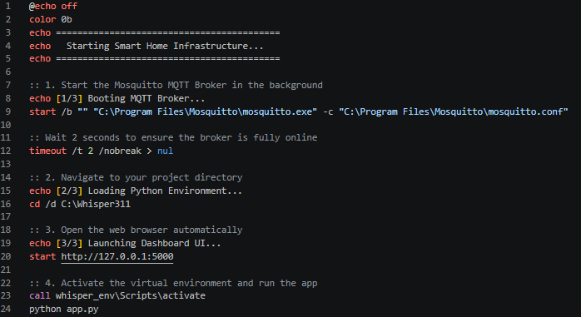
To run the system, simply double-click Start - SHVA.bat. It will automatically start the MQTT broker, open the web browser, and launch the Python backend.
Create Stop - SHVA.bat inside C:\Whisper311:
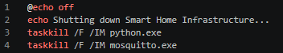

Wake-Word Interaction
- User says “Hey Home” (or variations).
- ESP32 microphone stream is processed by Whisper on PC.
- If wake word detected:
  - Acknowledge beep plays through speaker.
  - If a command immediately follows (“Hey Home turn on light”), it is extracted and executed directly.
  - Otherwise, the system listens for a separate command (up to 4 seconds).
- Transcribed command is sent to Qwen for intent parsing.
- Intents are published via MQTT; reply is spoken back.

5.4 Troubleshoot document location
C:\Whisper311\smart_home_voice_esp32_audio_fixed.py
C:\Users\USER\Documents\Arduino\esp32_shva_mic_speaker_mqtt_fixed\esp32_shva_mic_speaker_mqtt_fixed.ino

用户语音录音：C:\Whisper311\temp_esp32_mic.wav
系统回复音频：C:\Whisper311\assistant_reply.wav

