Assignment 1 - Example of good and bad interface design

Lucas Pratas Oliveira – 64485

As an example of good interface design, we'll be using the Moovit android application. The objective of the interface is to provide information on public transit lines to aid user navigation. One good aspect of the interface is that you can input a destination and get several possible public transport routes, allowing users which are not familiar with an area to easily find routes to their destination. Another good aspect is the feature of browsing and favoriting lines and stations, which allows users to keep track of the arrival times of lines which are nearby or that they frequently use. 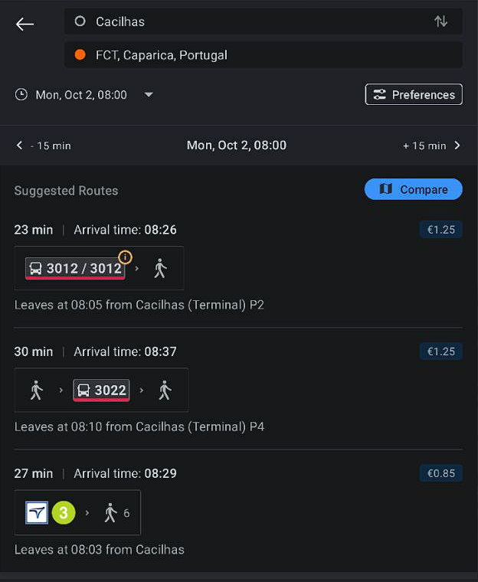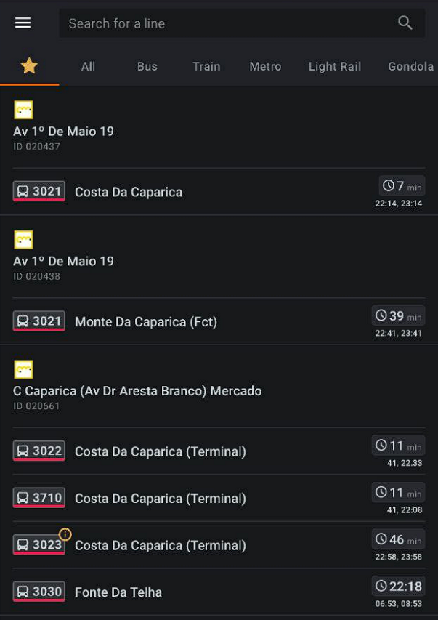

Figure : Moovit destination route search

Figure : Moovit favorite lines with arrival times

As an example of bad interface design, we'll be using Microsoft Teams. The objective of the interface is to allow users to chat with other users, schedule meetings, and perform conference calls. One bad aspect of the interface is the reply function. Clicking on the reply button on a previous message will embed it to the input field. The problem is that I often start typing before deciding to make my message a reply, and the embed gets placed below my typed message, destroying the logical flow of having your reply right below the embedded message that you're replying to. This issue could be improved by always placing the embed at the top of the input field, even if some text has already been typed.

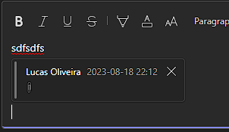

Figure : Teams reply inserted after already typed text

Another frustrating aspect is that sometimes when pasting in text from another program, the formatting will be automatically carried over. This could be improved by having a "paste as text" option in the right click menu with keyboard shortcut, as already is the case in other office apps.

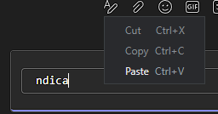

Figure : Text pasted from an IDE automatically monospaced, with no alternative paste options



Figure : Paste options present in Word, including "merge formatting" and "keep only text"