Ex-1 Check Prime Number

Source Code

import math

def isPrime(n):

    for i in range(2, int(math.sqrt(n))+1):

        if (n%1) == 0:

            return False

    return True

while True:

    num=int(input("Enter a number range in (2,32767) out of range to exit : "))

    if num<2 or num>32767:

        break

    if isPrime(num):

        print(num," is prime")

    else:

        print(num," is not prime")

Output Screen Capture

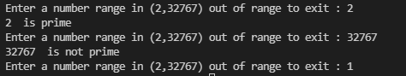

Ex-2 Dictionary Generation

Source Code

def makeDict(K, V):

    D = {}

    for i in range(len(K)):

        D[K[i]] = V[i]

    return D

K=('Korean', 'Mathmatics', 'English')

V=(90.3, 85.5, 92.7)

D=makeDict(K, V)

print(D)

Output Screen Capture

