Lab4

1. Linear regression source code

import pandas as pd

import numpy as np

from sklearn.preprocessing import LabelEncoder,StandardScaler

from sklearn.linear_model import LinearRegression

from sklearn.model_selection import train_test_split

from sklearn.metrics import mean_squared_error,r2_score

from math import sqrt

# read csv

df = pd.read_csv("data/housing.csv")

print('california housing data')

print(df)

# data scaling & encoding

print(df.isnull().sum())

print()

df.total_bedrooms = df.total_bedrooms.fillna(df.total_bedrooms.mean())

print(df.isnull().sum())

print()

label_encode = LabelEncoder()

df['ocean_proximity'] = label_encode.fit_transform(df['ocean_proximity'])

columns = df.columns

scaler = StandardScaler()

scaled_df = pd.DataFrame(scaler.fit_transform(df), columns=columns)

print('scaled california housing data')

print(scaled_df)

# create scaled dataframe & target dataframe

X = scaled_df[['longitude', 'latitude', 'housing_median_age', 'total_rooms', 'total_bedrooms', 'population', 'households', 'median_income', 'ocean_proximity']]

y = scaled_df['median_house_value']

for i in range(0, 2):

    if(i==0):

        # split random train & test data

        X_train, X_test, y_train, y_test = train_test_split(X, y, train_size=0.8, test_size=0.2, random_state=1, stratify=None)

        print('train & test data that train size is 0.8')

        print(X_train, y_train, X_test, y_test)

output screen capture

# linear regression

        linear_regression = LinearRegression()

        linear_regression.fit(X_train, y_train)

        LinearRegression(copy_X = True, fit_intercept=True, n_jobs=None, normalize=False)

        y_predict = linear_regression.predict(X_test)

        print(sqrt(mean_squared_error(y_test, y_predict)))

        print(r2_score(y_test, y_predict))

        print("--------------------------------------------------------")

    elif(i==1):

        # split random train & test data

        X_train, X_test, y_train, y_test = train_test_split(X, y, train_size=0.6, test_size=0.4, random_state=0, stratify=None)

        print('train & test data that train size is 0.6')

        print(X_train, y_train, X_test, y_test)

        # linear regression

        linear_regression = LinearRegression()

        linear_regression.fit(X_train, y_train)

        LinearRegression(copy_X = True, fit_intercept=True, n_jobs=None, normalize=False)

        y_predict = linear_regression.predict(X_test)

        print(sqrt(mean_squared_error(y_test, y_predict)))

        print(r2_score(y_test, y_predict))

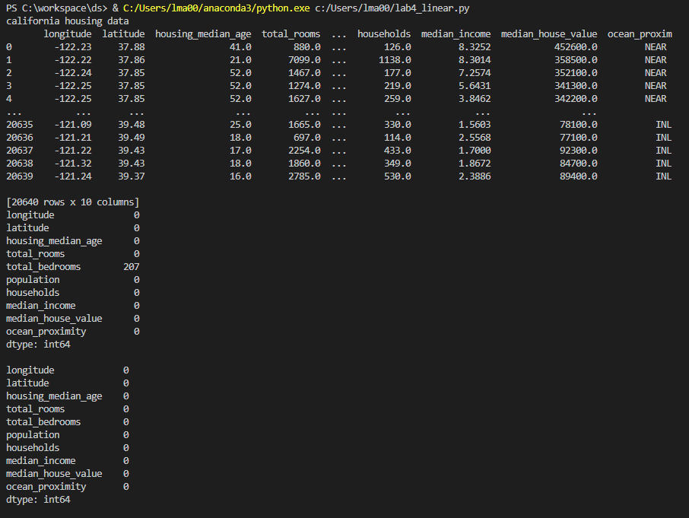

1. Decision tree source code

import numpy as np

import pandas as pd

from sklearn.model_selection import train_test_split

from sklearn.preprocessing import StandardScaler

from sklearn import tree

from sklearn.metrics import accuracy_score

# read csv

# separate data by ';'

df = pd.read_csv('data/winequality-red.csv',index_col = None, sep=';')

print('red wine quality data')

print(df)

# create target dataset

X = df.drop(['quality'], axis=1)

y = df[['quality']]

for i in range(0, 3):

    if i==0:

        # split random train & test data

        X_train, X_test, y_train, y_test = train_test_split(X, y, train_size=0.9, test_size=0.1, random_state=0)

        print('train & test data that train size is 0.9')

        print(X_train, X_test, y_train, y_test)

        # standardscaling

        sc = StandardScaler()

        sc.fit(X_train)

        train_std = sc.transform(X_train)

        test_std = sc.transform(X_test)

        # decision tree

        decision_tree = tree.DecisionTreeClassifier(criterion='entropy', random_state=0)

        decision_tree.fit(X_train, y_train)

        # predict & evaluate

        y_pred_tr = decision_tree.predict(X_test)

        print(accuracy_score(y_test, y_pred_tr))

    elif i==1:

        # split random train & test data

        X_train, X_test, y_train, y_test = train_test_split(X, y, train_size=0.8, test_size=0.2, random_state=0)

        print('train & test data that train size is 0.8')

        print(X_train, X_test, y_train, y_test)

output screen capture

# standardscaling

        sc = StandardScaler()

        sc.fit(X_train)

        train_std = sc.transform(X_train)

        test_std = sc.transform(X_test)

        # decision tree

        decision_tree = tree.DecisionTreeClassifier(criterion='entropy', random_state=0)

        decision_tree.fit(X_train, y_train)

        # predict & evaluate

        y_pred_tr = decision_tree.predict(X_test)

        print(accuracy_score(y_test, y_pred_tr))

    elif i==2:

        # split random train & test data

        X_train, X_test, y_train, y_test = train_test_split(X, y, train_size=0.7, test_size=0.3, random_state=0)

        print('train & test data that train size is 0.7')

        print(X_train, X_test, y_train, y_test)

        # standardscaling

        sc = StandardScaler()

        sc.fit(X_train)

        train_std = sc.transform(X_train)

        test_std = sc.transform(X_test)

        # decision tree

        decision_tree = tree.DecisionTreeClassifier(criterion='entropy', random_state=0)

        decision_tree.fit(X_train, y_train)

        # predict & evaluate

        y_pred_tr = decision_tree.predict(X_test)

        print(accuracy_score(y_test, y_pred_tr))

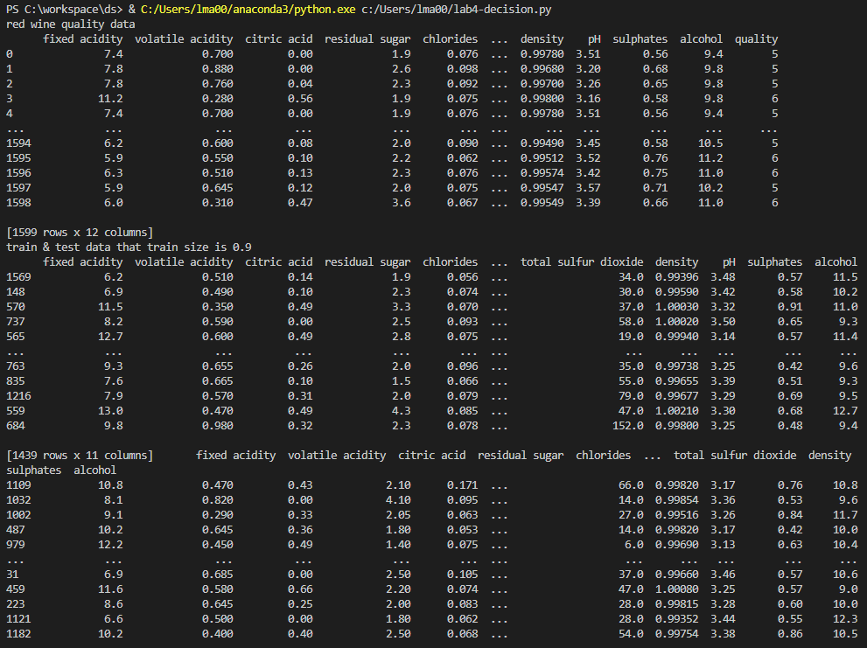

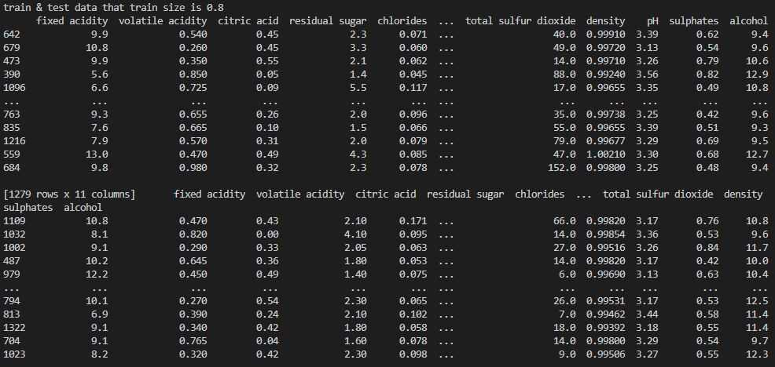

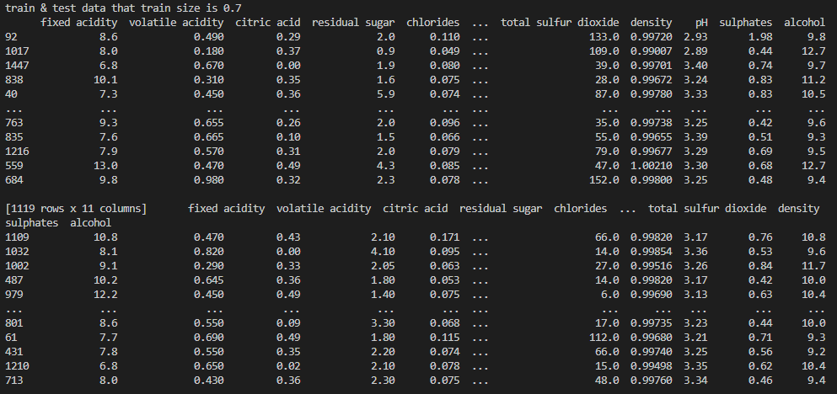

1. Knn

import numpy as np

import pandas as pd

from statistics import mean

from sklearn.model_selection import cross_val_score

from sklearn.neighbors import KNeighborsClassifier

from sklearn.model_selection import GridSearchCV

from sklearn.model_selection import RandomizedSearchCV

# read csv

data = pd.read_csv('data/mnist_test.csv')

# create target dataset

X = data.drop(columns=['label'])

y = data['label'].values

k_arr = [3, 5]

for i in range(0, 2):

        knn = KNeighborsClassifier(n_neighbors=k_arr[i])

        score = cross_val_score(knn, X, y, cv=5, scoring='accuracy')

        print('mean score')

        print(mean(score))

        knn_2 = KNeighborsClassifier()

        grid = {'n_neighbors': np.arange(1, 24)}

        knn_gridsearch = GridSearchCV(knn_2, grid, cv=5)

        knn_gridsearch.fit(X, y)

        print(knn_gridsearch.best_params_)

        print(knn_gridsearch.best_score_)

        knn_2 = KNeighborsClassifier()

        knn_random = RandomizedSearchCV(knn_2, grid, cv=5)

        knn_random.fit(X, y)

        print(knn_random.best_params_)

        print(knn_random.best_score_)

Output screen capture

