**LAB4 Submission – Best Solution**

**이준희_조현식_차원우_이민아**

**LAB4_Linear_Regression**

**Source Code**

import pandas as pd

from sklearn.linear_model import LinearRegression

from sklearn import preprocessing

from sklearn.model_selection import train_test_split

# read data

df = pd.read_csv('housing.csv')

# fill missing value

df.fillna(method='ffill', inplace=True)

# set independent, target

y = df['median_house_value']

X = df.drop(['median_house_value'], axis=1)

# encoding categorical data

ordinal = preprocessing.OrdinalEncoder()

ocean = pd.DataFrame(df['ocean_proximity'])

ordinal.fit(ocean)

X['ocean_proximity'] = pd.DataFrame(ordinal.transform(ocean))

# standard scaling

stdscaler = preprocessing.StandardScaler()

stdscaler.fit(X)

X = stdscaler.transform(X)

# split data 4:1

X_train, X_test, y_train, y_test = train_test_split(X, y, train_size=0.8, test_size=0.2, random_state=1)

# set regression model

LR = LinearRegression()

LR. fit(X_train,y_train)

# predict value and accuracy

predict = pd.DataFrame(LR.predict(X_test))

accuracy = LR.score(X_test,y_test)

# output

print("\n\nSplit data 4:1")

print("\n Test model result")

print(predict)

print("\n Original data result")

print(y_test)

print("\nAccuracy : "+str(accuracy))

# split data 3:2

X_train, X_test, y_train, y_test = train_test_split(X, y, train_size=0.6, test_size=0.4, random_state=1)

# set regression model

LR = LinearRegression()

LR. fit(X_train,y_train)

# predict value and accuracy

predict = pd.DataFrame(LR.predict(X_test))

accuracy = LR.score(X_test,y_test)

# output

print("\n\nSplit data 3:2")

print("\n Test model result")

print(predict)

print("\n Original data result")

print(y_test)

print("\nAccuracy : "+str(accuracy))

**Output Screen Capture**

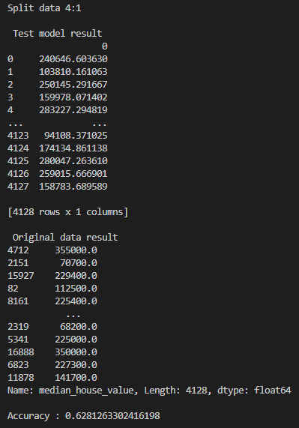 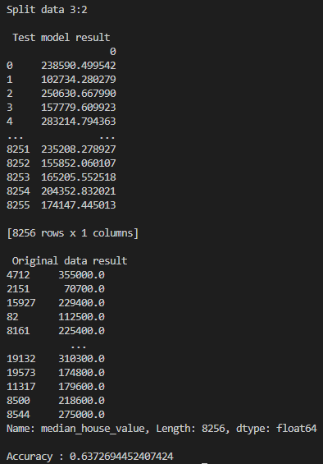

**LAB4_Decision_Tree**

**Source Code**

import numpy as np

import pandas as pd

from sklearn import preprocessing

from sklearn.model_selection import train_test_split

from sklearn.metrics import classification_report

from sklearn.tree import DecisionTreeClassifier

# read data

df = pd.read_csv('winequality-red.csv',index_col = None, sep=';')

# check dirty data

print("\nCheck dirty data")

print(df.isnull().sum())

print("\n\n")

# result : no dirty data

# set independent, target

y = df['quality']

X = df.drop(['quality'], axis=1)

# standard scaling

stdscaler = preprocessing.StandardScaler()

stdscaler.fit(X)

X=stdscaler.transform(X)

# split data 9:1

X_train, X_test, y_train, y_test = train_test_split(X, y, train_size=0.9, test_size=0.1, shuffle=True, random_state=1)

# decision tree setting

dt = DecisionTreeClassifier()

dt.fit(X_train,y_train)

# predcit value and accuracy

predict = pd.DataFrame(dt.predict(X_test))

accuracy = dt.score(X_test,y_test)

# output

print("Split data 9:1")

print("\n Test model result")

print(predict)

print("\n Original data result")

print(y_test)

print("\nAccuracy : "+str(accuracy))

# split data 8:2

X_train, X_test, y_train, y_test = train_test_split(X, y, train_size=0.8, test_size=0.2, shuffle=True, random_state=1)

# decision tree setting

dt = DecisionTreeClassifier()

dt.fit(X_train,y_train)

# predcit value and accuracy

predict = pd.DataFrame(dt.predict(X_test))

accuracy = dt.score(X_test,y_test)

# output

print("Split data 8:2")

print("\n Test model result")

print(predict)

print("\n Original data result")

print(y_test)

print("\nAccuracy : "+str(accuracy))

# split data 7:3

X_train, X_test, y_train, y_test = train_test_split(X, y, train_size=0.7, test_size=0.3, shuffle=True, random_state=1)

# decision tree setting

dt = DecisionTreeClassifier()

dt.fit(X_train,y_train)

# predcit value and accuracy

predict = pd.DataFrame(dt.predict(X_test))

accuracy = dt.score(X_test,y_test)

# output

print("\n\nSplit data 7:3")

print("\n Test model result")

print(predict)

print("\n Original data result")

print(y_test)

print("\nAccuracy : "+str(accuracy))

**Output Screen Capture**

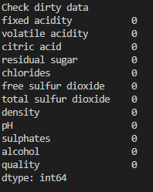

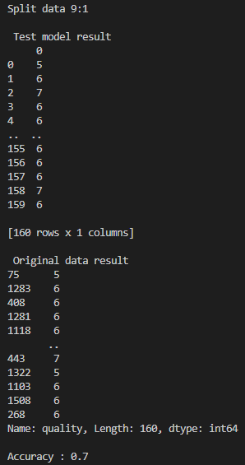 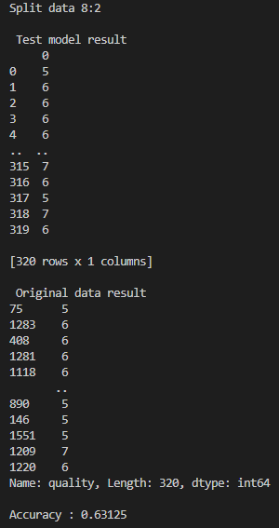

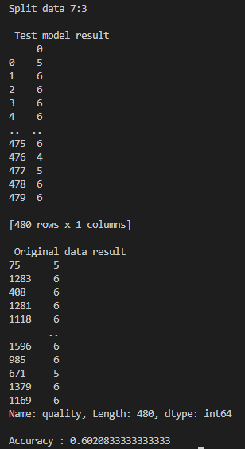

**LAB4_KNN**

**Source Code**

import pandas as pd

import numpy as np

from sklearn.model_selection import train_test_split

from sklearn import preprocessing

from sklearn.linear_model import LinearRegression

from sklearn.model_selection import KFold

from sklearn.neighbors import KNeighborsClassifier

from sklearn.model_selection import cross_val_score

from sklearn.model_selection import GridSearchCV

from sklearn.model_selection import RandomizedSearchCV

# read data / use mnist_test because of laptop performance

df = pd.read_csv('mnist_test.csv')

# check dirty data

print("\nCheck dirty data")

print(df.isnull().sum())

print("\n\n")

# result : no dirty data

# set independent, target

y = df['label']

X = df.drop(['label'], axis=1)

# standard scaling

stdscaler = preprocessing.StandardScaler()

stdscaler.fit(X)

X=stdscaler.transform(X)

# cross validation

kf5 = KFold(n_splits=5, shuffle = True, random_state=1)

# case : K = 3

for k in [3,5]:

    i=1

    for train, test in kf5.split(X):

        print("Split " + str(i) + "\n")

        i+=1

        X_train, X_test = X[train], X[test]

        y_train, y_test = y[train], y[test]

        knn_cv = KNeighborsClassifier(n_neighbors=k)

        scores = cross_val_score(knn_cv,X_train,y_train,cv=5)

        print("Case : initial K = "+str(k))

        print(scores)

        print("scores mean : {}".format(np.mean(scores)))

        knn = KNeighborsClassifier()

        param = {'n_neighbors':np.arange(1,25)}

        knn_gs = GridSearchCV(knn, param_grid=param, cv=5)

        knn_gs.fit(X_train,y_train)

        knn_rgs = RandomizedSearchCV(knn, param, cv=5, scoring='accuracy')

        knn_rgs.fit(X_train,y_train)

        print("\nCase : Hyperparameter tuning by GridSearch")

        print(knn_gs.best_params_)

        print(knn_gs.best_score_)

        print("\nCase : Hyperparameter tuning by Randomized GridSearch")

        print(knn_rgs.best_params_)

        print(knn_rgs.best_score_)

        print("\n")

**Output Screen Capture**

