**Numpy Coding Exercise**

**Source Code**

import numpy as np

import random

wt=np.random.uniform(40.0,90.0,100)

ht=np.random.randint(140,200,100)

bmi = np.round(wt/((ht*0.01)*(ht*0.01)),1)

print(bmi)

**Output Screen Capture**



**MatPlotLib Coding Exercise**

**Source Code**

import numpy as np

import random

from matplotlib import pyplot as plt

wt=np.random.uniform(40.0,90.0,100)

ht=np.random.randint(140,200,100)

bmi = np.round(wt/((ht*0.01)*(ht*0.01)),1)

Underweight=0

Healthy=0

Overweight=0

Obese=0

for i in bmi:

    if i<18.5:

        Underweight+=1

    elif i>=18.5 and i<=24.9:

        Healthy+=1

    elif i>=25.0 and i<=29.9:

        Overweight+=1

    else:

        Obese+=1

Weight_status=['Underweight','Healthy','Overweight','Obese']

data=[Underweight,Healthy,Overweight,Obese]

"""Bar chart"""

plt.bar(Weight_status,data)

plt.show()

"""Histogram"""

plt.hist(bmi, bins=[10,18.5,25.0,30.0,46.0])

plt.xticks([10.0,18.5,25.0,30.0,46.0])

plt.xlabel("BMI")

plt.ylabel("Number of Students")

plt.show()

"""Pie chart"""

plt.pie(data,labels=Weight_status,autopct='%1.2f%%')

plt.show()

"""Scatter plot"""

plt.scatter(ht,wt)

plt.xlabel("Height(cm)")

plt.ylabel("Weight(kg)")

plt.show()

**Output Screen Capture**

**Bar chart**

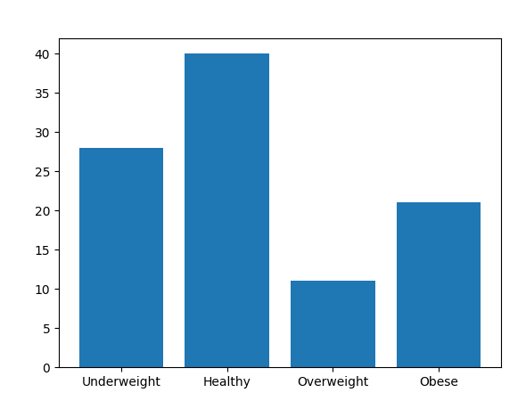

**Histogram**

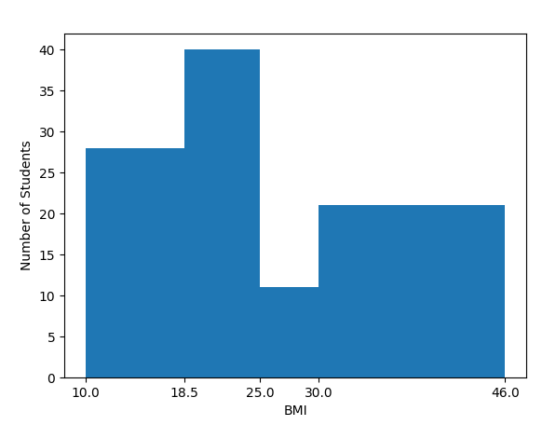

**Pie chart**

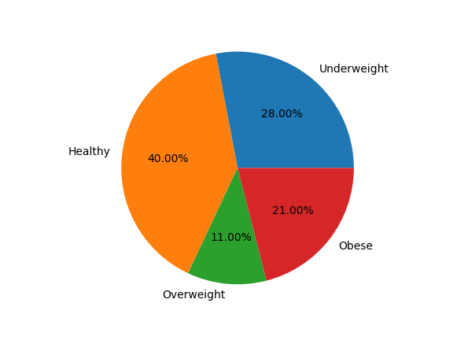

**Scatter plot**

