**LAB 3**

**1. Peek into the dataset (data exploration)**

**Source Code**

import pandas as pd

import numpy as np

from pyparsing import col

import seaborn as sns

import matplotlib.pyplot as plt

from sklearn import preprocessing

from sklearn import linear_model

# Read data frome file to dataf(dataframe)

dataf = pd.read_csv("bmi_data_lab3.csv")

# print statistical data

print("\nDataset Statistical Data")

print(dataf.describe())

# print feature name

print("\nFeature Name")

print(dataf.columns)

# print data type

print("\nData Type")

print(dataf.dtypes)

# make height histogram by BMI

histo=sns.FacetGrid(dataf,col="BMI")

histo.map(plt.hist,"Height (Inches)",bins=10,color="m")

plt.show()

# make weight histogram by BMI

histo=sns.FacetGrid(dataf,col="BMI")

histo.map(plt.hist,"Weight (Pounds)",bins=10,color="m")

plt.show()

# Scaling in sequence -> 0 = Standard, 1 = MinMax, 2 = Robust

for i in range(3):

    if i==0:

        scaler = preprocessing.StandardScaler()

        title="Standard Scaling"

    elif i==1:

        scaler = preprocessing.MinMaxScaler()

        title="MinMax Scaling"

    elif i==2:

        scaler = preprocessing.RobustScaler()

        title="Robust Scaling"

    scaled_df=scaler.fit_transform(dataf[["Height (Inches)","Weight (Pounds)"]])

    scaled_df=pd.DataFrame(scaled_df,columns=["Height (Inches)","Weight (Pounds)"])

    fig, (ax1, ax2) = plt.subplots(ncols=2, figsize=(6,5))

    ax1.set_title("Before Scaling")

    sns.kdeplot(dataf["Height (Inches)"], ax=ax1)

    sns.kdeplot(dataf["Weight (Pounds)"], ax=ax1)

    ax2.set_title(title)

    sns.kdeplot(scaled_df["Height (Inches)"], ax=ax2)

    sns.kdeplot(scaled_df["Weight (Pounds)"], ax=ax2)

    plt.show()

**Output Screen Capture**

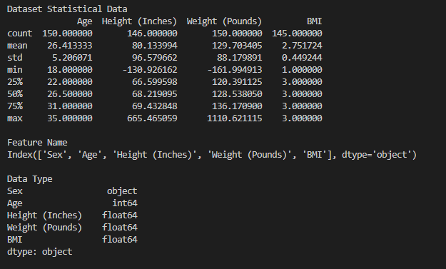

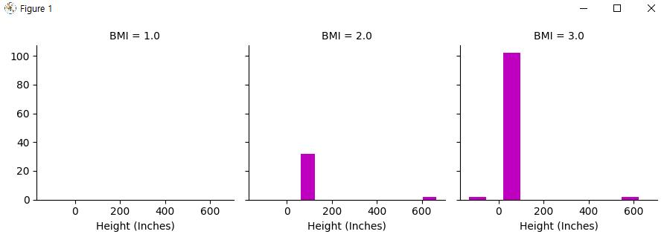

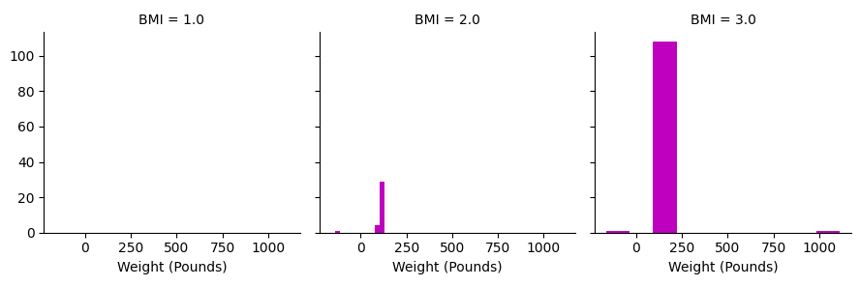

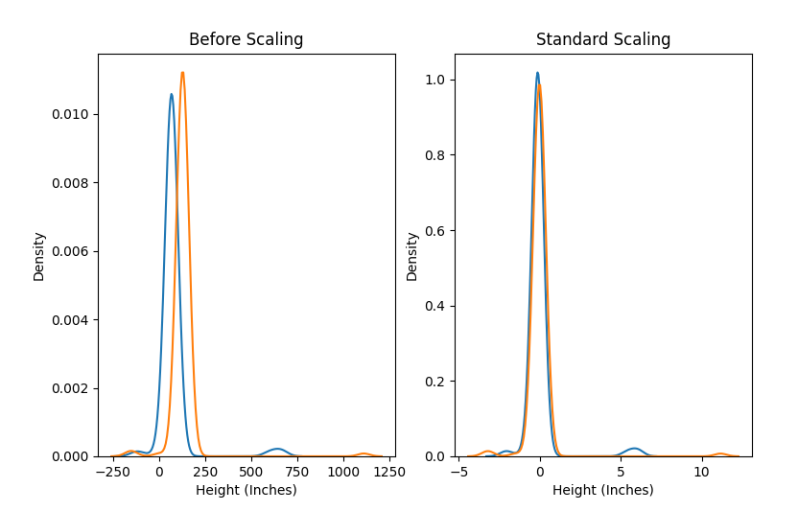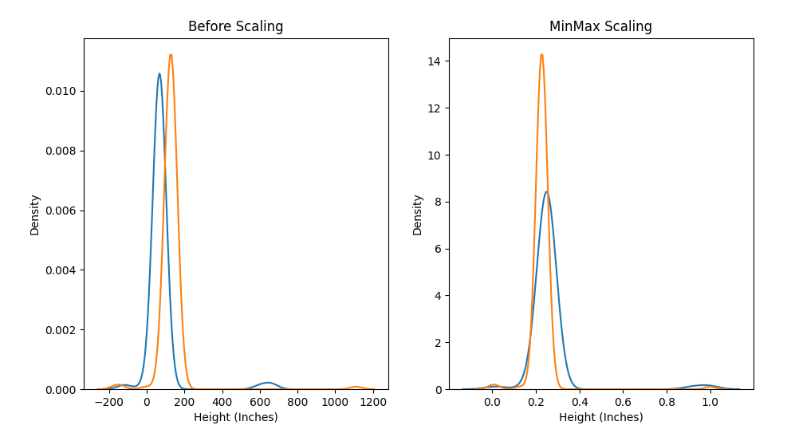

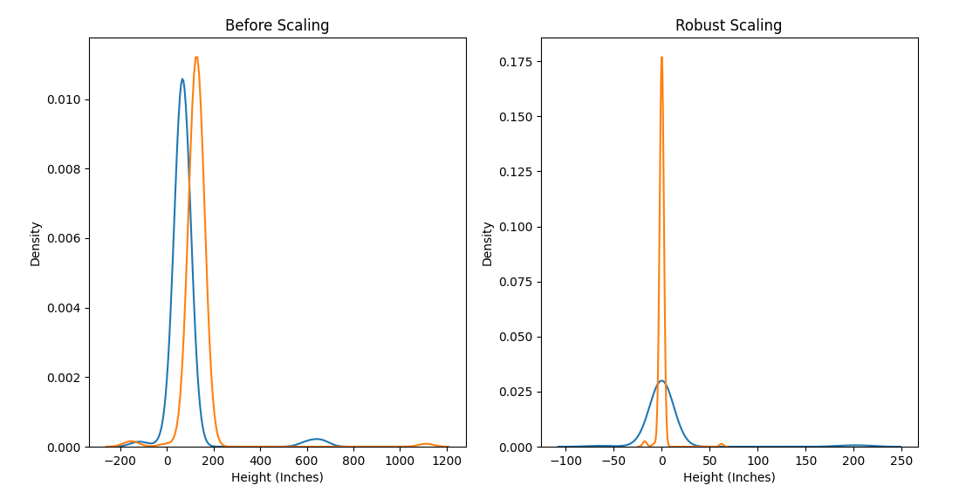

**2. Missing value manipulation (simple)**

**Source Code**

import pandas as pd

import numpy as np

from pyparsing import col

import seaborn as sns

import matplotlib.pyplot as plt

from sklearn import preprocessing

from sklearn import linear_model

# Read data frome file to dataf(dataframe)

dataf = pd.read_csv("bmi_data_lab3.csv")

# missing value manipulation

ms_df = dataf

# height minus or over 80 inches are dirty data

# weight minus or over 300 pounds are dirty data

# change dirty data to nan

for i in range(len(ms_df)):

    if ms_df.loc[i,"Height (Inches)"]>80 or ms_df.loc[i,"Height (Inches)"]<=0:

        ms_df.loc[i,"Height (Inches)"] = np.nan

    if ms_df.loc[i,"Weight (Pounds)"]>300 or ms_df.loc[i,"Weight (Pounds)"]<=0:

        ms_df.loc[i,"Weight (Pounds)"] = np.nan

# print data and count NAN

for i in ms_df:

    print("\n"+i)

    print(ms_df[ms_df[i].isna()])

    print("Nan count : "+ str(len(ms_df[ms_df[i].isna()])))

# extract all rows without NAN

print("Extract all rows without NAN")

print(ms_df.dropna(axis=0,how="any",inplace=False))

# make 4 dataframe to each fillna function

mean_df=ms_df.copy()

median_df=ms_df.copy()

ff_df=ms_df.copy()

bf_df=ms_df.copy()

# fill NAN with mean value

mean_df["Height (Inches)"]=mean_df["Height (Inches)"].fillna(mean_df["Height (Inches)"].mean())

mean_df["Weight (Pounds)"]=mean_df["Weight (Pounds)"].fillna(mean_df["Weight (Pounds)"].mean())

mean_df["BMI"]=mean_df["BMI"].fillna(mean_df["BMI"].mean())

# fill NAN with median value

median_df["Height (Inches)"]=median_df["Height (Inches)"].fillna(median_df["Height (Inches)"].median())

median_df["Weight (Pounds)"]=median_df["Weight (Pounds)"].fillna(median_df["Weight (Pounds)"].median())

median_df["BMI"]=median_df["BMI"].fillna(median_df["BMI"].median())

# print dataframe

print("\nFill NAN with Mean value")

print(mean_df)

print("\nFill NAN with Median value")

print(median_df)

print("\nUsing ffill function")

print(ff_df.ffill())

print("\nUsing bfill function")

print(bf_df.bfill())

**Output Screen Capture**

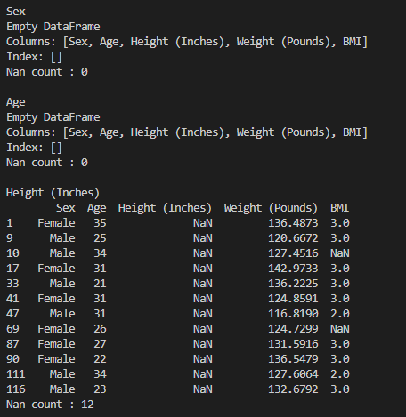

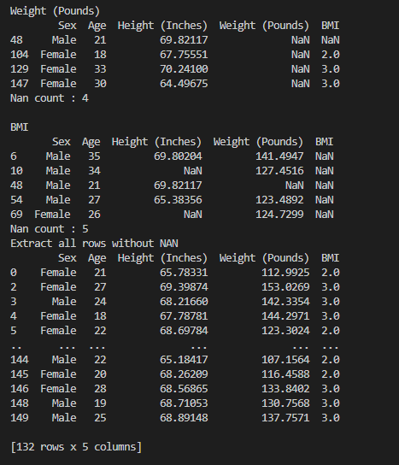

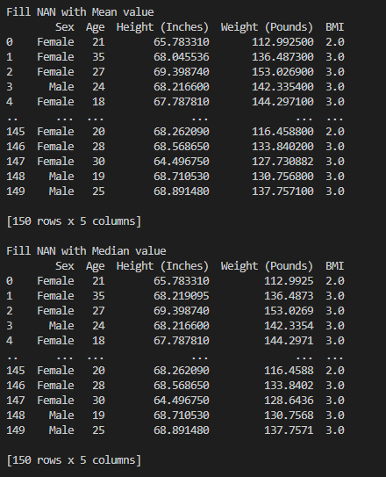

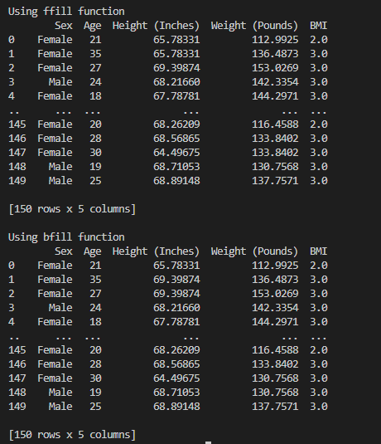

**3. Missing value manipulation (more elaborate)**

**Source Code**

import pandas as pd

import numpy as np

from pyparsing import col

import seaborn as sns

import matplotlib.pyplot as plt

from sklearn import preprocessing

from sklearn import linear_model

# Read data frome file to dataf(dataframe)

dataf = pd.read_csv("bmi_data_lab3.csv")

# missing value manipulation

ms_df = dataf

# height minus or over 80 inches are dirty data

# weight minus or over 300 pounds are dirty data

# change dirty data to nan

for i in range(len(ms_df)):

    if ms_df.loc[i,"Height (Inches)"]>80 or ms_df.loc[i,"Height (Inches)"]<=0:

        ms_df.loc[i,"Height (Inches)"] = np.nan

    if ms_df.loc[i,"Weight (Pounds)"]>300 or ms_df.loc[i,"Weight (Pounds)"]<=0:

        ms_df.loc[i,"Weight (Pounds)"] = np.nan

reg_df=ms_df.copy()

reg_df=reg_df.dropna(axis=0,how="any",inplace=False)

# Compute linear regression equation E

height=np.array(reg_df["Height (Inches)"])

weight=np.array(reg_df["Weight (Pounds)"])

reg=linear_model.LinearRegression()

reg.fit(height[:,np.newaxis],weight)

px=np.array([height.min()-1,height.max()+1])

py=reg.predict(px[:,np.newaxis])

plt.scatter(height, weight)

plt.plot(px,py,color="r")

plt.title('Result (ALL)', fontsize=20)

all_df=ms_df.copy()

# fill NAN to predict by E

for i in range(len(all_df)):

    if np.isnan(all_df.loc[i,"Height (Inches)"]):

        all_df.loc[i,"Height (Inches)"]=(all_df.loc[i,"Weight (Pounds)"]-reg.intercept_)/reg.coef_

        plt.scatter([all_df.loc[i,"Height (Inches)"]],[all_df.loc[i,"Weight (Pounds)"]],c="black")

    if np.isnan(all_df.loc[i,"Weight (Pounds)"]):

        all_df.loc[i,"Weight (Pounds)"]=reg.predict([[all_df.loc[i,"Height (Inches)"]]])

        plt.scatter([all_df.loc[i,"Height (Inches)"]],[all_df.loc[i,"Weight (Pounds)"]],c="black")

plt.show()

# make array

height_f=[]

weight_f=[]

height_m=[]

weight_m=[]

height_b1=[]

weight_b1=[]

height_b2=[]

weight_b2=[]

height_b3=[]

weight_b3=[]

# input value to array

for i in reg_df.index:

    if reg_df.loc[i,"Sex"]=="Female":

        height_f += [reg_df.loc[i,"Height (Inches)"]]

        weight_f += [reg_df.loc[i,"Weight (Pounds)"]]

    if reg_df.loc[i,"Sex"]=="Male":

        height_m += [reg_df.loc[i,"Height (Inches)"]]

        weight_m += [reg_df.loc[i,"Weight (Pounds)"]]

    if reg_df.loc[i,"BMI"]==1:

        height_b1 += [reg_df.loc[i,"Height (Inches)"]]

        weight_b1 += [reg_df.loc[i,"Weight (Pounds)"]]

    if reg_df.loc[i,"BMI"]==2:

        height_b2 += [reg_df.loc[i,"Height (Inches)"]]

        weight_b2 += [reg_df.loc[i,"Weight (Pounds)"]]

    if reg_df.loc[i,"BMI"]==3:

        height_b3 += [reg_df.loc[i,"Height (Inches)"]]

        weight_b3 += [reg_df.loc[i,"Weight (Pounds)"]]

# make np.array

height_f=np.array(height_f)

weight_f=np.array(weight_f)

height_m=np.array(height_m)

weight_m=np.array(weight_m)

height_b1=np.array(height_b1)

weight_b1=np.array(weight_b1)

height_b2=np.array(height_b2)

weight_b2=np.array(weight_b2)

height_b3=np.array(height_b3)

weight_b3=np.array(weight_b3)

# Female regression

reg_f=linear_model.LinearRegression()

reg_f.fit(height_f[:,np.newaxis],weight_f)

px=np.array([height_f.min()-1,height_f.max()+1])

py=reg_f.predict(px[:,np.newaxis])

plt.scatter(height_f, weight_f)

plt.plot(px,py,color="r")

plt.title('Result (Female)', fontsize=20)

fd_df=ms_df.copy()

for i in range(len(fd_df)):

    if fd_df.loc[i,"Sex"]=="Female":

        if np.isnan(fd_df.loc[i,"Height (Inches)"]):

            fd_df.loc[i,"Height (Inches)"]=(fd_df.loc[i,"Weight (Pounds)"]-reg_f.intercept_)/reg_f.coef_

            plt.scatter([fd_df.loc[i,"Height (Inches)"]],[fd_df.loc[i,"Weight (Pounds)"]],c="black")

        if np.isnan(fd_df.loc[i,"Weight (Pounds)"]):

            fd_df.loc[i,"Weight (Pounds)"]=reg_f.predict([[fd_df.loc[i,"Height (Inches)"]]])

            plt.scatter([fd_df.loc[i,"Height (Inches)"]],[fd_df.loc[i,"Weight (Pounds)"]],c="black")

plt.show()

# Male regression

reg_m=linear_model.LinearRegression()

reg_m.fit(height_m[:,np.newaxis],weight_m)

px=np.array([height_m.min()-1,height_m.max()+1])

py=reg_m.predict(px[:,np.newaxis])

plt.scatter(height_m, weight_m)

plt.plot(px,py,color="r")

plt.title('Result (Male)', fontsize=20)

ma_df=ms_df.copy()

for i in range(len(ma_df)):

    if ma_df.loc[i,"Sex"]=="Male":

        if np.isnan(ma_df.loc[i,"Height (Inches)"]):

            ma_df.loc[i,"Height (Inches)"]=(ma_df.loc[i,"Weight (Pounds)"]-reg_m.intercept_)/reg_m.coef_

            plt.scatter([ma_df.loc[i,"Height (Inches)"]],[ma_df.loc[i,"Weight (Pounds)"]],c="black")

        if np.isnan(ma_df.loc[i,"Weight (Pounds)"]):

            ma_df.loc[i,"Weight (Pounds)"]=reg_m.predict([[ma_df.loc[i,"Height (Inches)"]]])

            plt.scatter([ma_df.loc[i,"Height (Inches)"]],[ma_df.loc[i,"Weight (Pounds)"]],c="black")

plt.show()

# BMI 1 regression

reg_b1=linear_model.LinearRegression()

reg_b1.fit(height_b1[:,np.newaxis],weight_b1)

px=np.array([height_b1.min()-1,height_b1.max()+1])

py=reg_b1.predict(px[:,np.newaxis])

plt.scatter(height_b1, weight_b1)

plt.plot(px,py,color="r")

plt.title('Result (BMI(1))', fontsize=20)

b1_df=ms_df.copy()

for i in range(len(b1_df)):

    if b1_df.loc[i,"BMI"]==1:

        if np.isnan(b1_df.loc[i,"Height (Inches)"]):

            b1_df.loc[i,"Height (Inches)"]=(b1_df.loc[i,"Weight (Pounds)"]-reg_b1.intercept_)/reg_b1.coef_

            plt.scatter([b1_df.loc[i,"Height (Inches)"]],[b1_df.loc[i,"Weight (Pounds)"]],c="black")

        if np.isnan(b1_df.loc[i,"Weight (Pounds)"]):

            b1_df.loc[i,"Weight (Pounds)"]=reg_b1.predict([[b1_df.loc[i,"Height (Inches)"]]])

            plt.scatter([b1_df.loc[i,"Height (Inches)"]],[b1_df.loc[i,"Weight (Pounds)"]],c="black")

plt.show()

# BMI 2 regression

reg_b2=linear_model.LinearRegression()

reg_b2.fit(height_b2[:,np.newaxis],weight_b2)

px=np.array([height_b2.min()-1,height_b2.max()+1])

py=reg_b2.predict(px[:,np.newaxis])

plt.scatter(height_b2, weight_b2)

plt.plot(px,py,color="r")

plt.title('Result (BMI(2))', fontsize=20)

b2_df=ms_df.copy()

for i in range(len(b2_df)):

    if b2_df.loc[i,"BMI"]==2:

        if np.isnan(b2_df.loc[i,"Height (Inches)"]):

            b2_df.loc[i,"Height (Inches)"]=(b2_df.loc[i,"Weight (Pounds)"]-reg_b2.intercept_)/reg_b2.coef_

            plt.scatter([b2_df.loc[i,"Height (Inches)"]],[b2_df.loc[i,"Weight (Pounds)"]],c="black")

        if np.isnan(b2_df.loc[i,"Weight (Pounds)"]):

            b2_df.loc[i,"Weight (Pounds)"]=reg_b2.predict([[b2_df.loc[i,"Height (Inches)"]]])

            plt.scatter([b2_df.loc[i,"Height (Inches)"]],[b2_df.loc[i,"Weight (Pounds)"]],c="black")

plt.show()

# BMI 3 regression

reg_b3=linear_model.LinearRegression()

reg_b3.fit(height_b3[:,np.newaxis],weight_b3)

px=np.array([height_b3.min()-1,height_b3.max()+1])

py=reg_b3.predict(px[:,np.newaxis])

plt.scatter(height_b3, weight_b3)

plt.plot(px,py,color="r")

plt.title('Result (BMI(3))', fontsize=20)

b3_df=ms_df.copy()

for i in range(len(b3_df)):

    if b3_df.loc[i,"BMI"]==3:

        if np.isnan(b3_df.loc[i,"Height (Inches)"]):

            b3_df.loc[i,"Height (Inches)"]=(b3_df.loc[i,"Weight (Pounds)"]-reg_b3.intercept_)/reg_b3.coef_

            plt.scatter([b3_df.loc[i,"Height (Inches)"]],[b3_df.loc[i,"Weight (Pounds)"]],c="black")

        if np.isnan(b3_df.loc[i,"Weight (Pounds)"]):

            b3_df.loc[i,"Weight (Pounds)"]=reg_b3.predict([[b3_df.loc[i,"Height (Inches)"]]])

            plt.scatter([b3_df.loc[i,"Height (Inches)"]],[b3_df.loc[i,"Weight (Pounds)"]],c="black")

plt.show()

**Output Screen Capture**

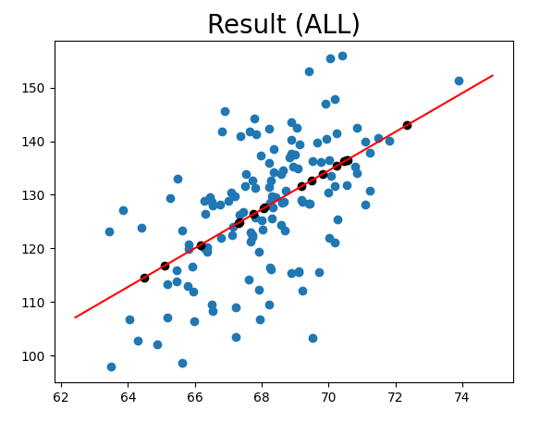 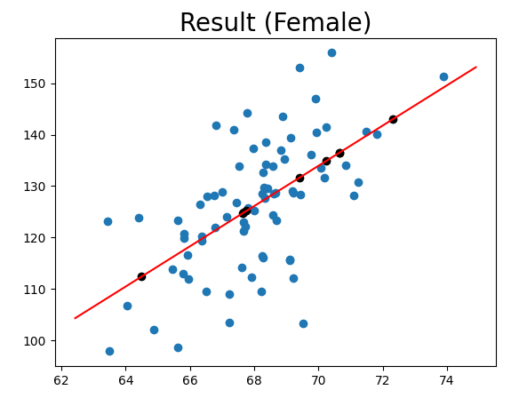

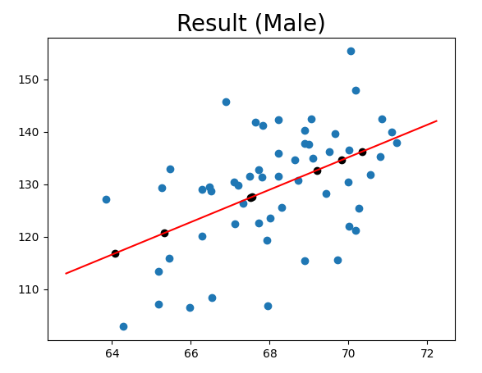 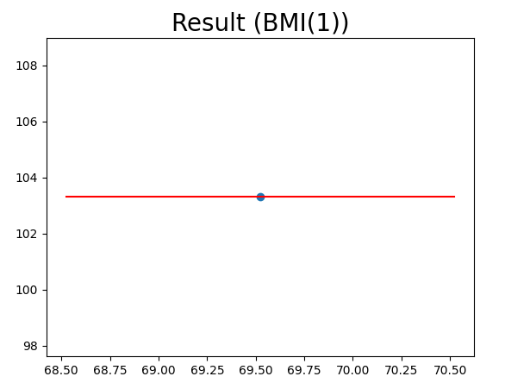

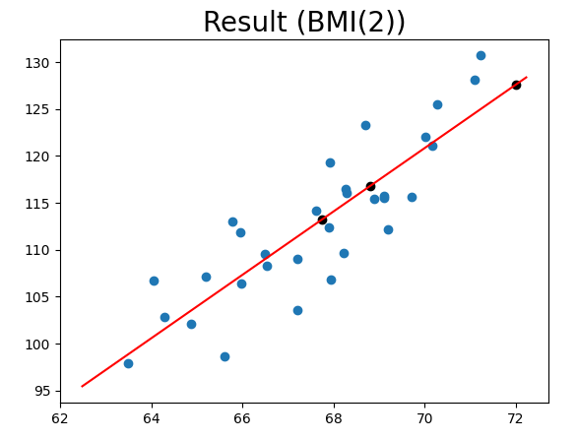 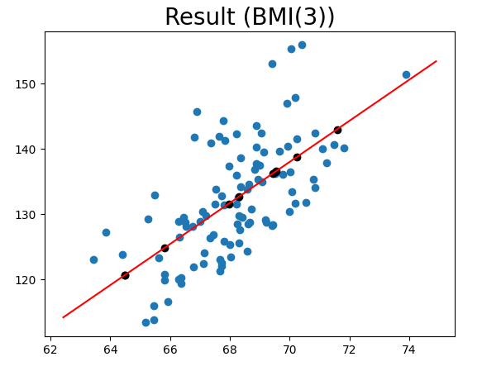

**Members role**

**이준희 – 1, 2, 3 (all data regression) / 25%**

**조현식 – 1, 2, 3 (Female data regression) / 25%**

**이민아 – 1, 2, 3 (BMI data regression) / 25%**

**차원우 – 1, 2, 3 (BMI data regression) / 25%**