**Week 9 class: Programming Homework**

**201835533 조현식**

**# Homework 1 - Decision Tree**

**# source code**

import numpy as np

import pandas as pd

# entropy calculator (target_feature: this node feature_name / target_value: one of category value in target_feature / parent_feature: parent node feature_name / parent_value: one of category value in parent_feature)

def entr(target_feature, target_value=None, parent_feature=None, parent_value=None):

# if root node

if target_feature == 'Outcome':

# calculate total, responded count, not responded count

total = df[target_feature].count()

responded = df[target_feature][df['Outcome']=='Responded'].count()

notResponded = df[target_feature][df['Outcome']=='Not responded'].count()

# not root node

else:

# extract dataframe

if parent_feature != None and parent_value != None:

ext_df = df[df[parent_feature]==parent_value]

else:

ext_df = df

ext_df = ext_df[ext_df[target_feature]==target_value]

# calculate total, responded count, not responded count

total = ext_df[target_feature][ext_df[target_feature]==target_value].count()

responded = ext_df[target_feature][ext_df['Outcome']=='Responded'].count()

notResponded = ext_df[target_feature][ext_df['Outcome']=='Not responded'].count()

# calculate entropy

# check np.log2(0)

if responded == 0 or notResponded == 0:

entr = 0

else:

entr = -(responded/total*np.log2(responded/total) + notResponded/total*np.log2(notResponded/total))

return round(entr,2),total

# add dataset

df = pd.DataFrame({'District':['Suburban','Suburban','Rural','Urban','Urban','Urban','Rural','Suburban','Suburban','Urban','Suburban','Rural','Rural','Urban'],

'House Type':['Detached','Detached','Detached','Semi-detached','Semi-detached','Semi-detached','Semi-detached','Terrace','Semi-detached','Terrace','Terrace','Terrace','Detached','Terrace'],

'Income':['High','High','High','High','Low','Low','Low','High','Low','Low','Low','High','Low','High'],

'Previous Customer':['No','Yes','No','No','No','Yes','Yes','No','No','No','Yes','Yes','No','Yes'],

'Outcome':['Not responded','Not responded','Responded','Responded','Responded','Not responded','Responded','Not responded','Responded','Responded','Responded','Responded','Responded','Not responded']})

# data exploration

print(df.info())

print(df,end="\n\n")

# 1. Calculate information gain (first attribute(root))

# calculate root entropy

root_entr,root_total = entr('Outcome')

print('Entropy(root):',round(root_entr,2))

print()

# calculate 'District' (Suburban,Rural,Urban)

suburban_entr,suburban_total = entr('District','Suburban')

rural_entr, rural_total = entr('District','Rural')

urban_entr, urban_total = entr('District','Urban')

print('Entropy(Suburban/Rural/Urban):',suburban_entr,'/',rural_entr,'/',urban_entr)

print('*Rural entropy is 0. So Stop split in Rural')

# calculate information gain

district_info = root_entr-(suburban_total*suburban_entr + rural_total*rural_entr + urban_total*urban_entr)/root_total

print('Information gain(District):',round(district_info,2))

print()

# calculate 'House Type' (Detached,Semi-detached,Terrace)

detached_entr,detached_total = entr('House Type','Detached')

semi_detached_entr, semi_detached_total = entr('House Type','Semi-detached')

terrace_entr, terrace_total = entr('House Type','Terrace')

print('Entropy(Detached/Semi-detached/Terrace):',detached_entr,'/',semi_detached_entr,'/',terrace_entr)

# calculate information gain

houseType_info = root_entr-(detached_total*detached_entr + semi_detached_total*semi_detached_entr + terrace_total*terrace_entr)/root_total

print('Information gain(House Type):',round(houseType_info,2))

print()

# calculate 'Income' (High,Low)

high_entr,high_total = entr('Income','High')

low_entr,low_total = entr('Income','Low')

print('Entropy(High/Low):',high_entr,'/',low_entr)

# calculate information gain

income_info = root_entr-(high_total*high_entr + low_total*low_entr)/root_total

print('Information gain(Income):',round(income_info,2))

print()

# calculate 'Previous Customer' (No,Yes)

no_entr,no_total = entr('Previous Customer','No')

yes_entr,yes_total = entr('Previous Customer','Yes')

print('Entropy(No/Yes):',no_entr,'/',yes_entr)

# calculate information gain

previousCustomer_info = root_entr-(no_total*no_entr + yes_total*yes_entr)/root_total

print('Information gain(Previous Customer):',round(previousCustomer_info,2))

print()

# root selection result

print('Root attribute: District (',round(district_info,2),')')

print('-'*50,end="\n\n")

# 2-1. Calculate information gain (Suburban -> second attribute)

# calculate root entropy (Suburban)

root_entr,root_total = entr('District','Suburban')

print('Entropy(root):',round(root_entr,2))

print()

# calculate 'House Type' (Detached,Semi-detached,Terrace)

detached_entr,detached_total = entr('House Type','Detached','District','Suburban')

semi_detached_entr,semi_detached_total = entr('House Type','Semi-detached','District','Suburban')

terrace_entr,terrace_total = entr('House Type','Terrace','District','Suburban')

print('Entropy(Detached/Semi-detached/Terrace):',detached_entr,'/',semi_detached_entr,'/',terrace_entr)

print('*Detached entropy is 0. So Stop split in Detached')

print('*Semi-detached entropy is 0. So Stop split in Semi-detached')

# calculate information gain

houseType_info = root_entr-(detached_total*detached_entr + semi_detached_total*semi_detached_entr + terrace_total*terrace_entr)/root_total

print('Information gain(House Type):',round(houseType_info,2))

print()

# calculate 'Income' (High,Low)

high_entr,high_total = entr('Income','High','District','Suburban')

low_entr,low_total = entr('Income','Low','District','Suburban')

print('Entropy(High/Low):',high_entr,'/',low_entr)

print('*High entropy is 0. So Stop split in High')

print('*Low entropy is 0. So Stop split in Low')

# calculate information gain

income_info = root_entr-(high_total*high_entr + low_total*low_entr)/root_total

print('Information gain(Income):',round(income_info,2))

print()

# calculate 'Previous Customer' (No,Yes)

no_entr,no_total = entr('Previous Customer','No','District','Suburban')

yes_entr,yes_total = entr('Previous Customer','Yes','District','Suburban')

print('Entropy(No/Yes):',no_entr,'/',yes_entr)

# calculate information gain

previousCustomer_info = root_entr-(no_total*no_entr + yes_total*yes_entr)/root_total

print('Information gain(Previous Customer):',round(previousCustomer_info,2))

print()

# root selection result

print('Second attribute(Suburban->): Income (',round(income_info,2),')')

print('-'*50, end="\n\n")

# 2-2. Calculate information gain (Urban -> second attribute)

# calculate root entropy (Urban)

root_entr,root_total = entr('District','Urban')

print('Entropy(root):',round(root_entr,2))

print()

# calculate 'House Type' (Detached,Semi-detached,Terrace)

detached_entr,detached_total = entr('House Type','Detached','District','Urban')

semi_detached_entr,semi_detached_total = entr('House Type','Semi-detached','District','Urban')

terrace_entr,terrace_total = entr('House Type','Terrace','District','Urban')

print('Entropy(Detached/Semi-detached/Terrace):',detached_entr,'/',semi_detached_entr,'/',terrace_entr)

print('*Detached entropy is 0. So Stop split in Detached')

# calculate information gain

houseType_info = root_entr-(detached_total*detached_entr + semi_detached_total*semi_detached_entr + terrace_total*terrace_entr)/root_total

print('Information gain(House Type):',round(houseType_info,2))

print()

# calculate 'Income' (High,Low)

high_entr,high_total = entr('Income','High','District','Urban')

low_entr,low_total = entr('Income','Low','District','Urban')

print('Entropy(High/Low):',high_entr,'/',low_entr)

# calculate information gain

income_info = root_entr-(high_total*high_entr + low_total*low_entr)/root_total

print('Information gain(Income):',round(income_info,2))

print()

# calculate 'Previous Customer' (No,Yes)

no_entr,no_total = entr('Previous Customer','No','District','Urban')

yes_entr,yes_total = entr('Previous Customer','Yes','District','Urban')

print('Entropy(No/Yes):',no_entr,'/',yes_entr)

print('*No entropy is 0. So Stop split in No')

print('*Yes entropy is 0. So Stop split in Yes')

# calculate information gain

previousCustomer_info = root_entr-(no_total*no_entr + yes_total*yes_entr)/root_total

print('Information gain(Previous Customer):',round(previousCustomer_info,2))

print()

# root selection result

print('Second attribute(Urban->): Previous Customer (',round(previousCustomer_info,2),')')

print('-'*50, end="\n\n")

#Tree result

print('<Tree Result>')

print(' '*30,'District')

print(' '*10,'(Suburban)\t\t(Rural)\t\t(Urban)')

print(' '*10,'Income\t\tResponded\tPrevious Customer')

print(' '*5,'(High)\t(Low)\t\t\t\t(No)\t\t(Yes)')

print('Not responded\tResponded\t\t\tResponded\tNot Responded')

**# Result screen**

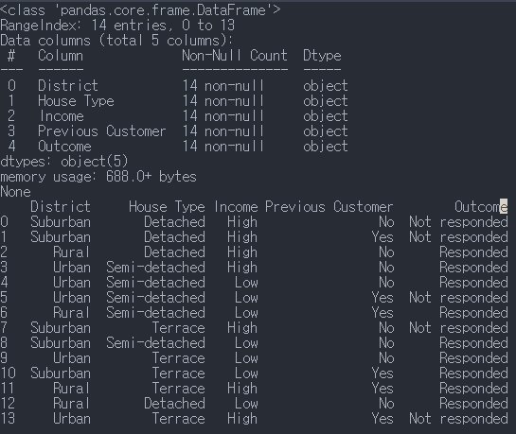

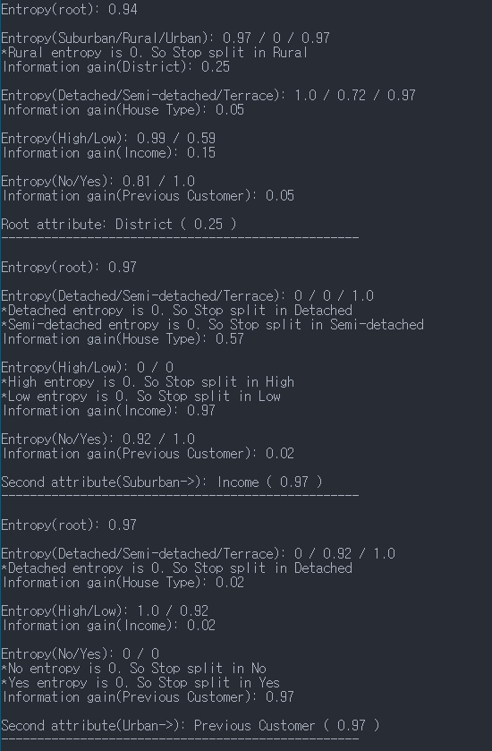

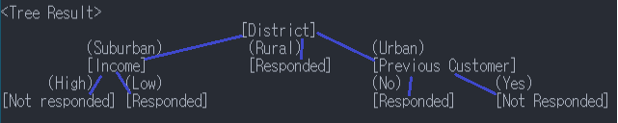

**# Homework 2 - KNN**

**# Source code**

import numpy as np

import pandas as pd

# make KNN algorithm

# data: dataset(DataFrame) / target: target value {height,weight} / k: hyperparameter

def KNN(df,target,k):

# 0. Scaling (but we have only numpy, pandas library. So, we will pass this phase.)

# 1. Calculate distance

distance=[]

for h,w,s in zip(df['HEIGHT(cm)'],df['WEIGHT(kg)'],df['T SHIRT SIZE']):

cal_result=np.sqrt(np.power(h-target['HEIGHT(cm)'],2)+np.power(w-target['WEIGHT(kg)'],2))

distance.append([cal_result,s])

# 2. Search for the top 5 ranked records in the dataset

# sort distance list

distance.sort()

# select k ranked values

ranked=distance[:k]

# 3. return the most frequency value (M or L)

M_count = 0

L_count = 0

for item in ranked:

if item[1] == 'M':

M_count+=1

elif item[1] == 'L':

L_count+=1

if M_count > L_count:

return 'M'

else : return 'L'

# add dataset

data = {'HEIGHT(cm)':[158,158,158,160,160,163,163,160,163,165,165,165,168,168,168,170,170,170],

'WEIGHT(kg)':[58,59,63,59,60,60,61,64,64,61,62,65,62,63,66,63,64,68],

'T SHIRT SIZE':['M','M','M','M','M','M','M','L','L','L','L','L','L','L','L','L','L','L']}

df = pd.DataFrame(data,columns=['HEIGHT(cm)','WEIGHT(kg)','T SHIRT SIZE'])

# data exploration

print(df.info())

print(df,end="\n\n")

# test KNN algorithm using the dataset (k=3)

target = {'HEIGHT(cm)':161,'WEIGHT(kg)':61}

result = KNN(df,target,3)

# show result (k=3)

print('Result of T-shirt size with KNN(k=3):',result)

# test KNN algorithm using the dataset (k=5)

target = {'HEIGHT(cm)':161,'WEIGHT(kg)':61}

result = KNN(df,target,5)

# show result (k=5)

print('Result of T-shirt size with KNN(k=5):',result)

**# Result screen**

