

Audio Recording & Mixing Mastering

Room Acoustic Designing

Front of House (FOH) Mixing Mastering

Surrounding Sounds Designing & Mixing Mastering

No 346/B, Aswedduma Road,Pahala Bop Padukka

+94 704 911 163

Jh.music.studio.srilanka@gmail.com

Audio Engineer :Sangeeth Visharad Javith Hansana Semal

**JH MUSIC STUDIOS(PVT).LTD**

**Music Collaboration Agreement – Terms and Conditions**

|  |  |  |  |  |  |  |  |
| --- | --- | --- | --- | --- | --- | --- | --- |
| D | D | M | M | Y | Y | Y | Y |

**Date:**

|  |  |  |  |  |  |  |  |  |  |  |  |  |  |  |  |  |  |  |
| --- | --- | --- | --- | --- | --- | --- | --- | --- | --- | --- | --- | --- | --- | --- | --- | --- | --- | --- |
|  |  |  |  |  |  |  |  |  |  |  |  |  |  |  |  |  |  |  |
|  |  |  |  |  |  |  |  |  |  |  |  |  |  |  |  |  |  |  |

**Project Title:**

**Parties Involved:**

|  |  |  |  |  |  |  |  |  |  |  |  |  |  |  |  |  |
| --- | --- | --- | --- | --- | --- | --- | --- | --- | --- | --- | --- | --- | --- | --- | --- | --- |
|  |  |  |  |  |  |  |  |  |  |  |  |  |  |  |  |  |
|  |  |  |  |  |  |  |  |  |  |  |  |  |  |  |  |  |

1. **Artist(s):**
2. **Name:**
3. **Address:**
4. **Id Number:**
5. **TP. Number:**

|  |  |  |  |  |  |  |  |  |  |  |  |  |  |  |  |  |
| --- | --- | --- | --- | --- | --- | --- | --- | --- | --- | --- | --- | --- | --- | --- | --- | --- |
|  |  |  |  |  |  |  |  |  |  |  |  |  |  |  |  |  |
|  |  |  |  |  |  |  |  |  |  |  |  |  |  |  |  |  |

|  |  |  |  |  |  |  |  |  |  |  |  |
| --- | --- | --- | --- | --- | --- | --- | --- | --- | --- | --- | --- |
|  |  |  |  |  |  |  |  |  |  |  |  |

|  |  |  |  |  |  |  |  |  |  |
| --- | --- | --- | --- | --- | --- | --- | --- | --- | --- |
|  |  |  |  |  |  |  |  |  |  |

|  |  |  |  |  |  |  |  |  |  |  |  |  |  |  |  |  |
| --- | --- | --- | --- | --- | --- | --- | --- | --- | --- | --- | --- | --- | --- | --- | --- | --- |
|  |  |  |  |  |  |  |  |  |  |  |  |  |  |  |  |  |
|  |  |  |  |  |  |  |  |  |  |  |  |  |  |  |  |  |

1. **Composer(s):**
2. **Name:**
3. **Address:**
4. **Id Number:**
5. **TP. Number:**

|  |  |  |  |  |  |  |  |  |  |  |  |  |  |  |  |  |
| --- | --- | --- | --- | --- | --- | --- | --- | --- | --- | --- | --- | --- | --- | --- | --- | --- |
|  |  |  |  |  |  |  |  |  |  |  |  |  |  |  |  |  |
|  |  |  |  |  |  |  |  |  |  |  |  |  |  |  |  |  |

|  |  |  |  |  |  |  |  |  |  |  |  |
| --- | --- | --- | --- | --- | --- | --- | --- | --- | --- | --- | --- |
|  |  |  |  |  |  |  |  |  |  |  |  |

|  |  |  |  |  |  |  |  |  |  |
| --- | --- | --- | --- | --- | --- | --- | --- | --- | --- |
|  |  |  |  |  |  |  |  |  |  |

|  |  |  |  |  |  |  |  |  |  |  |  |  |  |  |  |  |
| --- | --- | --- | --- | --- | --- | --- | --- | --- | --- | --- | --- | --- | --- | --- | --- | --- |
|  |  |  |  |  |  |  |  |  |  |  |  |  |  |  |  |  |
|  |  |  |  |  |  |  |  |  |  |  |  |  |  |  |  |  |

1. **Lyricist(s):**
2. **Name:**
3. **Address:**
4. **Id Number:**
5. **TP. Number:**

|  |  |  |  |  |  |  |  |  |  |  |  |  |  |  |  |  |
| --- | --- | --- | --- | --- | --- | --- | --- | --- | --- | --- | --- | --- | --- | --- | --- | --- |
|  |  |  |  |  |  |  |  |  |  |  |  |  |  |  |  |  |
|  |  |  |  |  |  |  |  |  |  |  |  |  |  |  |  |  |

|  |  |  |  |  |  |  |  |  |  |  |  |
| --- | --- | --- | --- | --- | --- | --- | --- | --- | --- | --- | --- |
|  |  |  |  |  |  |  |  |  |  |  |  |

|  |  |  |  |  |  |  |  |  |  |
| --- | --- | --- | --- | --- | --- | --- | --- | --- | --- |
|  |  |  |  |  |  |  |  |  |  |

|  |  |  |  |  |  |  |  |  |  |  |  |  |  |  |  |  |
| --- | --- | --- | --- | --- | --- | --- | --- | --- | --- | --- | --- | --- | --- | --- | --- | --- |
|  |  |  |  |  |  |  |  |  |  |  |  |  |  |  |  |  |
|  |  |  |  |  |  |  |  |  |  |  |  |  |  |  |  |  |

1. **Mixing/Mastering Engineer & Recording Label:**
2. **Name:**
3. **Address:**
4. **Id Number:**
5. **TP. Number:**

|  |  |  |  |  |  |  |  |  |  |  |  |  |  |  |  |  |
| --- | --- | --- | --- | --- | --- | --- | --- | --- | --- | --- | --- | --- | --- | --- | --- | --- |
|  |  |  |  |  |  |  |  |  |  |  |  |  |  |  |  |  |
|  |  |  |  |  |  |  |  |  |  |  |  |  |  |  |  |  |

|  |  |  |  |  |  |  |  |  |  |  |  |
| --- | --- | --- | --- | --- | --- | --- | --- | --- | --- | --- | --- |
|  |  |  |  |  |  |  |  |  |  |  |  |

|  |  |  |  |  |  |  |  |  |  |
| --- | --- | --- | --- | --- | --- | --- | --- | --- | --- |
|  |  |  |  |  |  |  |  |  |  |

|  |  |  |  |  |  |  |  |  |  |  |  |  |  |  |  |  |
| --- | --- | --- | --- | --- | --- | --- | --- | --- | --- | --- | --- | --- | --- | --- | --- | --- |
|  |  |  |  |  |  |  |  |  |  |  |  |  |  |  |  |  |
|  |  |  |  |  |  |  |  |  |  |  |  |  |  |  |  |  |

1. **Instrumentalist(s):**
2. **Name:**
3. **Address:**
4. **Id Number:**
5. **TP. Number:**

|  |  |  |  |  |  |  |  |  |  |  |  |  |  |  |  |  |
| --- | --- | --- | --- | --- | --- | --- | --- | --- | --- | --- | --- | --- | --- | --- | --- | --- |
|  |  |  |  |  |  |  |  |  |  |  |  |  |  |  |  |  |
|  |  |  |  |  |  |  |  |  |  |  |  |  |  |  |  |  |

|  |  |  |  |  |  |  |  |  |  |  |  |
| --- | --- | --- | --- | --- | --- | --- | --- | --- | --- | --- | --- |
|  |  |  |  |  |  |  |  |  |  |  |  |

|  |  |  |  |  |  |  |  |  |  |
| --- | --- | --- | --- | --- | --- | --- | --- | --- | --- |
|  |  |  |  |  |  |  |  |  |  |

**1. Purpose**

This agreement defines the roles, responsibilities, ownership rights, and financial entitlements of all parties collaborating on the production and distribution of the musical work titled

|  |  |  |  |  |  |  |  |  |  |  |  |  |  |  |  |  |  |  |  |  |  |  |
| --- | --- | --- | --- | --- | --- | --- | --- | --- | --- | --- | --- | --- | --- | --- | --- | --- | --- | --- | --- | --- | --- | --- |
|  |  |  |  |  |  |  |  |  |  |  |  |  |  |  |  |  |  |  |  |  |  |  |
|  |  |  |  |  |  |  |  |  |  |  |  |  |  |  |  |  |  |  |  |  |  |  |

### 2. ****Creative Contributions & Roles****

* **Artist(s):** Responsible for the vocal or performance aspects of the track.
* **Composer(s):** Responsible for composing the melody, arrangement, and overall music composition.
* **Lyricist(s):** Provides original lyrics for the track.
* **Mixing/Mastering Engineer(s):** Ensures the technical quality and final sound of the song.
* **Instrumentalist(s):** Contribute performances of live or digital instruments for the track.

### 3. ****Ownership & Copyright****

* In accordance with the **Intellectual Property Act, No. 36 of 2003**, the copyright of the final work will be **shared as per the contribution percentage** listed in Section 6
* The copyright will be registered under all applicable contributors, and usage rights will require written consent from all owners. ​
* The master recording rights will be held jointly by the primary artist/producer or as otherwise agreed. ​

……………………………………………………………………………………………………………………………………………

### 4. ****Distribution & Publishing****

* The final song will be distributed through
* Spotify
* Apple Music
* YouTube Music
* Amazon Music

By JH Music Studios (PVT.)LTD. Or …………………………………………………………………………………………

* All streaming royalties and digital earnings will be collected via …………………………………………….
* Earnings will be distributed according to the agreed royalty splits.​

### 5. ****Financial Compensation****

* Any upfront fees (e.g., studio charges, session payments) must be settled prior to release.​
* Royalties and revenue from digital platforms, sync licensing, and public performances will be divided based on Section 6.​

### 6. ****Royalty & Ownership Split****

| **Contributor** | **Role** | **Ownership %** | **Royalty %** |
| --- | --- | --- | --- |
| ………………………………………………….. | Lead Artist | 25% | 25% |
| ………………………………………………….. | Composer/Producer | 25% | 25% |
| ………………………………………………….. | Lyric Writer | 20% | 20% |
| ………………………………………………….. | Mixing & Mastering | 10% | 10% |
| ………………………………………………….. | Guitar/Bass/Other | …..% | …..% |
| ………………………………………………….. | Service Fee | …..% | Deducted per platform terms |

### 7. ****Credits****

All contributors shall be credited appropriately in the song metadata and on all platforms, including YouTube, Spotify, Apple Music, etc.​

### 8. ****Moral Rights & Creative Integrity****

Each contributor retains moral rights to their creative work and must be consulted for any significant alteration or remix of the final work.​

### 9. ****Transfer of Rights****

* Any transfer of rights under this agreement shall be in writing and signed by the transferor, as stipulated in **Section 18(2)** of the **Intellectual Property Act, No. 36 of 2003**.​

### 10. ****Duration of Rights****

* The economic rights granted under this agreement shall be protected during the life of the author and for fifty years after their death, in accordance with **Section 19(1)** of the **Intellectual Property Act, No. 36 of 2003**.

### 11. ****Termination****

This agreement remains valid indefinitely unless:

* Mutually terminated in writing by all parties.​
* There is a breach of agreement by any party, in which case legal action or financial compensation may be pursued.

### 12. ****Dispute Resolution****

Any disputes arising from this agreement will be resolved through:

1. Mediation​
2. Arbitration (if mediation fails)​
3. Legal proceedings under the jurisdiction of Sri Lanka, adhering to the relevant provisions of the **Intellectual Property Act, No. 36 of 2003**.​

### 13. ****Signatures****

……………………………………

Artist

……………………………………

Lyrics

……………………………………

Composer

……………………………………

Corus Parts or Other

……………………………………

Instruments

……………………………………

Mixing Mastering Engineer

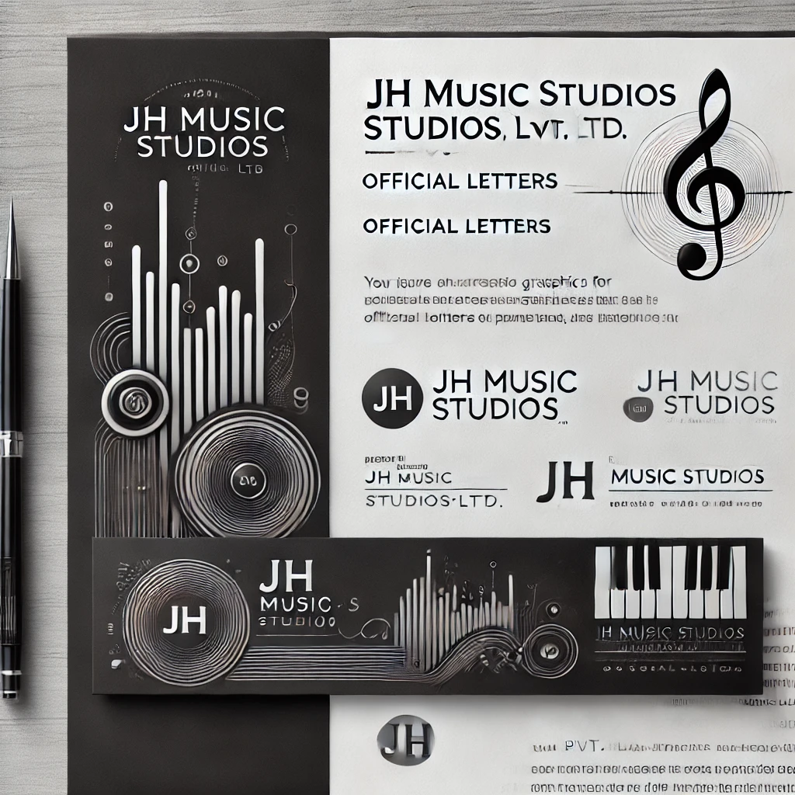

……………………………………

Authorization

……………………………………

Date