SAFEVIEW: System of monitoring blind spots for large trucks
SAFEVIEW: Blind spot monitoring system for large trucks
SAFEVIEW: Sistema de monitoreo de puntos ciegos para camiones grandes

Ester Rodrigues Soares
ester.soares3@etec.sp.gov.br

Gabrielly Nascimento Bento¹
gabrielly.bento@etec.sp.gov.br

Gustavo Henrique Ribeiro da Silva¹
gustavo.silva2122@etec.sp.gov.br

Jhonata Alves do Nascimento¹
jhonata.nascimento4@etec.sp.gov.br

Jeferson Roberto de Lima¹
jeferson.lima17@etec.sp.gov.br
Palavras-chave:  Motorista.  Caminhões.  Pontos cegos.  Sistema integrado.  Keywords:  Driver.  Trucks.  Blind spots.  Integrated system.  Palabras clave:  Conductor.  Camiones.  Puntos ciegos.  Sistema integrado.  Apresentado em:  03 dezembro, 2025  Evento:  8º EnGeTec  Local do evento:  Fatec Zona Leste  Avaliadores:  Avaliador 1  Avaliador 2   | Resumo:  Estima-se que uma parcela significativa dos acidentes com caminhões de grande porte decorre da falta de visibilidade dos motoristas em relação a outros agentes do tráfego ao seu redor, como ciclistas, pedestres e veículos menores, que são vítimas frequentes desses incidentes. Nesse contexto, este artigo apresenta um sistema integrado, físico e digital capaz de fornecer imagens e alertas do entorno do veículo, reduzindo distrações e facilitando a realização de manobras. Diante da importância da segurança, a adoção do presente projeto, denominado SafeView, possibilitaria ao motorista visualizar o ambiente externo e investir em uma tecnologia acessível e de operação simples, tornando a solução vantajosa para aqueles que buscam garantir a própria segurança e a dos outros. Apesar do conhecimento dos pontos cegos dos veículos, não há estudos que ofereçam informações detalhadas sobre ocorrências de acidentes relacionados a eles, dificultando a aplicação adequada das medidas mencionadas. Contudo, através de pesquisas de campo que evidenciam fatores de acidentes no trânsito, será possível identificar padrões e situações críticas na interação entre motoristas e pontos cegos, fornecendo base sólida para a implementação do projeto SafeView.  Abstract:  It is estimated that a significant portion of accidents involving large trucks results from drivers’ limited visibility of other traffic participants, such as cyclists, pedestrians, and smaller vehicles, who are frequently victims of these incidents. In this context, this article presents an integrated, physical, and digital system capable of providing images and alerts of the vehicle’s surroundings, reducing distractions and facilitating the execution of maneuvers. Considering the critical importance of safety, the adoption of the project, named SafeView, would allow drivers to visualize the external environment while benefiting from accessible and easy-to-operate technology, making the solution advantageous for those seeking to ensure both their own safety and that of others. Despite existing knowledge about vehicle blind spots, there are no studies offering detailed information on accidents related to them, limiting the proper application of the mentioned measures. However, through field research identifying factors that contribute to traffic accidents, it is possible to detect patterns and critical situations in the interaction between drivers and blind spots, providing a solid foundation for the implementation of the SafeView project.  Resumen:  Se estima que una parte significativa de los accidentes con camiones de gran tamaño se debe a la falta de visibilidad de los conductores respecto a otros agentes del tráfico, como ciclistas, peatones y vehículos menores, quienes son víctimas frecuentes de estos incidentes. En este contexto, este artículo presenta un sistema integrado, físico y digital, capaz de proporcionar imágenes y alertas del entorno del vehículo, evitando distracciones y facilitando la ejecución de maniobras. Dada la importancia de la seguridad, la adopción del proyecto denominado SafeView permitiría al conductor visualizar el entorno externo e invertir en una tecnología accesible y de operación sencilla, convirtiéndose en una solución ventajosa para quienes buscan garantizar su propia seguridad y la de los demás. A pesar del conocimiento existente sobre los puntos ciegos de los vehículos, no hay estudios que ofrezcan información detallada sobre los accidentes relacionados con ellos. Sin embargo, mediante investigaciones de campo que evidencian factores contribuyentes en los accidentes de tráfico, será posible identificar patrones y situaciones críticas en la interacción entre conductores y puntos ciegos, proporcionando una base sólida para la implementación del proyecto SafeView.

- Introduction
It is indisputable that the work performed by truck drivers is crucial to the Brazilian economy, as it maintains the national economic flow. Clear evidence of this importance was the truckers' strike in 2018, which impacted several productive sectors of the country. The extensive working hours and unfavorable conditions to which drivers are subjected, such as weather, poor road conditions, and reduced visibility at night, all contribute to fatigue. This factor compromises attention on the road and affects drivers from smaller companies and independent drivers.
Small businesses and independent drivers play a crucial role in the transportation and logistics sector; nevertheless, due to their limited resources, they often face greater risks than necessary. They are generally primarily responsible for their own safety and that of others. Consequently, because of the high cost of safety equipment, they neglect their own safety to avoid financial losses. This reality highlights the need for affordable solutions.
So, how can the Internet of Things (IoT) drive innovation and financial viability in road-safety solutions?
- Theoretical Basis
  - Field test
The study presents and consolidates a qualitative methodology, given the shortage of quantitative data on the subject. As described by Marconi and Lakatos (2017), qualitative changes do not stem from quantitative ones, but rather replace them, undoing a latent progression and introducing something new. What if based on phenomena to justify oneself? Proving to be an appropriate research method for this study.
To fill this gap, field research was conducted to observe, collect, and analyze data from the environments where these accidents occur. To build a solid body of information, we selected questions we considered relevant to gather evidence supporting the existence of the problem. Thus, the research aimed to understand drivers' experiences better when faced with blind spots.
Figure 1 – Search Form SafeView.
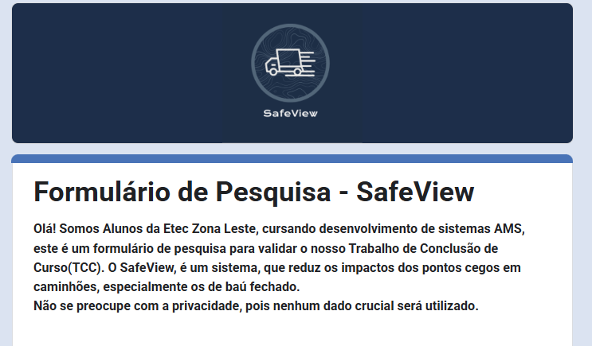
Source: Author's own (2025).
To establish trust with the interviewee, the form presents information about the researchers and the purpose of the data collection.
Figure 2 – Initial question of Form.
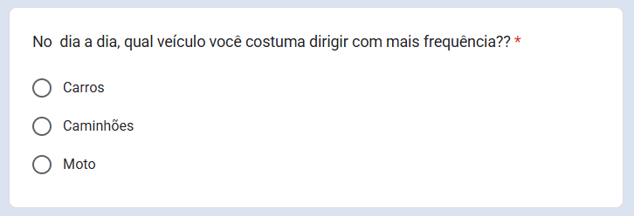
Source: Author's own (2025).
The first question will help formulate the following questions, which fit the interviewee's scenario. Suppose the participant is a driver of a motorcycle or a car. In that case, the questionnaire will be supplemented with questions that place greater emphasis on identifying and evaluating situations with blind spots. In big trucks, they caused harm. Additionally, in the questions in the section for truck drivers, the aim is to deepen their understanding of the experience gained in the road context, identify whether the use of any tool reduced the impacts of the points that blind people face, and gather their respective feedback. Some of the questions are:

Figure 3 – Survey Form Question: Truck drivers.
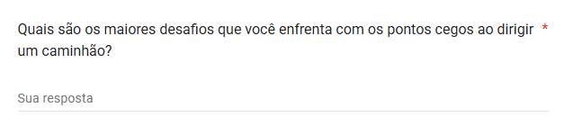
Source: Author's own (2025).
Figure 4 – Survey Form Question: Truck drivers.
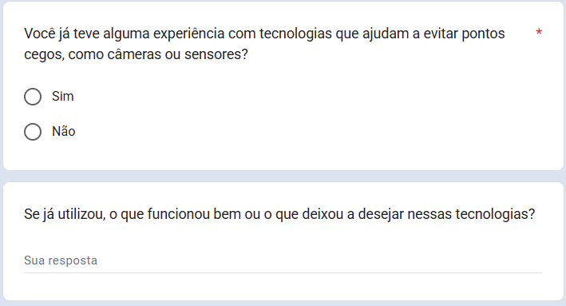
Source: Author's own (2025).
Figure 5 – Survey Form Question: Truck drivers.
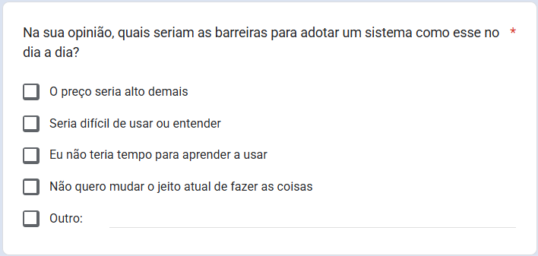
Source: Author's own (2025).
Figure 6 – Survey Form Question: Truck drivers.
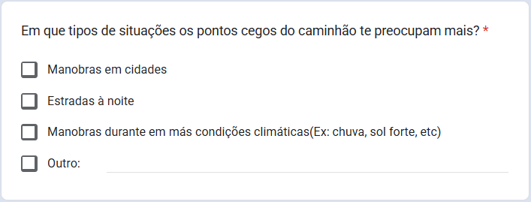
Source: Author's own (2025).

Figure 7 – Survey Form Question: Truck drivers.
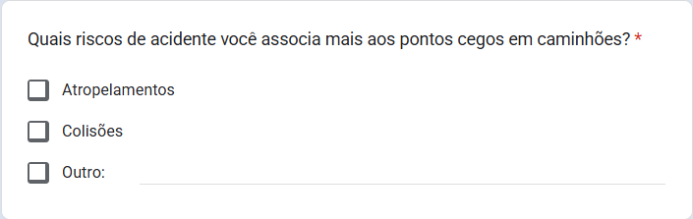
Source: Author's own (2025).
Put quite from the analysis of answers collected of about of 14 people - number considered enough for to ascertain the urgency and need from the solution proposal — he was possible observe what, despite of Although the number of car and motorcycle drivers is higher (71.4% of those interviewed), the vast majority of participants truck drivers have more of 10 years of experience, the what you turns one source solid for investigating the situation.
Graphic 1 – Survey Form: Length of experience in this area.
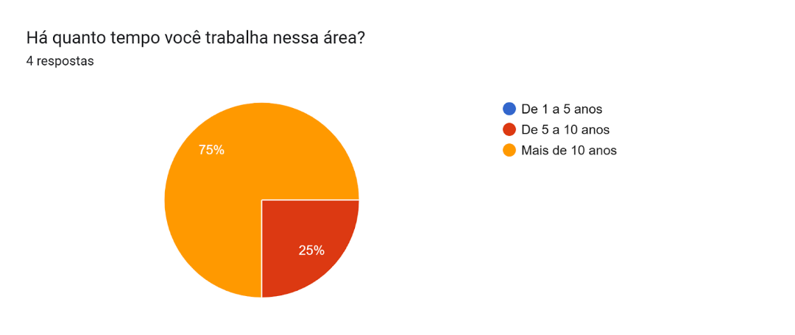
Source: Author's own (2025).
  - Difficulty for the truck drivers
During the analysis of the responses, it was noted that the most significant challenges in driving these vehicles are related to the presence of motorcycle couriers, inattentive pedestrians crossing too close to the trucks, and people parking outside the reach of the rearview mirrors, which, thanks to their positioning in height high, no provide visibility total from the area, especially in the areas near the cabin. This observation was reinforced by an answer to the question in Figure 3, which drew our attention to information that, until then, was not within our knowledge.
"Mainly to see the vehicle that becomes very next from the passenger door of the truck, "That is the blind spot that causes the most traffic collisions…", reported the participant.
The records obtained during the research show moments of difficulty that, in some cases, resulted in more serious accidents. One of the truck drivers reported, for example, that on one occasion a motorcyclist entered from the right and, result from reduced visibility, collided, resulting in the motorcyclist and the motorcycle being trapped under the lower part of the vehicle, between the wheels.
In another case, the participant described one that occurred during a maneuver that appeared Simple. Even though, it posed a risk to other drivers: while making a sharp turn, he failed to notice a cyclist performing the same maneuver, resulting in a collision.
Graphic 2 – Survey Form: Risks associated with the blind spots.
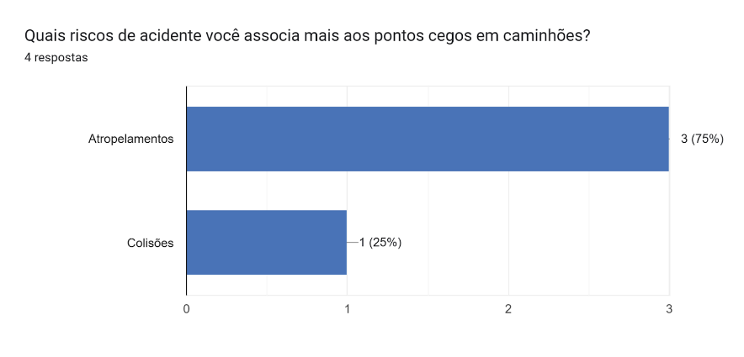
Source: Author's own (2025).
These accounts indicate that, although drivers recognize factors that hinder driving and understand that a support tool would positively impact their work—by preventing accidents and making roads safer—there is still a lack of adoption of proactive, accessible solutions to minimize these adverse situations. This finding led us to investigate the reasons behind the lack of demand for this type of tool.
Graphic 3 – Survey Form: Difficulty with technological tools.
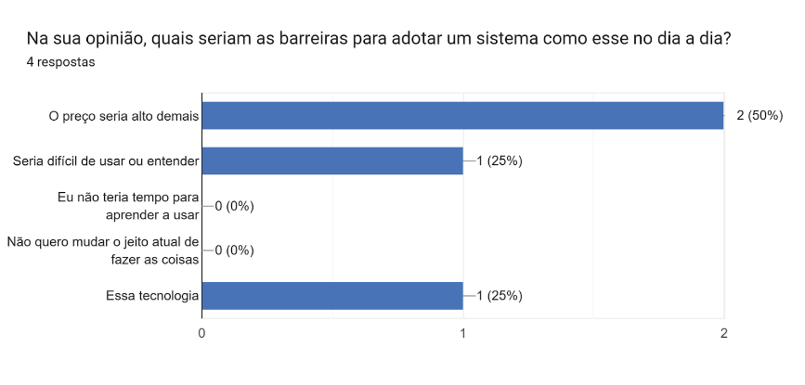
Source: Author's own (2025).
The results show that the factors relevant to the refusal to adopt these tools are, firstly, the high cost, which can represent an economic loss, leading many drivers to neglect their own safety to avoid financial damage. Another factor to consider is the participants' age profile. Since they are an older audience, many lack digital skills, leading them to avoid using technological tools because they consider them too complex.
  - Difficulty for car and motorcycle drivers
Notably, there is a high number of collisions on the roads involving large vehicles. One relevant point is that during teaching at Driver Training Centers (CFCs), instructors frequently warn — especially during practical tests — about the need to exercise extra caution when driving near smaller vehicles.

Graphic 4 – Survey Form: Knowledge about blind spots.
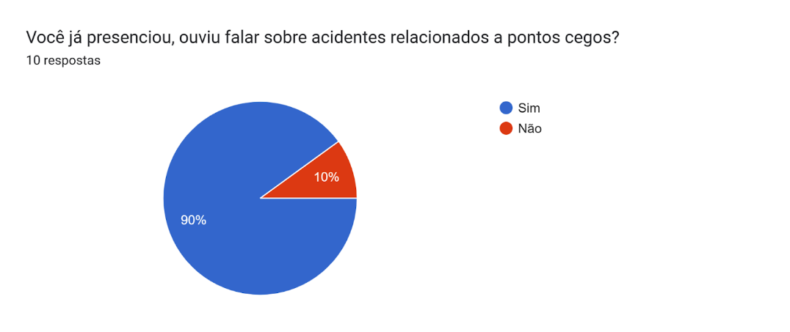
Source: Author's own (2025).
Overall, the results indicate that drivers of smaller vehicles are aware of the limitation. Of visibility for truck drivers, and put that, feel insecure, what he takes is to redouble the attention during overtaking, maneuvers and lane changes made by drivers of larger vehicles. They also acknowledge the actions implemented to reduce the impact of blind spots — such as reporting some participants to mention the existence of a bus in the city of They are Paul, who have stickers and devices with sound installed in tanker trucks, issuing one alert upon activation from the arrow. Moreover, participants suggested measures to mitigate the problem, such as the use of technology (sensors and cameras), educational campaigns, wider lanes, and greater respect on the roads, a result also observed among truck drivers.
  - Study analysis
In 2019, the Annual Traffic Accident Report, provided by the Traffic Engineering Company (CET) of the state of São Paulo, reported approximately 758 fatal accidents involving run-overs, collisions, and crashes, and 791 deaths. It is worth noting that the number of deaths (791) is slightly higher. Bigger: number of fatal accide58, one time some accidents involve multiple victims.
The Federal Highway Police (2024) confirms that among the causes of this class of accidents (traffic accidents) are blind spots — areas around the vehicle where the driver has low or no visibility — on large vehicles, such as trucks, buses, and other long road vehicles.
To elaborate on the work of form and the aspects contemplated, an exploratory study was initiated on the difficulties truck drivers face in traffic. Trunk closed, what took us to find information about the positioning of blind spots. Your vital points of limitation are visual concentration in part in front of the vehicle — due to the height of the cabin — and on the sides near the doors and in the rear area — owing to the length of the cargo box.
  - Implementing the technology on the security road
In agreement with Sérgio de Oliveira (2021), the Internet of Things (known as IoT) is a network of interconnected devices, accessible in a manner that allows them to communicate with physical devices. With this combination of sources, it is possible to obtain a broader and more integrated view of the challenges at hand, which is essential.
The project includes components such as physicists, languages of schedule, frameworks, among others, to provide a more comprehensive visualization of the surroundings of the vehicle. By allowing the driver to see areas that would usually be invisible thanks to blind spots, this demonstrates the applicability of IoT in road safety.
  - Raspberry PI
The Raspberry Pi, according to Eberman et al. (2017), emerged from the idea of creating a small, accessible computer for children; this was a significant challenge, given what was already in use among children at the time: more sophisticated electronics like smartphones.
According to Oliveira (2021), the Raspberry Pi had some features that led it down the path of systems embarked, already with one architecture reduced; he brought various doors. It features input and output capabilities and excellent integration with Python, providing a complete programming environment.
Figure 8 – Raspberry PI 3.
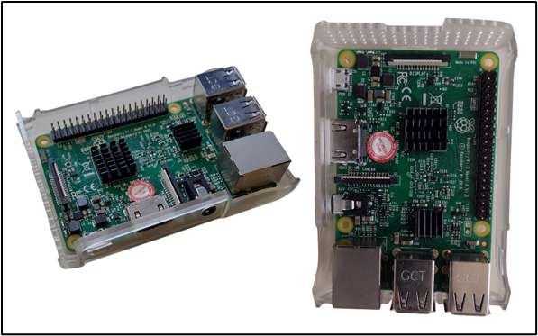
Source: Author's own (2025).
  - ESP32 and ESP32-CAM
Released in 2016 by Espressif Systems, the ESP32 is a microcontroller known for its Wi-Fi and Bluetooth communication interfaces (ELETRÔNICA ÔMEGA, 2025). Another important aspect is that, although it is similar to other microcontrollers such as the Arduino Uno, the ESP32 offers higher processing speed and connectivity, making it more suitable for IoT projects (RIBEIRO, VALLE JUNIOR, MARTINS, 2022).
In this project, we will use the ESP32 and the ESP32-CAM, a variant of the ESP32 microprocessor with a small 2MP OV2640 camera and a MicroSD card slot. Furthermore, it is possible to send the images it captures via the Internet and store them on the MicroSD card.

Figure 9 – Microcontroller ESP32.
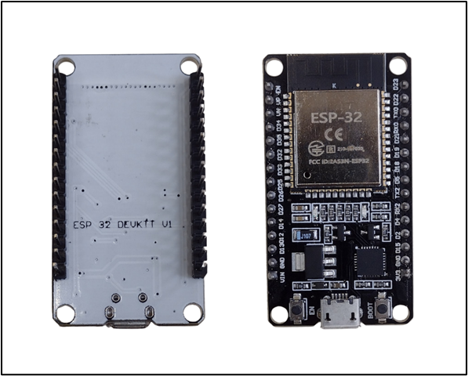
Source: Author's own (2025).
Figure 10 – Microcontroller ESP32 with camera.
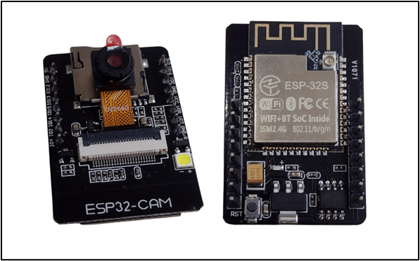
Source: Author's own (2025).
  - Ultrasonic sensor HC-SR04
Aligned with Robocore (2012), it works by sending and receiving a wave without performing any measurement metrics on the controller. The calculation is done for the own controller, based on the time it takes for the ultrasonic wave to reach the object and return.

Figure 11 – Ultrasonic sensor HC-S04.
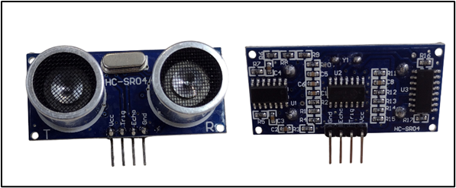
Source: Author's own (2025).
  - Lithium-ion batteries and TP4056
According to Iberdrola (2025), lithium-ion batteries, popularly known as Li-Ion batteries, are rechargeable and structured with lithium compounds as one of their electrodes. They will be responsible for the power source of some of the devices previously presented.
Figure 12 – Support and lithium-ion batteries.
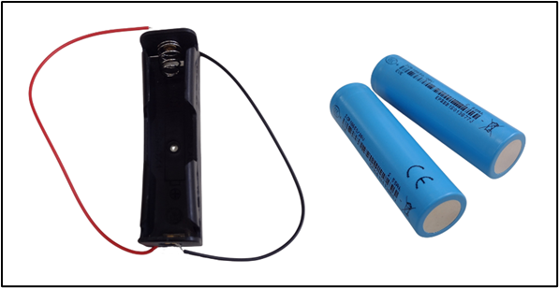
Source: Author's own (2025).
Similarly, the TP4056 is responsible for charging Lithium-ion (Li-Ion) or lithium-polymer (Li-Po) batteries, which are commonly used in small circuits with microcontrollers. (GUSE, 2023).
Figure 13 – Module TP4056.
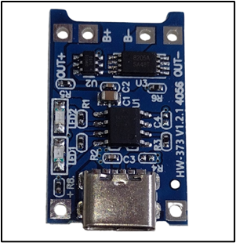
Source: Author's own (2025).

  - C++
De acordo com Horstmann (2008), o C++ foi uma linguagem desenvolvida sobre C, tendo como diferencial características para Orientação a Objeto, isto é, um estilo de programação para modelagem de objetos do mundo real. A programação em C++, além de ser usada para orientar objetos, pode ser utilizada como linguagem estruturada quando se deseja trabalhar com algoritmos e estrutura de dados. (AGUILAR, 2011).
  - Python
According to the Official Python Documentation (2025), the Python programming language was developed by Guido van Rossum in February 1991 with the objective of overcoming the limitations of the languages of the time. From Menezes's perspective (2019), Python is a robust, objective language that has become widely used across various areas of computing, such as artificial intelligence and biotechnology, owing to its high scalability, ease of maintenance, and straightforward syntax.
Among the various Python libraries, OpenCV (Open Source Computer Vision Library) is a cross-platform, open-source library created by Intel in 2000 (Barelli, 2018). It was developed to simplify the contact between programmers and the vision computational, with optimized functions, as pointed out by Marengoni and Stringhini (2010), hence becoming one of the most recognized libraries in the field of technology.
To better use Python, we will leverage your OpenCV resources, one of the important tools for this project.
  - React Native
In agreement with Falcão (2022), React Native is a library created for Facebook, leveraging the same benefits of React, the JavaScript’s library, which precedes, although the goal is to develop mobile applications. As described by Escudelario and Pinho (2021), the React Native platform brings together the latest in front-end development into a series of tools that allow the best environment for hybrid mobile applications, i.e., both Android and iOS.
- Materials and methods
Putting quite a lot of the equipment previously described, he was able to elaborate on the IoT device. With A physical structure strategically designed for easy installation and handling, 3D modeling was used to create it. The prototype is protected against external factors without interfering with the cameras' visibility or the sensors' data collection.
Figure 14 – Case with ESP32-CAM and another with ESP32.
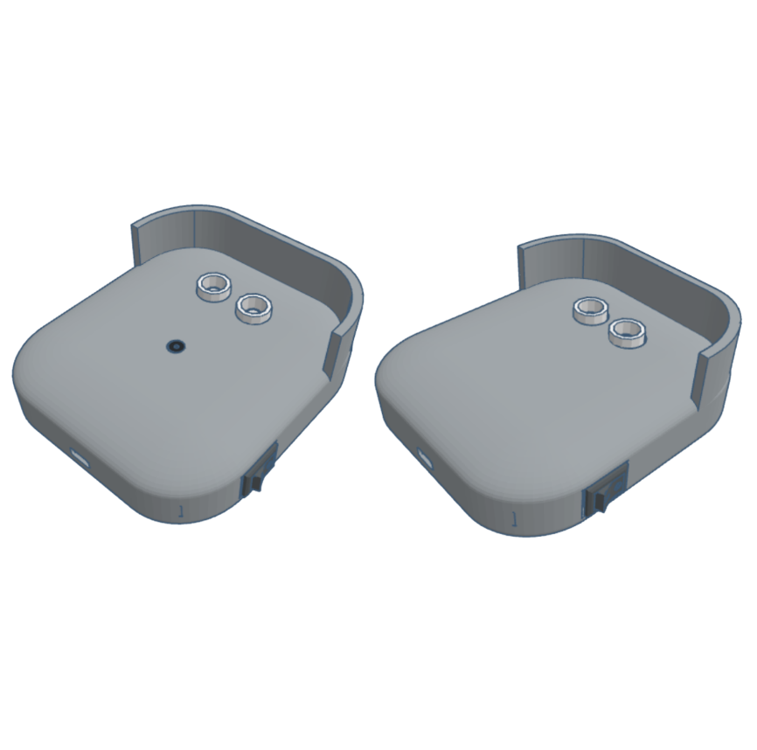
Source: Author's own (2025).
In the set of devices, the SafeView application includes one React Native logic component, designed to meet driver needs through an intuitive interface. The platform provides information on installing devices — such as ideal mounting points and the correct application method — as well as access to images captured by the cameras and alerts issued by the sensors.
Through the Wi-Fi network connected to the Raspberry Pi and the application, the device transmits the collected information to the interface. Before displaying the alerts from the ultrasonic sensors, and carrying out an analysis of the data received, the end goal is to measure the level of proximity — represented by colors — of objects in relation to the determined blind spot. Simultaneously, the images captured by the ESP32-CAMs are displayed on the screen, automatically adjusting to changes in distance.
The processing logic for sensor data and camera image data, responsible for measuring critical levels in blind spots, was implemented in C++. Python, running on a Raspberry Pi server, acts as an intermediary between the devices and the central system, integrating videos sent by the ESP32-CAMs, reading data from the ultrasonic sensors, and sending alerts and feedback to the application.
- Results and Discussions
Based on the proposal, the device is expected to feature fast processing, easy handling, and practical installation, along with an application that smoothly transmits the information captured by the cameras and sensors. Likewise, the interface was designed to be intuitive and straightforward, avoiding visual elements that could distract the driver.
The SafeView was designed to cover three points blind; nonetheless, not everyone has cameras. The equipment installation was planned so that the cameras are positioned at the rear and on the right side of the vehicle, while the front blind spot uses only sensors.
It is recognized, nonetheless, that there are still aspects that need improvement, especially regarding the installation method. For this reason, a user guide has been prepared with detailed instructions for installing and maintaining the devices.
- Final considerations or Conclusion
From this form, and of extreme importance, the theme is widely discussed, considering the need to develop a solution that provides greater security and assistance to the truck drivers, allowing them to have greater control over the vehicle's surroundings and a wider view of their blind spots. Addressing the identified demands, the presentation and analysis of the data, along with the application of the developed resources, resulted in one alternative that effectively minimized the difficulties faced.
In light of the results, studies conducted by institutions such as CET and PRF reinforce understanding of the limitations faced by drivers, and consistent data confirm the need for measures to promote greater road safety. In addition, the field search enabled a deeper analysis of the target audience's experiences, highlighting the practical and social relevance of the proposed solution.
It can therefore be concluded that integrating technology and road safety is essential to reduce the impact of blind spots and promote safer, more efficient, and more conscious traffic.
References
BARELLI, F. Introdução à visão computacional: uma abordagem prática com Python e OpenCV. 1ª. ed. São Paulo: Casa do Código, 2018.
EBERMAM, E. et al. Programação Para Leigos Com Raspberry Pi. 1ª. ed. João Pessoa: Editora IFPB, 2017.
ELETRÔNICA ÔMEGA. Internet das Coisas para Iniciantes com ESP-32: atualizado 2025. [S.I.]: Eletrônica Ômega, 2025. Disponivel em: https://blog.arduinoomega.com/ebooks/Eletronica-Omega-Iot-Iniciantes-Esp32.pdf.
ESCUDELARIO, B.; PINHO, D. React Native: Desenvolvimento de aplicativos mobile com React. São Paulo: Casa do Código, 2021.
FALCÃO, F. D. Desenvolvimento do aplicativo turista Beberibe utilizando react native. Universidade Federal do Ceará. Fortaleza, p. 68. 2022.
GUSE, R. Saiba como funciona o carregador de bateria TP4056. Makerhero, 2023. Disponivel em: https://www.makerhero.com/blog/saiba-como-funciona-o-modulo-tp4056. Acesso em: 11 Agosto 2025.
IBERDROLA. Baterias de íon de lítio. Iberdrola, 2025. Disponivel em: https://www.iberdrola.com/quem-somos/nosso-modelo-inovacao/baterias-ion-litio. Acesso em: 11 Agosto 2025.
JUNIOR, R. Relatório Anual de Acidentes de Trânsito do Município de São Paulo 2019. CET. São Paulo, p. 58. 2019.
MAGRANI, E. Internet da Coisas. 1ª. ed. Rio de Janeiro: Editora FGV, 2018.
MARCONI, M. A.; LAKATOS, E. M. Fundamentos de Metodologia Científica. 8ª. ed. São Paulo: Atlas S.A. (GEN – Grupo Editorial Nacional), 2017.
MARENGONI, ; STRINGHINI ,. Tutorial: Introdução à Visão Computacional usando OpenCV. Revista de Informática Teórica e Aplicada, São Paulo, 8 Março 2010. Disponivel em: https://seer.ufrgs.br/index.php/rita/article/view/rita_v16_n1_p125. Acesso em: 24 Maio 2025.
MENEZES, N. N. C. Introdução à programação com Python: algoritmos e lógica de programação para iniciantes. 3ª. ed. São Paulo: Novatec Editora, 2019.
MORAES, A.; HAYASHI, V. T. Segurança em IoT: Entendendo os Riscos e Ameaças em IoT. 1ª. ed. Rio de Janeiro: Alta Books, 2021.
MORAES, W. B. Construindo Aplicações com Node.js. 3ª. ed. [S.l.]: Novatec, 2021.
PEREIRA, E. Trilhas Python: programação multiparadigma e desenvolvimento web com Flask. 1ª. ed. São Paulo: Casa do Código, 2018.
POLÍCIA RODOVIÁRIA FEDERAL. Motos representam quase metade dos sinistros de trânsito registrados na BR 324. gov.br, 2024. Disponivel em: https://www.gov.br/prf/pt-br/noticias/estaduais/bahia/2024/maio/motos-representam-quase-metade-dos-sinistros-de-transito-registrados-na-br-324. Acesso em: 10 Agosto 2025.
PYTHON DOCUMENTATION. 3.13.9 Documentation - Python Geral. Python Documentation, 2025. Disponivel em: https://docs.python.org/pt-br/3.13/faq/general.html#is-there-a-newsgroup-or-mailing-list-devoted-to-python. Acesso em: 24 Maio 2025.
RIBEIRO, M. M. D. A.; VALLE JUNIOR, O.; MARTINS, C. P. Hortomação: sistema de automação de horta utilizando IoT em parceria com escola estadual. Repositório Institucional do Conhecimento do Centro Paula Souza, São José do Rio Preto, 6 Dezembro 2022., p. 02-04
ROBOCORE. Primeiros Passos com Sensor Ultrassônico. Robocore, 2012. Disponivel em: https://www.robocore.net/tutoriais/primeiros-passos-com-sensor-ultrassonico?srsltid=AfmBOoo56x4FrvqQ6Q867PWv8eJZkmIgpbKRfmQCTbv-3HZjUeFvlD2P. Acesso em: 3 Setembro 2025.

"You content express node work, like this, as you retain the copyright of figures and data, good as your own. The author(s) are entirely responsible for proofreading and ensuring compliance with spelling and grammar standards.”

"The authors of this work declare that the ChatGPT tool/service was used during the preparation of the manuscript." of Artificial Intelligence (AI) to correct grammatical errors. After using this tool/service, the authors edited and revised the content as needed and assume full responsibility for the publication's content.”

ETEC Zona Leste

