

AOS-25-0679
September 2025

STIX Modeler Tool
User Guide
Version 1.0
Prepared for: Department of Homeland Security (DHS)
Cybersecurity and Infrastructure Security Agency (CISA)
Prepared by: The Johns Hopkins University Applied Physics Laboratory
11100 Johns Hopkins Road
Laurel, MD 20723-6099
Hannah Ripley
Luanne Chamberlain
Task No.: | CYS98
Contract No.: | N0024-22-D-6404
Distribution Statement A. Approved for public release: distribution is unlimited.
25-04315

CONTENTS
Page
Figures iv
Tables v
1. Introduction 1–1
1.1 Purpose and Audience 1–1
1.2 Document Organization 1–1
2. Background and Definitions 2–1
3. User Guide 3–7
3.1 Overview 3–7
3.2 STIX Modeler Canvas 3–7
3.3 Nodes 3–8
3.3.1 Creating a Node 3–8
3.3.2 Editing a Node 3–9
3.3.3 Creating an SCO Node 3–10
3.3.4 Grouping Nodes 3–11
3.4 Relationships 3–12
3.4.1 Creating a Relationship 3–12
3.4.2 Defining a New Relationship Type 3–13
3.4.3 Editing a Relationship 3–14
3.4.4 Configuring Layout 3–14
3.5 STIX Bundles 3–16
3.5.1 Importing a Bundle Panel 3–16
3.5.2 Viewing a STIX Bundle 3–18
3.5.3 Viewing Bundle Errors 3–19
3.5.4 Exporting a Bundle 3–19
3.5.5 Resetting a Bundle 3–19
3.6 STIX Extensions 3–20
3.6.1 Importing an Extension Schema via Paste 3–20
3.6.2 Editing a STIX Extension 3–21
3.7 Importing a Schema or Bundle From a File 3–22
4. Conclusions 4–1
5. References 5–1
Appendix A. Getting Started with the STIX Modeler A–1
Appendix B. STIX Object Fields B–1
Appendix C. Abbreviations and Acronyms C–1

Figures
Page
Figure 2-1 STIX Modeler Landscape 2–1
Figure 2-2 Example STIX Bundle 2–4
Figure 2-3 Visual Depiction of the Bundle 2–4
Figure 2-4 Example STIX Schema 2–5
Figure 2-5 Example STIX Extension 2–5
Figure 2-6 Example STIX Object with an Extension 2–6
Figure 3-1 The STIX Modeler Canvas 3–7
Figure 3-2 Dragging a New Node Onto the Canvas 3–8
Figure 3-3 Editing a Node’s Properties 3–9
Figure 3-4 Creating an SCO Node 3–10
Figure 3-5 Possible Relationships Between Malware SDO and All SCOs 3–11
Figure 3-6 Creating a New Grouping 3–12
Figure 3-7 Starting the Creation of a Relationship 3–12
Figure 3-8 Dragging Relationship Connector to Target Node 3–13
Figure 3-9 Possible Relationship Panel 3–13
Figure 3-10 The Established Relationship 3–13
Figure 3-11 The New Relationship Panel 3–14
Figure 3-12 Editing a Relationship 3–14
Figure 3-13 An Imported Bundle 3–15
Figure 3-14 The Layout Panel 3–15
Figure 3-15 Hierarchical, Column View 3–16
Figure 3-16 The Paste Bundle Panel 3–17
Figure 3-17 Visual Depiction After Pasting the Bundle 3–17
Figure 3-18 The View Bundle Panel 3–18
Figure 3-19 Invalid STIX Bundle Error Message and Badge Notification 3–18
Figure 3-20 The Errors Panel 3–19
Figure 3-21 The Paste Schema Panel 3–20
Figure 3-22 New SDO Icon in Node Creation Menu 3–21
Figure 3-23 The Extension Selection Panel 3–21
Figure 3-24 The Extension Editor Panel 3–22
Figure 3-25 The File Import Panel 3–22

Tables
Page
Table 2-1 STIX Domain Object (SDO) 2–2
Table 2-2 STIX Relationship Object (SRO) 2–2
Table 2-3 STIX Cybersecurity Observable Object (SCO) 2–2
Table 2-4 STIX Meta Object (SMO) 2–3
Table 2-5 STIX Bundle 2–3
Table 3-1 Fields Common to All Objects 3–9
Table 3-2 Grouping Nodes 3–11

Introduction

Purpose and Audience
The Structured Threat Information Expression (STIX) Modeler is a React-based [1] user interface tool for creating, modifying, and visualizing STIX 2.1 [2] bundles. Appendix A provides a guide to downloading and installing the tool and extensions.
This report provides an overview of the STIX Modeler User Interface (UI) components and common use cases for modeling activities. The intended audience for this tool is cybersecurity professionals and threat intelligence analysts who need to understand and analyze structured threat intelligence data. Common uses include:
- Visualizing attack kill chains (using MITRE ATT&CK® [3] (Adversarial Tactics, Techniques, and Common Knowledge) and STIX)
- Analyzing the spread of malware or campaigns over time
- Understanding adversary infrastructure (Internet Protocols (IPs), domains, tools)
- Collaborative threat sharing [e.g., via Information Sharing and Analysis Centers (ISACs)]

Document Organization
This report is organized as follows:
- Section 2 provides some STIX background concepts and definitions.
- Section 3 is the STIX Modeler User Guide.
- Section 4 provides report conclusions.
- Appendix A is a guide to getting started with the STIX Modeler.
- Appendix B provides the detailed definitions of all STIX Objects fields for all objects.
- Appendix C is a list of acronyms and abbreviations.

Background and Definitions
This section describes several concepts that are essential to understanding STIX and the STIX Modeler. STIX 2.1 bundles are containers used to share a set of cyber threat intelligence (CTI) objects in a structured and machine-readable format. Figure 2-1 shows the STIX Modeler landscape.
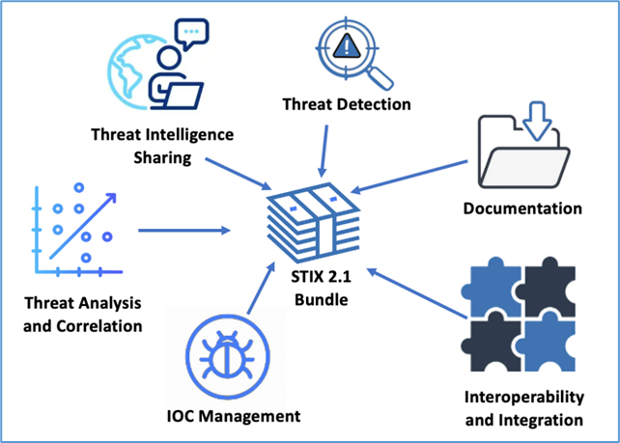
Figure 2-1 STIX Modeler Landscape
The STIX Modeler can be used for:
- Sharing Threat Intelligence: between organizations and between vendors and consumers
- Threat Analysis and Correlation: context-rich investigation
- Indicators of Compromise (IOC) Management: distribution of IOCs
- Threat Detection: automated IOC ingestion and detection
- Documentation: historical threat intelligence records and after-action reporting
- Interoperability and Integration: interoperability between tools or integration into new tools
STIX objects are the building blocks used to describe threat intelligence. STIX objects are written in JavaScript Object Notation (JSON). STIX objects belong to four main categories:
- STIX Domain Objects (SDOs) represent intelligence and threat information (e.g., malware, campaigns, threat actors). The format of an SDO is shown in Table 2-1.
- STIX Relationship Objects (SROs) link SDOs to SCOs, SDOs to SDOs, and SCOs to SCOs together, showing the relationship between them. The format of an SRO is shown in Table 2-2.
- STIX Cyber Observable Objects (SCOs) represent observables (e.g., IP addresses, file hashes, domain names). The format of an SCO is shown in Table 2-3.
- STIX Meta Objects (SMOs) provide additional information (e.g., purpose). The format of an SMO is shown in Table 2-4.
Each object also contains a spec_version field that refers to the unique identifier for a specific STIX specification or version. Its value, for the STIX Modeler examples in this report, is 2.1, representing STIX version 2.1. STIX objects may have additional, optional fields.
Table 2-1 STIX Domain Object (SDO)
Field | Description
type | The object type (e.g., malware, threat-actor, etc.)
id | Unique ID in the form type--<UUID>
created | When the object was created
modified | Last time the object was modified

Table 2-2 STIX Relationship Object (SRO)
Field | Description
type | Always “relationship”
id | Unique ID in the form relationship--<UUID>
created | Timestamp of when the object was created
modified | Timestamp of the last modification
relationship_type | Describes the kind of relationship (e.g., uses, attributed-to, indicates)
source_ref | The ID of the source object (e.g., threat-actor--...)
target_ref | The ID of the target object (e.g., malware--...)

Table 2-3 STIX Cybersecurity Observable Object (SCO)
Field | Description
type | The type of observable (e.g., file, ipv4-addr, domain-name, email-message, url, process)
id | Unique ID in the form type--<UUID>

Table 2-4 STIX Meta Object (SMO)
Field | Description
type | “marking-definition”
id | STIX ID (e.g., marking-definition--...)
created | Creation timestamp
definition_type | Type of marking: “tlp” or “statement”
definition | The actual marking content (e.g., { “tlp”: “amber” })
external_references | Sources or citations

A STIX 2.1 bundle is a container that groups together multiple STIX objects for sharing and exchanging CTI. Like STIX objects, STIX bundles are structured JSON objects. Table 2-5 shows the format of a STIX bundle; Figure 2-2 shows a notional instantiation of the bundle; and Figure 2-3 shows the visual depiction of the bundle.
Table 2-5 STIX Bundle
Field | Description
type | Must be “bundle”
id | A unique ID in the format bundle--UUID
spec_version | Must be “2.1” for STIX 2.1
objects | A list of STIX objects (SDOs, SCOs, SROs, etc.)

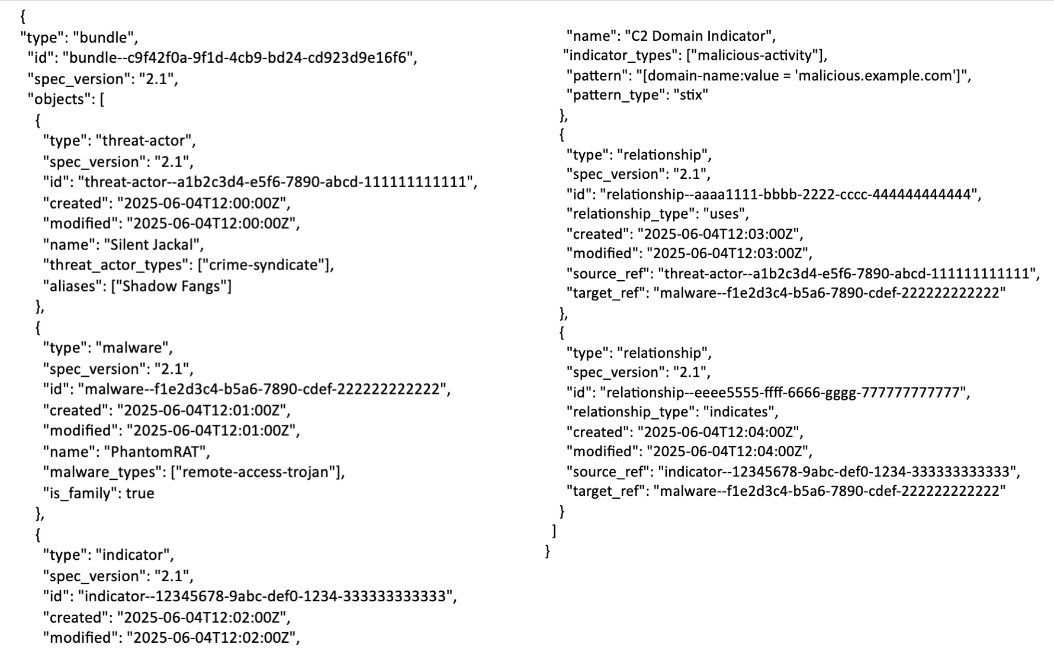
Figure 2-2 Example STIX Bundle

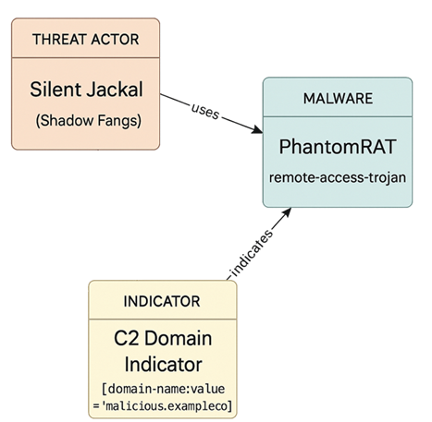
Figure 2-3 Visual Depiction of the Bundle
A STIX schema defines the structure, fields, data types, and constraints used to create and validate STIX objects — including SDOs, SCOs, SROs, Bundles, and SMOs. This ensures that cyber threat information exchanged using STIX is consistent and understandable by both humans and automated systems. A simple Indicator schema is shown in Figure 2-4.
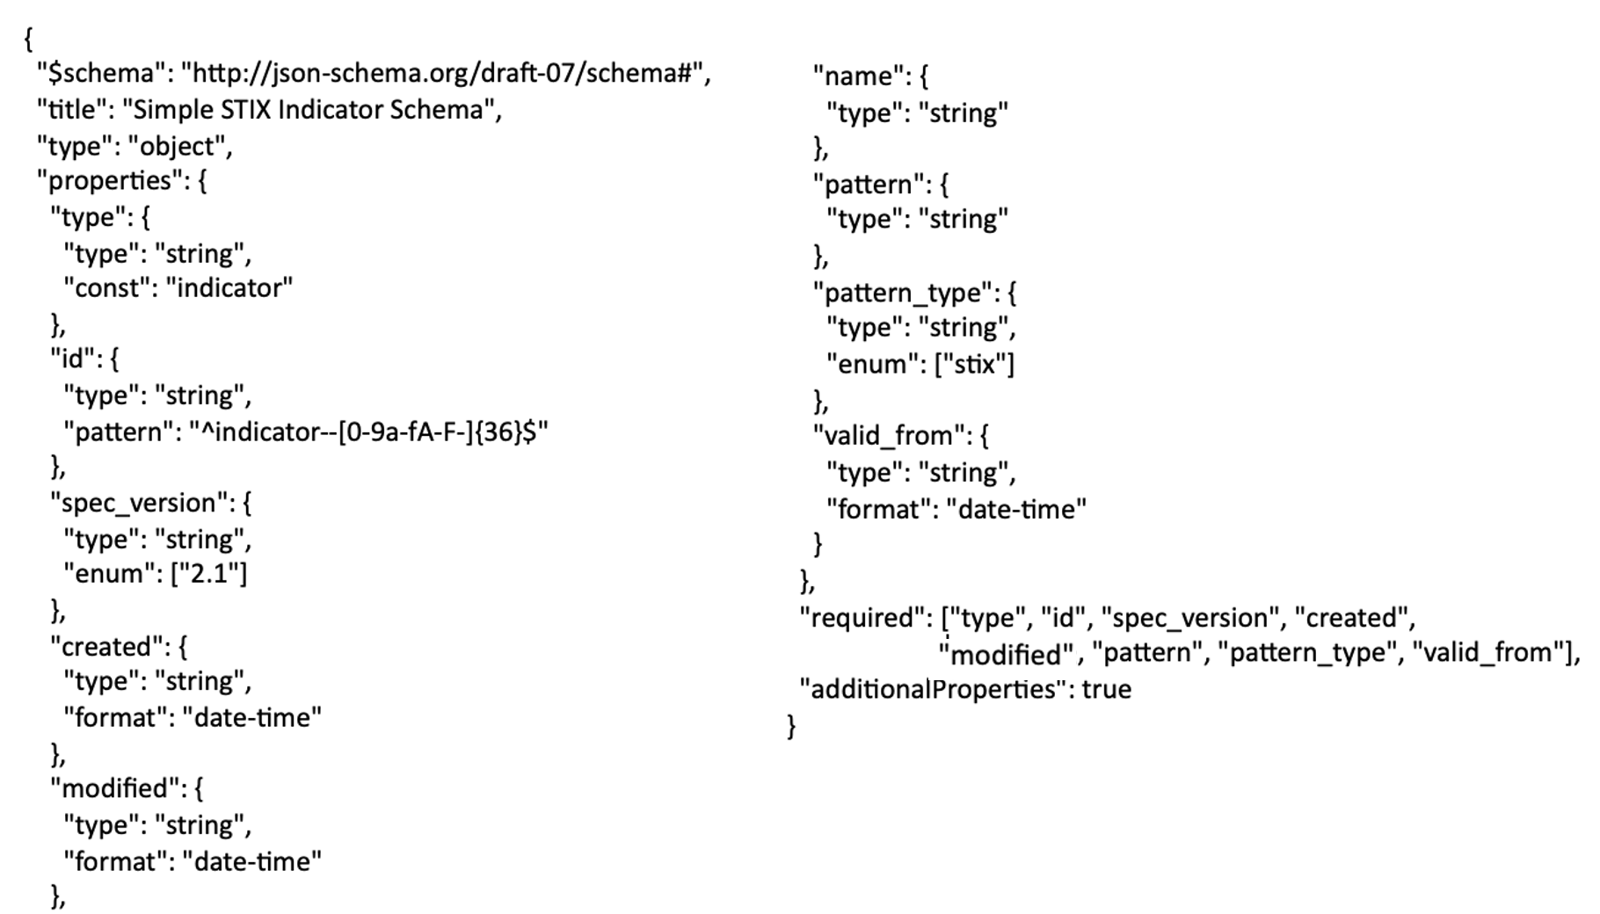
Figure 2-4 Example STIX Schema
A STIX 2.1 extension (Figure 2-5) allows the user to customize or extend the standard STIX object types (Figure 2-6) without violating the STIX 2.1 specification.
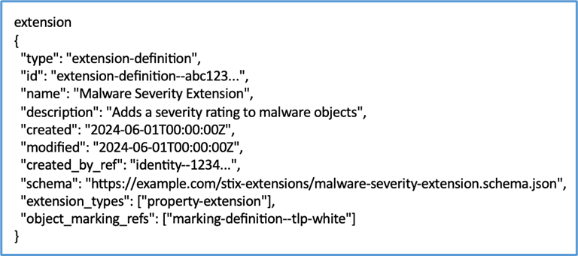
Figure 2-5 Example STIX Extension

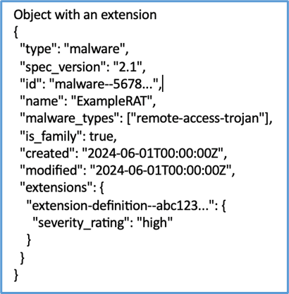
Figure 2-6 Example STIX Object with an Extension
A STIX Modeler node is a graphical vertex representation of a STIX object, either an SDO or an SCO. Figure 2-3 has three nodes: representing a Threat Actor SDO (“Silent Jackal”), a Malware SDO (“PhantomRAT”), and an Indicator SDO (“C2 Domain Indicator”).
A STIX Modeler edge is a graphical representation of a relationship between two STIX objects, either an SRO or an embedded (i.e. specified by an object property) relationship. Figure 2-3 has two edges: representing two SROs named “uses” and “indicates.”
Nodes and edges, as defined in this document, are STIX Modeler structures but are not official STIX 2.1 specification-defined structures.

User Guide

Overview
The STIX Modeler enables several capabilities:
- Creating SDOs and SCOs
- Modifying existing SDOs and SCOs
- Creating SROs
- Creating new STIX bundles
- Modifying STIX bundles
- Visualizing STIX bundles
- Creating extended (defined by a STIX extension schema) SDOs and SCOs
- Validating STIX bundles

STIX Modeler Canvas
All elements of the STIX Modeler are contained within the canvas. Figure 3-1 shows the default view for the STIX Modeler. The red notations on the canvas identify the elements and buttons; more detail is provided in the sections that follow.
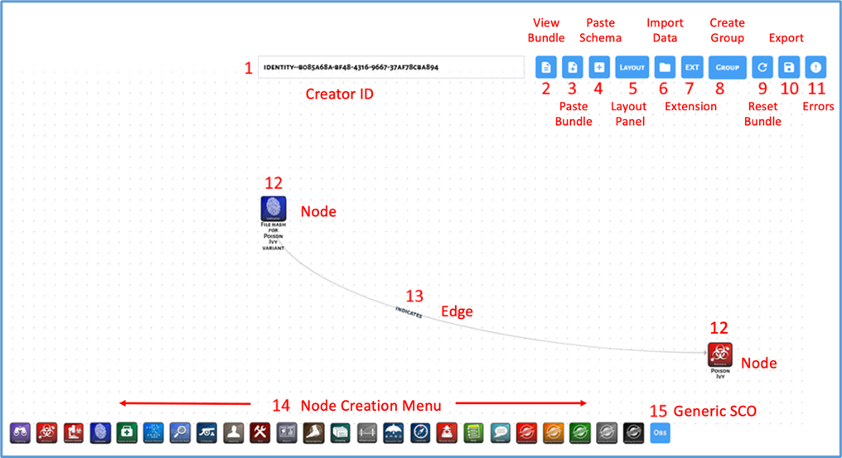
Figure 3-1 The STIX Modeler Canvas
The canvas is comprised of the following elements:
- The Creator ID field specifies the created_by_ref value for nodes created using the STIX Modeler UI.
- The View Bundle button opens the View Bundle panel.
- The Paste Bundle button opens the Paste Bundle panel.
- The Paste Schema button opens the Paste Schema panel.
- The Layout button opens the Auto Layout panel.
- The Import Data button opens the File Import panel.
- The Extension button opens the Extension Selection panel.
- The Group button enables the Grouping Mode.
- The Reset button deletes all nodes and relationships from the STIX Modeler UI.
- The Export button exports the bundle as a JSON file.
- The View Errors button opens the Errors panel.
- A node represents an SDO or SCO.
- An edge represents a relationship, either:
  - An SRO, where the source_ref value is the source node ID and the target_ref value is the target node ID
  - A reference property of the source node (typically ending in _ref), with a value of or including the target node ID
- The Node Creation menu contains SDO icons, which may be dragged onto the UI to create a new node of the specified type.
- The Observable Icon represents a generic SCO and may be dragged onto an existing node to create a new SCO (of a relevant type, if one exists).

Nodes

Creating a Node
Dragging an icon from the Node Creation menu onto the UI creates a new node of the specified type (Figure 3-2).
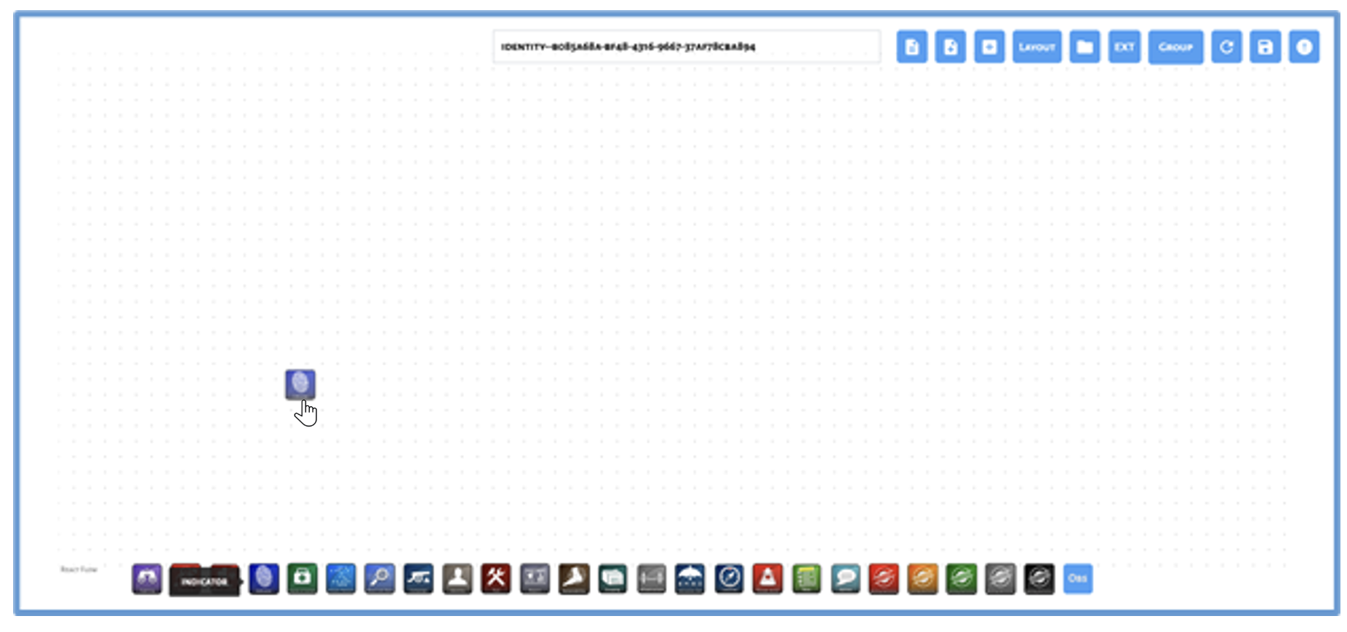
Figure 3-2 Dragging a New Node Onto the Canvas

Editing a Node
Clicking on a node in the STIX UI opens the Details panel. The Details panel allows node properties to be updated. Required fields that have not been filled in yet are bordered by a red box. The Delete button deletes the node (Figure 3-3). Table 3-1 describes the fields common to all objects. Appendix B describes other fields that are specific to each object type.
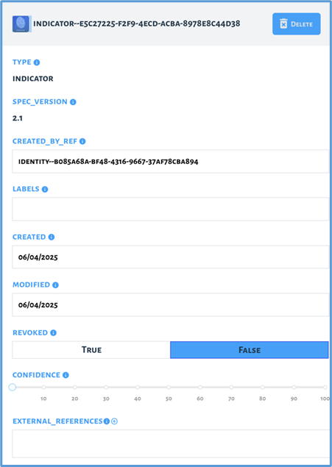
Figure 3-3 Editing a Node’s Properties

Table 3-1 Fields Common to All Objects
Field | Description | Auto Filled | Default | Editable
type | The type of this object | Y |  | N
spec_version | The version of the STIX specification used to represent this object | Y | 2.1 | N
created_by_ref | The ID of the identity object that describes who created this object | Y |  | Y
labels | The set of terms used to describe this object | N |  | Y
created | The time at which this object was created | Y |  | Y
modified | The time at which this object was last modified | Y |  | Y
revoked | Whether this object has been revoked | Y | False | Y
confidence | The confidence the creator has in the correctness of their data | N | 0 | Y
external_refs | A list of external references which refers to non-STIX information | N |  | Y

Creating an SCO Node
New SCOs can be created by dragging the Observable Icon onto an existing node. In Figure 3-4, the Observable Icon is being dragged to overlay the Poison Ivy Malware node on the canvas.
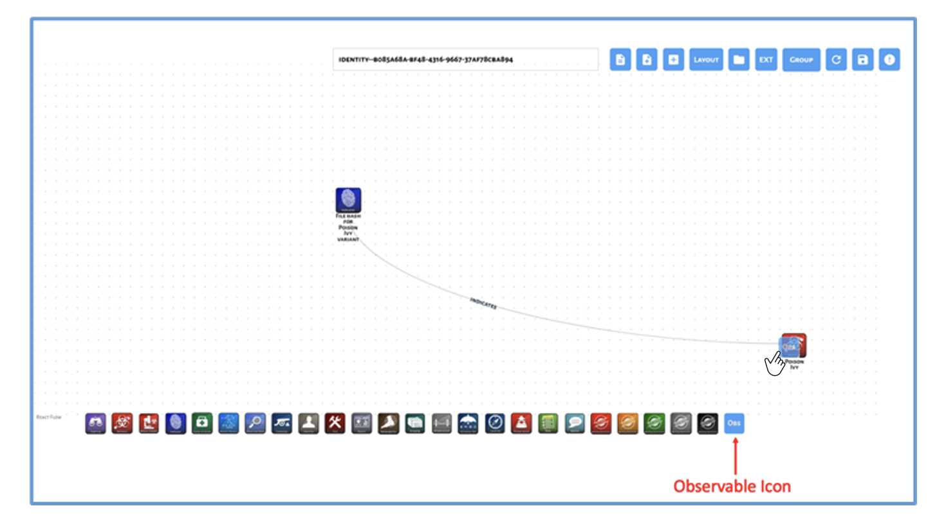
Figure 3-4 Creating an SCO Node
When the observable is dropped, the relevant SCOs for the target node are enumerated in the Possible Relationships panel (Figure 3-5).
Selection of an SCO in the Relationship Selection panel creates both of the following:
- A new SCO, of the specified type
- A new relationship between the SCO and the target node
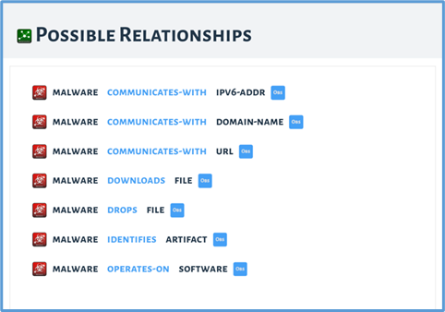
Figure 3-5 Possible Relationships Between Malware SDO and All SCOs

Grouping Nodes
Grouping Mode can be used to create a new Group via node selection. Nodes can be clicked to be selected in Grouping Mode. The steps for group node selection are shown in Table 3-2. Figure 3-6 shows a new grouping.
Table 3-2 Grouping Nodes
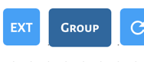 | When the Group button is selected, the user enters a new mode where any number of nodes can be selected. When selected, a node is bordered by a blue box. Clicking a selected node will deselect it.
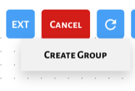 | After selecting all the nodes in the group, the Create Group button creates a new Group node, where the object_refs property contains the selected node IDs.
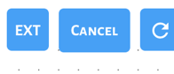 | The selection of nodes for a group can be canceled by choosing the Cancel button, which exits Grouping Mode without the creation of a new group.

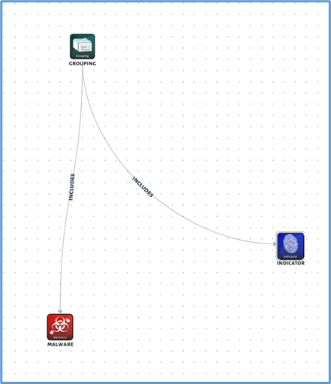
Figure 3-6 Creating a New Grouping

Relationships

Creating a Relationship
A new relationship can be created by clicking the edge of a node and dragging the relationship to the edge of a second node. In Figure 3-7, the cross-hair on the malware node shows that the source of the relationship has been selected. Figure 3-8 shows dragging the relationship to its target, the indicator node.
Figure 3-9 shows the panel that is displayed when the user drops the relationship line onto the target. The Relationship Selection panel lists possible relationship types between two nodes. Clicking a relationship in the Relationship Selection panel creates a new relationship of the specified type. The Create New Relationship button opens the New Relationship panel.
Figure 3-10 shows the established relationship.
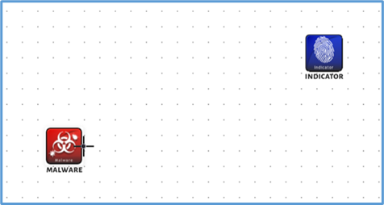
Figure 3-7 Starting the Creation of a Relationship

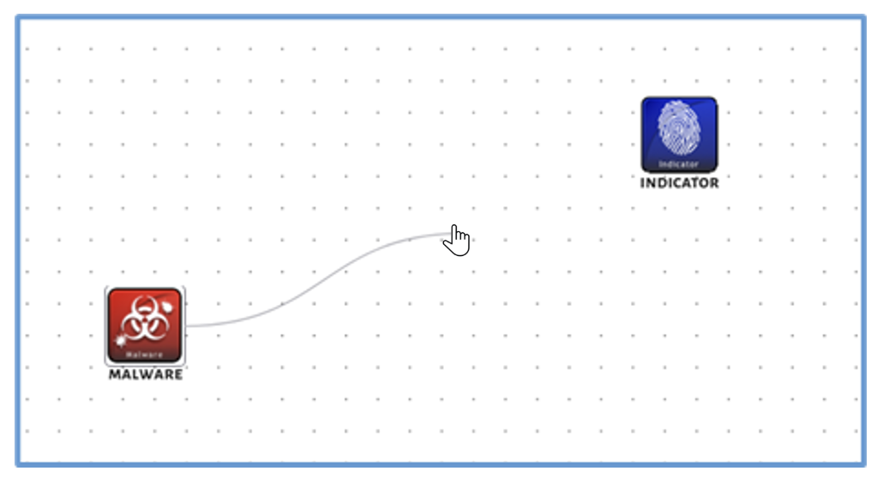
Figure 3-8 Dragging Relationship Connector to Target Node

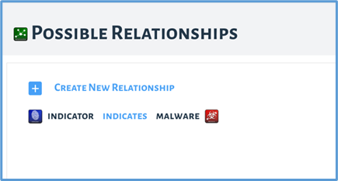
Figure 3-9 Possible Relationship Panel

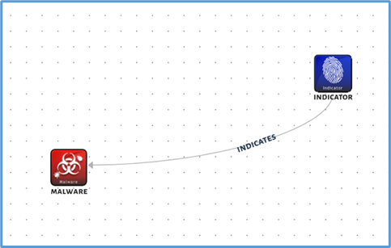
Figure 3-10 The Established Relationship

Defining a New Relationship Type
The New Relationship panel, shown in Figure 3-11, allows a new relationship type to be defined between two nodes. From the Possible Relationships panel (shown in Figure 3-9), the user can select New Relationship option at the top.
Clicking the Submit button creates an instance of the new relationship type between the specified nodes. The new relationship type is also added to the Possible Relationships list. The x-exclusive property should be True to indicate a 1:1 relationship. The default is False.
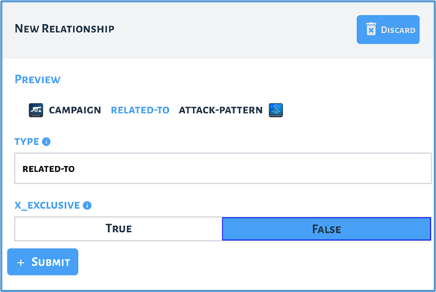
Figure 3-11 The New Relationship Panel

Editing a Relationship
Clicking on an existing relationship edge opens the Edit Relationship panel (Figure 3-12). The Edit Relationship panel allows a relationship to be modified or deleted. Clicking the Delete button deletes the relationship.
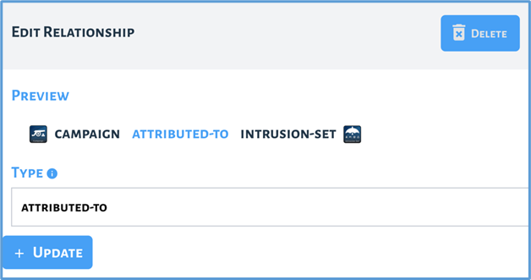
Figure 3-12 Editing a Relationship

Configuring Layout
Figure 3-13 shows an imported bundle. The nodes can be manually moved around to make the visualization easier to understand. The STIX Modeler also offers a tool for automatically rearranging it.
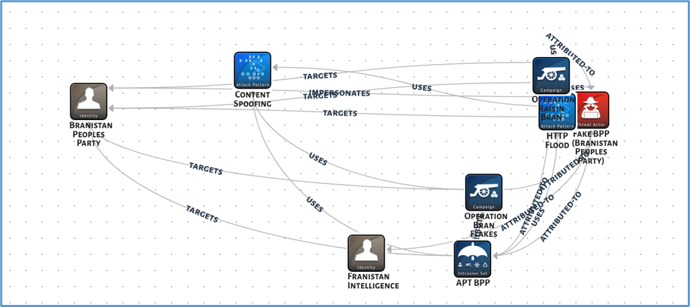
Figure 3-13 An Imported Bundle
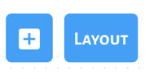 | The Layout panel enables positional arrangement of nodes in the STIX Modeler UI (Figure 3-14).
Nodes may be arranged in the following Layout Modes:
- Hierarchy, according to incoming and outgoing relationships
- Grid, according to node type
Nodes can be oriented in the following orientations:
- Row, where elements are grouped horizontally
- Column, where elements are grouped vertically (Figure 3-15)
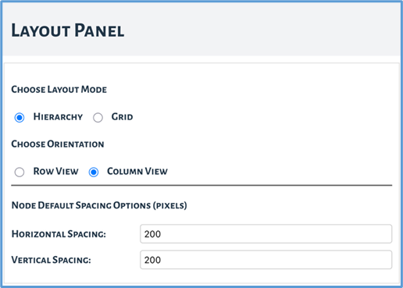
Figure 3-14 The Layout Panel

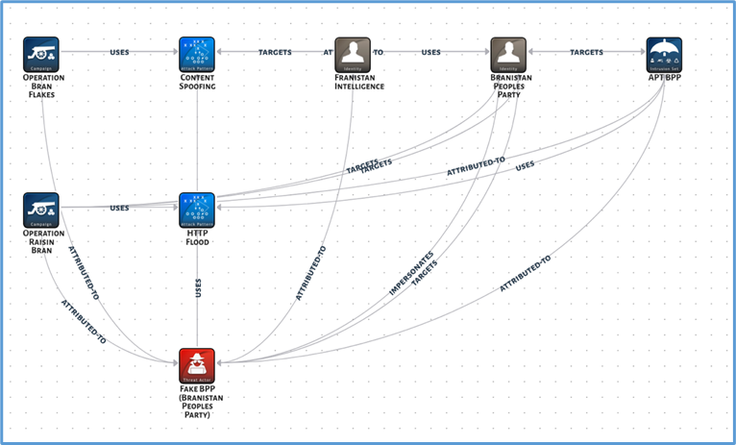
Figure 3-15 Hierarchical, Column View

STIX Bundles

Importing a Bundle Panel
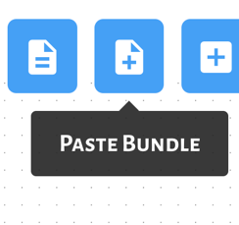 | The Paste Bundle panel allows the contents of a STIX bundle JSON file to be directly pasted and loaded into the STIX Modeler UI. Clicking the Load button causes the STIX bundle to be imported and visualized in the STIX Modeler UI. Figure 3-16 shows the bundle from Figure 2-2 pasted into the pop-up window. Figure 3-17 shows the visual depiction after pasting the bundle.
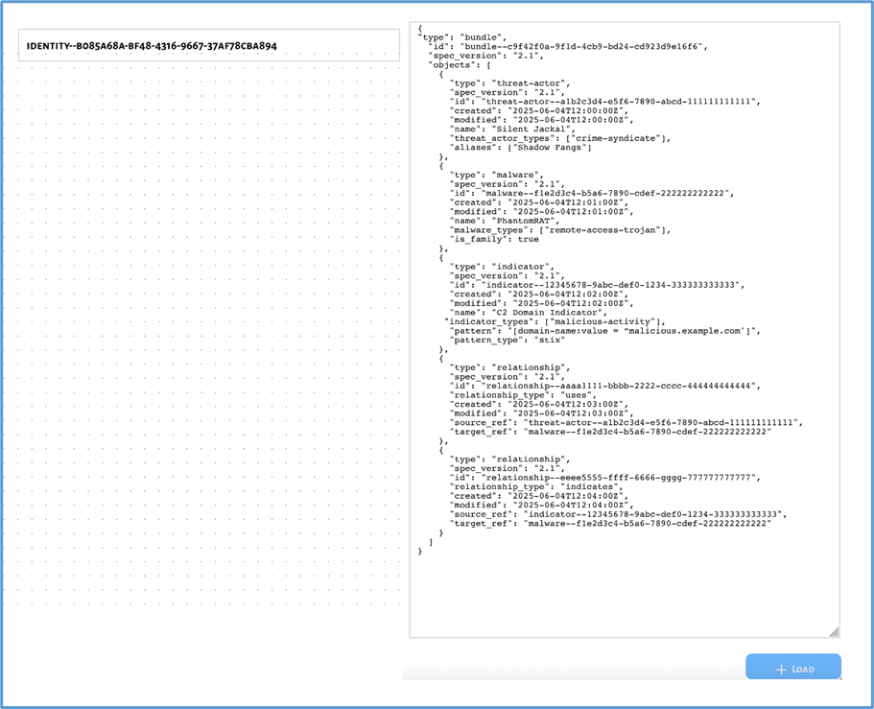
Figure 3-16 The Paste Bundle Panel

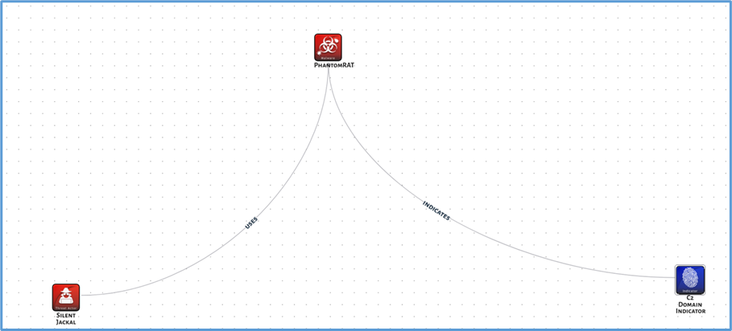
Figure 3-17 Visual Depiction After Pasting the Bundle

Viewing a STIX Bundle
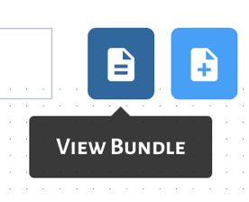 | The View Bundle panel (Figure 3-18) displays the STIX bundle JSON contents.

Clicking the Copy button copies the contents of the STIX bundle JSON representation to the system clipboard.
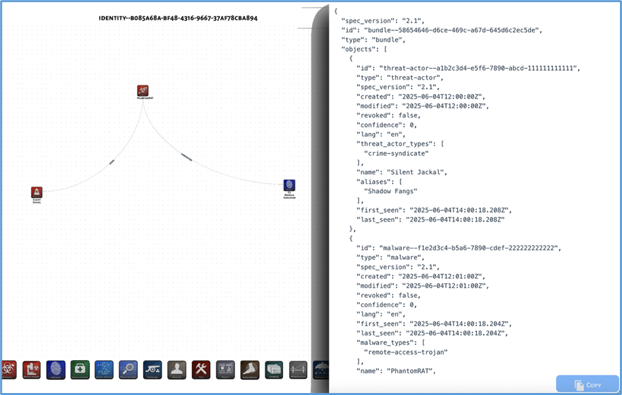
Figure 3-18 The View Bundle Panel
When the View Bundle panel is opened, the bundle is validated. If any STIX object is missing required fields, a pop-up message will be displayed in the top-left corner of the UI and a badge will appear on the Errors button, as shown in Figure 3-19.
Figure 3-19 Invalid STIX Bundle Error Message and Badge Notification

Viewing Bundle Errors
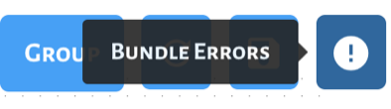 | The Errors panel enumerates nodes with missing or invalid properties, as shown in Figure 3-20. Clicking on a node listed in the Errors panel opens its associated Details panel.

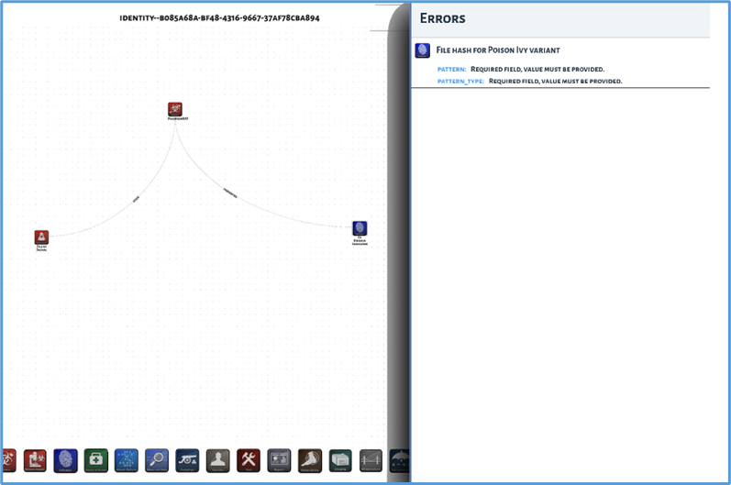
Figure 3-20 The Errors Panel

Exporting a Bundle
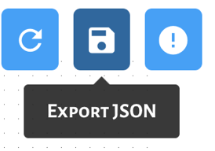 | The Export button locally downloads the STIX bundle as a JSON file. By default, the file is called bundle.json.

Resetting a Bundle
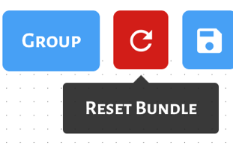 | The Reset button deletes all SDOs, SCOs, and SROs from the STIX bundle, and deletes all nodes and relationships from the STIX Modeler UI.

Resetting the bundle does not remove STIX extensions from the STIX Modeler UI. These must be removed manually via the Extension Editor panel (see section 3.6.2).

STIX Extensions

Importing an Extension Schema via Paste
The Paste Schema panel allows the contents of a STIX extension (either new-sdo or property-extension) schema JSON file to be directly pasted and loaded into the STIX Modeler UI.
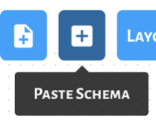 | The Paste Schema panel allows the contents of a STIX extension (either new-sdo or property-extension) schema JSON file to be directly pasted and loaded into the STIX Modeler UI, as shown in Figure 3-21.

Clicking the Load button causes the STIX extension schema to be imported to the STIX Modeler UI.

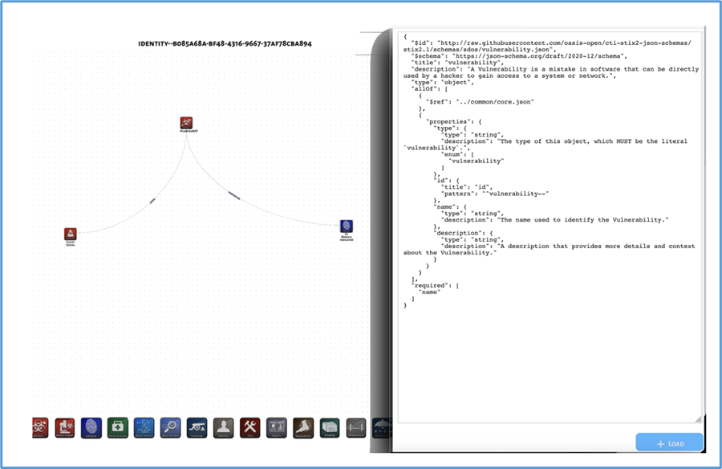
Figure 3-21 The Paste Schema Panel
Upon successfully loading a STIX new-sdo extension schema, a new icon (by default, the Custom SDO icon) will be added to the Node Creation menu, as shown in Figure 3-22.
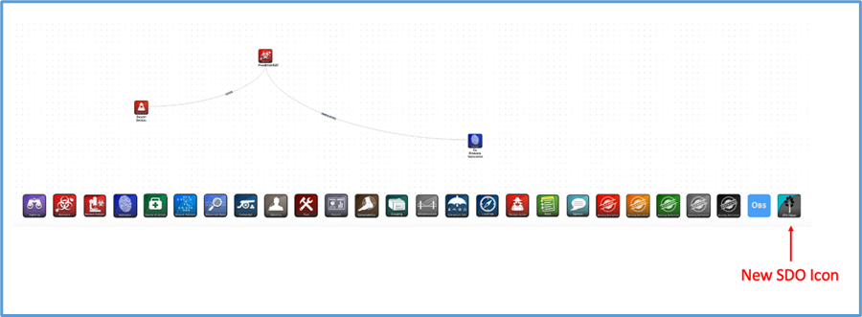
Figure 3-22 New SDO Icon in Node Creation Menu

Editing a STIX Extension
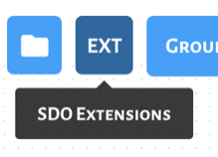 | The Extension Selection panel lists all imported STIX extensions, as shown in Figure 3-23.

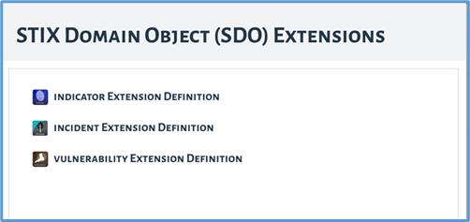
Figure 3-23 The Extension Selection Panel
Clicking on a STIX extension definition in the Extension Selection panel opens the Extension Editor panel, as shown in Figure 3-24.
The Extension Editor panel allows the fields of a STIX extension definition to be updated.
The Update Icon button allows a new icon image to be selected via a File Selector dialog box. On selection, all nodes of the extension type, as well as the associated Node Selection icon, are updated to display the new image.
The Delete button deletes the STIX extension definition, all SDOs and SCOs defined by the extension, and any properties added by the extension.
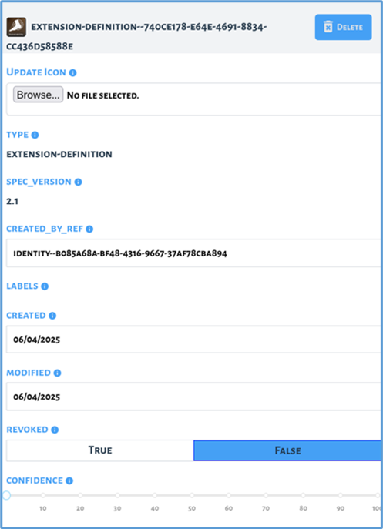
Figure 3-24 The Extension Editor Panel
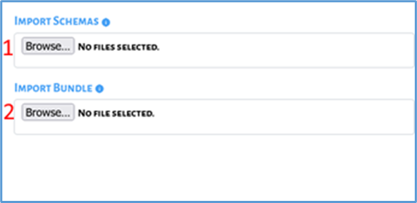
Figure 3-25 The File Import Panel

Importing a Schema or Bundle From a File
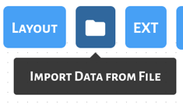 | The File Import panel enables the selection of local STIX bundle and STIX extension schema JSON files, as shown in Figure 3-25.
The Import Schemas button allows one or more local STIX extensions schema JSON files to be selected via a File Selector dialog box, and then imported into the STIX Modeler UI.
The Import Bundle button allows one local STIX bundle JSON file to be selected via a File Selector dialog box, and then imported into the STIX Modeler UI.

Conclusions
The STIX Modeler provides a tool for created structured and flexible representations of diverse forms of threat intelligence in STIX 2.1 format. By capturing technical indicators, adversary tactics, attack patterns, infrastructure details, and other contextual information, the modeler enables analysts to organize intelligence in a way that is both machine-readable and operationally useful.
The process begins with extracting key insights from threat intelligence reports, modeling them in structured objects, and building relationships that capture the full context of an adversary’s activity. These structured representations can then be combined into STIX bundles and shared with partners to promote interoperability and collective defense.
As threats grow more complex, the ability to represent and exchange threat intelligence in standardized formats is increasingly essential. Leveraging STIX 2.1, integrating with TAXII for automated exchange, and using tools such as the STIX Modeler empower organizations to improve detection, response, and collaboration across the cybersecurity community. This guide serves as a foundation for advancing structured intelligence practices and strengthening defenses against evolving threats.

References
- Meta Platforms, Inc., React.dev, web development page. Available at https://react.dev/. Accessed August 14, 2025.
- OASIS, “STIX™ Version 2.1, Committee Specification Draft 01 / Public Review Draft 01,” 26 July 2019. Available at https://docs.oasis-open.org/cti/stix/v2.1/csprd01/stix-v2.1-csprd01.html. Accessed 14 August 2025.
- The MITRE Corporation, MITRE ATT&CK® [Adversarial Tactics, Techniques, and Common Knowledge], ATT&CK Matrix. Available at https://attack.mitre.org/. Accessed 14 August 2025.
- Cybersecurity and Infrastructure Security Agency (CISA), “Traffic Light Protocol User Guide 2.0,” 2022. Available at https://www.cisa.gov/sites/default/files/2023-02/tlp-2-0-user-guide_508c.pdf. Accessed 12 August 2025.
- B. Schneier, “Who Are the Shadow Brokers?” The Atlantic, 23 May 2017. Available at https://www.theatlantic.com/technology/archive/2017/05/shadow-brokers/527778. Accessed 14 August 2025.
- The Johns Hopkins University Applied Physics Laboratory (JHU/APL), “ASPR Cyber Capabilities Evaluation and Strategic Support (ACCESS): Cybersecurity Incident Severity Level Scoring Methodology,” AOS-24-0366, June 2024.
- U.S. Department of Justice Archives, “Justice Department Sues to Block UnitedHealth Group’s Acquisition of Change Healthcare,” 24 February 2022. Available at https://www.justice.gov/archives/opa/pr/justice-department-sues-block-unitedhealth-group-s-acquisition-change-healthcare. Accessed 14 August 2025.
- American Hospital Association, letter to the Chairman and Ranking Member of the U.S. House Committee on Ways and Means, 19 March 2024. Available at https://www.aha.org/system/files/media/file/2024/03/Congress-Urged-to-Help-Hospitals-Impacted-by-Change-Healthcare-Cyberattack-letter-20240320.pdf. Accessed 14 August 2025.
- HHS Announces Next Steps in Ongoing Wfork to Enhance Cybersecurity for Health Care and Public Health Sectors | SDAHO
- S. Alder, “Healthcare Data Breach Statistics,” The HIPAA Journal, 15 July 2025. Available at https://www.hipaajournal.com/healthcare-data-breach-statistics. Accessed August 14 2025.

Getting Started with the STIX Modeler
This appendix provides a step-by-step walkthrough for setting up the STIX Modeler and using it with Indicators of Behavior (IOB) extensions.
The IOB project was selected as the example because it relies heavily on custom STIX extensions. Unlike core STIX objects (such as Indicators or Observed Data), IOB introduces new object types to represent adversary behaviors, detections, detectors, and playbooks. This makes IOB an ideal learning case: by working through it, one will not only set up the Modeler but also gain hands-on experience with importing and using extensions — a process that applies to many other extension-based projects.
By the end of this guide, you will have the tool running locally and be able to load and visualize these IOB extensions to capture adversary workflows.

Basic Installation
Before beginning, follow these steps:
- Install STIX Modeler: Follow the installation instructions available at the GitHub repository.
- Prepare Prerequisites:
    - Install Node.js (version 23.7)
    - Install Node Package Manager (npm) (version 10.9.2) for local deployment.
- Load the Tool: Run the application and access the graphical user interface through your browser (e.g., http://localhost:5173/)

Importing Extensions
The IOB framework demonstrates how STIX extensions can be used to extend the language beyond its core specification. Because IOB depends entirely on extensions to model behaviors and their relationships, it provides a clear and practical example of the import process.
To load the IOB extensions into the STIX Modeler:
- Download Extension Files: Obtain the necessary extensions from the Open Cybersecurity Alliance (OCA) GitHub repository. Required extensions include the following:
- x-oca-behavior
- x-oca-detection
- x-oca-detector
- x-oca-playbook
- x-oca-coa-playbook-ext
- Import Extensions: Use the Import Schema feature in STIX Modeler to add these extensions.
- Select the EXT button: Select one or more extensions, as shown in Figure A-1.
- Customize Icons: Assign custom PNG icons to differentiate imported objects for better visualization. To assign a custom icon, select the extension from the screen shown in Figure A-1, then choose an icon file (such as a PNG image) in the screen shown in Figure A-2
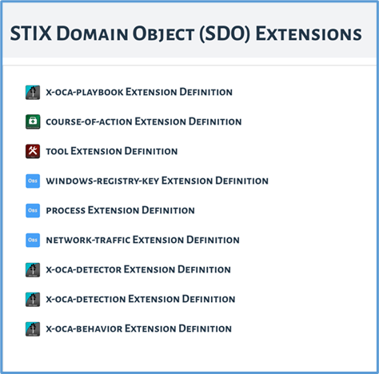
Figure A-1 STIX SDO Extensions

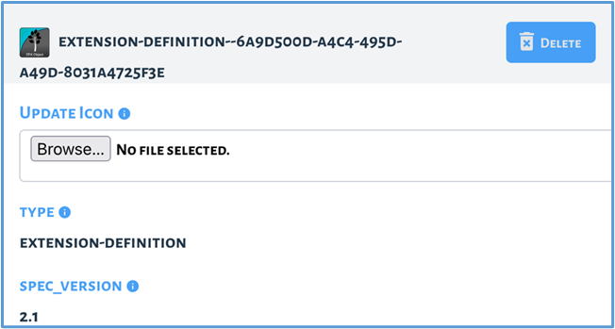
Figure A-2 Assigning Custom Icons for Extension
If you can successfully import the IOB extensions, you can apply the same process to any other STIX extension-based project. IOB is simply the teaching example here, but the workflow you just practiced is the general recipe for extending the Modeler with new schemas.

STIX Object Fields

Required Fields for All Objects
This section describes the fields for each type of object; bolded field names are required. Appendix B.1 shows the fields that are required for all objects. A STIX open vocabulary describes STIX objects using a predefined, non-exhaustive list of common and industry-accepted terminology.
Field | Description | Auto Filled | Default | Editable
type | The type of this object | Y |  | N
spec_version | The version of the STIX specification used to represent this object | Y | 2.1 | N
created_by_ref | The ID of the source object that describes who created this object | Y |  | Y
labels | Specifies a set of terms used to describe this object | N |  | Y
created | Date created | Y |  | Y
modified | Date last modified | Y |  | Y
revoked | Whether this object has been revoked | Y | False | Y
confidence | The confidence the creator has in the correctness of their data | N | 0 | Y
external_refs | A list of external references which refers to non-STIX information | N |  | Y

Attack Pattern
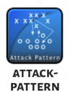
Attack Patterns are a type of TTP (i.e., Tactics, Techniques, and Procedures) that describe ways that adversaries attempt to compromise targets.
Field | Description | Field Type
All fields from B.1
aliases | Alternative names used to identify this Attack Pattern | Text entry
name | The name used to identify the Attack Pattern | Text entry
description | A description that provides more details and context about the Attack Pattern, potentially including its purpose and its key characteristics | Text entry
kill_chain_phases | The list of kill chain phases for which this Attack Pattern instance is used | Choose from list

Campaign

A Campaign is a grouping of adversary behavior that describes a set of malicious activities or attacks that occur over a period of time against a specific set of targets.
Field | Description | Field Type
All fields from B.1
name | The name used to identify the Campaign | Text entry
description | A description that provides more details and context about the Campaign, potentially including its purpose and its key characteristics | Text Entry
aliases | Alternative names used to identify this Campaign | Text entry
first_seen | The time that this Campaign instance was first seen | Date entry
last_seen | The time that this Campaign instance was last seen | Date entry
objective | The Campaign’s primary goal, objective, desired outcome, or intended effect | Text entry

Course of Action

A Course of Action (COA) is an action taken either to prevent an attack or to respond to an attack that is in progress.
Field | Description | Field Type
All fields from B.1
name | The name used to identify the Course of Action | Text entry
description | A description that provides more details and context about this object, potentially including its purpose and its key characteristic | Text Entry

Grouping
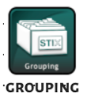
A Grouping object explicitly asserts that the referenced STIX objects have a shared content.
Field | Description | Field Type
All fields from B.1
name | The name used to identify the Grouping | Text entry
description | A description that provides more details and context about the Grouping, potentially including the purpose and key characteristics | Text entry
context | A short description of the particular context shared by the content referenced by the Grouping | Text entry

Identity
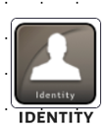
Identities can represent actual individuals, organizations, or groups (e.g., ACME, Inc.) as well as classes of individuals, organizations, or groups.
Field | Description | Field Type
All fields from B.1
roles | The list of roles that this Identity performs (e.g., CEO, Domain Administrators, Doctors, Hospital, or Retailer)  No open Vocabulary is yet defined for this property. | Text entry
name | The name of this Identity | Text entry
description | A description that provides more details and context about the Identity | Text entry
identity_class | The type of entity that this Identity describes, e.g., an individual or organization  Open Vocab - identity-class-ov | Choose from list
sectors | The list of sectors that this Identity belongs to  Open Vocab - industry-sector-ov | Choose from list
contact_info | The contact information (e-mail, phone number, etc.) for this Identity | Text entry

Indicator

Indicators contain a pattern that can be used to detect suspicious or malicious cyber activity.
Field | Description | Field Type
All fields from B.1
indicator_type | This field specifies the type of indicator.  Open Vocab - indicator-type-ov | Choose from list
name | The name used to identify the identity | Text entry
description | A description that provides the recipient with context about this Indicator, potentially including its purpose and its key characteristics | Text entry
pattern | The detection pattern for this indicator | Text entry
pattern_type | The type of pattern used in this indicator | Choose from list
pattern_version | The version of the pattern that is used | Text entry
valid_from | The time from which this indicator should be considered valuable intelligence | Date entry
valid_until | The time at which this indicator should no longer be considered valuable intelligence | Date entry
kill_chain_phases | The phases of the kill chain that this indicator detects | Choose from list

Infrastructure

Infrastructure objects describe systems, software services, and associated physical or virtual resources.
Field | Description | Field Type
All fields from B.1
name | The name used to identify the Infrastructure | Text entry
description | A description that provides more details and context about this Infrastructure, potentially including its purpose and its key characteristics | Text entry
infrastructure_types | This field specifies the type of infrastructure.  Open Vocab - infrastructure-type-ov | Choose from list
aliases | Alternative names used to identify this Infrastructure | Text entry
kill_chain_phases | The list of kill chain phases for which this infrastructure is used | Choose from list
first_seen | The time that this infrastructure was first seen performing malicious activities | Date entry
last_seen | The time that this infrastructure was last seen performing malicious activities | Date entry

Intrusion Set
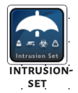
An Intrusion Set is a grouped set of adversary behavior and resources with common properties that is believed to be orchestrated by a single organization.
Field | Description | Field Type
All fields from B.1
name | The name used to identify the Intrusion Set | Text entry
description | Provides more context and details about the Intrusion Set object | Text entry
aliases | Alternative names used to identify this Intrusion Set | Text entry
first_seen | The time that this Intrusion Set was first seen | Date entry
last_seen | The time that this Intrusion Set was last seen | Date entry
goals | The high-level goals of this Intrusion Set | Text entry
resource_level | This defines the organizational level at which this Intrusion Set typically works.  Open Vocab - attack-resource-level-ov | Choose from list
primary_motivation | The primary reason, motivation, or purpose behind this Intrusion Set  Open Vocab - attack-motivation-ov | Choose from list
secondary_motivations | The secondary reasons, motivations, or purposes behind this Intrusion Set  Open Vocab - attack-motivation-ov | Choose from list

Location

A Location represents a geographic location. The location may be described as any, some, or all of the following: region (e.g., North America), civic address (e.g., New York, U.S.), latitude, and longitude.
Field | Description | Field Type
All fields from B.1
name | The name used to identify the Location | Text entry
description | A textual description of the Location | Text entry
latitude | The latitude of the location in decimal degrees | Text entry
longitude | The longitude of the location in decimal degrees | Text entry
precision | Defines the precision of the coordinates specified by the latitude and longitude properties, measured in meters | Text Entry
region | The region that this Location describes | Text Entry
country | The country that this Location describes | Text Entry
administrative_area | The state, province, or other sub-national administrative area that this Location describes | Text Entry
city | The city that this Location describes | Text Entry
street_address | The street address that this Location describes | Text Entry
postal_code | The postal code for this Location | Text Entry

Malware

Malware is a type of TTP that is also known as malicious code and malicious software and refers to a program that is inserted into a system, usually covertly, with the intent of compromising the confidentiality, integrity, or availability of the victim’s data, applications, or operating system, or of otherwise annoying or disrupting the victim.
Field | Description | Field Type
All fields from B.1
aliases | Alternative names used to identify this malware or malware family | Text entry
first_seen | The time that the malware instance or family was first seen | Date entry
last_seen | The time that the malware instance or family was last seen | Date entry
architecture_execution_envs | The processor architectures (e.g., x86 ARM etc.) that the malware instance or family is executable on  Open - processor-architecture-os | Choose from list
implementation_languages | The programming language(s) used to implement the malware instance or family Open Vocab - implementation-language-ov | Choose from list
capabilities | Specifies any capabilities identified for the malware instance or family  Open Vocab - malware-capabilities-ov | Choose from list
malware_types | The type of malware being described  Open Vocab - malware-type-ov | Choose from list
name | The name used to identify the malware | Text entry
description | Provides more context and details about the malware object | Text entry
kill_chain_phases | The list of kill chain phases for which this malware instance can be used | Choose from list

Malware Analysis

Malware Analysis captures the metadata and results of a particular analysis performed (static or dynamic) on the malware instance or family.
Field | Description | Field Type
All fields from B.1
product | The name of the analysis engine or product that was used for this analysis | Text entry
version | The version of the analysis product that was used to perform this analysis | Text entry
configuration_version | The version of the analysis product configuration that was used to perform this analysis | Text entry
modules | The particular analysis product modules that were used to perform the analysis | Text entry
analysis_engine_version | The version of the analysis engine or product that was used to perform this analysis | Text entry
analysis_definition_version | The version of the analysis definitions used by the analysis tool | Text entry
submitted | The date and time that this malware was first submitted for scanning or analysis | Date entry
analysis_started | The date and time that the malware analysis was initiated | Date entry
analysis_ended | The date and time that the malware analysis ended | Date entry
result_name | The classification result or name assigned to the malware instance by the scanner tool | Text entry
result | The classification result, as determined by the scanner or tool analysis process | Text entry

Note

A Note is a comment or note containing informative text to help explain the context of one or more STIX Objects (SDOs or SROs) or to provide additional analysis that is not contained in the original object.
Field | Description | Field Type
All fields from B.1
abstract | A brief summary of the note | Text entry
content | The content of the note | Text entry
authors | The name of the author(s) of this note (e.g., the analyst(s) that created it) | Text entry

Observed Data
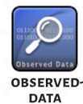
Observed data conveys information that was observed on systems and networks, such as log data or network traffic, using the Cyber Observable specification.
Field | Description | Field Type
All fields from B.1
first_observed | The beginning of the time window during which the data was observed | Date entry
last_observed | The end of the time window during which the data was observed | Date entry
number_observed | The number of times the data was observed  This MUST be an integer between 1 and 999,999,999 inclusive. | Slider

Opinion

An Opinion is an assessment of the correctness of the information in a STIX Object produced by a different entity and captures the level of agreement or disagreement using a fixed scale.
Field | Description | Field Type
All fields from B.1
explanation | An explanation of why the producer has this Opinion | Text entry
authors | The name of the author(s) of this opinion (e.g., the analyst(s) that created it) | Text entry
opinion | The opinion that the producer has about all of the STIX Object(s) listed in the object_refs property | Text entry

Report

Reports are collections of threat intelligence focused on one or more topics, such as a description of a threat actor, malware, or attack technique, including context and related details.
Field | Description | Field Type
All fields from B.1
report_types | This field specifies the primary subject of this report.  The suggested values for this field are in:  Open Vocab report-type-ov | Choose from list
name | The name used to identify the report | Text entry
description | A description that provides more details and context about this report | Text entry
published | The date that this report object was officially published by the creator of this report | Date entry

Sighting

A Sighting denotes the belief that something in CTI (an indicator, malware, tool, threat actor, etc.) was seen.
Field | Description | Field Type
All fields from B.1
description | A description that provides more details and context about the sighting | Text entry
first_seen | The beginning of the time window during which the SDO referenced by the sighting_of_ref property was sighted | Date entry
last_seen | The end of the time window during which the SDO referenced by the sighting_of_ref property was sighted | Date entry
count | This is an integer between 0 and 999,999,999 inclusive and represents the number of times the object was sighted | Slider

Threat Actor
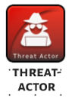
Threat Actors are actual individuals, groups, or organizations believed to be operating with malicious intent.
Field | Description | Field Type
All fields from B.1
threat_actor_types | This field specifies the type of threat actor.  Open Vocab - threat-actor-type-ov | Choose from list
name | A name used to identify this threat actor or threat actor group | Text entry
description | A description that provides more details and context about the threat actor | Text entry
aliases | A list of other names that this threat actor is believed to use | Text entry
roles | This is a list of roles the threat actor plays.  Open Vocab - threat-actor-role-ov | Choose from list
goals | The high-level goals of this threat actor— what are they trying to accomplish | Text entry
first_seen | The time that this threat actor was first seen | Date entry
last_seen | The time that this threat actor was last seen | Date entry
sophistication | The skill, specific knowledge, special training, or expertise a threat actor must have to perform the attack  Open Vocab - threat-actor-sophistication-ov | Choose from list
resource_level | This defines the organizational level at which this threat actor typically works.  Open Vocab - attack-resource-level-ov | Choose from list
primary_motivation | The primary reason, motivation, or purpose behind this threat actor  Open Vocab - attack-motivation-ov | Choose from list
secondary_motivations | The secondary reasons, motivations, or purposes behind this threat actor  Open Vocab - attack-motivation-ov | Choose from list
personal_motivations | The personal reasons, motivations, or purposes of the threat actor regardless of organizational goals.  Open Vocab - attack-motivation-ov | Choose from list

Tool
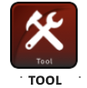
Tools are legitimate software that can be used by threat actors to perform attacks.
Field | Description | Field Type
All fields from B.1
aliases | Alternative names used to identify this tool | Text entry
tool_types | The kind(s) of tool(s) being described  Open Vocab - tool-type-ov | Text entry
name | The name used to identify the tool | Text entry
description | Provides more context and details about the tool object | Text entry
tool_version | The version identifier associated with the tool | Text entry
kill_chain_phases | The list of kill chain phases for which this tool instance can be used | Choose from list

Vulnerability
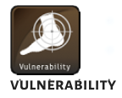
A Vulnerability is a mistake in software that can be directly used by a hacker to gain access to a system or network.
Field | Description | Field Type
All fields from B.1
name | The name used to identify the vulnerability | Text entry
description | A description that provides more details and context about the vulnerability | Text entry

Abbreviations and Acronyms
ATT&CK® Adversarial Tactics, Techniques, and Common Knowledge
C2 Command and Control
CEO Chief Executive Officer
CISA Cybersecurity and Infrastructure Security Agency
COA Course of Action
CTI Cyber Threat Intelligence
DHS Department of Homeland Security
IOB Indicator of Behavior
IOC Indicators of Compromise
IP Internet Protocol
ISAC Information Sharing and Analysis Centers
JHU/APL The Johns Hopkins University Applied Physics Laboratory
JSON JavaScript Object Notation
NPM Node Package Manager
OCA Open Cybersecurity Alliance
PNG Portable Network Graphic
SCO STIX Cybersecurity Observable Object
SDO STIX Domain Object
SMO STIX Meta Object
SRO STIX Relationship Object
STIX Structured Threat Information eXpression
TAXII Trusted Automated eXchange of Intelligence Information
TLP Traffic Light Protocol
TTP Tactics, Techniques, and Procedures
UI User Interface
UUID Universally Unique Identifier

“tlp” refers to “Traffic Light Protocol,” which “is a system of markings that designates the extent to which recipients may share potentially sensitive information,” and is used by the Cybersecurity and Infrastructure Security Agency (CISA)
https://docs.oasis-open.org/cti/stix/v2.1/csprd01/stix-v2.1-csprd01.html

