
JOMO KENYATTA UNIVERSITY OF AGRICULTURE AND TECHNOLOGY
Directorate of Linkages (RPE)
Linkages Agreement Lifecycle and Performance Management System
Complete Requirements, Website Wireframes and Figma-Ready Developer Handoff
For MoU / CRA / CA processing, approval, signing, monitoring, evaluation and executive reporting

Prepared for | Directorate of Linkages, JKUAT
Prepared by | JHUB Africa
Version | 2.0 - revised with Champion, Legal workspace, DVC RPE gate, M&E alert, chatbot and scoring requirements
Date | 21 July 2026
Document purpose | Implementation-grade product requirements and UX design blueprint for developers.

Design language: JKUAT institutional green/blue palette, secure portal style, role-based workspaces, responsive desktop/tablet/mobile UI.

Document Control and Reading Guide
Item | Specification
Primary users | Champions, Linkages Directorate, Legal Office, DVC RPE, VC Office, partner liaisons, executives and system administrators.
Core agreement types | MoU / CRA / CA, implemented as configurable agreement types so official labels and future types can be added.
Design artefacts included | Solution context, sitemap, workflow swimlane, lifecycle state machine, technical architecture, ERD, score model and 17 Figma-style wireframes.
Developer intent | This document can be used for product backlog creation, UI implementation, database design, workflow configuration, testing and acceptance.
Source basis | Directorate memo dated 9 July 2026 requesting an MoU/CRA/CA management dashboard and specifying executive KPI, lifecycle, M&E and automation needs.

Contents
- 1. Executive summary and product scope
- 2. Feedback incorporated and business rules
- 3. User roles, permissions and workspaces
- 4. End-to-end agreement lifecycle workflow
- 5. Website information architecture and JKUAT fit
- 6. Figma-ready design system and component library
- 7. Website wireframe catalogue
- 8. Target technical architecture and data model
- 9. Functional requirements catalogue
- 10. Non-functional requirements, security and auditability
- 11. Acceptance criteria and implementation roadmap
- Appendices: template categories, scoring configuration and chatbot scope

1. Executive Summary and Product Scope
The Linkages Agreement Lifecycle and Performance Management System is specified as a secure, role-based website application embedded into the JKUAT digital experience. It manages the complete lifecycle of MoU / CRA / CA collaborations from partner inquiry or Champion initiation through template selection, drafting, Legal Office review, DVC RPE sign-off, VC submission, signature tracking, active agreement monitoring, six-month M&E reporting and renewal decision-making.
The design moves beyond a dashboard into a full agreement lifecycle platform. It creates a single source of truth for draft versions, legal feedback, approvals, signed agreements, performance reports, collaboration scores, alerts and executive metrics.

1.1 In-scope Product Modules
Module | Core purpose | Primary roles
Public Linkages Portal | Explains the system, allows collaboration inquiry, provides help and directs users into secure login. | Partners, public users, Champions
Champion Workspace | Allows JKUAT or partner-originated collaboration Champions to initiate, track, respond and report. | JKUAT Champion, Partner Champion/Liaison
Partner Request Logging | Allows Linkages to log requests from external organizations and route them to a JKUAT Champion. | Linkages Directorate
Template Library | Provides editable agreement templates by partner category and agreement type. | Linkages, Admin, Champion
Draft and Legal Workspace | Manages draft files, feedback threads, Legal Office review and approval. | Legal Office, Champion, Linkages
Approval Gate | Controls Legal approval, DVC RPE sign-off and VC submission completeness. | Legal, DVC RPE, Linkages, VC Office
Agreement Repository | Stores drafts, signed files, evidence, audit history and searchable records. | Authorized institutional users
M&E and Reporting | Collects six-month Champion reports and deliverable actuals from active collaborations. | Champion, Linkages
Scorecard and Analytics | Evaluates collaboration value using configurable metrics from Champion input, Linkages input and system signals. | Linkages, Executives, Admin
Alerts and Chatbot | Sends alerts and provides system Q&A/help. | All users

1.2 Success Definition
- Every collaboration request has a clear Champion, stage, owner, document version, legal status and next action.
- Partner-originated requests are captured by Linkages and routed to an internal JKUAT Champion before drafting begins.
- Legal feedback and draft versions are visible to the Champion and Linkages, while legal approval remains controlled by Legal Office.
- VC submission is technically blocked until Legal approval has been recorded and DVC RPE has signed/endorsed the package.
- Active agreements automatically generate six-month reporting alerts to Champions and feed M&E metrics, scorecards and executive dashboards.
- Leadership can view active partnerships, pipeline volume, at-risk/dormant agreements and estimated financial/resource value at any time.

2. Feedback Incorporated and Business Rules
The table below translates the latest stakeholder feedback into explicit, testable product rules. These should be treated as mandatory unless revised by the Directorate of Linkages during formal validation.
Rule ID | Area | Mandatory requirement
BR-001 | Champion terminology | The person who initiates or owns a collaboration shall be called a Champion. The system shall distinguish between internal JKUAT Champion and partner-side Champion/Liaison where applicable.
BR-002 | Partner-originated requests | When a partner organization approaches JKUAT for collaboration, Linkages shall log the request and route it to an internal JKUAT Champion who takes ownership of pushing the agreement. Drafting cannot proceed until this internal Champion is assigned.
BR-003 | Configurable templates | The system shall support multiple templates by partner type, including University, country government, county government, manufacturing industry and other categories that administrators can add later.
BR-004 | Legal workspace | Legal Office shall have its own workspace to review drafts, give feedback, approve or return, and maintain a visible feedback thread for Linkages and the Champion.
BR-005 | Draft retention | All drafts shall be retained in the system with version number, author, timestamp, related comments and status. Approved versions must be locked for downstream approval.
BR-006 | VC submission gate | Linkages submission to the VC shall only be marked complete after Legal Office approval and DVC RPE sign-off/endorsement. The system shall block release of the VC package until both conditions pass.
BR-007 | Six-month M&E alert | Once a collaboration agreement is signed and activated, the Champion shall receive an alert every six months to report activities arising from the collaboration and submit them to Linkages.
BR-008 | Chatbot support | A chatbot shall provide Q&A about the system, roles, workflow, statuses, reporting and help. It shall not give legal advice or expose unauthorized agreement records.
BR-009 | Adjustable scoring metric | The system shall include an adjustable metric for evaluating each collaboration agreement using Champion input, Linkages input and automated signals such as timeliness, dormancy and expiry risk.
BR-010 | JKUAT website fit | The user interface shall visually fit the JKUAT website experience using institutional branding, secure portal-style navigation and responsive web design.

2.1 Source-Derived Baseline Requirements
The original Directorate request identifies the need for an MoU/CRA/CA management dashboard to enhance turnaround time. The attached capabilities specify an executive KPI summary, lifecycle tracker, M&E accountability metrics, deliverable checklists, automated expiry/dormancy alerts, researcher submission, editable sample MoU/CRA/CA templates and researcher progress tracking. This document preserves those requirements and extends them into a complete implementation design.

3. User Roles, Permissions and Workspaces
Role | Core responsibilities | Key permissions
Public Visitor / Partner Prospect | Learn about collaboration process, ask system Q&A, submit or trigger an inquiry if public initiation is enabled. | Read public pages; chatbot Q&A; create inquiry only if permitted.
Partner Champion / Partner Liaison | External partner-side contact responsible for collaboration coordination. | View partner-permitted records, respond to requests, provide documents where partner portal is enabled.
JKUAT Champion | Internal university owner responsible for initiating or pushing agreement and reporting activities after signing. | Create requests, update drafts, view legal feedback, respond to actions, submit six-month M&E reports, view scorecard.
Linkages Officer | Operational manager for intake, routing, template support, monitoring and follow-up. | Log partner requests, assign Champion, route drafts, prepare VC package, validate M&E, run reports.
Director Linkages | Strategic owner of process and executive reports. | Portfolio dashboards, escalations, approvals configured for Linkages, reporting, override only as governed.
Legal Office Reviewer | Reviews draft agreements, provides comments, approves or returns drafts. | Legal workspace access, feedback authoring, approve/return, lock legal-approved version.
DVC RPE | Endorses/signs after legal approval before VC submission. | DVC queue, review package, sign/endorse or return with remarks.
VC Office | Receives complete package and tracks signature status. | View approved package, update VC signature milestones, schedule signing.
Executive Viewer | Views institutional partnership health and performance. | Read KPI dashboards, scorecards and reports; no editing of operational records.
System Administrator | Configures users, templates, categories, scoring, alerts and chatbot FAQ. | Manage configuration with audit trail; no silent alteration of signed records.

3.1 Permission Principles
- Least privilege: users only see and act on records relevant to their role, office and assigned responsibilities.
- Shared visibility: Champion and Linkages can view Legal Office feedback so they can act on it; legal approval authority remains with Legal Office.
- Gate integrity: no user can bypass Legal approval or DVC RPE sign-off to create a complete VC submission package.
- Auditability: every status change, draft upload, approval, score update and configuration change must be logged.
- Separation of duties: admins can configure templates and weights but cannot forge business approvals or modify signed agreement records without governed correction workflow.

4. Master Design Diagrams
The following figures provide the implementation blueprint. They are intentionally produced as Figma-style frames so developers can translate them into a Figma board, product backlog, database schema and frontend components.
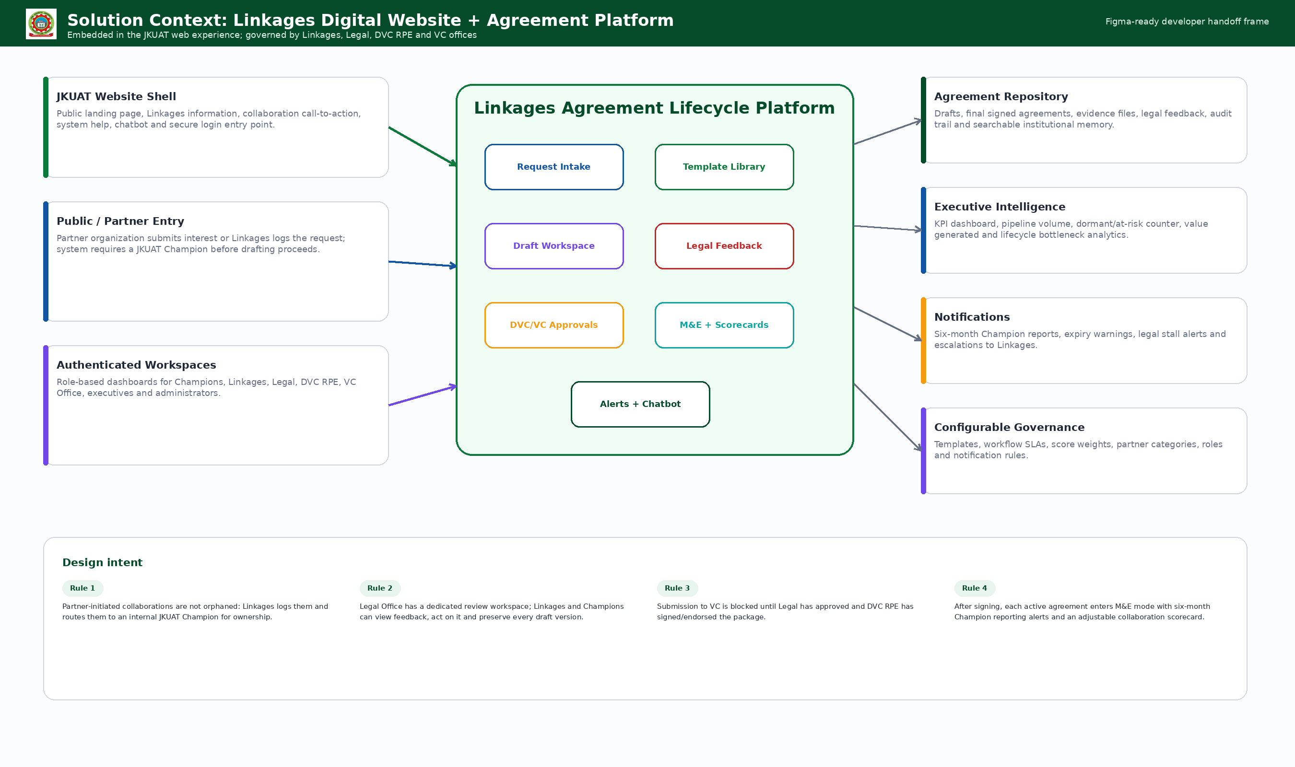
Figure 1. Solution context showing how the Linkages platform fits into JKUAT website, public entry, authenticated workspaces and governance modules.

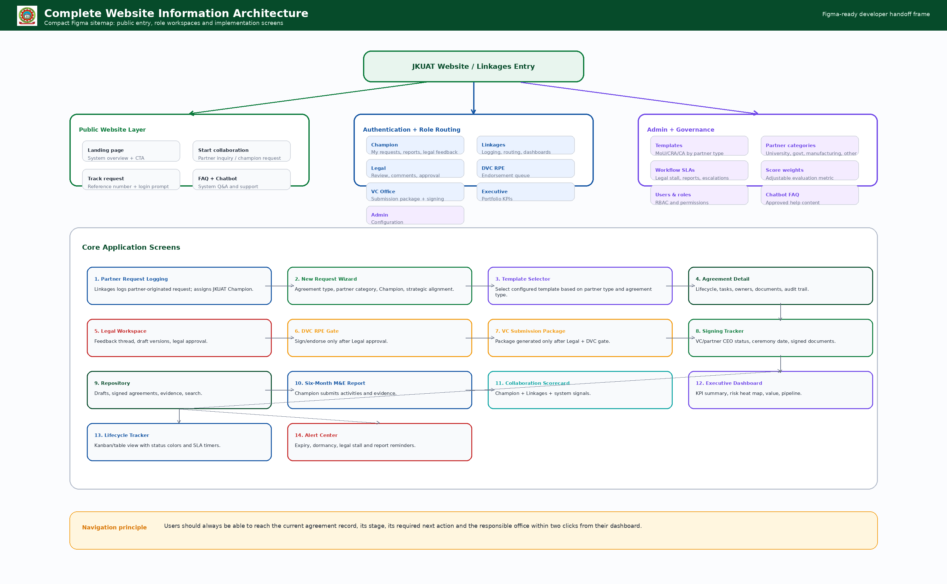
Figure 2. Complete website information architecture covering public pages, role workspaces and core application screens.

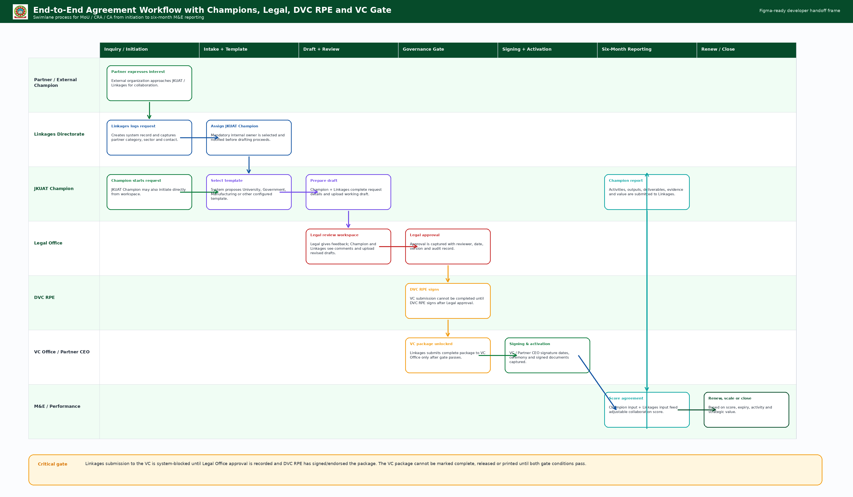
Figure 3. End-to-end swimlane workflow with Champion, Linkages, Legal, DVC RPE, VC Office, partner signing and M&E reporting.

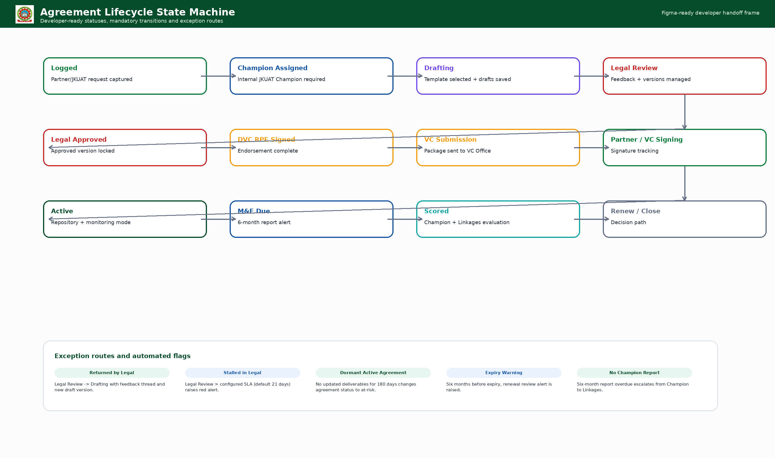
Figure 4. Agreement lifecycle state machine with standard transitions and exception routes.

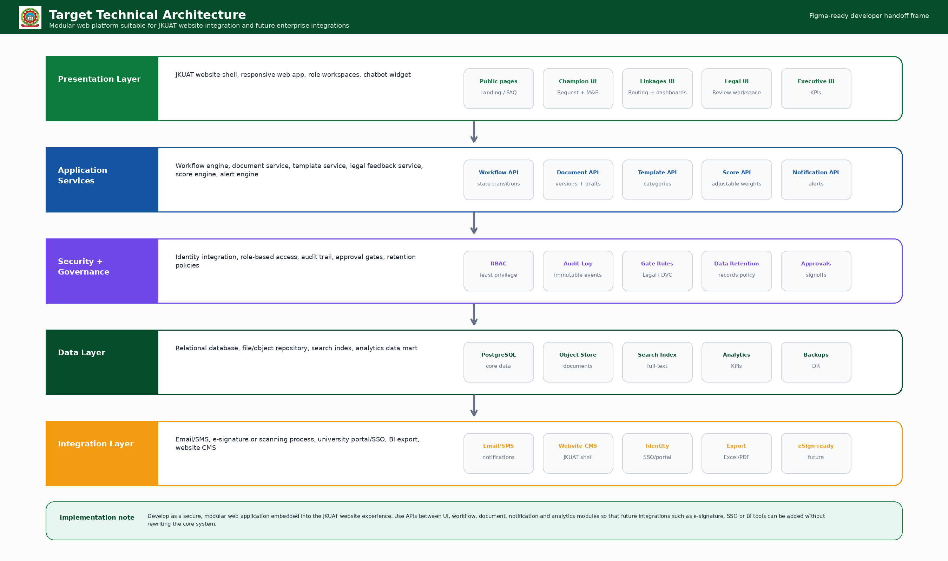
Figure 5. Target technical architecture with presentation, service, governance, data and integration layers.

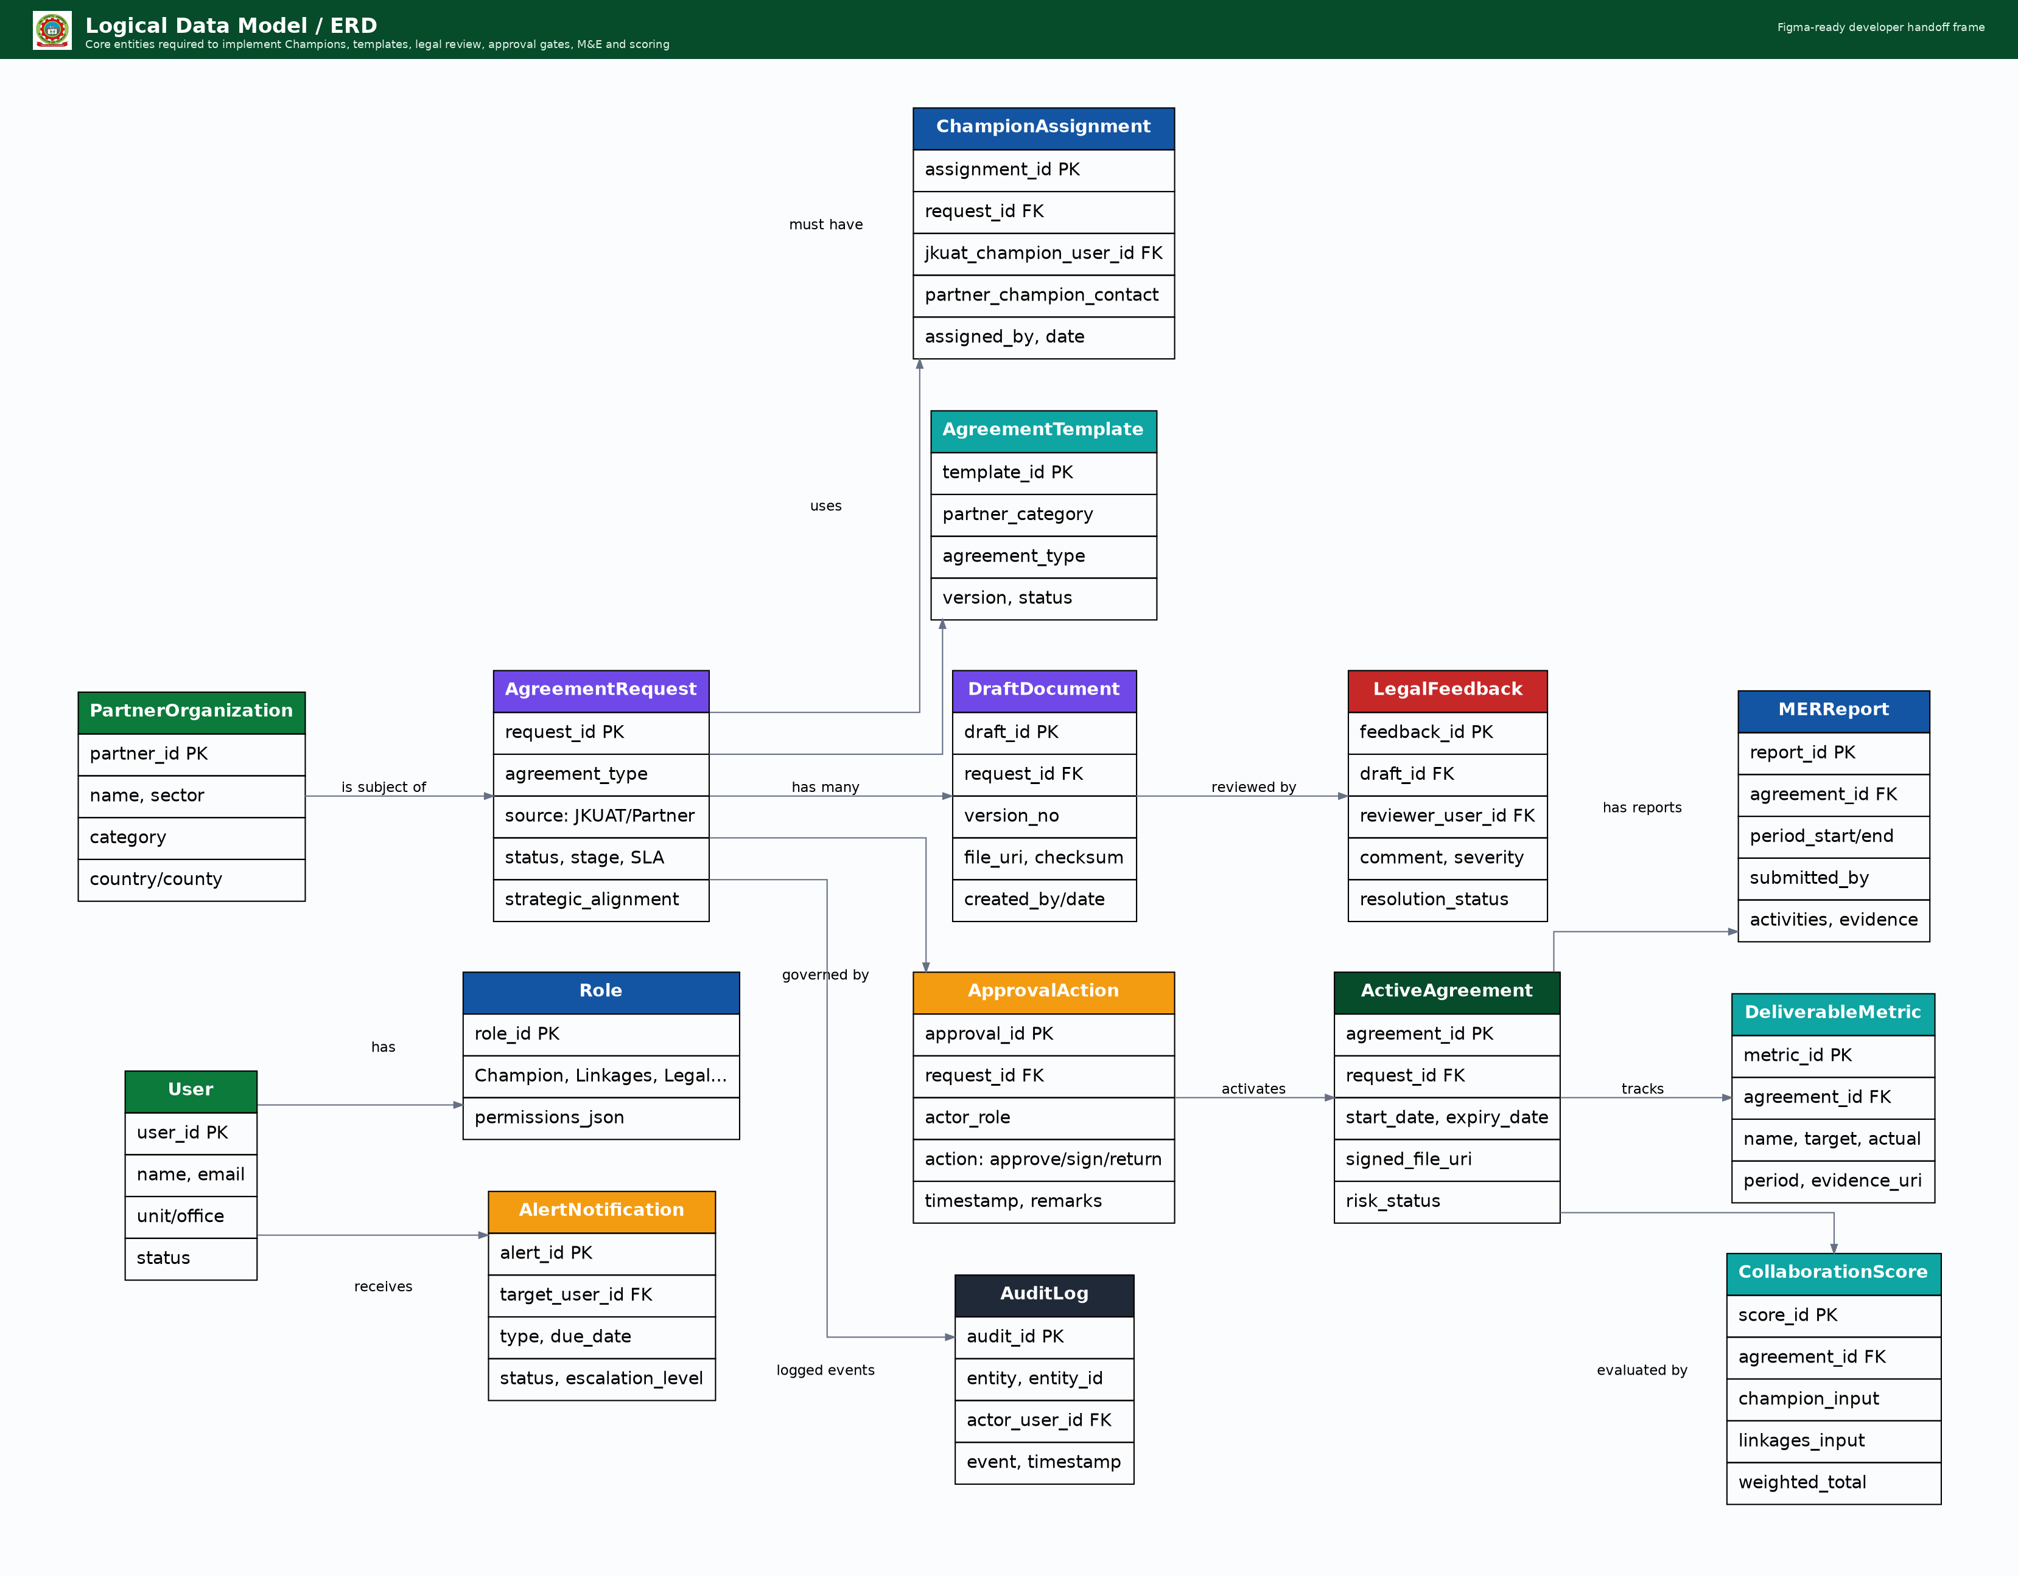
Figure 6. Logical entity relationship model for requests, Champions, templates, drafts, legal feedback, approvals, agreements, M&E, scoring, alerts and audit logs.

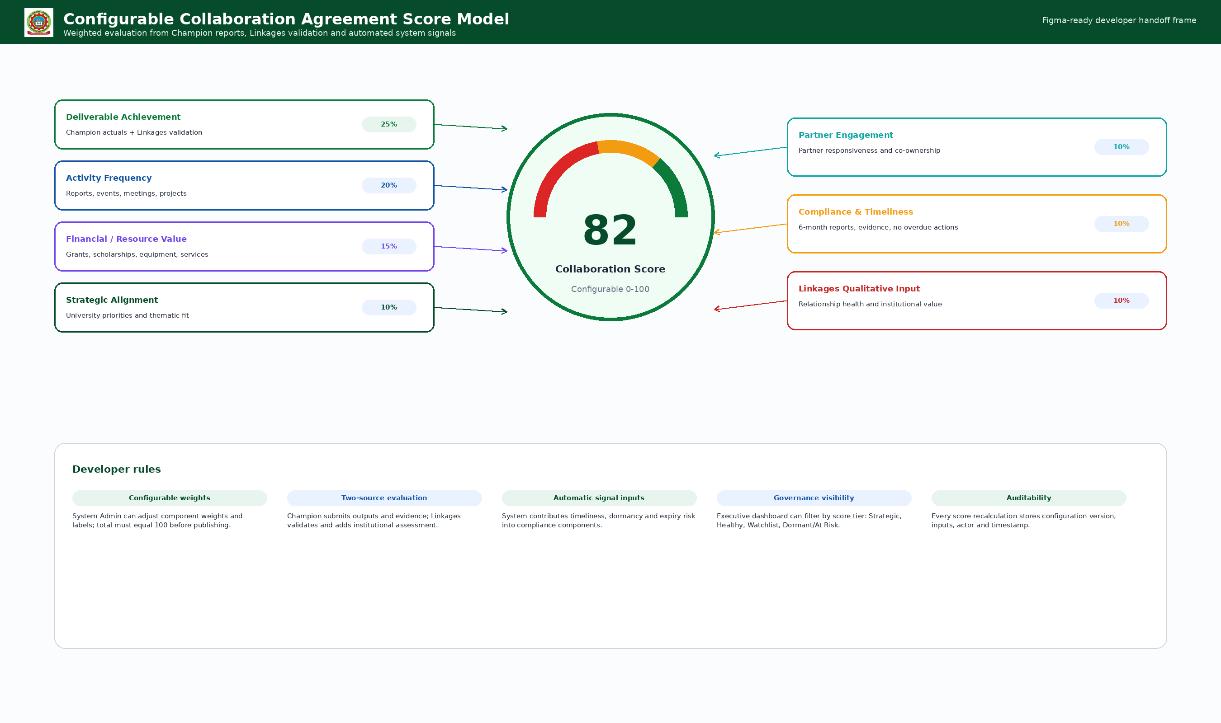
Figure 7. Configurable collaboration agreement score model combining Champion input, Linkages input and automated signals.

5. JKUAT Website Fit and UI Design System

5.1 Website Placement and Experience
The recommended deployment model is a public Linkages entry page under the JKUAT website experience and a secure authenticated application area for operational workspaces. Public pages should inherit the university web header/footer, institutional crest, green/blue visual palette and official tone. Authenticated pages should use a portal-style shell with role-based navigation, clear dashboard actions and persistent help through the chatbot widget.

5.2 Figma Frame Standards
Design item | Specification
Desktop frame | 1440 x 1024 px, 12-column grid, max content width aligned to JKUAT web shell.
Tablet frame | 768 x 1024 px, collapsible navigation, two-column cards where space permits.
Mobile frame | 390 x 844 px, single-column workflow, dashboard tasks first, floating chatbot/help button.
Grid and spacing | 8 px spacing system; primary content cards use 16-24 px internal padding; complex dashboards use consistent card gutters.
Primary colors | JKUAT-style green for institutional identity and approvals; blue for information/navigation; orange for pending; red for risk/stalled; purple/cyan for analytics/configuration.
Typography | Use a modern sans-serif aligned with JKUAT web standards. Minimum 14 px body text in web UI, 16 px preferred for forms.
Components | Header, sidebar/top nav, KPI cards, status chips, timeline, Kanban card, data table, wizard stepper, document viewer, feedback thread, score gauge, alert list, chatbot bubble.
Accessibility | WCAG-aware contrast, keyboard navigation, labelled form fields, screen-reader text for status colors and downloadable accessible reports.

5.3 Status Color Rules
Status color | Meaning | Example
Green | Approved, complete, active or on schedule. | Legal approved; signing complete; report submitted.
Yellow / Orange | Pending, nearing SLA, awaiting action or expiry approaching. | Awaiting signature; Legal review within threshold; renewal review.
Red | Stalled, overdue, dormant, blocked or high risk. | Legal review over SLA; no deliverable update for 180 days; report overdue.
Blue | Information, workflow navigation or scheduled task. | M&E report due; status timeline; dashboard filters.
Purple / Cyan | Configuration, analytics and scoring. | Template admin; scorecard configuration; metrics.

5.4 Interaction and Layout Rules for Developers
- Use clear next-action buttons on every record: continue draft, view feedback, submit report, approve, return or assign Champion.
- Do not rely on color alone; every green/orange/red status must also have a text label and tooltip explaining the rule.
- Persist unsent form drafts, especially for Champion M&E reports and long request wizard forms.
- Keep agreement ID, stage, Champion, partner and next action visible in page headers for all record-detail pages.
- Use audit-friendly confirmation modals for irreversible actions such as legal approval, DVC sign-off, VC submission and agreement activation.
- Ensure mobile screens prioritize urgent tasks, alerts, report submission and chatbot help before secondary analytics.

6. Complete Website Wireframe Catalogue
The wireframes below describe the end-to-end website and application experience. Each frame includes implementation annotations that should be converted into Figma comments, user stories and acceptance criteria.

WF-01 Public Landing
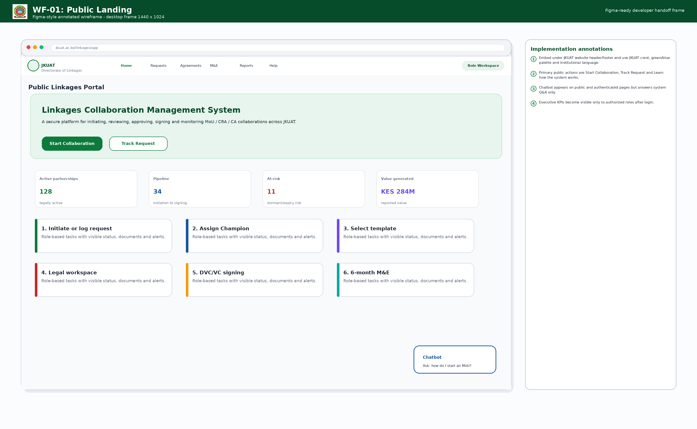
Public Linkages landing page with JKUAT web shell, collaboration entry points, KPI preview and chatbot.

WF-02 Login and Role Routing
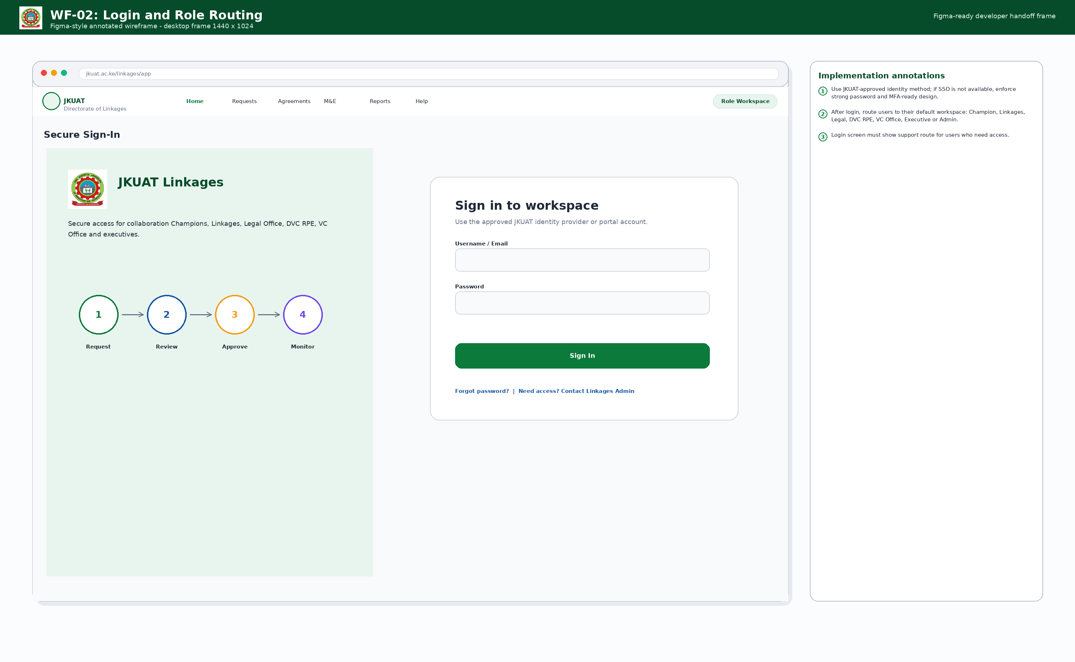
Secure sign-in and role-routing page for JKUAT users and approved stakeholders.

WF-03 Champion Dashboard
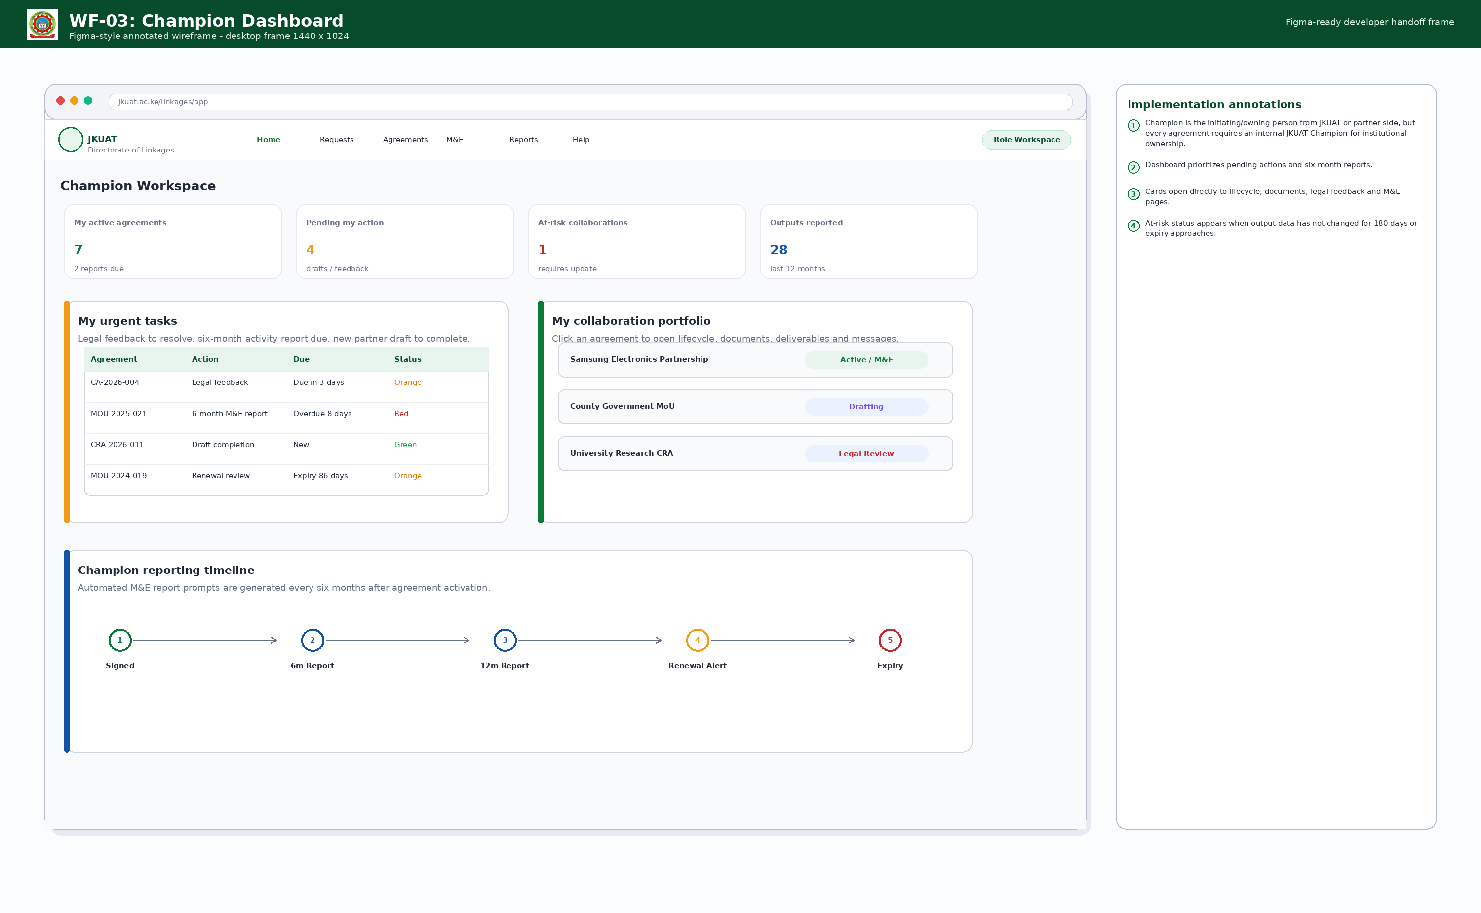
Champion workspace for tasks, agreements, legal feedback and M&E reporting.

WF-04 Partner Request Logging
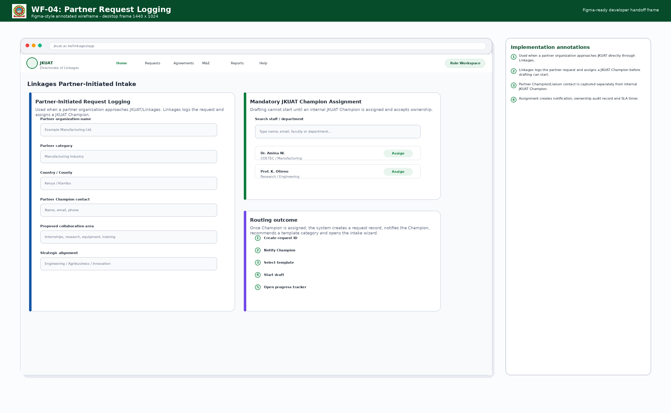
Linkages intake screen for partner-originated requests and mandatory JKUAT Champion assignment.

WF-05 New Request Wizard and Templates
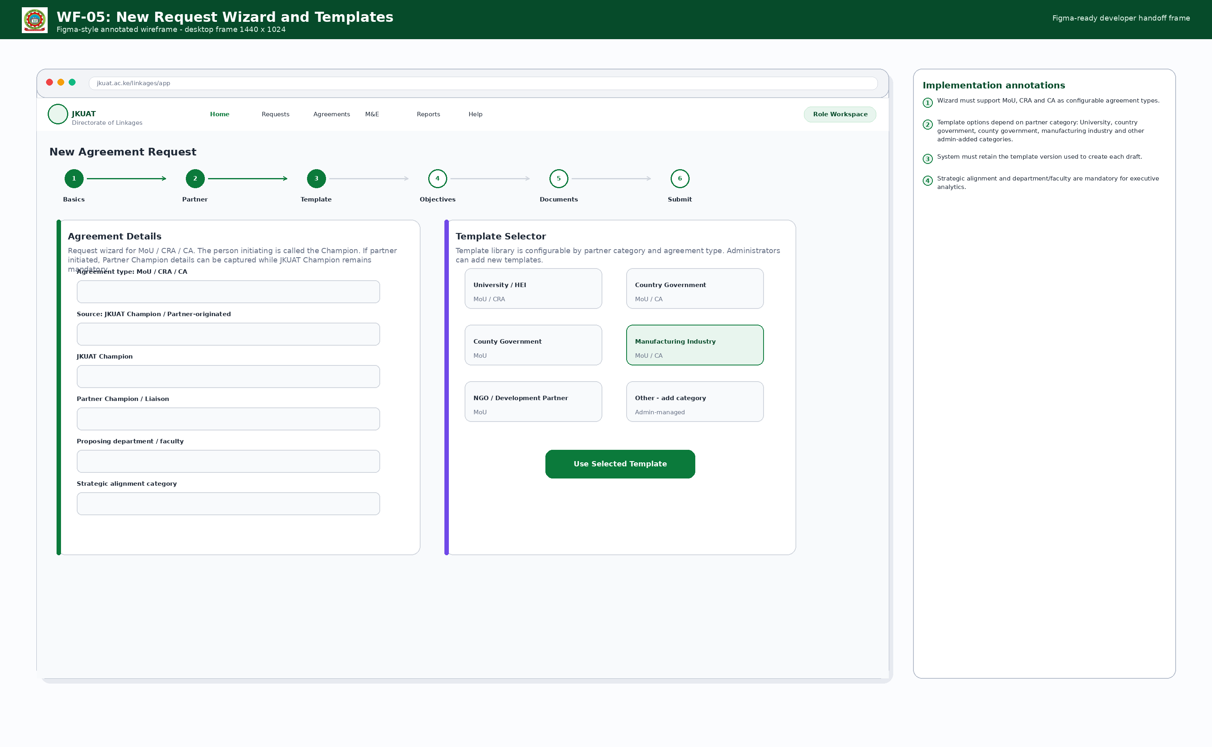
Agreement request wizard and configurable template selector by partner category.

WF-06 Agreement Detail and Lifecycle
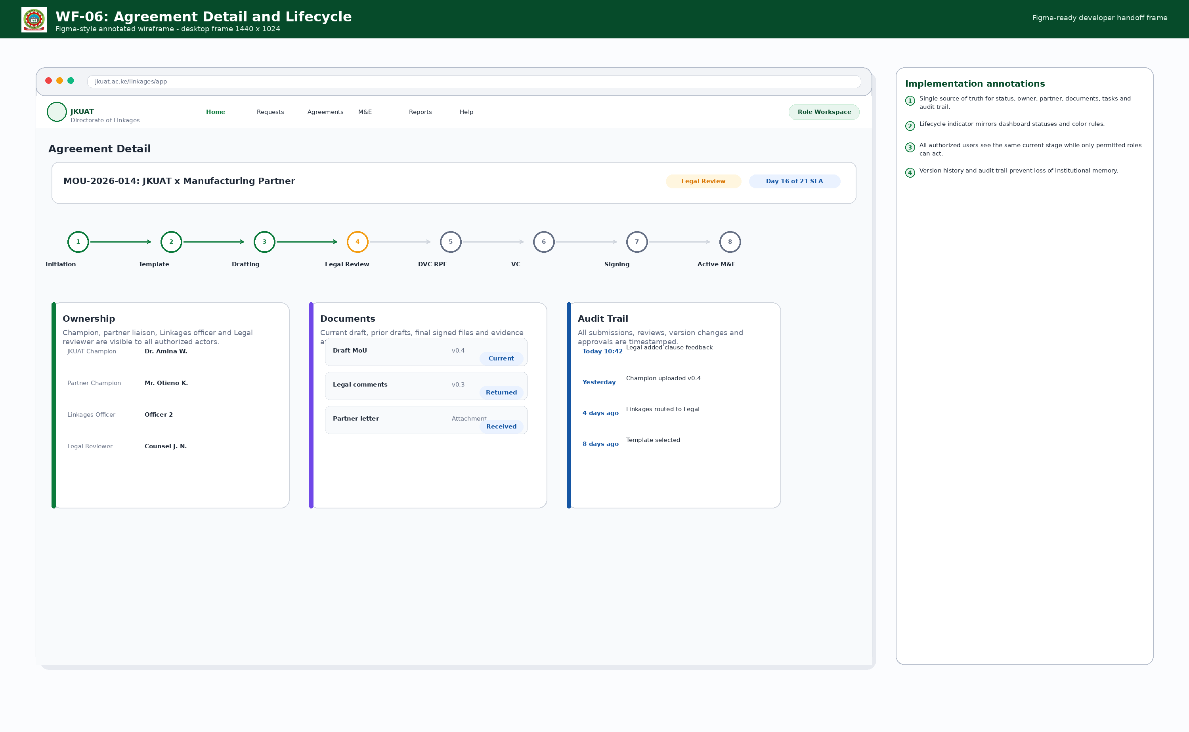
Single agreement page with status, lifecycle, ownership, documents and audit trail.

WF-07 Legal Workspace
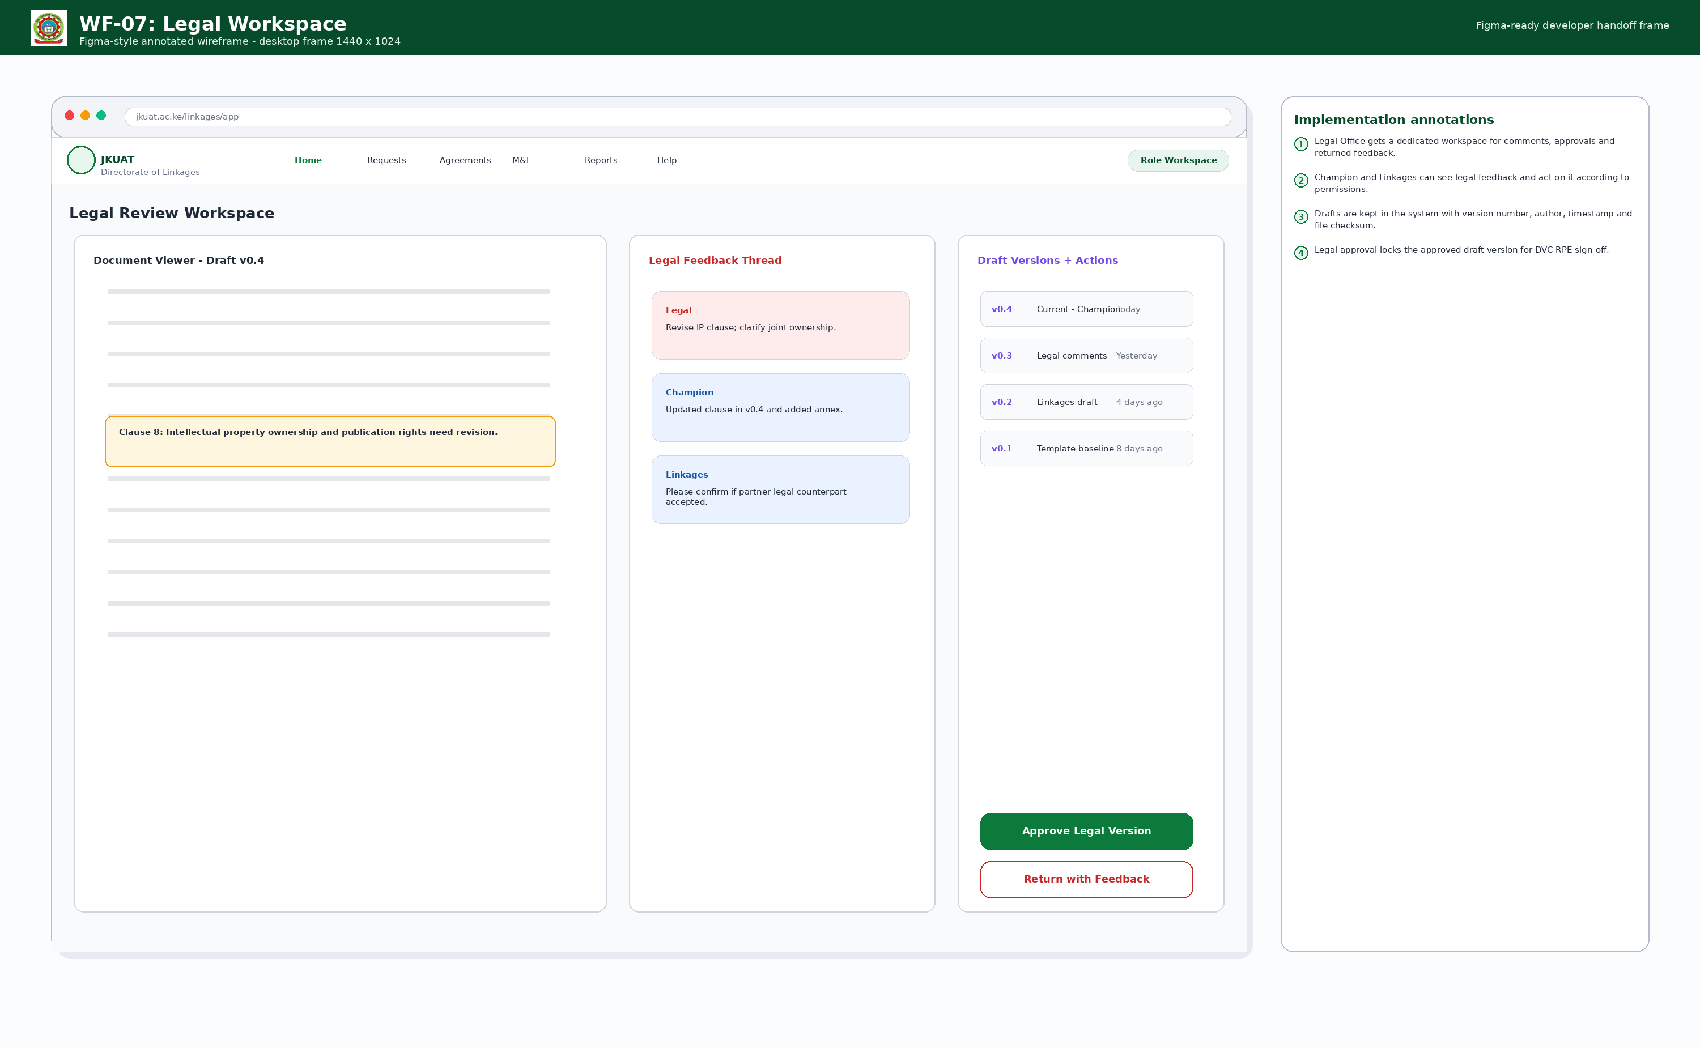
Legal Office workspace with document viewer, feedback thread, draft versions and approval actions.

WF-08 DVC RPE Sign-Off Gate
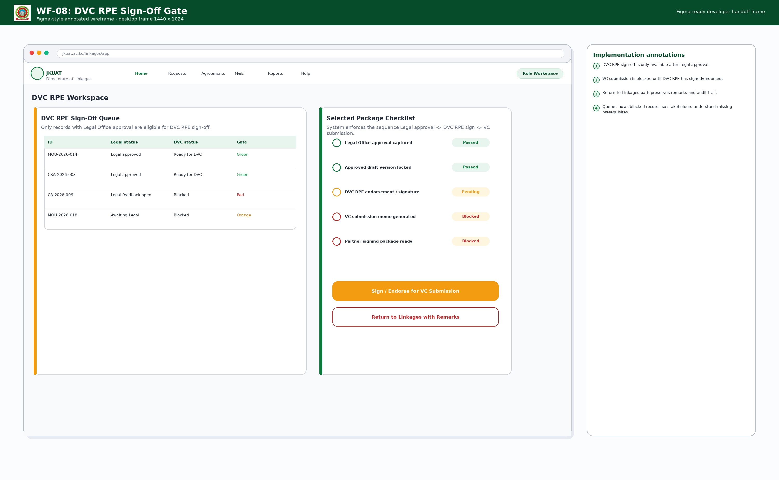
DVC RPE queue and gate checklist enforcing post-legal sign-off before VC submission.

WF-09 VC Submission and Signing
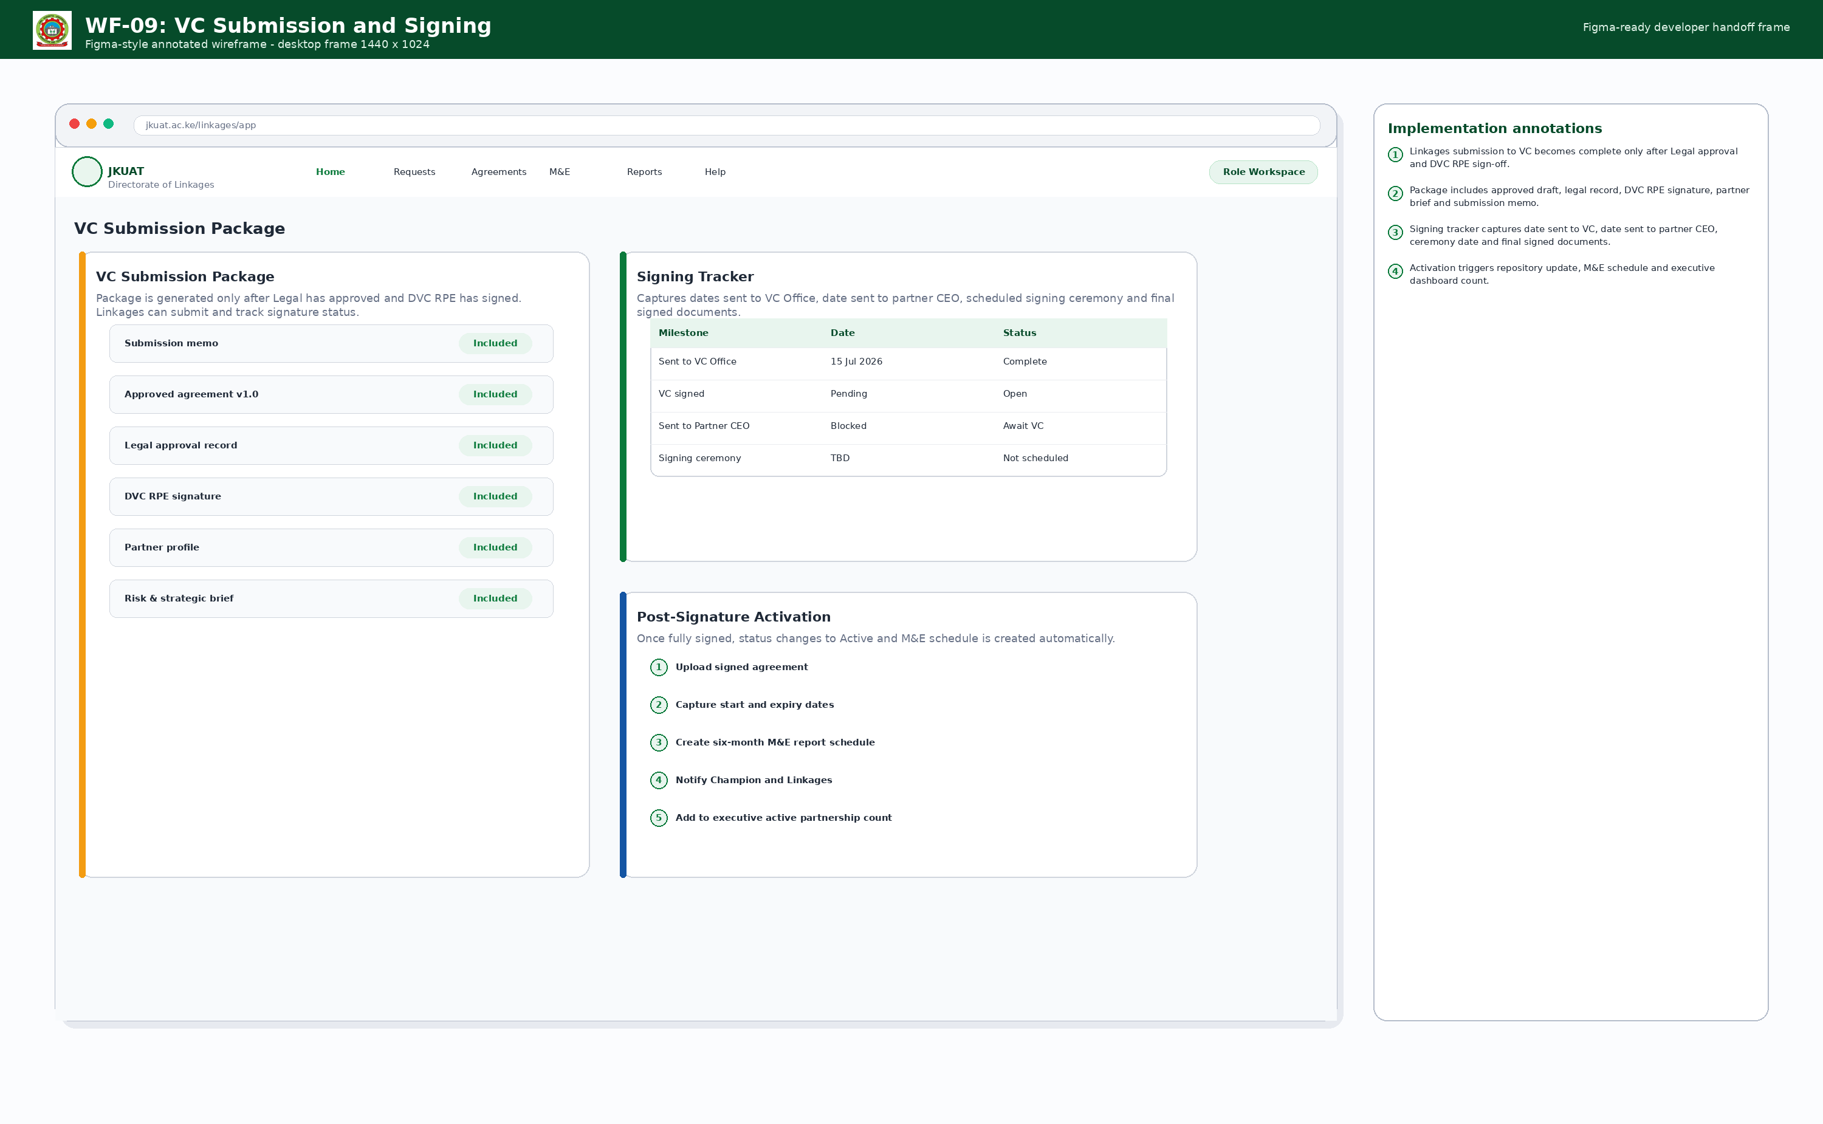
VC submission package and signature tracking workflow.

WF-10 Executive KPI Dashboard
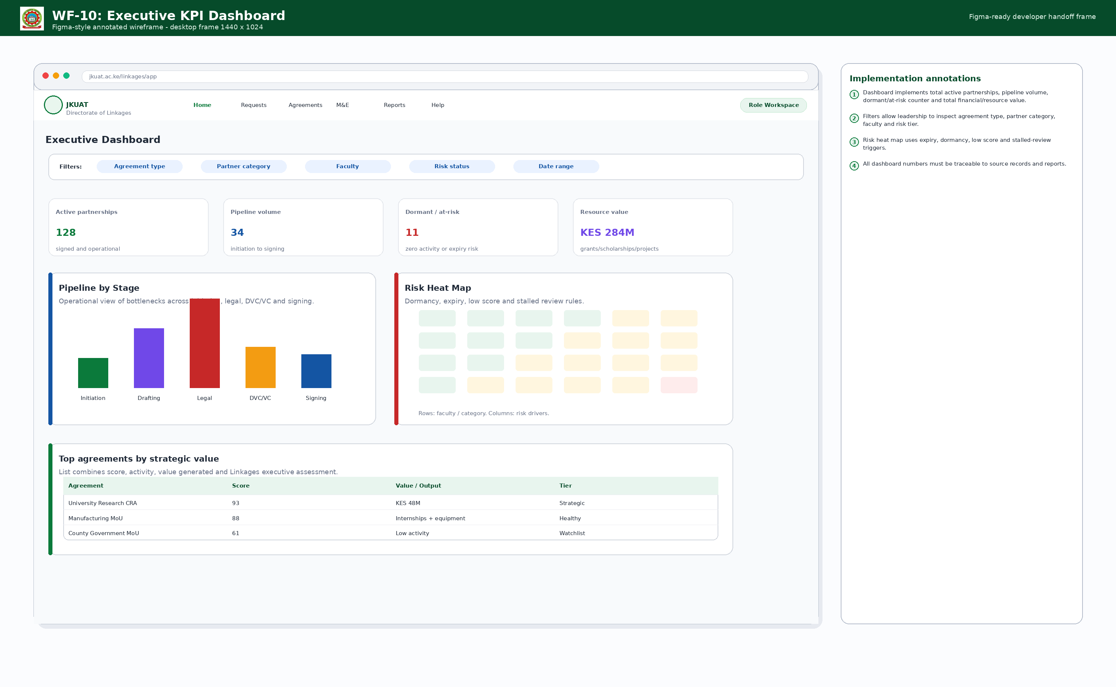
Executive dashboard with active partnerships, pipeline, at-risk count, value and filters.

WF-11 Lifecycle Tracker
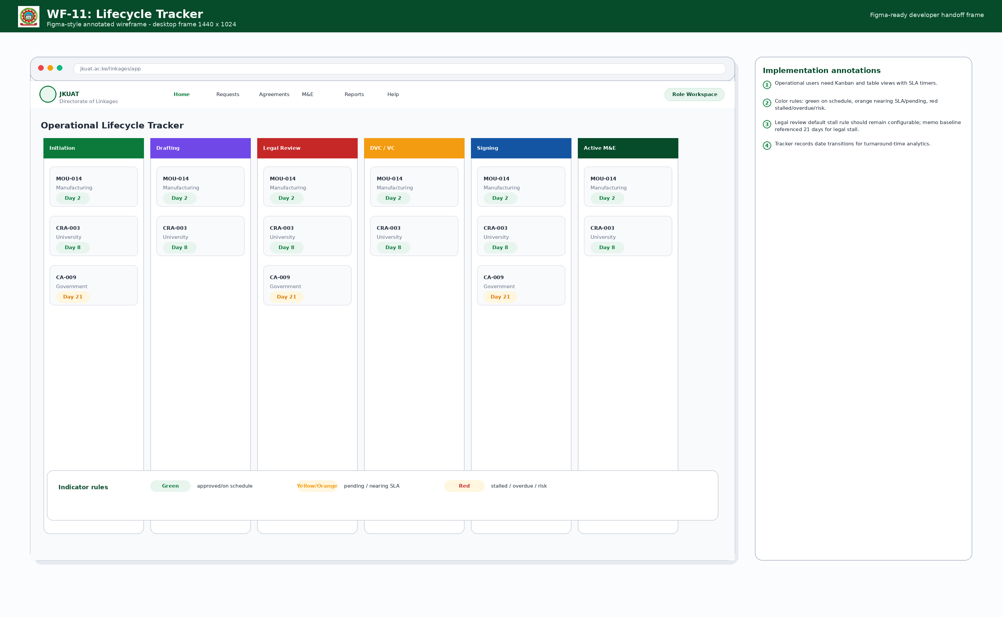
Operational Kanban/table lifecycle tracker with color-coded SLA indicators.

WF-12 M&E Reporting
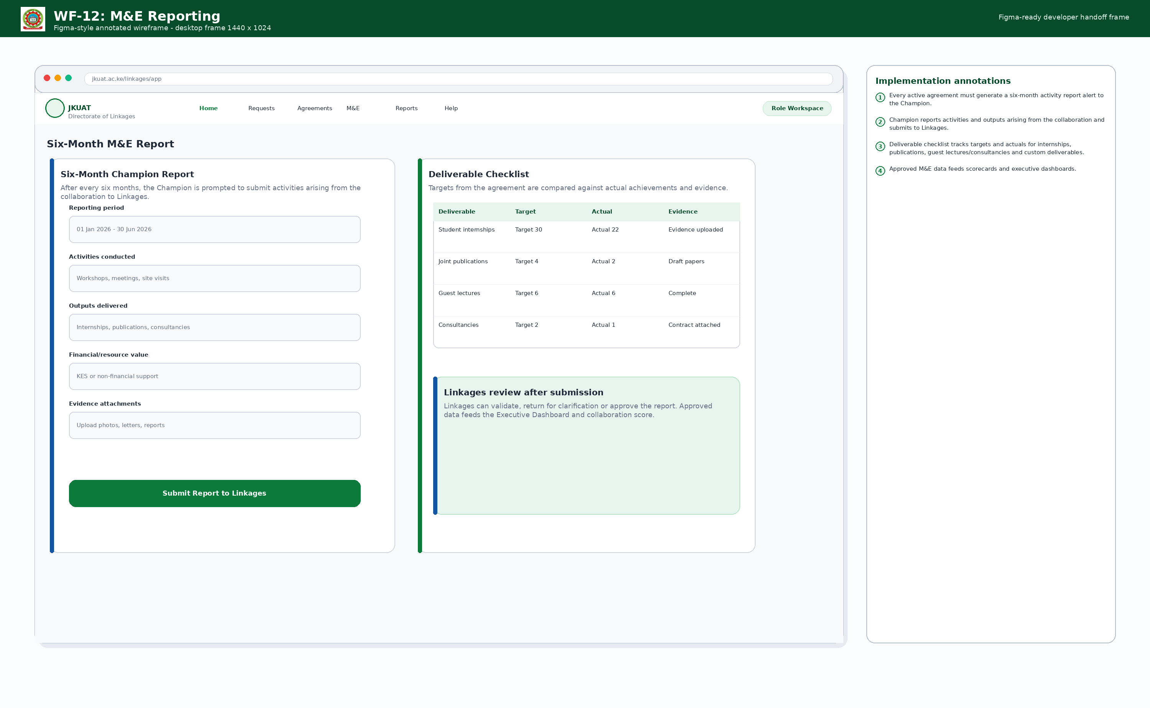
Six-month Champion report form with deliverable checklist and evidence upload.

WF-13 Collaboration Scorecard
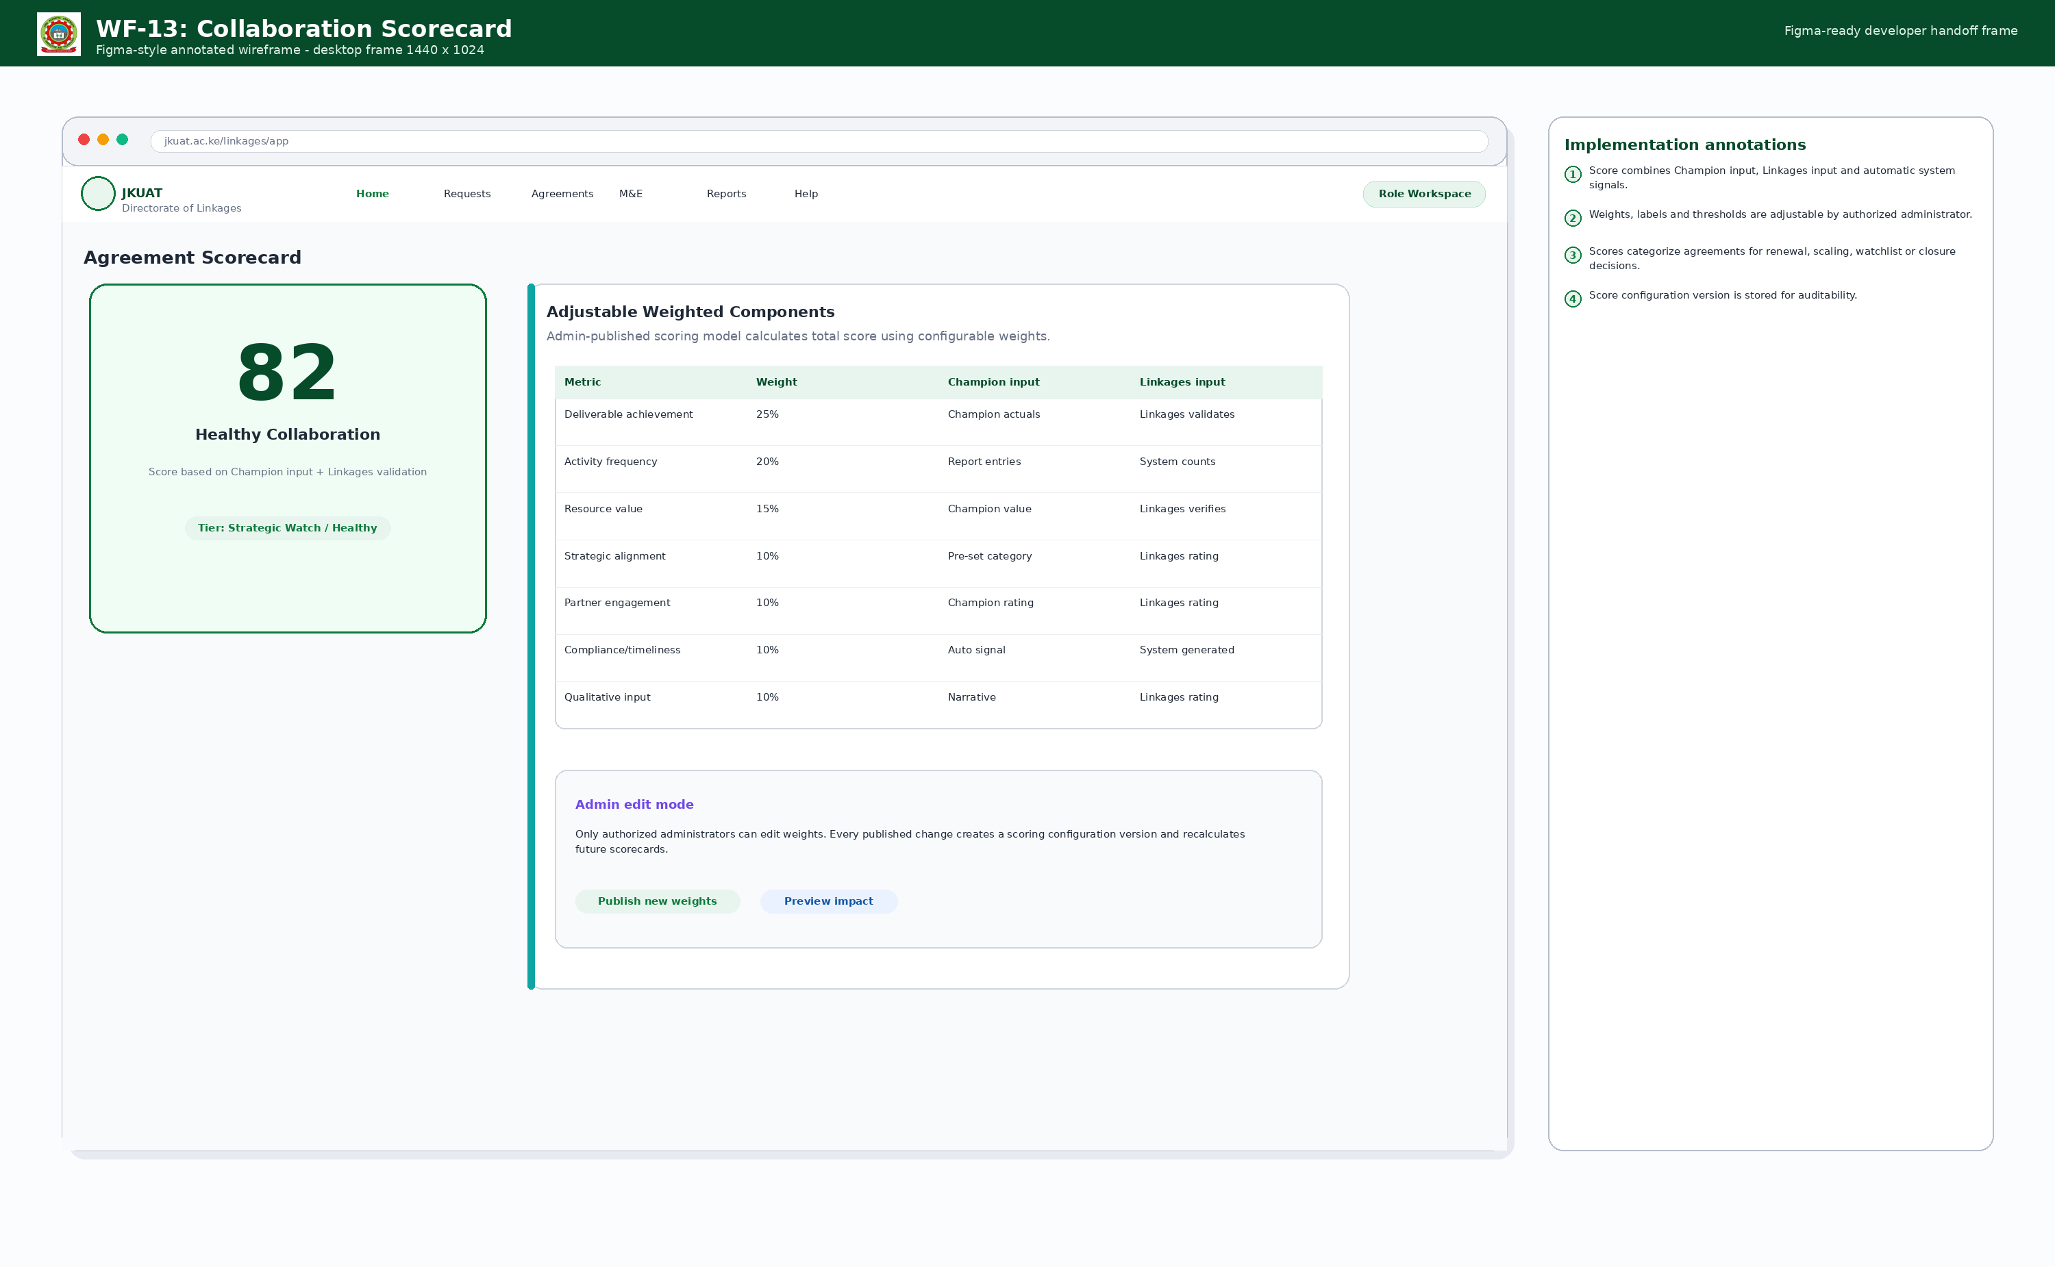
Adjustable scorecard using Champion input, Linkages validation and system signals.

WF-14 Alerts Center
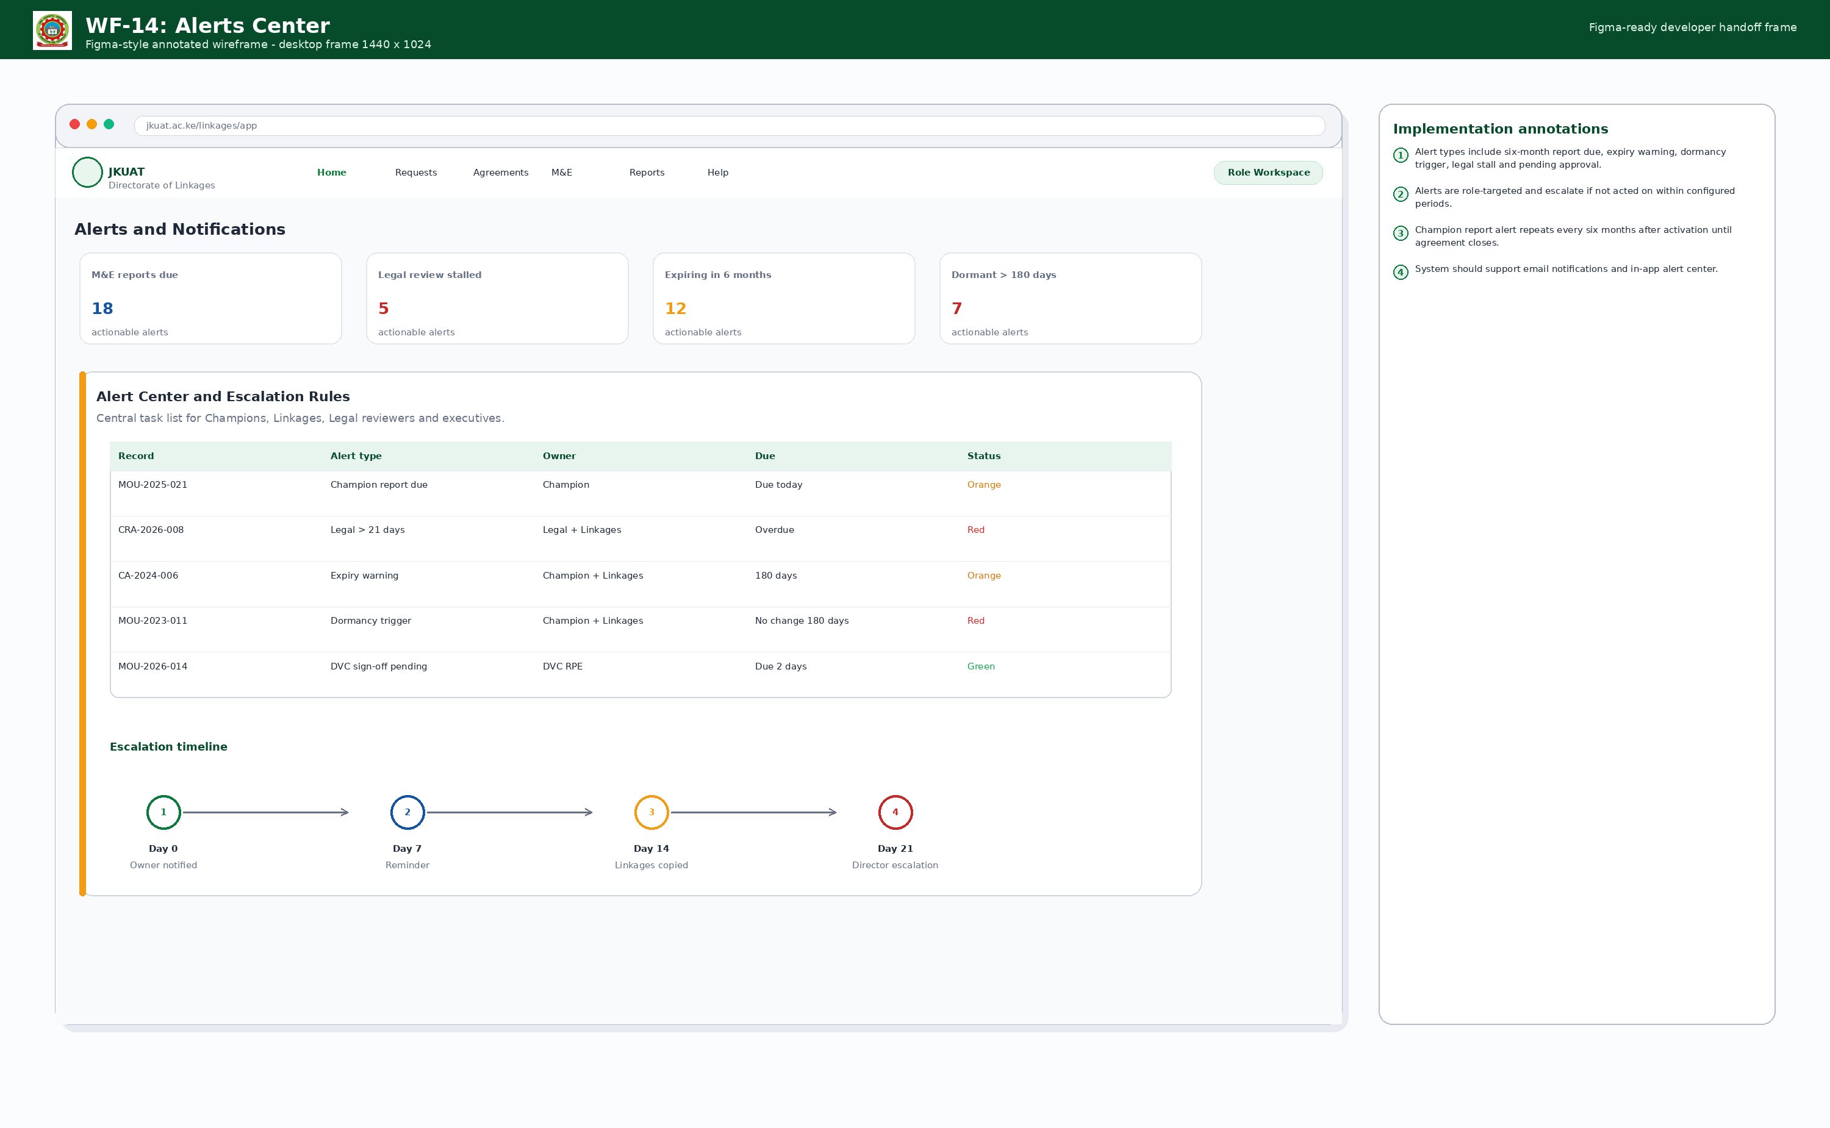
Alert center for M&E due, legal stall, expiry, dormancy and pending approvals.

WF-15 Responsive Mobile Frames
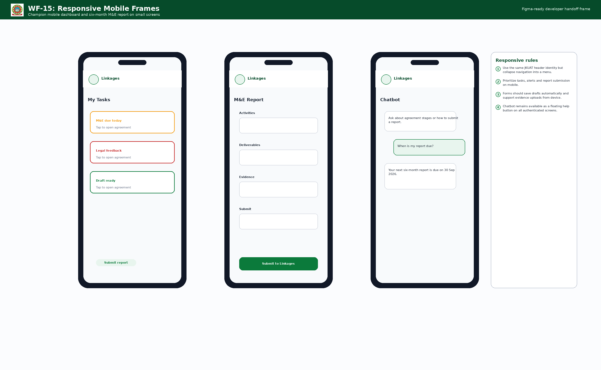
Mobile dashboard, M&E report and chatbot experience for responsive implementation.

WF-16 Admin Console
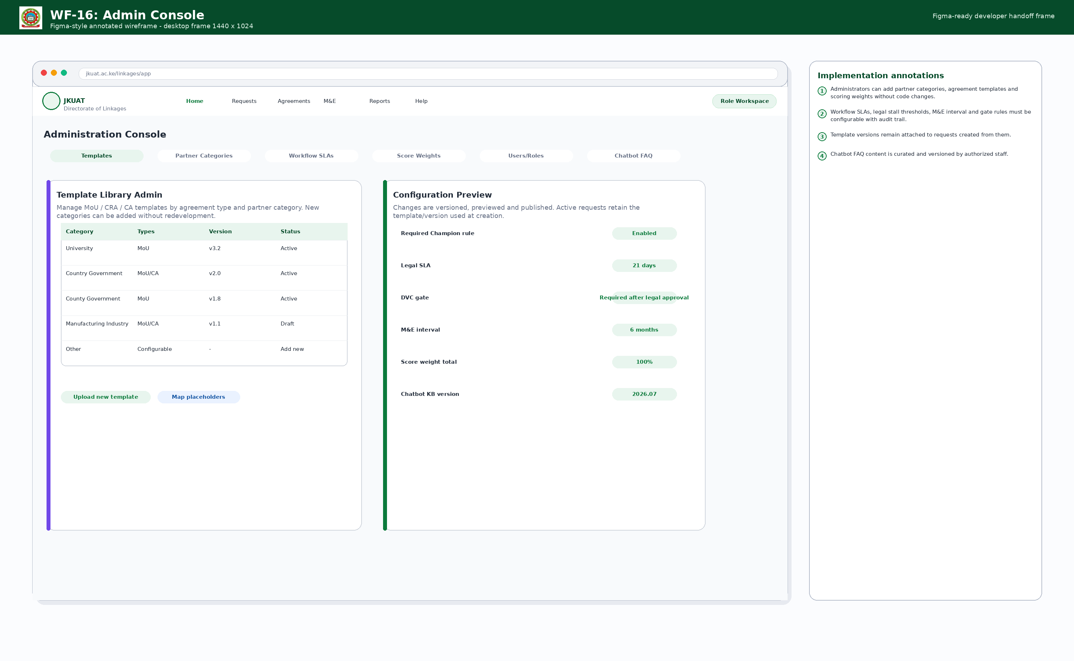
Administration console for templates, partner categories, workflows, score weights, users and chatbot FAQ.

WF-17 Chatbot Help
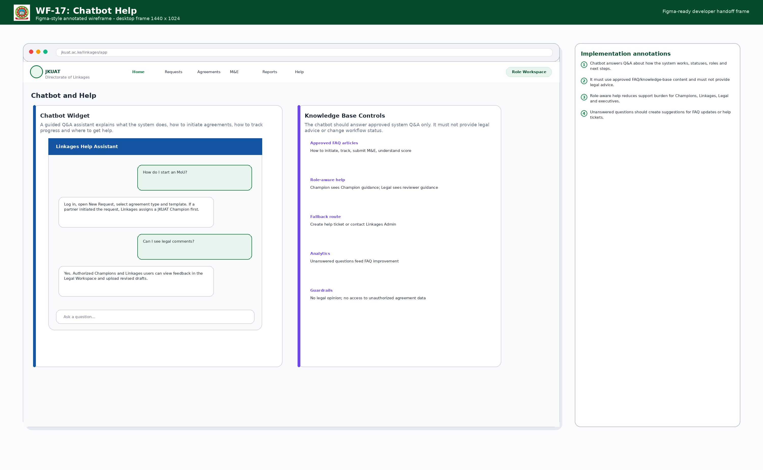
System Q&A chatbot and knowledge-base guardrail interface.

7. Functional Requirements Catalogue
Requirements below use “shall” to indicate mandatory developer implementation. Each requirement should map to backlog epics, user stories, acceptance tests and QA scripts.
ID | Module | Requirement | Priority
FR-001 | Champion Management | The system shall label the initiator/owner role as Champion and capture Champion type: JKUAT Champion, partner-side Champion/Liaison or both. | Must
FR-002 | Champion Management | The system shall require an internal JKUAT Champion before any partner-originated request can proceed to drafting. | Must
FR-003 | Champion Management | The system shall allow Linkages to assign, reassign or deactivate a Champion with reason, timestamp and notification. | Must
FR-004 | Partner Request Intake | The system shall allow Linkages to log a collaboration request received from a partner organization, including partner profile, sector, category, country/county, proposed collaboration area and partner contact. | Must
FR-005 | Request Wizard | The system shall allow JKUAT Champions to initiate MoU, CRA or CA requests using a step-by-step wizard. | Must
FR-006 | Request Wizard | The system shall capture agreement type, source, partner category, strategic alignment, department/faculty, expected outputs, risk notes and supporting documents. | Must
FR-007 | Template Library | The system shall provide a configurable template library by agreement type and partner category, including University, country government, county government, manufacturing industry and other categories added by administrators. | Must
FR-008 | Template Library | The system shall preserve the exact template version used to generate each draft. | Must
FR-009 | Draft Management | The system shall store every draft file with version number, author, date/time, file checksum, status and relation to review comments. | Must
FR-010 | Draft Management | The system shall prevent deletion of draft history by ordinary users; correction shall be handled through an auditable administrative process. | Must
FR-011 | Legal Workspace | The system shall provide Legal Office with a workspace to view drafts, comment, return, request clarification and approve legally reviewed versions. | Must
FR-012 | Legal Workspace | The system shall make Legal Office feedback visible to authorized Champion and Linkages users so they can act on comments. | Must
FR-013 | Legal Workspace | The system shall track days spent in Legal review and flag records exceeding the configured legal SLA, with a default implementation option of 21 days. | Must
FR-014 | Approval Gate | The system shall record Legal Office approval with reviewer, date/time, approved draft version and audit trail. | Must
FR-015 | Approval Gate | The system shall allow DVC RPE sign-off only after Legal Office approval exists for the current approved draft version. | Must
FR-016 | Approval Gate | The system shall block VC submission package completion until Legal approval and DVC RPE sign-off have both passed. | Must
FR-017 | VC Submission | The system shall generate or assemble a VC submission package containing approved agreement draft, legal approval record, DVC RPE sign-off, partner brief, submission memo and supporting documents. | Must
FR-018 | Signing Tracker | The system shall capture date sent to VC Office, date sent to partner CEO, VC signature date, partner signature date, signing ceremony date and final signed agreement upload. | Must
FR-019 | Activation | The system shall activate an agreement only when signed documents and start/expiry dates have been recorded. | Must
FR-020 | Repository | The system shall provide searchable repository access for drafts, signed agreements, evidence, partner records and audit trails based on role permissions. | Must

ID | Module | Requirement | Priority
FR-021 | M&E | The system shall create six-month M&E reporting schedules for every active signed agreement and notify the JKUAT Champion when a report is due. | Must
FR-022 | M&E | The system shall allow Champions to report activities arising from the collaboration and submit them to Linkages. | Must
FR-023 | M&E | The system shall track deliverable targets and actuals for internships, joint publications, guest lectures, consultancies and configurable deliverables. | Must
FR-024 | M&E | The system shall allow evidence uploads against each reporting period and deliverable. | Must
FR-025 | M&E | The system shall allow Linkages to validate, approve, return or query submitted Champion reports. | Must
FR-026 | Scorecard | The system shall calculate a collaboration agreement score using adjustable component weights published by authorized administrators. | Must
FR-027 | Scorecard | The score shall combine Champion input, Linkages input and automated system signals such as timeliness, dormancy, expiry risk and completion status. | Must
FR-028 | Scorecard | The system shall store score configuration version, component values, weighted total, actor, date/time and interpretation tier. | Must
FR-029 | Executive Dashboard | The system shall display total active partnerships, pipeline volume, dormant/at-risk counter and total financial/resource value generated. | Must
FR-030 | Executive Dashboard | The dashboard shall support filtering by agreement type, partner category, sector, faculty/department, country/county, stage, risk status and period. | Must
FR-031 | Lifecycle Tracker | The system shall provide operational table and Kanban views showing stage, owner, Champion, partner, days in stage, SLA state and next action. | Must
FR-032 | Alerts | The system shall generate expiry warning alerts six months before agreement expiry and renewal review tasks to Champion and Linkages. | Must
FR-033 | Alerts | The system shall generate dormancy alerts when deliverable actuals or activity reports have not changed for 180 days. | Must
FR-034 | Alerts | The system shall generate legal review stalled alerts when review exceeds configured SLA. | Must
FR-035 | Alerts | The system shall support in-app alerts and email notifications, with escalation rules configurable by administrator. | Must
FR-036 | Chatbot | The system shall provide a chatbot for Q&A about system purpose, roles, request initiation, status meaning, reporting, alerts and help procedures. | Must
FR-037 | Chatbot | The chatbot shall use approved FAQ/knowledge-base content and shall not give legal advice or disclose records outside user permissions. | Must
FR-038 | Admin | The system shall allow authorized administrators to manage templates, partner categories, scoring weights, workflow SLAs, notification rules, users, roles and chatbot FAQs. | Must
FR-039 | Audit | The system shall log all significant events including creation, assignment, draft upload, comment, approval, sign-off, submission, activation, report, score change and configuration update. | Must
FR-040 | Reports | The system shall export dashboards, lifecycle reports, M&E reports, scorecards and agreement registers to PDF/Excel or approved institutional formats. | Must

8. Non-Functional Requirements, Security and Data Governance
ID | Area | Requirement
NFR-001 | Performance | Dashboard pages shall load within an acceptable institutional performance target under expected user load; detailed thresholds shall be confirmed during technical design.
NFR-002 | Availability | The platform shall be designed for reliable business-hours operation with backup and disaster recovery procedures.
NFR-003 | Security | All access shall be authenticated; role-based access shall be enforced server-side, not only in the user interface.
NFR-004 | Confidentiality | Drafts, legal comments and signed agreements shall be protected from unauthorized access and downloads.
NFR-005 | Integrity | Workflow gates and approval records shall be tamper-evident through audit logging and restricted permissions.
NFR-006 | Accessibility | The website shall follow accessible design principles: keyboard navigation, readable contrast, labelled forms and status text in addition to colors.
NFR-007 | Responsive design | Core functions shall work on desktop, tablet and mobile, with mobile priority for alerts, task review and M&E report submission.
NFR-008 | Maintainability | Partner categories, templates, scoring weights, alert thresholds and workflow SLAs shall be configurable without code deployment.
NFR-009 | Searchability | Users with permission shall be able to search agreements by partner, Champion, faculty, agreement type, stage, expiry and keywords.
NFR-010 | Audit retention | Audit logs shall be retained according to JKUAT records policy and protected from ordinary user modification.

8.1 Security Model
- Authentication: integrate with JKUAT-approved identity method where available; otherwise implement strong credentials and administrative provisioning.
- Authorization: implement permissions for view, create, edit, comment, approve, sign, submit, validate, configure and export actions.
- Document controls: signed agreements and legally approved drafts should be locked; new revisions require a new workflow record or amendment process.
- Audit trail: every sensitive action should capture actor, role, timestamp, IP/device metadata where permitted, entity, before/after state and reason.
- Data protection: store files securely, scan uploads, restrict downloads, back up records and apply retention/archival policy.

9. Acceptance Criteria and Implementation Roadmap
Test ID | Scenario | Expected result
AT-001 | Partner organization approaches JKUAT and Linkages logs the request. | System creates request record, captures partner data and blocks drafting until a JKUAT Champion is assigned.
AT-002 | Linkages assigns an internal JKUAT Champion. | Champion receives notification; request status changes to Champion Assigned; audit record is created.
AT-003 | Champion starts a new agreement using partner category Manufacturing Industry. | System recommends available templates for manufacturing industry and stores selected template version.
AT-004 | Legal Office returns comments on a draft. | Champion and Linkages can view feedback, upload revised draft and see preserved version history.
AT-005 | User attempts VC submission before Legal approval. | System blocks package completion and displays missing prerequisite.
AT-006 | Legal approves and DVC RPE signs. | VC submission package is unlocked and can be submitted/tracked by Linkages.
AT-007 | Agreement is fully signed and activated. | System stores signed document, start/expiry dates, changes status to Active and creates six-month M&E schedule.
AT-008 | Six-month report due date arrives. | Champion receives alert; Linkages can view pending report; escalation starts if overdue.
AT-009 | Champion submits M&E report and Linkages validates. | Deliverable actuals update, evidence is stored, dashboard metrics and scorecard inputs refresh.
AT-010 | Admin modifies collaboration score weights. | System validates total equals 100, publishes new configuration version and applies it to future/recalculated scores.
AT-011 | Chatbot receives question about how to start an MoU. | Chatbot answers from approved FAQ and provides link to New Request or Linkages support.
AT-012 | Legal review exceeds configured SLA. | System marks record as stalled, raises red alert and escalates according to notification configuration.

9.1 Recommended Implementation Phases
Phase | Scope | Outcome
Phase 0: Discovery and validation | Confirm official CRA/CA terminology, roles, templates, approval wording, retention rules, integration constraints and JKUAT web/identity standards. | Signed functional specification and validated Figma board.
Phase 1: Core workflow MVP | Authentication/RBAC, request intake, Champion assignment, template selector, agreement detail, draft storage and lifecycle tracker. | Usable internal workflow from initiation to legal review.
Phase 2: Legal and approval gates | Legal workspace, feedback, approvals, DVC RPE gate, VC package and signing tracker. | Governed agreement processing with auditable approvals.
Phase 3: Repository, dashboards and alerts | Agreement repository, executive dashboard, SLA indicators, email/in-app alerts and exports. | Operational and leadership visibility.
Phase 4: M&E, scorecard and chatbot | Six-month Champion reporting, deliverable evidence, configurable scoring, chatbot FAQ and mobile refinements. | Performance management and user support.
Phase 5: Hardening and rollout | Security testing, data migration, user training, accessibility QA, backup/restore test and go-live support. | Production-ready system adopted by Linkages stakeholders.

Appendix A: Partner Template Configuration
Partner category | Template examples | Required metadata
University / Higher Education Institution | MoU, CRA, exchange/addendum, research collaboration template | Institution name, country, lead faculty, research area, publication/IP clauses, mobility terms.
Country Government | MoU, CA, implementation framework, government-to-university collaboration template | Ministry/agency, mandate, authorized signatories, policy alignment, funding/resource commitments.
County Government | MoU, local implementation agreement, community outreach or innovation collaboration template | County, department, county liaison, local implementation scope, beneficiary groups.
Manufacturing Industry | MoU, CA, internship/industrial attachment, equipment/lab support, consultancy template | Company profile, sector, site, safety/compliance requirements, internships/equipment/consultancy outputs.
NGO / Development Partner | MoU, project collaboration, grant/resource support template | Program area, funding/non-financial support, reporting requirements, safeguarding/compliance clauses.
Other / Custom | Admin-defined templates for future partner categories | Category owner, approval workflow, template placeholders and legal review notes.

Appendix B: Default Collaboration Score Configuration
Component | Default weight | Primary input | Notes
Deliverable achievement | 25% | Champion actuals + Linkages validation | Targets vs actuals for internships, publications, consultancies and custom deliverables.
Activity frequency | 20% | Champion report + system count | Events, meetings, trainings, projects and updates during reporting period.
Financial/resource value | 15% | Champion declared value + Linkages verification | Grants, scholarships, equipment, services, facilities or other value.
Strategic alignment | 10% | Linkages rating | Fit to university priorities, RPE goals and faculty strategies.
Partner engagement | 10% | Champion and Linkages ratings | Partner responsiveness, co-ownership and sustained involvement.
Compliance and timeliness | 10% | System-generated | Report timeliness, overdue alerts, missing evidence and dormancy indicators.
Linkages qualitative input | 10% | Linkages narrative/rating | Relationship health, institutional value and renewal recommendation.

Appendix C: Chatbot Scope and Guardrails
Question type | Allowed response
What does the system do? | Explain lifecycle, dashboard, legal review, approvals, M&E, scorecard and alerts.
How do I initiate an agreement? | Guide user to login, New Request wizard, Champion role and required fields.
What is a Champion? | Explain JKUAT Champion and partner-side Champion/Liaison distinction.
Where can I see Legal feedback? | Guide authorized users to Legal Workspace and draft version history.
Why can I not submit to VC? | Explain missing prerequisites: Legal approval and/or DVC RPE sign-off.
When is my M&E report due? | For authenticated users, answer based on permitted records; otherwise give generic reporting rule.
Can you approve this clause? | Decline legal advice and direct user to Legal Office workflow.
Show me another person’s agreement. | Decline unauthorized access and explain permission rules.

Appendix D: Developer Handoff Checklist
- Create Figma board using frames WF-01 to WF-17 and the design tokens in Section 5.
- Create database schema from Figure 6 and validate keys, document storage and audit strategy with technical architect.
- Implement workflow states from Figure 4 and enforce gate rules BR-006 / FR-014 to FR-016 server-side.
- Create backlog epics from the modules in Section 1 and requirements in Section 7.
- Write automated tests for all acceptance scenarios in Section 9 before user acceptance testing.
- Validate JKUAT website integration, identity method, official logo usage, hosting environment and records retention policy during discovery.

