
Stage 3.5 of the Design Sequence

Use Cases & Sequence Diagrams
Making the static model move
Eight core workflows walked step by step: the guards checked and in what order, what is written inside which transaction, which events are raised after commit, and every exception path — the artifact that makes module architecture and the API surface obvious rather than invented.
Product | MentorMAMA — Digital Mentorship Toolkit for Safer Midwifery Clinical Placement
Prepared by | Sinaps Technology — Bouric Okwaro Enos (Ric), Co-Founder & Team Lead
Document type | Stage 3.5 of the design sequence: Use Cases & Sequence Diagrams
Precedes | Stage 4 (Module Architecture) → Stage 5 (Database Architecture) → Stage 6 (API Design)
Builds on | Stage 3 Business Rules & Domain Invariants v1.1; Stage 2 Domain Model; Stage 1 Business Discovery v1.0
Version | 1.1 (JKUAT decisions of 30 July 2026 incorporated — §12)
Date | July 2026
Sinaps Technology | Driving Innovation Out of Isolation · Confidential — Sinaps Technology / JHUB Africa

1. Why This Stage Exists
Stages 1 through 3 produced a static system: entities, ownership, rules, invariants, transitions. Nothing in them describes sequence — what happens, in what order, holding which lock, raising which event.
That gap is where the original SADD went wrong. It specified REST endpoints (v1.0 §6.3) and a table schema (§5) before anyone had walked through what actually occurs when a mentor taps "Save" on a session log from a ward with two bars of signal. The endpoints looked reasonable and were still wrong, because an endpoint list is a consequence of workflow, not an input to it.
This document walks all eight core workflows step by step. For each one it names:
- the initiating actor and the preconditions that must already hold
- every guard checked, in the order checked (order matters: cheap authorization checks precede expensive integrity checks, and every check precedes the first write)
- what is written, inside which transaction boundary
- which domain events are raised, and what happens after commit
- the exception paths — not just the happy path

1.1 What this stage deliberately does not do
No HTTP verbs. No URL paths. No table or column names. No framework specifics. Operations are named as commands (LogSession, AssignMentor) because a command is a domain concept, while an endpoint is a transport decision belonging to Stage 6. Appendix A collects the full command surface these workflows imply — that list is the input to Stage 4, not a substitute for it.

1.2 Reading the diagrams
Participants are consistent across all eight diagrams:
Participant | What it is
Client | The PWA, including its local draft store and outbox
Gate | Request pipeline: authentication, scope resolution (AUTH-001), idempotency
Placement | Placement domain service — owner of the state machine
Induction, Session, Assessment, Escalation, Training | Domain services within their bounded contexts
Progress | Derived-metrics service — computes, never stores authored truth
Audit | Append-only audit writer (WFR-030)
Outbox | Transactional event outbox (WFR-026)
Notify | Notification dispatcher — executes, never decides (WFR-023)
Rule references (INV-05, T-10, TX-04, POL-014) point to Stage 3. If a step in this document contradicts Stage 3, Stage 3 wins and this document is the defect.

2. Cross-Cutting Mechanics
These four mechanics recur in every workflow. They are stated once here rather than repeated eight times.

2.1 Scope resolution happens before anything else
Every request resolves scope = { program_id, role, institution_id?, facility_id?, ward_ids?, user_id } from the authenticated principal (AUTH-001). No workflow step below ever reads a scope value from the request body. A cross-scope access attempt terminates at Gate with UnauthorizedFacilityAccess rendered as 404, never 403 (AUTH-004) — a 403 confirms the record exists, which is itself a leak when the record is a placement at another facility.

2.2 Guard order is part of the specification
Every workflow checks guards in this order, and the order is not cosmetic:
- Authentication — is there an actor at all (INV-11)
- Authorization — may this actor perform this command in this scope (Part 8)
- Existence and scope of the target — does the target exist within the actor's scope
- State — is the aggregate in a state where this command is legal (transition table, INV-05, INV-06)
- Integrity — do the domain invariants still hold after this change (INV-04, INV-16, INV-12)
- Idempotency — has this exact command already been applied (WFR-014)
Checking integrity before authorization leaks information through error messages. Checking state after writing leaves the aggregate briefly illegal. This order is what makes the invariants defensible.

2.3 Every write is one transaction, every side effect is outside it
The pattern is identical in all eight workflows and matches Stage 3 §10:
BEGIN
lock aggregate row (WFR-028)
re-check guards under lock
write domain rows
write audit row (WFR-030)
write outbox event row (WFR-026)
COMMIT
-> outbox worker dispatches: notifications, projections, exports
Re-checking guards under the lock is the part teams skip. A guard checked before BEGIN is a guard checked against stale state; two concurrent CompleteInduction calls both pass a pre-lock check and both try to activate the placement.

2.4 Offline is a first-class path, not an error path
The Concept Note requires draft-saving and retry sync on the ward floor, which means every mutating command in the mentor and student journeys will be replayed at least once. Consequences, applied throughout:
- The client generates a command_id (UUID) at form-open time, not at send time, and reuses it across retries.
- The server treats command_id as an idempotency key: a replay returns the original result, not a duplicate and not an error.
- Retries can arrive minutes or hours late, after the placement's state has changed. A replayed session log is validated against the state at arrival time, not at draft time (see W-05 §7.4). This is the single most under-specified behaviour in the original SADD.

3. Workflow W-01 — Student Onboarding & Placement Invitation
Field | Detail
Primary actor | University Coordinator
Secondary actors | Student, Notification Service
Trigger | A new term's cohort needs students placed
Preconditions | Coordinator authenticated, scoped to their Institution; Facility and Ward exist (created by Program Admin)
Commands | CreateCohort, EnrolStudent, InvitePlacementParticipant, ConfirmPlacement
Rules exercised | POL-008, AUTH-003, T-03, T-06, INV-11

3.1 Step table
# | Actor | Step | Guards checked | Writes | Events
1 | Coordinator | CreateCohort (name, dates, planned_capacity) | Role = Coordinator; institution_id from scope; start < end | Cohort; Audit | CohortCreated
2 | Coordinator | EnrolStudent (bulk or single) | Cohort in scope; student not already in an overlapping cohort | Student record; Cohort membership; Audit | StudentEnrolled
3 | — | Placement created — see W-02 | — | — | —
4 | Coordinator | InvitePlacementParticipant on a Scheduled placement | Placement in scope; state = Scheduled; mentor training complete (POL-009) | Placement → Awaiting Student (T-03); invitation token; Audit | PlacementInvitationIssued
5 | Notify | Dispatch invitation (email) | Post-commit only | Notification record | —
6 | Student | Redeem invitation, set password | Token valid, unexpired, unredeemed | User activation; Audit | AccountActivated
7 | Student | ConfirmPlacement | Actor is the placement's student; state = Awaiting Student | Placement → Orientation (T-06); Audit | PlacementConfirmed

3.2 Sequence
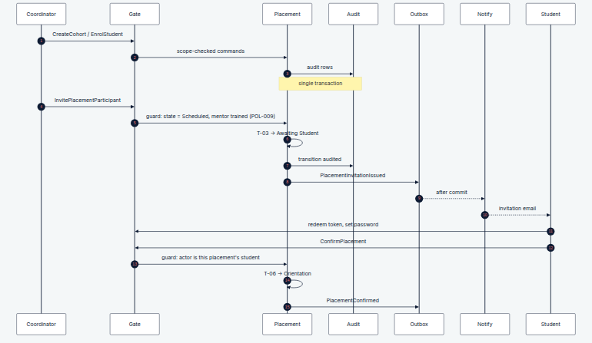

3.3 Exceptions
Condition | Behaviour
Student already has an overlapping active placement | StudentAlreadyAssigned; enrolment allowed, placement creation blocked
Invitation token expired | Reissue is a new command producing a new token; the old token stays dead and audited
Student never confirms | Placement remains Awaiting Student indefinitely; surfaced on the Coordinator dashboard as a stalled placement. No automatic withdrawal — an unconfirmed placement is a human follow-up, not a timeout
Mentor training incomplete at step 4 | TrainingIncomplete; Program Admin may override with a reason (WFR-033)

4. Workflow W-02 — Placement Creation & Ward Allocation
Field | Detail
Primary actor | University Coordinator (Program Admin may act on their behalf during pilot setup)
Trigger | Coordinator allocates a named student to a named ward
Preconditions | Cohort exists; Student enrolled; Facility and Ward exist
Commands | CreatePlacement, AllocateWard, TransferWard
Rules exercised | POL-001, POL-004, POL-006, POL-007, INV-01, INV-12, INV-16, INV-17, T-01
This is the workflow where the two-institution boundary bites: the Coordinator allocates the ward, but the Nurse Manager assigns the mentor (W-03). Neither can complete the placement alone, and neither may press the other's button. That is why T-01 (Draft → Scheduled) is system-derived — it fires when the assignment set becomes complete, whichever institution completed it (WFR-002).

4.1 Step table
# | Actor | Step | Guards checked | Writes | Events
1 | Coordinator | CreatePlacement (student, cohort, dates) | Cohort in institution scope; student is a member; start < end | Placement (Draft); Student Assignment; Audit | PlacementCreated
2 | Coordinator | AllocateWard (ward) | Ward exists; lock Ward row; active placements < max_students (INV-16) | Ward Assignment (active); derived facility_id (INV-17); Audit | WardAllocated
3 | System | Evaluate T-01 under the same lock | Student + Ward + Mentor assignments all present; dates valid; capacity held | Placement → Scheduled | PlacementScheduled
4 | Outbox | Post-commit | — | — | Notify Nurse Manager that a placement awaits a mentor

4.2 Sequence
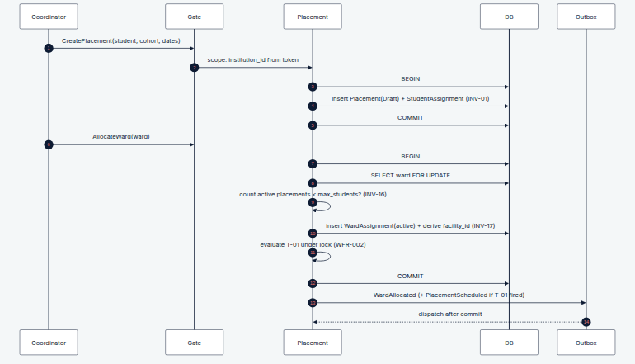

4.3 Exceptions
Condition | Behaviour
Ward at capacity | WardCapacityExceeded. The placement stays in Draft — it is not silently queued. Capacity negotiation remains an offline conversation (Stage 1 §9)
Two coordinators allocate the last slot concurrently | The Ward row lock serialises them; the second receives WardCapacityExceeded. This is exactly why INV-16 is TXN and not SVC
TransferWard mid-placement | Closes the current Ward Assignment, opens a new one, re-checks capacity on the target ward, re-derives facility_id. If the target ward is in a different facility, this is a withdrawal and a new placement, not a transfer — a placement cannot change facility (POL-003)
Cohort deleted | Not possible; cohorts soft-archive, and archiving a cohort with non-terminal placements is blocked

5. Workflow W-03 — Mentor Assignment & Reassignment
Field | Detail
Primary actor | Nurse Manager (Program Admin fallback)
Trigger | A Draft/Scheduled placement needs a mentor, or staffing changes mid-placement
Preconditions | Placement exists within the Nurse Manager's facility; candidate mentor employed at that facility
Commands | AssignMentor, ReassignMentor
Rules exercised | POL-005, POL-009, INV-12, T-01, TX-02, AUTH-006

5.1 Step table
# | Actor | Step | Guards checked | Writes | Events
1 | Nurse Manager | AssignMentor(placement, mentor) | Placement's facility_id = scope facility; mentor belongs to that facility; placement not terminal | Mentor Assignment (active); Audit | MentorAssigned
2 | System | Evaluate T-01 | Assignment set complete | Placement → Scheduled | PlacementScheduled
3 | Nurse Manager | ReassignMentor(placement, new mentor) | As above; lock Placement row; new ≠ current mentor | Close current assignment (ended_at, reason); open new; Audit ×2 | MentorReassigned
4 | Outbox | Post-commit | — | Notification record | Notify incoming mentor, outgoing mentor, student

5.2 Sequence
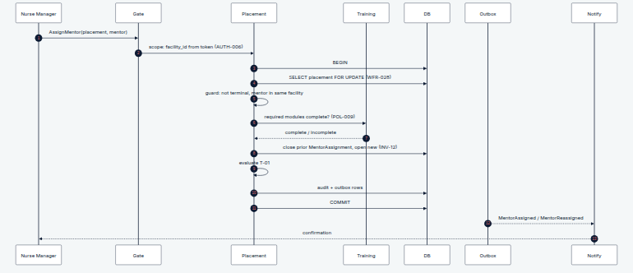

5.3 Reassignment semantics — what survives and what does not
This is the question the SADD's reassignMentor() method left unanswered, and the reason Stage 2 split assignments into their own sub-entities:
Artifact | On reassignment
Sessions logged by the outgoing mentor | Retained, attributed to the outgoing mentor, still owned by the placement (INV-03)
Induction checklist, if already complete | Retained. Induction belongs to the placement, not the mentor; a new mentor does not re-induct
Induction checklist, if in progress | Retained and continuable by the incoming mentor. Partial induction is not discarded because staffing changed
Placement state | Unchanged. Reassignment is not a transition; an Active placement stays Active
Outgoing mentor's access | Revoked immediately for new writes; retains read access to their own past entries (WFR-012)
Feedback already submitted about the outgoing mentor | Retained, and still attributed to the assignment period in which it was given

5.4 Exceptions
Condition | Behaviour
Mentor's required training incomplete | Assignment is permitted; the placement simply cannot pass T-03 until training completes or is overridden. Blocking assignment would stall wards for a paperwork reason
Mentor belongs to another facility | UnauthorizedFacilityAccess (404)
Placement is Completed/Archived/Withdrawn | PlacementArchived / PlacementClosed (INV-09)
Mentor account deactivated mid-placement | Placement is flagged as needing reassignment on the Nurse Manager dashboard; state is untouched. Sessions cannot be logged, because the assignment is inactive (WFR-011)

6. Workflow W-04 — Orientation → Arrival → Induction → Activation
Field | Detail
Primary actors | Student (orientation), Clinical Mentor (induction)
Trigger | Student confirms placement; later, student physically arrives at the unit
Commands | RecordOrientationProgress, OpenInduction, CompleteChecklistItem, SignInduction
Rules exercised | INV-02, INV-06, T-08, T-10, TX-03
This workflow contains the system's single most important invariant: a placement cannot become Active until induction is complete (INV-02). Everything about how it is sequenced exists to make that unbypassable.

6.1 Step table
# | Actor | Step | Guards checked | Writes | Events
1 | Student | RecordOrientationProgress | State = Orientation; actor is this placement's student | Orientation completion rows; Audit | OrientationProgressed
2 | Mentor / NM | OpenInduction (student has arrived) | State = Orientation; required orientation complete or override with reason (T-08, WFR-033) | Placement → Induction; Induction Checklist (from active template); Audit | InductionOpened
3 | Mentor | CompleteChecklistItem (×N, offline-capable) | State = Induction (INV-06); actor is active mentor; idempotent on command_id | Checklist item response; Audit | ChecklistItemCompleted
4 | Mentor | SignInduction | Lock Placement; all required items answered; actor is active mentor | Checklist → complete; Placement → Active (T-10); Audit ×2 | InductionCompleted, PlacementActivated
5 | Outbox | Post-commit | — | — | Notify student + Nurse Manager; recompute progress
Steps 3 and 4 are separate commands but a single transaction at step 4 (TX-03). The final item completion, the checklist status change, and the placement activation commit together — otherwise a crash between them leaves a complete checklist with an inactive placement, and a mentor who cannot log the session they just delivered.

6.2 Sequence
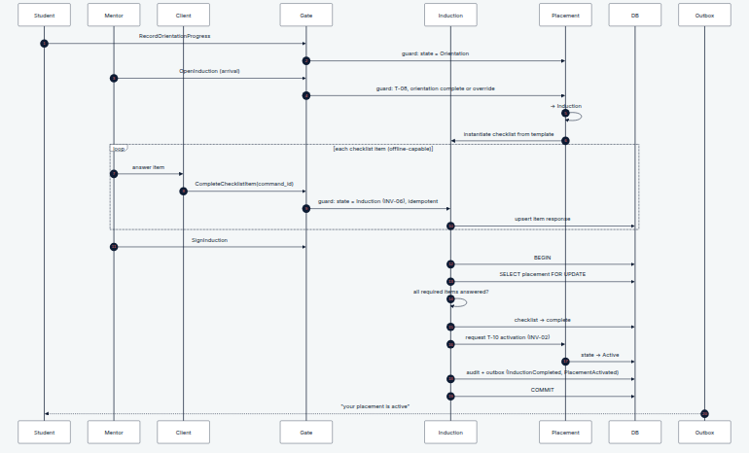

6.3 Exceptions
Condition | Behaviour
Student arrives without completing orientation | Nurse Manager override at T-08 with a recorded reason. Real wards do not turn students away for unfinished e-learning; the override is visible, not silent
Mentor signs induction with items unanswered | InductionIncomplete — the transition is refused, not the checklist
Placement paused mid-induction | Item completion is refused (INV-06 requires Induction; Paused is not it). Queued offline items are held client-side and replayed on resume — see W-05 §7.4
Two mentors sign concurrently | Placement row lock serialises; the second sees the placement already Active and receives the idempotent success, not PlacementAlreadyActive
Checklist template changed after instantiation | The placement keeps the template version it was instantiated with. Templates are versioned; live checklists never mutate underneath a mentor

7. Workflow W-05 — Mentorship Session Logging (with the offline retry path)
Field | Detail
Primary actor | Clinical Mentor
Trigger | Mentor completes a mentorship interaction; must log in under 3 minutes
Preconditions | Placement Active; actor is the active Mentor Assignment
Commands | LogSession, CorrectSession
Rules exercised | INV-03, INV-04, INV-05, WFR-009 – WFR-015, TX-04
This is the highest-frequency write in the system, the one performed on a ward floor with bad signal, and therefore the one whose failure modes matter most.

7.1 Step table
# | Actor | Step | Guards checked (in order) | Writes | Events
1 | Client | Form opens; command_id generated; draft saved locally | — | Local draft | —
2 | Client | LogSession(command_id, …) | — | — | —
3 | Gate | Authenticate; resolve scope; idempotency lookup on command_id | Replay → return original result (200) | — | —
4 | Session | Authorization | Actor is the placement's active mentor (WFR-011) | — | —
5 | Session | State | Placement = Active (INV-05) | — | —
6 | Session | Window | session_date inside placement period and outside every pause interval (INV-04) | — | —
7 | Session | Payload | Placement, mentor, date, type, ≥1 topic present (WFR-009) | — | —
8 | Session | Duplicate | Same placement + mentor + date, submitted within 5 min (WFR-014) | — | —
9 | Session | Commit | — | Session; Audit; Outbox | SessionLogged
10 | Outbox | Post-commit | — | Notification if follow_up = supervisor_review | Progress recompute; follow-up flag

7.2 Sequence — online path
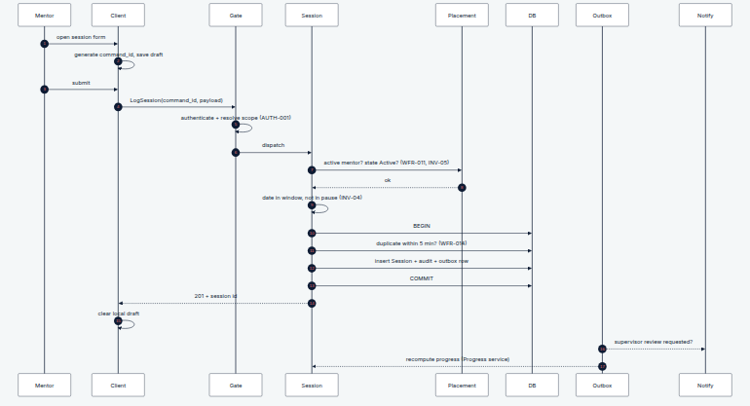

7.3 Sequence — offline retry path
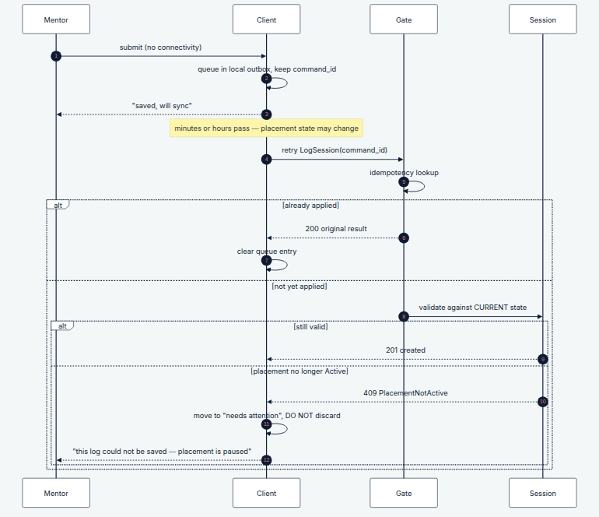

7.4 The late-replay decision, stated explicitly
A queued session log validated at arrival, not at draft time, can legitimately fail — the placement may have been paused or withdrawn in the interim. Three options exist, and the choice is a product decision, so it is recorded rather than assumed:
Option | Consequence
Reject and discard | Mentor loses documented work they performed. Unacceptable
Reject and retain client-side for human resolution (adopted) | Mentor sees a "needs attention" queue; a Nurse Manager can resume the placement, or the mentor can discard deliberately. Nothing is lost silently
Accept retroactively against past state | Breaks INV-04/INV-05 and lets a paused placement accumulate activity. Rejected
Adopted: reject, retain, surface. The client never silently drops a mentor's work, and the server never relaxes an invariant to accommodate a late arrival. Logged as OD-09 for stakeholder confirmation, since it implies a visible "unsynced logs" affordance in the mentor UI that the Concept Note does not describe.

7.5 Exceptions
Condition | Behaviour
Double-tap on Save | Same command_id → idempotent 200; no duplicate row
Two genuine sessions, same student, same day | Permitted. WFR-014's 5-minute window exists precisely so a morning and an afternoon session are not conflated
Mentor reassigned between draft and sync | UnauthorizedFacilityAccess; the log is retained client-side and routed to the Nurse Manager for reattribution. A session is never silently reattributed to a different mentor
Correction after 24h | SessionCorrectionWindowClosed; mentor may file a linked revision instead (WFR-013)
Clock skew on the device | session_date is a date, not a timestamp; server records submitted_at from server time. Never trust the device clock for the duplicate window

8. Workflow W-06 — Feedback & Assessment Submission (including anonymous routing)
Field | Detail
Primary actor | Student
Trigger | Periodic feedback, baseline confidence, or end-of-placement exit survey
Commands | SubmitFeedback, SubmitBaselineConfidence, SubmitFinalAssessment
Rules exercised | POL-012, POL-013, POL-014, INV-08, INV-14, INV-15, WFR-018 – WFR-021, TX-05

8.1 Step table
# | Actor | Step | Guards checked | Writes | Events
1 | Student | SubmitBaselineConfidence | State ∈ {Orientation, Induction} (WFR-018); scores in range (INV-15) | Assessment (immutable); Audit | BaselineSubmitted
2 | Student | SubmitFeedback | State ∈ {Orientation, Induction, Active, Paused} (WFR-020); scores in range | Feedback (immutable) — routed per anonymity mode | FeedbackSubmitted
3 | System | Anonymity routing | Mode is chosen per submission, defaulting to confidential (POL-014a). Confidential attaches to the Placement. Anonymous attaches to Cohort + Facility + Ward and holds no placement or student reference (POL-014) | — | —
4 | Student | SubmitFinalAssessment | On/after end_date or closure initiated (WFR-019); baseline exists | Assessment (immutable); Audit | FinalAssessmentSubmitted
5 | Progress | On read | ≥3 submissions before any mentor-visible aggregate (POL-013) | — (computed) | —

8.2 Sequence
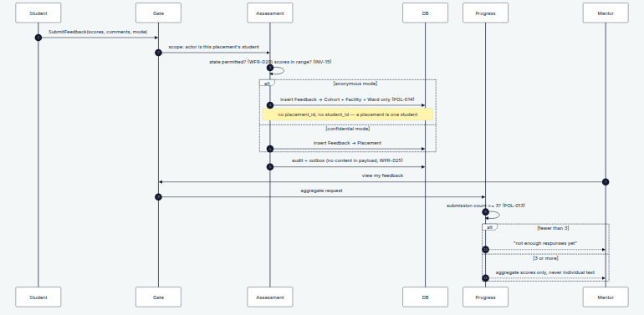

8.3 Exceptions
Condition | Behaviour
Student edits submitted feedback | FeedbackImmutable; a linked revision is created (POL-012)
Final assessment before end date | AssessmentOutOfWindow, unless closure has been initiated (WFR-019)
Confidence score 105 | ScoreOutOfRange at the DB check constraint, not just the form
Mentor requests feedback with n = 1 | Aggregate withheld. The response is "not enough responses", not an empty aggregate — an empty aggregate tells the mentor a response exists
Mentor filters an aggregate that passes n ≥ 3 in total but not per slice | Suppressed. The threshold is evaluated on the figure actually displayed, and no mentor-visible view offers attribute breakdowns at all (POL-013a)
Anonymous feedback needs follow-up | The student can flag "unresolved concern" without deanonymising; it routes as an Escalation (W-07) which has its own identity rules. Anonymity and follow-up are separate mechanisms and must not be conflated

9. Workflow W-07 — Escalation: Raise → Review → Resolve → Close
Field | Detail
Primary actors | Student or Mentor (raise); Nurse Manager / Coordinator (review)
Trigger | A serious concern about safety, conduct, or the learning environment
Commands | RaiseEscalation, AssignReviewer, RecordFinding, RecordAction, CloseEscalation
Rules exercised | INV-13, E-01 – E-06, WFR-005 – WFR-008, POL-019, TX-06, TX-07
This is the safeguarding-critical path and carries the strictest access control in the product. Note what is absent from every step below: no escalation content is ever placed in a notification, an event payload, an audit value, or a dashboard.

9.1 Step table
# | Actor | Step | Guards checked | Writes | Events
1 | Student/Mentor | RaiseEscalation (category, severity, description) | Actor linked to the placement; description present | Escalation (Open); Audit | EscalationRaised (id + severity only)
2 | Outbox | Route notification | Nurse Manager always; + Coordinator if severity = high (WFR-007) | Notification (no content, WFR-025) | —
3 | NM / Coord | AssignReviewer | Reviewer authorised for scope; reviewer ≠ subject (WFR-008) | Escalation → Under Review (E-02); Audit | EscalationUnderReview
4 | Reviewer | RecordFinding | Actor is assigned reviewer | Escalation → Action Required (E-03); Audit | —
5 | Reviewer | RecordAction | action_taken present | Escalation → Resolved (E-04/E-05); Audit | EscalationResolved
6 | Reviewer / NM | CloseEscalation | State = Resolved; closure_date set | Escalation → Closed (E-06); Audit | EscalationClosed
7 | Placement | Unblocks completion | No non-Closed escalations remain (INV-07) | — | —

9.2 Sequence
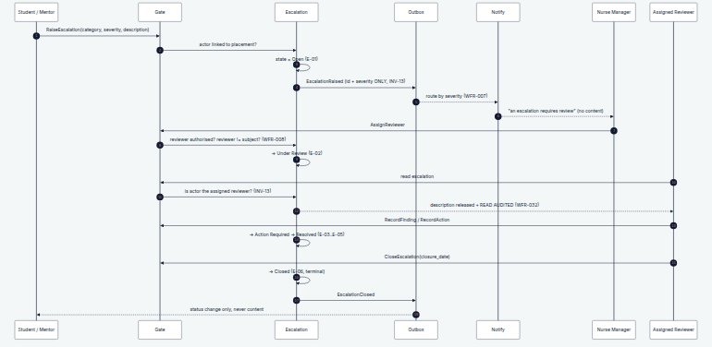

9.3 Exceptions
Condition | Behaviour
Reviewer is the subject | ReviewerConflictOfInterest; assignment escalates to Coordinator or Program Admin (WFR-008)
Unauthorised read of description | EscalationAccessDenied as 404, and the attempt is audited
Escalation raised by an anonymous feedback path | The escalation itself is not anonymous — it needs a reachable submitter to be investigable. The UI must state this before submission, not after
Closed escalation recurs | New escalation with related_escalation_id; no reopen (WFR-005)
Placement ends with escalation open | Completion blocked (INV-07). Deferral requires an authorised override with reason (OD-08)
Escalation names a patient | Cannot be structurally prevented in free text; the field carries the standing instruction (POL-015) and reviewers are trained to redact. Flagged as a residual risk, not a solved problem

10. Workflow W-08 — Completion, Reporting & Archival
Field | Detail
Primary actor | Nurse Manager (Program Admin fallback); system for archival
Trigger | Placement reaches its end date, or early closure is authorised
Commands | CompletePlacement, GenerateReport, ExportData, ArchivePlacement
Rules exercised | INV-07, INV-08, INV-09, T-13, T-17, TX-08, TX-09, WFR-032

10.1 Step table
# | Actor | Step | Guards checked (in order) | Writes | Events
1 | Student | Final assessment submitted | See W-06 step 4 | Assessment | FinalAssessmentSubmitted
2 | Nurse Manager | CompletePlacement | Lock Placement; state = Active; end date reached or authorised early closure; final assessment exists (INV-08); no non-Closed escalations (INV-07) | Placement → Completed (T-13); Audit | PlacementCompleted
3 | Outbox | Post-commit | — | Report artifact; certificate where applicable | Notify Coordinator, Student, Mentor
4 | Coordinator / NM | GenerateReport / ExportData | Scope-filtered; field-level restrictions applied (POL-016, INV-13) | Export record: actor, scope, filters, row count; Audit (WFR-032) | DataExported
5 | System | ArchivePlacement | Archive delay elapsed (default 30 days) | Placement → Archived (T-17); now immutable (INV-09) | PlacementArchived

10.2 Sequence
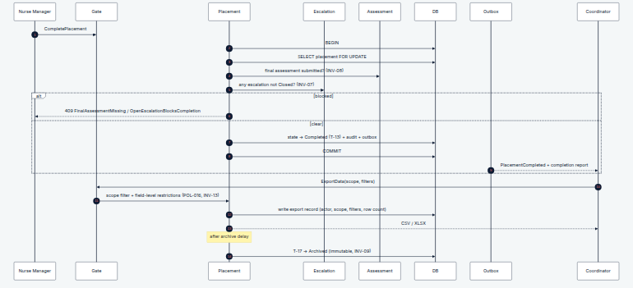

10.3 Exceptions
Condition | Behaviour
End date passed, student never submitted final assessment | Placement stalls in Active and appears on both dashboards as overdue. No auto-completion — completing without the exit survey destroys the primary outcome measure of the pilot
Low-severity escalation still open | Blocked by default; deferral override by Coordinator or Program Admin with reason (OD-08)
Export requested across scopes | Silently scope-filtered, and the export record states the applied scope so the recipient knows the extract is partial
Write attempted on an archived placement | PlacementArchived, enforced at DB — not merely a hidden button
Placement withdrawn instead of completed | Terminal immediately (WFR-004); reportable; no final assessment required

11. Rule Coverage Matrix
Every invariant should be exercised by at least one workflow. Anything unexercised is either dead or missing a workflow — this matrix is how we find out before Stage 4 rather than after.
Rule | W-01 | W-02 | W-03 | W-04 | W-05 | W-06 | W-07 | W-08
INV-01 student assignment |  | ✓
INV-02 induction gates Active |  |  |  | ✓
INV-03 session owned by placement |  |  | ✓ |  | ✓
INV-04 session window / pause |  |  |  |  | ✓
INV-05 Active-only logging |  |  |  | ✓ | ✓
INV-06 induction-state items |  |  |  | ✓
INV-07 escalation gates completion |  |  |  |  |  |  | ✓ | ✓
INV-08 final assessment gates completion |  |  |  |  |  | ✓ |  | ✓
INV-09 terminal immutability |  |  | ✓ |  |  |  |  | ✓
INV-10 no hard delete |  | ✓ |  |  |  | ✓
INV-11 attributable writes | ✓ | ✓ | ✓ | ✓ | ✓ | ✓ | ✓ | ✓
INV-12 one active assignment |  | ✓ | ✓
INV-13 escalation confidentiality |  |  |  |  |  |  | ✓ | ✓
INV-14 immutable submissions |  |  |  |  |  | ✓
INV-15 score ranges |  |  |  |  |  | ✓
INV-16 ward capacity |  | ✓
INV-17 derived scope fields |  | ✓
INV-18 no patient data | ✓ | ✓ | ✓ | ✓ | ✓ | ✓ | ✓ | ✓
All eighteen invariants are exercised. Two observations worth carrying into Stage 4:
- INV-10 (no hard delete) is barely exercised because no workflow deletes anything. That is the intended outcome, but it means the rule is enforced by the absence of commands — so Stage 4 must not introduce a delete command by reflex when scaffolding CRUD.
- INV-18 is exercised everywhere and enforced nowhere at runtime. It is a schema-review gate plus a UI instruction, and free-text fields remain a residual risk (W-07 §9.3). This should be named as an accepted risk in the pilot's data-governance sign-off rather than treated as closed.

12. Open Decisions — Status
Stage 3 logged OD-01 to OD-08. Walking the workflows surfaced three more. Three of Stage 3's were resolved by JKUAT on 30 July 2026 and are reflected throughout this document: OD-01 (a pause extends the actual end date, with planned dates retained), OD-03 (feedback visibility, with the min-3 threshold now applying per displayed figure), and OD-06 (both confidential and anonymous modes supported, confidential by default). One new question is outstanding — OD-12, whether the research evaluation requires sex-disaggregated reporting.
The three raised by this stage:
ID | Question | Recommendation | Blocking?
OD-09 | Late-arriving offline session logs that no longer validate: discard, retain for human resolution, or accept retroactively? (W-05 §7.4) | Retain and surface in a mentor-visible "unsynced" queue. Implies a UI affordance not in the Concept Note | Not blocking, but it changes the mentor UI scope — decide before Stage 7 (UI/UX)
OD-10 | Should an unconfirmed placement time out? (W-01 §3.3) | No. Surface as stalled; a human follows up. Auto-withdrawal would erase a real placement for an email-delivery failure | Not blocking
OD-11 | May a Nurse Manager complete a placement early, before end_date, and does it need Coordinator counter-approval? (extends OD-07) | Nurse Manager may, with a reason; Coordinator is notified, not asked. Requiring cross-institution approval to close a placement would stall closure indefinitely | Not blocking; confirm with both institutions

13. What Stage 4 Takes From This
Stage 4 (Module Architecture) inherits three concrete inputs, and should not need to invent any of them:
- The command surface (Appendix A) — the complete set of state-changing operations, with the context that owns each. Module boundaries follow from who owns which command, not from feature naming.
- The event surface (Appendix B) — every domain event raised, with its consumers. This is the module communication contract, so contexts never call each other synchronously to trigger side effects.
- The transaction inventory (Stage 3 §10, exercised here) — the set of operations that must be atomic. A module boundary drawn through a transaction is the wrong boundary, and this is how we detect it before it exists.
One conclusion I would put on the record now, since it will shape Stage 4: the current backend app layout (apps/sessions, apps/induction, apps/feedback, with no placements app at all) cannot express these workflows. Every one of the eight above is coordinated by the Placement aggregate, which currently has no home in the codebase, while three of its children each have their own. Stage 4 should restructure around bounded contexts and treat the existing app list as scaffolding to be replaced.

Appendix A — Command Surface
Command | Owning context | Actor | Workflow
CreateCohort, EnrolStudent | Institution | Coordinator | W-01
InvitePlacementParticipant | Placement | Coordinator | W-01
ConfirmPlacement | Placement | Student | W-01
CreatePlacement | Placement | Coordinator | W-02
AllocateWard, TransferWard | Placement | Coordinator | W-02
AssignMentor, ReassignMentor | Placement | Nurse Manager | W-03
RecordOrientationProgress | Learning | Student | W-04
OpenInduction, CompleteChecklistItem, SignInduction | Induction | Mentor / NM | W-04
LogSession, CorrectSession | Mentorship | Mentor | W-05
SubmitFeedback, SubmitBaselineConfidence, SubmitFinalAssessment | Assessment | Student | W-06
RaiseEscalation, AssignReviewer, RecordFinding, RecordAction, CloseEscalation | Safeguarding | Various | W-07
CompletePlacement, ArchivePlacement | Placement | NM / system | W-08
GenerateReport, ExportData | Analytics | NM / Coordinator / Admin | W-08
PausePlacement, ResumePlacement, WithdrawPlacement | Placement | NM / Coordinator | T-12, T-15, T-14
CompleteTrainingModule | Learning | Mentor | W-03 precondition

Appendix B — Event Surface
Event | Raised by | Consumed by
CohortCreated, StudentEnrolled | Institution | Analytics
PlacementCreated, WardAllocated, PlacementScheduled | Placement | Notification, Analytics
PlacementInvitationIssued, PlacementConfirmed | Placement | Notification, Analytics
MentorAssigned, MentorReassigned | Placement | Notification, Analytics
InductionOpened, ChecklistItemCompleted, InductionCompleted | Induction | Progress, Analytics
PlacementActivated | Placement | Notification, Progress
SessionLogged | Mentorship | Progress, Notification (supervisor review only), Analytics
BaselineSubmitted, FeedbackSubmitted, FinalAssessmentSubmitted | Assessment | Progress, Analytics
EscalationRaised, EscalationUnderReview, EscalationResolved, EscalationClosed | Safeguarding | Notification (routing only), Analytics (counts only)
PlacementCompleted, PlacementArchived | Placement | Reporting, Notification, Analytics
DataExported | Analytics | Audit
No event payload carries escalation content, individual feedback text, or session free text (WFR-025).

End of Stage 3.5: Use Cases & Sequence Diagrams — Sinaps Technology / JHUB Africa. Confidential.

