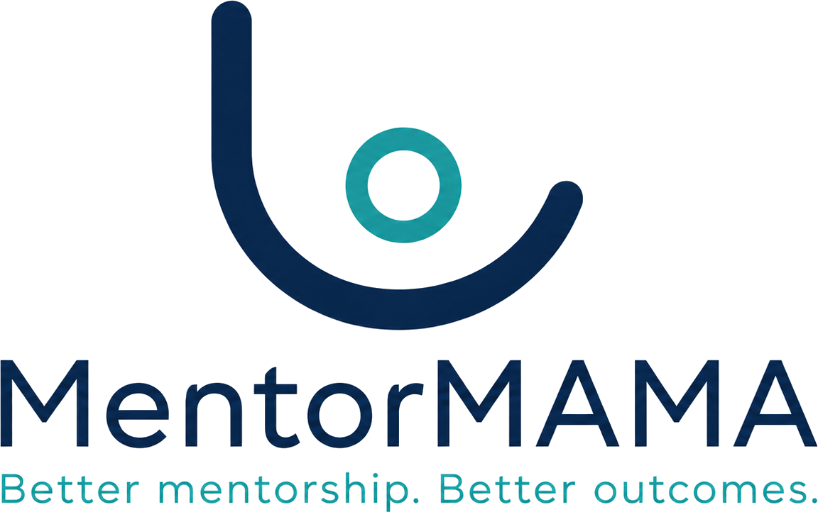
Stage 7 of the Design Sequence

UI / UX Architecture
Designing for two bars of signal and three minutes
Information architecture, the six mandatory screen states, the offline queue model, and the error copy catalogue — written against one user: a mentor mid-shift, on a phone, with a ward round starting in four minutes.
Product | MentorMAMA — Digital Mentorship Toolkit for Safer Midwifery Clinical Placement
Prepared by | Sinaps Technology — Bouric Okwaro Enos (Ric), Co-Founder & Team Lead
Document type | Stage 7 of the design sequence: UI / UX Architecture
Supersedes | SADD v2.0 §8.1–8.2 (information architecture and UI principles)
Precedes | Stage 8 (Sprints & Delivery Plan)
Builds on | Stage 6 API Design v1.0; Stage 5 Database Architecture v1.0; Stage 3 Business Rules v1.2; Brand Guidelines v1.0
Version | 1.0
Date | July 2026
Sinaps Technology | Driving Innovation Out of Isolation · Confidential — Sinaps Technology / JHUB Africa

1. What This Stage Decides
Everything the interface must do has already been decided somewhere else. The state machine is server-owned (Stage 3). Authorisation is a scope intersection (Stage 3 Part 8). Idempotency is a contract (Stage 6). What remains is the part nobody else can decide: what a person sees, in what order, when the connection drops halfway through.
This stage is written against one user, not a persona set: a clinical mentor, standing, mid-shift, on a phone, having just finished a teaching moment with a student, with a ward round starting in four minutes. If the interface works for her it will work for the Coordinator at a desk. The reverse is not true.

1.1 What Stage 7 inherits — and does not re-derive
Four things arrived from Stage 6 and the walking skeleton as running endpoints, not proposals. The UI consumes them; it does not reimplement them.
Inherited | Shape | Consequence for the UI
GET /me capability flags | {"capabilities": {"log_session": true, "complete_placement": false, …}} | Navigation and buttons render from flags. Never from a role string (FE-04)
GET /placements/{id}/transitions | {"state": "active", "available": ["paused","completed","withdrawn"], "blocked": [{"command":"complete","reasons":[{"code":"FinalAssessmentMissing"}]}]} | Action buttons are enabled from available; blocked reasons become the explanatory copy (FE-05)
The error catalogue with retryable | {"code": "PlacementNotActive", "retryable": false, …} | One sentence of copy per code, written once (§9). retryable decides queue behaviour, not the client
The idempotency contract | Idempotency-Key assigned at form-open | The client owns a queue, not a retry button (§6)

1.2 What this stage does not do
No visual design comps, no Figma file, no per-pixel spacing. Those are production artifacts that follow from this. This document decides structure, states, copy rules, and the offline model — the parts that are architecture rather than taste, and the parts that are expensive to change later.

2. Principles, in Priority Order
When two of these conflict, the higher one wins. That ordering is the useful part; every product claims all five.
- Never lose a mentor's work. She documented something that actually happened. If we cannot save it, we say so, keep it, and let her resolve it. Silence is the one unacceptable outcome (§6).
- Three minutes, and it is not negotiable. The Concept Note's acceptance criterion. A session log that takes five minutes will be filled in at the end of the week from memory, or not at all — at which point the product measures nothing.
- The student must be able to speak safely. The feedback and escalation paths are the reason the product is ethically defensible. Their copy must be plain about who will read what (§7).
- Show the state, including the awkward ones. Empty, loading, offline-queued, blocked, failed. A screen that only renders its happy path is unfinished (§5).
- Calm, not cheerful. This is a hospital. The brand's own voice rule: "encouraging without being cheerful — this is a hospital, not a wellness app."

3. Information Architecture
Five role-scoped zones, driven by capability flags. A user sees exactly one zone.
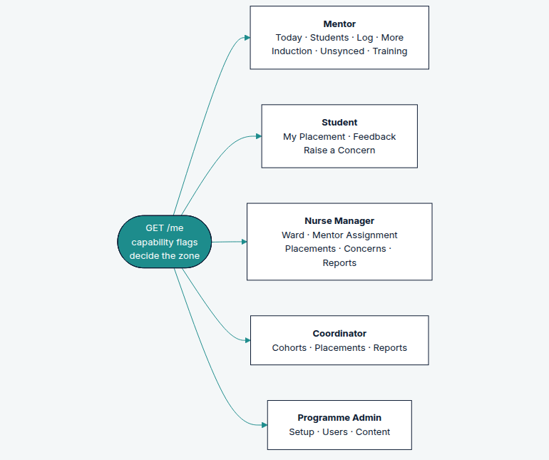

3.1 Navigation model
Breakpoint | Pattern
Mobile (375–767px) | Bottom tab bar, max four tabs, plus one primary action. Thumb-reachable; no hamburger for primary destinations
Tablet (768–1023px) | Same tabs, promoted to a side rail
Desktop (1024px+) | Persistent left navigation. Same destinations, no extra features — a Nurse Manager on a phone is not a second-class user
Mentor tabs: Today · Students · Log · More. The primary action (Log a session) is a tab rather than a floating button, because it is used dozens of times a week and a FAB is a smaller target that overlaps content.

3.2 The Mentor's "Today"
The landing screen answers three questions in one glance, ordered by consequence:
- Anything unsynced? If yes, this is the first thing on the screen, always (§6.4).
- Who needs an induction? Students whose placement is in induction — blocking their ward practice.
- Who has not been seen recently? Assigned students ranked by days since last session.
No graphs. A mentor mid-shift needs a list of names and a next action, not a bar chart of her own activity.

4. The Session Log — the screen the product lives or dies on
Every other screen can be mediocre and the pilot can still succeed. If this one takes five minutes, nothing else matters.

4.1 Field specification
# | Field | Control | Required | Default
1 | Student | Single-select list | Yes | Pre-selected if entered from a student's page
2 | Date | Date, session_date | Yes | Today
3 | Session type | Chip group, single select, 7 options | Yes | none
4 | Topics | Chip group, multi-select, 8 options | Yes (≥1) | none
5 | Time spent | Chip group: 5 / 10 / 15 / 30 / 45+ min | No | none
6 | What was covered | Textarea, 2 rows | No | —
7 | Feedback given | Textarea, 2 rows | No | —
8 | Follow-up | Single-select, 5 options | No | "None"
Chips rather than dropdowns for 3–5: a native select on Android costs a tap, a modal, a scroll and a confirm — four interactions where a chip costs one. Fields 1–4 are the only required ones, so the form is submittable in five taps.
Fields 6 and 7 are optional and last, with the no-patient-identifiers instruction shown at the point of entry (POL-015) — not in a tooltip, not in a help page.

4.2 Interaction rules
- Idempotency-Key is generated when the form opens (Stage 6 §5), not on submit.
- The draft is persisted locally on every field change. Closing the app mid-form loses nothing.
- Submit is enabled as soon as fields 1–4 are valid. It never spins for longer than 400ms before showing an outcome — if the request is still in flight, the outcome shown is "Queued", which is true (§6).
- After submit: a single confirmation line and the option to log another for the same student, because mentors work through students in batches.
- No confirmation dialogue. The correction window (WFR-013, 24 hours) exists precisely so that a mis-tap is fixable without a modal in front of every save.

4.3 The three-minute budget, allocated
Step | Budget
Open the app to the form (including cold start) | 20s
Select student and date | 15s
Type and topics | 20s
Optional free text (when used) | 60s
Submit and confirm | 5s
Total, worst case | 2:00
The margin is deliberate. If the measured median in usability testing exceeds 2:00, fields 6–7 move behind a "Add detail" disclosure rather than the budget being renegotiated.

5. Screen States — all six are mandatory
Every screen defines all of these before it is considered done (FE-06). Five come from the SADD; the sixth is new and comes from the authorisation model.
State | Rule | Example copy
Loading | Skeleton matching the eventual layout, never a centred spinner on a full page. No layout shift on arrival | —
Empty | Says why it is empty and what to do next. Never just "No data" | "No students assigned yet. Your nurse manager assigns students when they arrive on the ward."
Error | The catalogue sentence for the code (§9), plus the one action available | "We couldn't load this. Try again."
Offline-queued | Explicit and reassuring. The item is visible and marked, not hidden | "Saved on this phone. It will sync when you have signal."
Blocked | The action exists but is unavailable, and the screen says why — from transitions.blocked | "Can't complete yet: the student's exit survey hasn't been submitted."
Success | Confirms what changed, in the user's terms | "Session logged for Amina."
The Blocked state is the one teams skip, and it is the difference between an interface that explains the rules and one that appears broken. A disabled button with no reason produces a support call; a disabled button with "Can't complete yet: one concern is still open" produces a resolved concern.

6. The Offline Model
This is the section that justifies the stage. Everything here follows from one fact established in Stage 3.5 §2.4: every mutating request in the mentor and student journeys will be sent more than once, and some will arrive hours late against a placement whose state has changed.

6.1 One queue, owned by lib/offline
No feature performs its own write (FE-02). Every command goes into a single client outbox with a durable status:
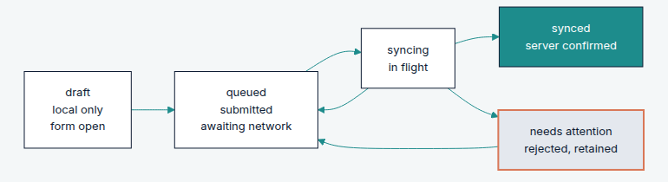
syncing → queued is a retryable failure (network, 503, CommandInProgress). syncing → needs attention is a non-retryable rejection. The client makes that decision from the response's retryable field, never from its own list of error codes (Stage 6 §6.3).

6.2 Nothing is ever silently dropped
Situation | What the mentor sees
Submitted with no signal | "Saved on this phone. It will sync when you have signal." Row appears with a queued marker
Response lost, command actually applied | Reconciled via GET /commands/{command_id}; the row flips to synced with no duplicate
Replay of an applied command | Server returns the original; the client clears the queue entry silently
Late arrival, placement now paused | Row moves to needs attention with the reason, and the option to ask the nurse manager or discard deliberately
Reassigned between draft and sync | Row moves to needs attention: "You're no longer this student's mentor. Send to the nurse manager to reattribute?"

6.3 A queued item is a first-class citizen
Queued sessions appear in the student's session list, marked, counted in "days since last session", and included in the mentor's own activity view. They are not hidden until sync.
The reason is behavioural: if a mentor logs a session and it vanishes from the list until the connection returns, she will log it again. Hiding queued work manufactures the duplicates the idempotency contract then has to clean up.
Server-derived numbers (dashboards, cohort indicators) never include queued items, because those come from projections. Any figure that mixes local and server state is labelled "including 2 not yet synced".

6.4 The Unsynced screen
Required by OD-09, and absent from the Concept Note — flagged there as a scope addition.
- Reachable in one tap from Today whenever the queue is non-empty, and not shown at all when it is empty.
- Grouped: Needs attention first, then Waiting for signal.
- Each row: what it was, who it was about, when it was captured, and — for needs-attention — the reason in plain language plus one or two actions.
- A manual "Sync now", because a mentor who has just walked into a signal area will press it, and denying her that produces a reload-the-app superstition.

7. Safeguarding and Feedback UX
The two flows where the interface carries ethical weight rather than merely functional weight.

7.1 Raise a Concern — honest before submission
The escalation path is not anonymous (Stage 3.5 §9.3): an uninvestigable safeguarding report helps nobody. The interface says so before the text field, not after submission:
Your name is shared with the reviewer handling this. Only they, and the programme administrator, can read what you write here.
Also stated: severity affects who is notified (WFR-007), and the student may see status changes but not the reviewer's notes.

7.2 Feedback — two modes, and the trade-off stated plainly
POL-014a requires the choice at submission, defaulting to confidential. The copy must make the consequence legible to a 21-year-old student on a phone, not to a lawyer:
Mode | Label | Explanation shown
Confidential (default) | "Confidential" | "Your nurse manager and university coordinator can see this and who wrote it. Your mentor cannot."
Anonymous | "Anonymous" | "Nobody can tell this came from you — not even us. Because of that, nobody can follow it up with you, and it won't be linked to your placement."
The anonymous option must not be presented as the safer choice by default styling. It is a genuine trade-off, and a student who wants follow-up should not have to discover afterwards that she chose against it.

7.3 Reviewer and mentor views
- Escalation lists never contain content (SEC-05) — category, severity, state and age only. This is a UI consequence of a serialisation rule, and both must hold.
- The mentor's feedback view shows aggregates only, and below three responses shows "Not enough responses yet" — not an empty chart, because an empty chart tells the mentor a response exists (POL-013).
- No filters on the mentor's aggregate view. Not "no filters for now": the projection has no attribute columns to filter on (POL-013a), and the UI must not imply a capability the data model deliberately lacks.

8. Actions Driven by the Server

8.1 Buttons come from transitions
GET /placements/{id}/transitions
→ available: ["paused", "completed", "withdrawn"]
blocked: [{command: "complete", reasons: [{code: "FinalAssessmentMissing"}]}]
Rendering rule: an action in available is enabled. An action in blocked is visible but disabled, with its reason shown inline — not hidden. Hiding it makes the workflow unlearnable; showing it with a reason teaches the rule at the moment it matters.

8.2 Navigation comes from capabilities
GET /me decides which zone and which destinations exist. A client that infers role === "mentor" and builds a menu has re-implemented the authorisation matrix, and will drift from it the first time a rule changes (FE-04). The flags exist so that never happens.

9. Error Copy Catalogue
One sentence per code, written once, mapped in lib/api (MA-19, FE-03). Extracted here because the copy is a design artifact, not a string constant.
Code | User-facing copy | Retry | Screen state
PlacementNotActive | "This placement isn't active, so sessions can't be logged right now." | No | Needs attention
SessionOutsidePlacementWindow | "That date is outside the placement period." | No | Field error on date
SessionValidationFailed | "Add at least one topic before saving." | No | Field error
DuplicateSession | "Already logged — we kept the first one." | n/a (200) | Success
SessionCorrectionWindowClosed | "This session is older than 24 hours. Add a correction instead." | No | Blocked
InductionIncomplete | "Some required checklist items are still unanswered." | No | Blocked
FinalAssessmentMissing | "Can't complete yet: the student's exit survey hasn't been submitted." | No | Blocked
OpenEscalationBlocksCompletion | "Can't complete yet: a concern is still open on this placement." | No | Blocked
MentorAlreadyAssigned | "This placement already has an active mentor." | No | Blocked
WardCapacityExceeded | "This ward is full. Choose another ward or free a place first." | No | Blocked
TrainingIncomplete | "This mentor still has required training to finish." | No | Blocked
StudentAlreadyAssigned | "This student already has a placement over these dates." | No | Blocked
FeedbackImmutable | "Submitted feedback can't be edited. You can add a correction." | No | Blocked
ReviewerConflictOfInterest | "Someone else needs to review this — it concerns you." | No | Blocked
InvalidTransition | "That isn't possible from the placement's current state." | No | Blocked
UnauthorizedFacilityAccess | "Not found." | No | Empty / 404
IdempotencyKeyRequired | (never shown — a client bug; log it) | No | —
CommandInProgress | "Still saving. One moment." | Yes | Syncing
StaleResource | "Someone changed this while you had it open. Reload to see the latest." | No | Error with reload
network / 5xx | "No connection. Saved on this phone and will sync." | Yes | Offline-queued
Two deliberate choices. UnauthorizedFacilityAccess renders as an ordinary not-found, because AUTH-004's whole point is not confirming the record exists. And IdempotencyKeyRequired is never shown to a user: if it happens, the client failed to do its job, and the fix is a bug report rather than copy.

10. Accessibility and Performance Budgets

10.1 Accessibility — non-negotiable, not aspirational
Requirement | Standard
Contrast | 4.5:1 body, 3:1 large text. Terracotta on white fails at small sizes — never body text
Touch targets | 44 × 44px minimum, 8px apart. Chips are 44px tall regardless of label length
Keyboard | Every action reachable and operable; visible focus ring (never outline: none)
Screen readers | Form fields labelled, not placeholder-only. The logo carries aria-label="MentorMAMA"
Motion | Honour prefers-reduced-motion — the site uses GSAP, so this is a real obligation, not a checkbox
Errors | Announced via aria-live, and associated with their field via aria-describedby
Zoom | Usable at 200% without horizontal scrolling

10.2 Performance — budgets, because "fast" is not a requirement
Metric | Budget | Why
First contentful paint, 3G, mid-range Android | < 2.0s | SADD §7.5
Time to interactive on the session log | < 2.5s | Inside the three-minute budget
JS bundle, initial route | < 180KB gzipped | The marketing site is already 150KB; the portal must not exceed it
Fonts | 2 families, 4 weights total, font-display: swap, preconnected | Manrope + Inter (Brand §07)
Images | None on the mentor critical path. Content-library media is lazy and behind a tap | Bandwidth is a clinical constraint
Offline shell | Service worker caches the app shell and the mentor's assigned-student list | The form must open with no connection

11. Reuse and Tokens
The portal uses packages/ui and the brand tokens rather than starting a second design system.
- Palette from packages/ui/src/tokens/colors.ts: navy ~30%, white/mist ~50%, teal ~15%, terracotta under 5% and never decorative — a rule this repo has already broken once and had to repair.
- Type: Manrope headings, Inter body, per Brand §07. The marketing site's Playfair Display was a deviation and was corrected; the portal must not reintroduce it.
- The logo comes from the Logo component, never re-set as text (assets/brand/logo/README.md).
- Shape language: soft, rounded, continuous. Radius 8px for cards and inputs, pill for primary actions.

12. New Open Decisions
ID | Question | Recommendation
OD-19 | Do queued sessions count toward the "days since last session" indicator the mentor sees? | Yes locally, labelled — §6.3. Server projections never count them, so mentor-local and dashboard figures can differ by design. Confirm this is acceptable to the programme team
OD-20 | Does a student see the status of a concern she raised, and at what granularity? | Recommend state only (under review, resolved, closed) with no reviewer notes. Needs JKUAT confirmation — it is a safeguarding-communication decision, not a UI one
OD-21 | Is English-only acceptable for the pilot UI, with Kiswahili after usability testing? | Yes, per Concept Note §19 — but copy should be written for translation now (no concatenated sentences, no text baked into images)

13. What Stage 8 Inherits
Stage 8 (Sprints & Delivery) receives a screen inventory with states, the offline model, the copy catalogue, and the budgets. Two things it should carry forward as sequencing constraints:
- The mentor journey ships first and complete, including the Unsynced screen. A partial offline implementation is worse than none, because it teaches mentors that the app loses work.
- Usability testing measures the three-minute budget on real devices before feature breadth is added. If the median exceeds 2:00, the response is to move fields behind disclosure, not to renegotiate the budget.

End of Stage 7: UI / UX Architecture — Sinaps Technology / JHUB Africa. Confidential.

