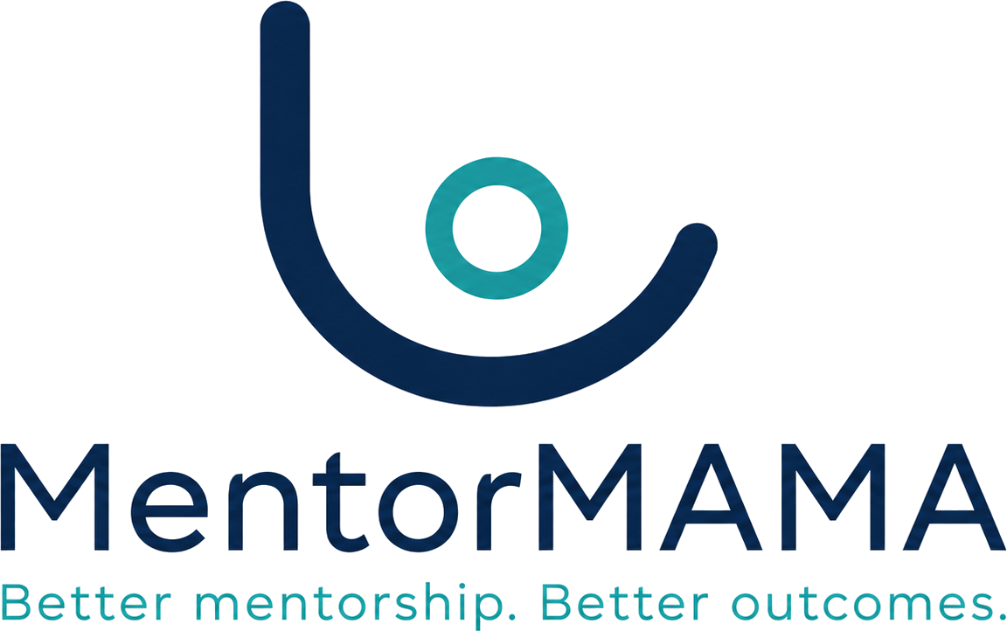
Product Governance · Decision Memo

Three Decisions We Need From You
And seven we have made on your behalf
Two decisions block the pilot because they determine what students and mentors must be told before a single response is collected. One blocks the database design. The rest are recorded so they can be overturned.
To | Dr. Carolyne Kerubo Nyariki, JKUAT School of Nursing · AfyaVentures programme team · JHUB Africa
From | Sinaps Technology — Bouric Okwaro Enos (Ric), Co-Founder & Team Lead
Document type | Decision memo — product governance
Date | 30 July 2026
Response requested by | 13 August 2026 (10 working days)
Version | 1.0
Sinaps Technology | Driving Innovation Out of Isolation · Confidential — Sinaps Technology / JHUB Africa

1. Why You Are Receiving This
We have completed the design work that precedes coding: the business discovery, the domain model, the business rules, and the step-by-step workflows. That work surfaced eleven open decisions. Eight of them are engineering judgement calls and we have made them, with our reasoning recorded so you can overturn any of them.
Three are not ours to make. Two of those three block the pilot — not the code, the pilot — because they determine what we must tell students and mentors before they submit a single response. The third determines a database structure we would rather not rebuild after data exists.
This memo asks for those three, lists ten places where our design changed something the Concept Note said, and tells you what we will do if we do not hear back.
If we have no response by 13 August, we will proceed on the recommendation stated for each item and record it as a Sinaps decision rather than a stakeholder decision. That is a worse outcome for two of these three, because they carry research-ethics and consent implications we are not the right people to settle.

2. Decision 1 — Who can see student feedback? (Blocks the pilot)
Reference: OD-03. Raised as an open decision in the Concept Note itself (§19).

The question
A student submits feedback saying their mentor was unavailable, or that the learning environment did not feel respectful. Who can read it?
Four candidate answers, with what each costs:
Option | Consequence
Mentor sees individual responses | Students will not report honestly about the person supervising and assessing them. The feedback becomes worthless as a quality signal
Nurse Manager and Coordinator see individual responses; mentor sees nothing | Honest feedback, but the mentor never learns anything from it — which undercuts the capacity-building purpose of the product
Nurse Manager and Coordinator see individual; mentor sees aggregates only, and only once at least 3 responses exist (recommended) | Honest feedback, mentor still gets a signal they can act on, and no single student is identifiable
Nobody sees anything but aggregates | Safeguarding concerns hidden inside routine feedback would never reach a human

Why the threshold of 3 matters
"The mentor sees aggregate data only" sounds safe and is not. If a mentor has one student and that student submits one response, the "aggregate" is that student's response, attributed by process of elimination. Any system that shows a mentor an average of one thing has shown them an individual's answer.
We recommend suppressing mentor-visible aggregates until at least three responses exist, and displaying "not enough responses yet" rather than an empty chart — because an empty chart still tells a mentor that a response was submitted.

What we need from you
- Confirm the recommended option, or choose another.
- Confirm the threshold of 3 is acceptable for the pilot's cohort sizes.
- Confirm who drafts the consent wording that tells students this, and by when.
This blocks the pilot because the consent language depends on the answer, and consent must be in place before the first response is collected — not before the first line of code.

3. Decision 2 — What does anonymous feedback attach to? (Blocks the pilot)
Reference: OD-06.

The question
If a student submits feedback anonymously, what record does it belong to?
Here is the problem we found. The obvious implementation attaches the response to the student's placement and omits their name. But a placement concerns exactly one student — so a response attached to a placement identifies the student completely, name or no name. "Anonymous" feedback linked to a placement is not anonymous.
Our design therefore attaches anonymous responses to Cohort + Facility + Ward and stores no placement or student reference at all. That is genuinely anonymous. It also means:
- Anonymous responses cannot be traced back to a placement for analysis.
- Anonymous responses cannot trigger follow-up with that student.
- If a ward has only one student from one cohort in a period, even this grouping narrows to one person. In a small pilot that is a realistic scenario.

The trade-off you need to decide
If you want | Then
Genuine anonymity | Accept that anonymous responses are analysable only at ward/cohort level, and cannot be followed up
Placement-level analysis of feedback | The mode must be called confidential (restricted access), not anonymous, and students must be told exactly that
Both | Not possible. This is a real constraint, not an implementation limitation
Note this also affects the research evaluation: if the study needs to correlate feedback with individual placement characteristics, an anonymous mode cannot supply that data.

What we need from you
- Confirm the anonymous mode is genuinely anonymous (our recommendation), or replace it with a clearly labelled confidential mode.
- Confirm whether the research evaluation requires placement-level linkage of feedback. If it does, we need to know now.
- Confirm the small-ward caveat is acceptable, and that consent wording will say so plainly rather than promising an anonymity the numbers cannot deliver.
A separate mechanism already exists for concerns needing follow-up: the escalation pathway, which is deliberately not anonymous because an uninvestigable safeguarding report helps nobody. The interface will state this before submission. Please confirm you are comfortable with that distinction.

4. Decision 3 — When a placement is paused, does the end date move? (Blocks the database design)
Reference: OD-01.

The question
A student's placement runs 1 July to 1 September. On 15 July the ward closes for two weeks, or the student falls ill. The placement is paused and resumes on 29 July.
Does the placement now end on 1 September (calendar preserved, student gets two weeks less mentorship) or 15 September (mentorship time preserved, calendar extended)?
Option | Consequence
End date extends (recommended) | The student receives their full intended mentorship time. Placement may run past the cohort's planned window and past the academic term
End date fixed | The calendar is predictable and cohort reporting is clean, but a paused student is quietly short-changed on supervision
We recommend extending, and keeping the original dates recorded separately as planned start and end, so both the intended and actual windows are reportable.
This is a genuine academic and regulatory question, not a technical one: it turns on whether the placement's required duration is a quantity of supervised practice or a period on the calendar. You will know which your accreditation treats it as; we do not.

Why we need it before building the database
The answer determines whether placement dates are fixed values or mutable ones, and whether we store one pair of dates or two. Changing that after real placements exist means a data migration on live pilot records.
This blocks Stage 5 (database design), not the pilot. We can continue with module architecture in the meantime.

5. Ten Places Where Our Design Changed Something the Concept Note Said
None of these are defects in the Concept Note. They are the design sequence doing its job. We are listing them so nothing is silently overridden — please flag anything you disagree with.
# | Concept Note | Our design | Type | Needs your acknowledgement
C-01 | CPD/Content Reviewer is an MVP role | Deferred to Phase 2 — it touches no part of the placement workflow, and the Note already defers regulator integration | Scope reduction | Yes
C-02 | Student profile holds their assigned mentor and placement dates | Those belong to the placement; a student has several placements over time | Structural only | No
C-03 | Feedback visibility is an open decision | See §2 | Decision | Yes — blocks pilot
C-04 | Induction checklist is completed when the student reports to the unit | Also a hard gate: no mentorship session can be logged until induction is complete | Strengthening | Yes — this can block a ward, deliberately
C-05 | Escalation access "restricted to authorised reviewers" | Only the assigned reviewer, the submitter, and the Programme Administrator can read the description; the subject of a concern can never review it; every read is logged | Strengthening | Yes — informs consent wording
C-06 | Offline support means draft-saving and retry sync | Retries can arrive hours later, after the placement has changed. Mentors will get a visible "unsynced logs" screen so nothing is silently lost | New requirement | Yes — small UI addition
C-07 | Dashboard indicators are stored metrics | Calculated on demand from the underlying records, so they can never disagree with the facts | Implementation only | No
C-08 | A ward has a maximum number of students | Enforced as a hard block on allocation, not a warning | Strengthening | Yes — confirm hard block is what you want
C-09 | "Escalation flag for serious concerns" | A full five-stage reviewed lifecycle with conflict-of-interest rules | Deeper than specified, given safeguarding stakes | Yes — acknowledge the added effort
C-10 | Capacity negotiation between coordinator and hospital | Stays an offline conversation for the MVP; we record the agreed number and build no workflow around it | Scope reduction | Yes — already recommended at Stage 1

6. Eight Decisions We Have Made
Recorded so you can overturn any of them. Full reasoning is in Stage 3 §13 and Stage 3.5 §12.
ID | Decision | Our call
OD-02 | Must a mentor finish required training before a placement is announced to the student? | Yes by default, with a programme-level setting and an Administrator override that records a reason. A mentor can still be assigned while training is outstanding, so wards are never stalled by paperwork
OD-04 | Is a Nurse Manager's boundary the facility or the ward? | The facility, with ward as a filter. At pilot scale they are the same set
OD-05 | How long after completion does a placement become read-only? | 30 days, configurable
OD-07 / OD-11 | Who may close a placement early, and does the university approve? | The Nurse Manager, with a recorded reason; the Coordinator is notified, not asked. Requiring cross-institution approval would stall closures indefinitely
OD-08 | Can a placement be completed while a concern is still open? | No by default. A low-severity concern may be deferred by explicit override with a reason; a high-severity one never can
OD-09 | What happens to an offline session log that no longer validates when it finally syncs? | Retained and shown to the mentor for resolution. Never silently discarded, and never accepted retroactively against a paused placement
OD-10 | Should a placement time out if the student never confirms it? | No. It is flagged for human follow-up. Auto-withdrawing a real placement because an email failed to arrive is the worse error
— | Are co-mentors supported (two mentors on one placement)? | Not in the MVP. Nothing in the source material establishes it, and the model preserves reassignment history without it. Straightforward to add later if wards actually work that way — tell us if they do

7. One Risk We Cannot Engineer Away
The system will not collect patient-identifiable data: there is no field anywhere in it for a patient name, phone number, or file number. That part is structural and we are confident in it.
What we cannot prevent is a mentor or student typing a patient's name into a free-text box — a session note, a concern description. We mitigate it with an instruction at the point of entry and restricted access to those fields, and reviewers can redact. But it is a residual risk, not a solved problem, and it should appear as such in the data-governance sign-off rather than being described as prevented.
If your governance process needs a stronger control than instruction-plus-redaction, tell us now: options include removing free text from the highest-risk fields altogether, or adding a pattern-based warning before submission. Both cost usability on a form that must stay under three minutes.

8. What Happens Next
Track | Status
Stage 4 — Module Architecture | Starting now; does not depend on any of these decisions
Stage 5 — Database Architecture | Blocked on OD-01 (§4)
Consent wording & data-governance sign-off | Blocked on OD-03 and OD-06 (§2, §3)
Pilot data collection | Blocked on consent sign-off
Stage 7 — UI/UX | Needs OD-09 confirmed (already decided; flag if you disagree)
We are happy to walk through §2 and §3 in a 30-minute call rather than by email — they are easier to settle in conversation, and both turn on judgement rather than fact.

Prepared by Sinaps Technology for AfyaVentures / JHUB Africa / JKUAT School of Nursing. Confidential.

