Button mushroom house — wall thermal analysis
Comparing an aluminium / XPS foam / PVC composite panel wall against a solid 230mm brick wall for a 6m x 3m (18m²) wall section

1. Purpose and target conditions
This report evaluates two candidate wall assemblies for a button mushroom (Agaricus bisporus) fruiting house: a lightweight aluminium/XPS-foam/PVC composite sandwich panel, and a solid 230mm clay brick wall. The goal is to compare their steady-state insulation performance and their dynamic response to a full day of outside temperature swing, against the crop's required fruiting conditions.
- Target inside temperature: 16-18°C
- Target relative humidity: 85-95% (not modeled here - thermal only)
- Outside temperature range modeled: 0°C to 43°C, varying as a 24-hour sine wave
- Wall section modeled: 6m x 3m = 18 m²

2. Wall assemblies modeled

2.1 Composite panel (aluminium / XPS foam / PVC)
Layer | Thickness | Conductivity k | Density | Role
Outside air film | - | - | - | Surface resistance, R = 0.04 m²K/W
Aluminium sheet | 0.5 mm | 205 W/m·K | 2700 kg/m³ | Weatherproof skin, negligible R
XPS foam core | 75 mm | 0.029 W/m·K | 35 kg/m³ | 87% of wall's insulation value
PVC foam liner | 8 mm | 0.04 W/m·K | 600 kg/m³ | Washable interior, 7% of R
Inside air film | - | - | - | Surface resistance, R = 0.13 m²K/W

2.2 Solid brick wall
Layer | Thickness | Conductivity k | Density | Specific heat
Outside air film | - | - | - | -
Solid clay brick | 230 mm | 0.72 W/m·K | 1700 kg/m³ | 840 J/kg·K
Inside air film | - | - | - | -
The brick wall is modeled with no added insulation layer, matching the plain brick option as originally proposed, so its performance can be judged on its own before considering a combined brick-plus-insulation design.

3. Steady-state heat transfer
Steady-state performance is governed by each layer's thermal resistance, calculated in series:
R = L / k (m²K/W) for each conductive layer
R_total = R_outside film + R_layer1 + R_layer2 + ... + R_inside film
U = 1 / R_total (W/m²K)
Q = U x A x (T_outside - T_inside) (W)
With the inside setpoint held at 17°C and A = 18 m², the two assemblies compare as follows:
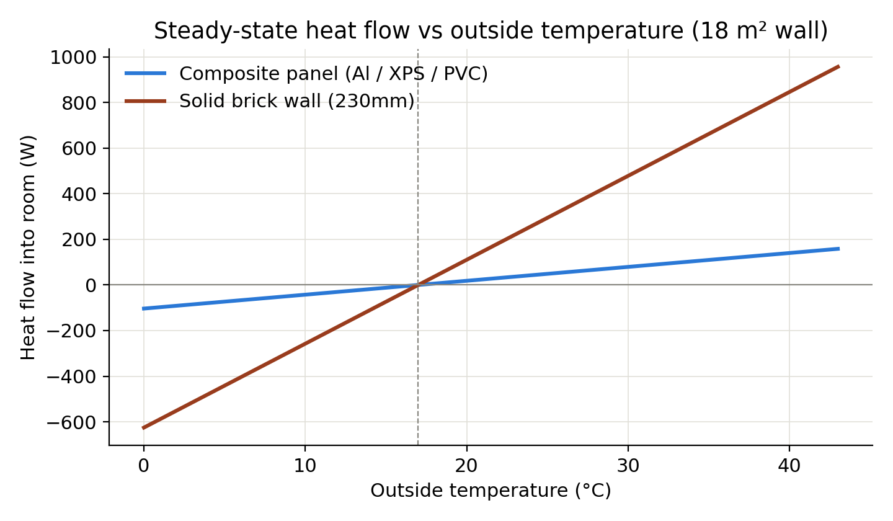
Figure 1 - Steady-state heat flow into the room vs outside temperature
The brick wall's U-value is roughly six times higher than the composite panel, meaning cooling and heating equipment sized for the panel wall would be badly undersized for brick alone.

4. Dynamic (24-hour) thermal response
Steady-state values assume a fixed outside temperature, but outside conditions cycle daily. Each wall's thermal mass (capacitance) damps and delays how much of that swing reaches the inside surface. This is modeled as a first-order RC thermal circuit driven by a sinusoidal outside temperature.
C = m x cp (J/K), where m is layer mass and cp is specific heat
tau = R x C (s), the wall's thermal time constant
T_out(t) = T_mean + T_amp x sin(w t - pi/2), with T_mean = T_amp = 21.5°C, period = 24h
Attenuation = 1 / sqrt(1 + (w R C)^2) Phase lag = arctan(w R C) / w
T_inside(t) = T_mean - T_amp x Attenuation x cos(w t - Phase lag)
Applying this to both walls over a 24-hour cycle:
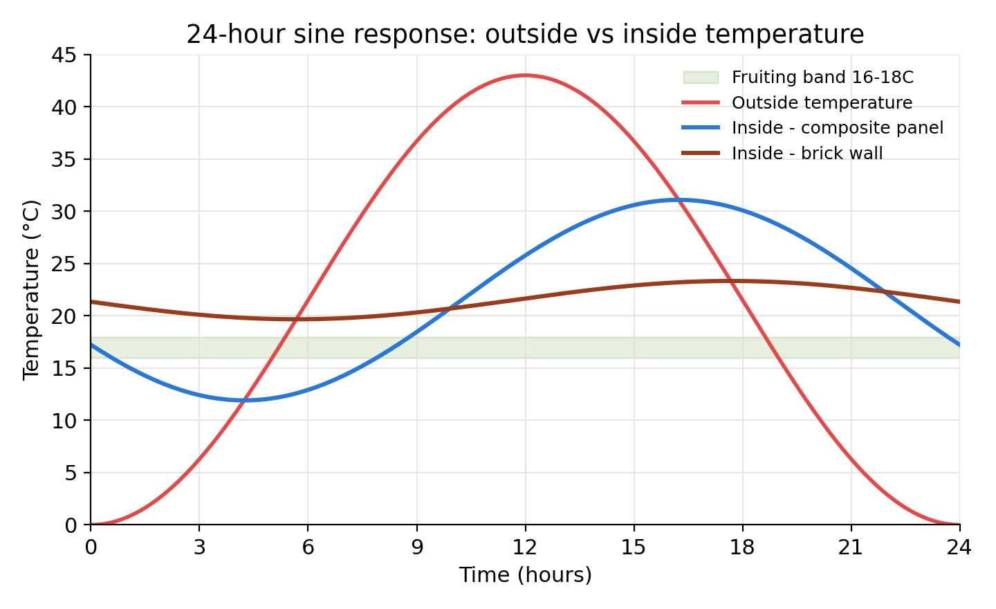
Figure 2 - 24-hour outside temperature vs resulting inside temperature for both walls

5. Comparison summary
Parameter | Composite panel  (Aluminium / XPS / PVC) | Solid brick wall  (230mm, unfinished)
Wall area | 18 m² | 18 m²
U-value | 0.338 W/m²K | 2.043 W/m²K
Total R-value | 2.956 m²K/W | 0.489 m²K/W
Heat gain at 43°C outside | +158 W | +956 W
Heat loss at 0°C outside | -103 W | -625 W
Thermal mass (C) | 168.1 kJ/K | 5,911.9 kJ/K
Time constant (τ) | 7.67 hours | 44.65 hours
24h amplitude damping | 44.6% (55.4% reduction) | 8.5% (91.5% reduction)
Phase lag | 4.24 hours | 5.67 hours
Resulting inside swing (0-43°C outside) | 11.9°C – 31.1°C | 19.7°C – 23.3°C

6. Interpretation and recommendation
- Composite panel: better steady-state insulation (lower U-value, lower heating/cooling load) but a shorter time constant, so the inside surface still swings widely (12-31°C) over a day - active climate control has to work continuously to fight that swing.
- Brick wall: much poorer steady-state insulation (higher heat load), but its large thermal mass damps the daily swing by over 90%, holding a very stable inside temperature - centered on the daily average outside temperature, not on the fruiting target.
- Neither wall passively holds 16-18°C on its own. Active heating/cooling is required in both cases to bring the mean down into the fruiting band.
- The combined approach recommended earlier - brick as the structural outer leaf with an interior insulation layer (XPS/PVC) - captures brick's damping and durability while adding the panel's low U-value, reducing both the daily swing and the average cooling load your equipment has to manage.

7. Key formulas reference
Conductive heat transfer: Q = (k A / L)(T1 - T2)
Convective heat transfer: Q = h A (T1 - T2)
Thermal resistance (series): R_total = sum of R_layer
Thermal capacitance: C = m cp = (rho L A) cp
Time constant: tau = R C
Sinusoidal response: amplitude ratio = 1/sqrt(1+(w tau)^2), phase lag = arctan(w tau)

