Smart IoT-Based Mushroom Farming System
Determining the Optimal Room Size
Group 1: Room Structure & Equipment Layout | Leader: Caroline | Members: Caroline, Charles, Tevin

1. Why Room Size Is Not Arbitrary
The dimensions of the fruiting room are not a free choice — they fall out of the environmental conditions oyster mushrooms need to fruit well, and of what it physically takes to grow a useful batch inside those conditions. Getting the room size right up front means the ventilation, humidification, and heating equipment chosen later can be small, cheap, and effective, rather than oversized to compensate for a poorly sized room.

2. Environmental Requirements Driving Size
These are the fruiting-stage targets the room has to sustain. Each one has a direct consequence for how big — or how small — the room should be.
Parameter | Target range | Effect on room size
Temperature | 15 – 21 °C | Smaller, insulated room is easier and cheaper to hold at a stable temperature
Relative humidity | 85 – 95 % | Smaller sealed volume needs a smaller humidifier to maintain saturation
CO2 concentration | < 800 – 1,000 ppm | Full air exchange needed roughly every 10 minutes — the larger the room, the larger (and louder/costlier) the fan needed
Light | Low, indirect, 10–12 h/day | No natural light needed, so no minimum size is imposed by window placement

The CO2 requirement is the one that most directly caps room size in practice: because the entire air volume must be replaced roughly every 10 minutes, keeping the room compact keeps the exhaust fan small and the system power-efficient — this is why the room is sized to the shelving, not made larger than it needs to be.

3. Sizing Constraints
Three constraints were balanced against each other to reach a final size:
- Production capacity — the shelving must hold a meaningful batch of substrate blocks without crowding them, since overcrowded blocks trap moisture and airflow around themselves and become more prone to contamination.
- Access and safety — a minimum clear aisle is needed so a person can inspect, mist, and harvest each tier without brushing against neighbouring blocks or equipment.
- Air-exchange feasibility — since all the room's air needs to be replaced roughly every 10 minutes to control CO2, the room is kept only as large as production requires, so this air exchange stays achievable with a modestly sized fan.

4. Working Out the Size

4.1 Shelving and batch size
Two 4-tier shelving racks, each 3.0 m long by 0.6 m deep, are placed along opposite walls. At roughly 0.3 m × 0.3 m of spacing per substrate block (enough for air to circulate around each one), each tier holds about 10 blocks, giving:
- 4 tiers × 10 blocks = 40 blocks per rack
- 2 racks × 40 blocks = 80 substrate blocks per batch

4.2 Aisle and clearance
A 1.0 m aisle is left between the two racks — enough for a person to comfortably turn, carry a watering can or tray, and access the lowest and highest tiers without stooping into the rack itself.

4.3 Height and tiers
Four tiers at 0.6 m of vertical spacing each account for 2.4 m, leaving headroom within a 2.5 m ceiling for airflow to circulate above the top tier and for the exhaust fan/light fittings to be ceiling-mounted without obstruction.

4.4 Resulting air-exchange load
At a total room volume of about 26.3 m³, replacing the full volume every 10 minutes requires an air-changeover rate of only about 2.6 m³ per minute — comfortably achievable with a single small in/out fan pair, which keeps the power draw and noise level low.

5. Final Room Dimensions
Dimension | Value | Justification
Length | 3.5 m | Fits two 3.0 m racks plus wall clearance for framing/insulation
Width | 3.0 m | Two 0.6 m rack depths + 1.0 m aisle + minor wall clearance
Height | 2.5 m | Four 0.6 m shelf tiers plus headroom for airflow and ceiling-mounted equipment
Floor area | ≈ 10.5 m² (113 ft²) | Matches published small-scale oyster-mushroom room outputs of ~200–400 kg/month at this scale
Room volume | ≈ 26.3 m³ | Keeps the 10-minute full air-exchange requirement achievable with a small fan pair
Batch capacity | ≈ 80 substrate blocks | 40 blocks per rack × 2 racks, at spacing that preserves airflow around each block

6. Dimensioned Layout
The diagrams below show exactly how the final dimensions are distributed across the floor plan and the rack height.
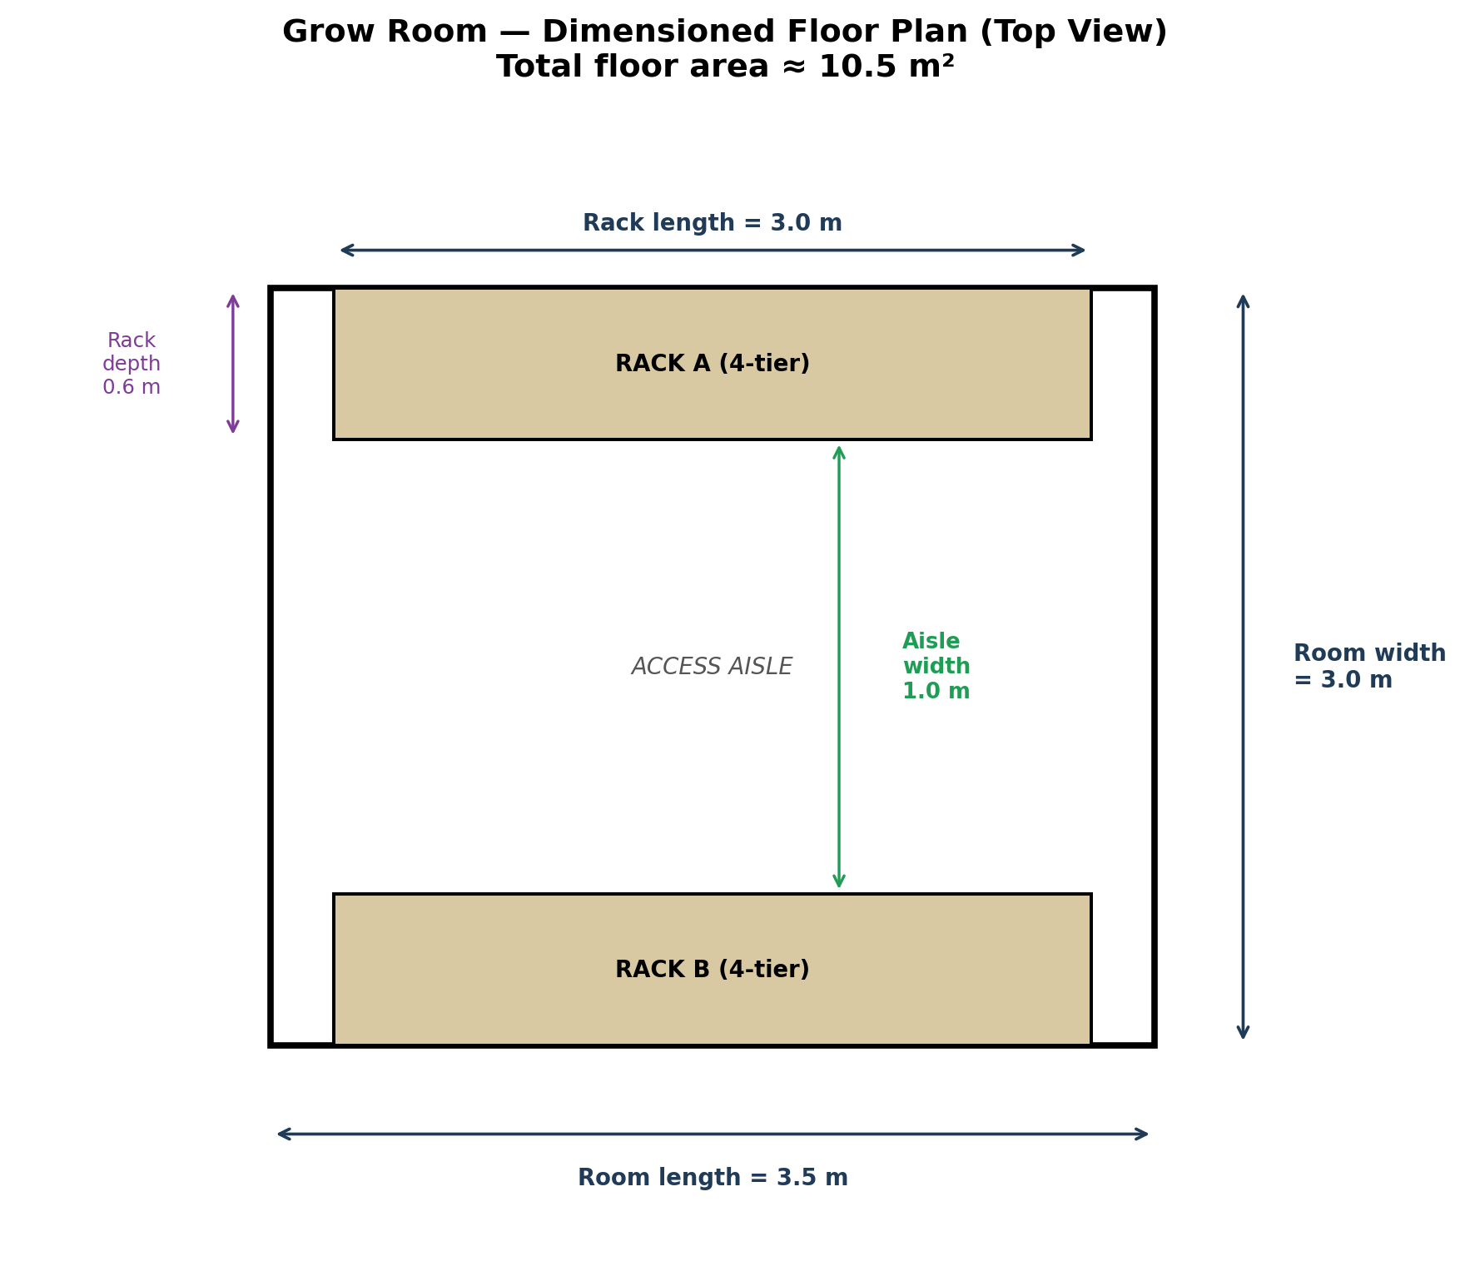
Figure 1. Dimensioned top-down floor plan: room length, width, rack footprint, and aisle width.
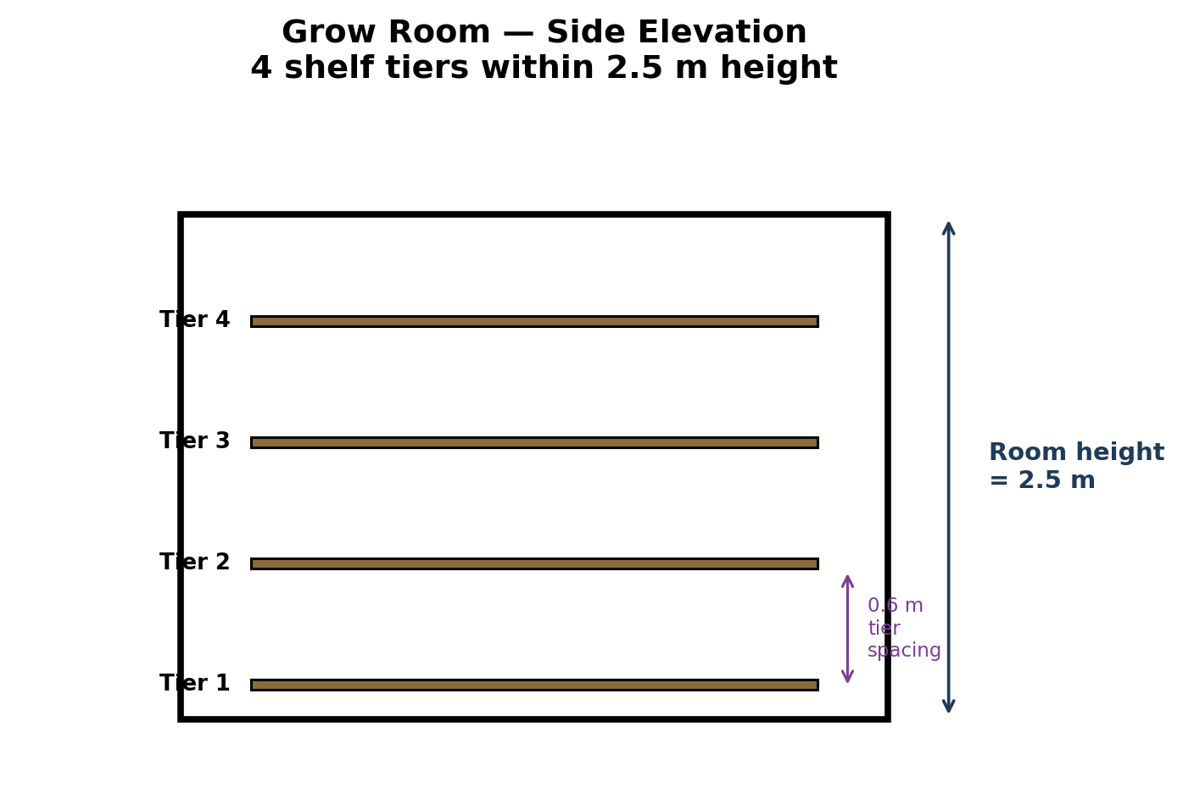
Figure 2. Dimensioned side elevation: room height and 0.6 m spacing between the four shelf tiers.

