Fastfood Restaurant mobile app

Setup & Guideline

|  |  |
| --- | --- |
|  |  |

Setup & Install

1. **Requirement**

|  |  |
| --- | --- |
| **Tool** | Android studio v3.0 or newer |
| **Jdk** | Version 1.7 or newer |
| **Device** | Android Phone v4.0 or newer |

**II. Customize**

**A. Customization**

* **How to edit app name?**

Go to “app/res/values/main_config.xml” file then change value of “app_name” key.

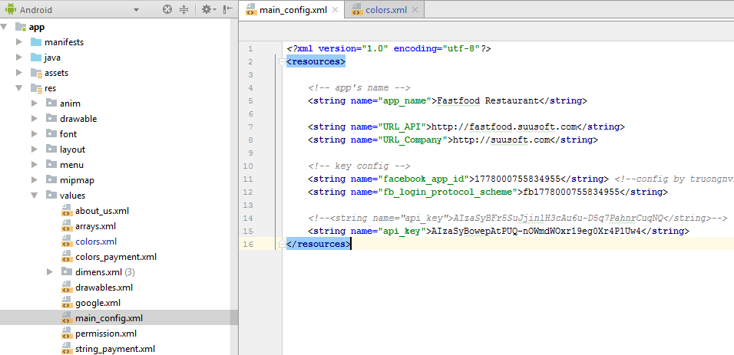

* **How to edit app Icon?**

In left menu you will need to search “ic_launcher.png” files in all “app/res/mipmap-xxxx” folders and replace them by your app icon.

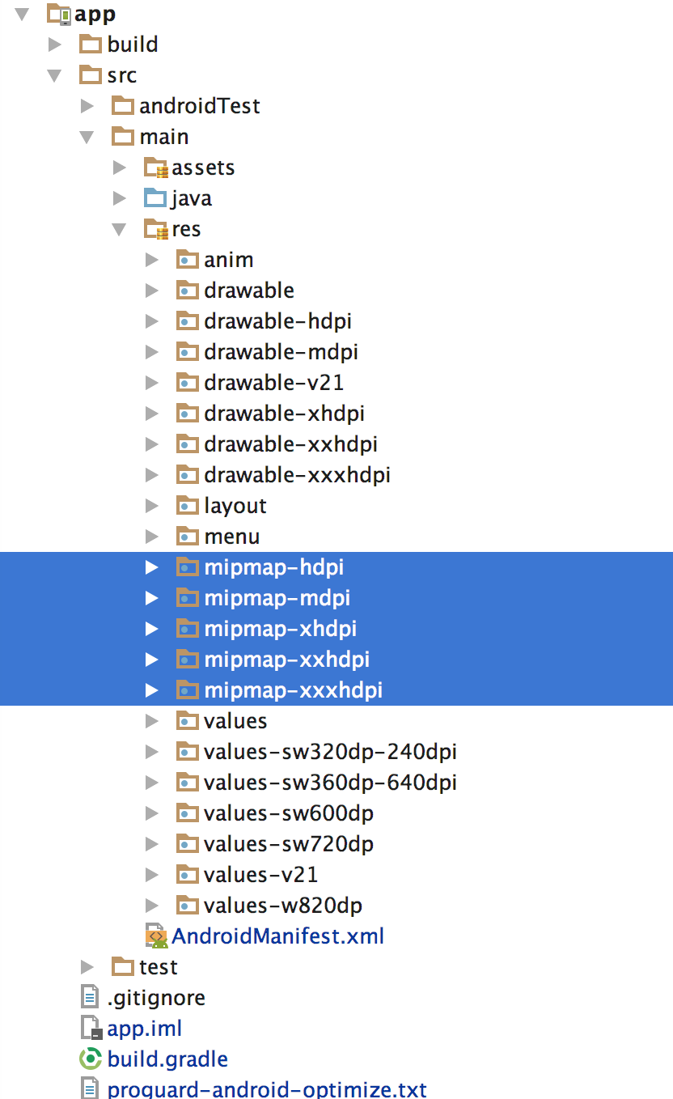

* **How to edit images?**

You can find and edit any image in all “app/res/drawable-xxxx” folders. Make your image for all folder drawable-xxx

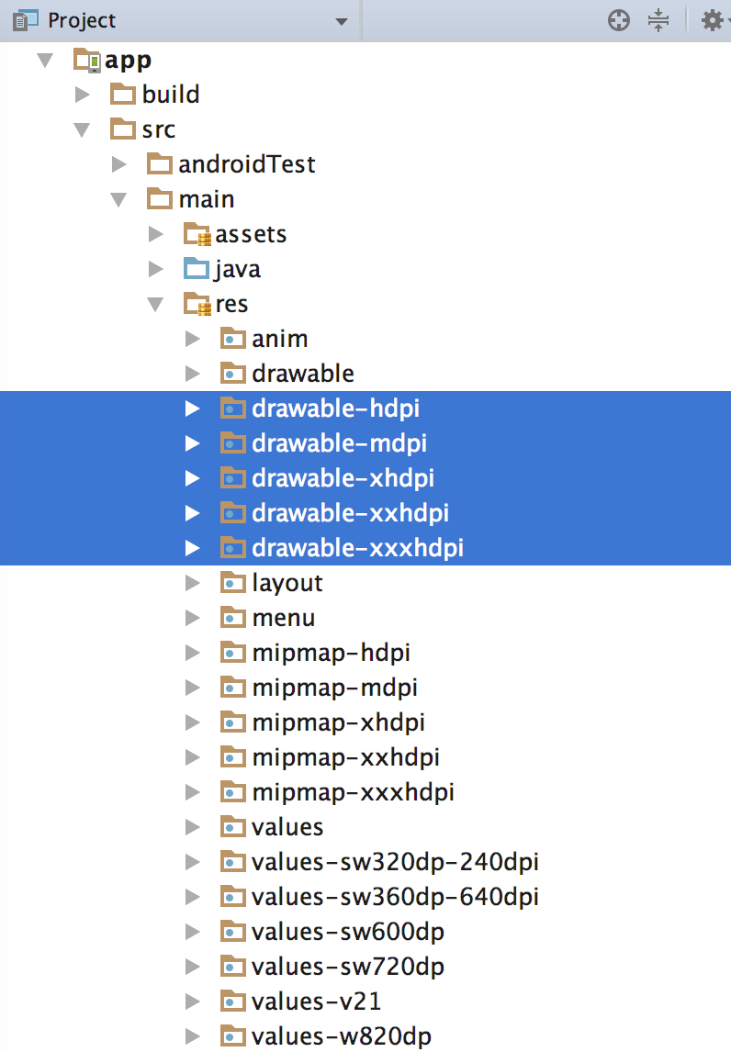

* **How to edit layouts?**

You can find and edit any layout in “app/res/layout” folder.

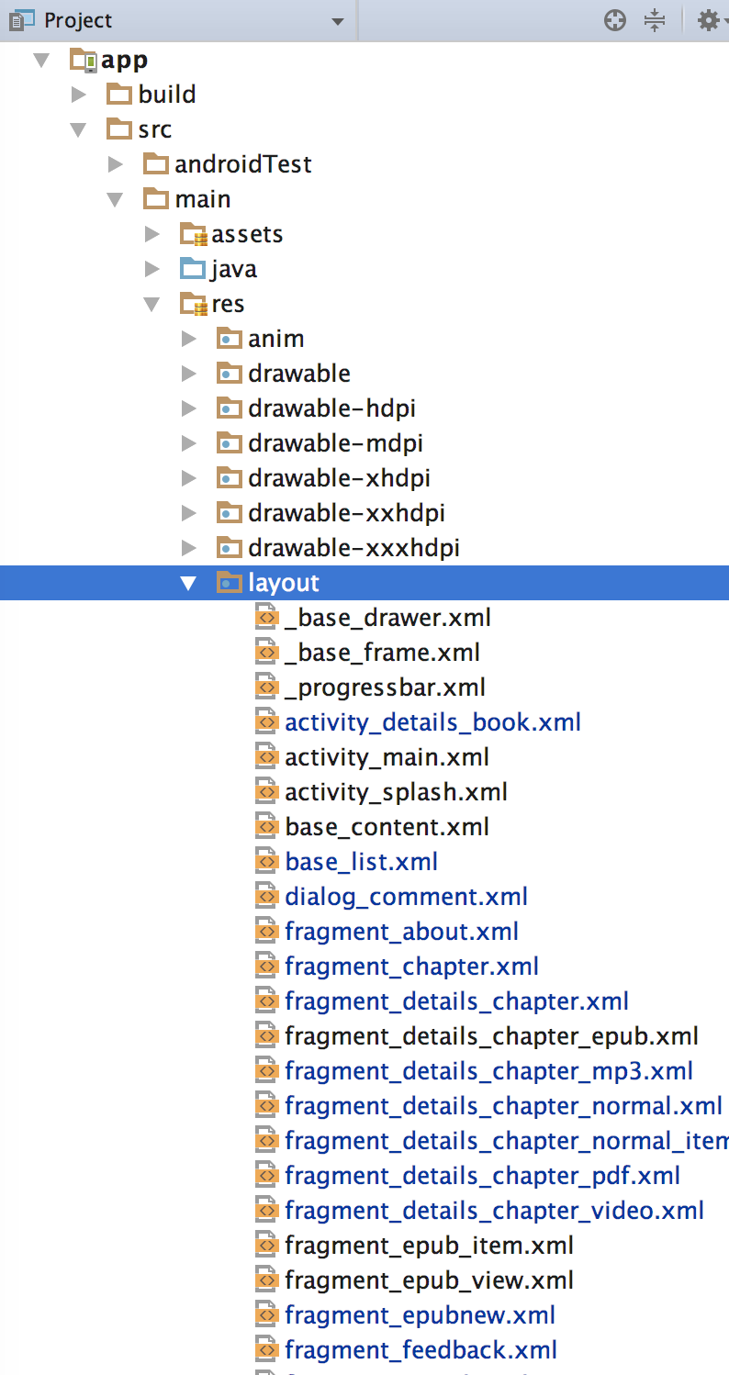

* **How to edit colors?**

You can find and edit any color in “app/res/values/colors.xml”

* **NOTE**:

- The <!-- main color --> is app theme, you can edit and make a new theme

- The <!—base color --> we do not recommended you edit it

- Other colors you can edit

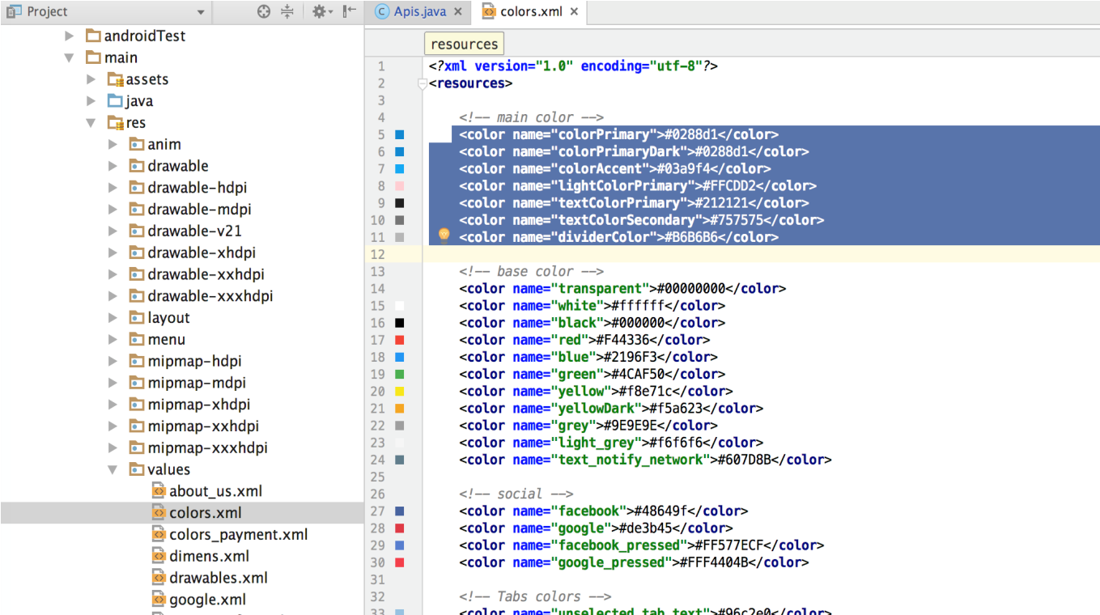

* **How to edit file language when you want to multi-language on app?**
* **Step 1:** Right click on res folder and create new resource file

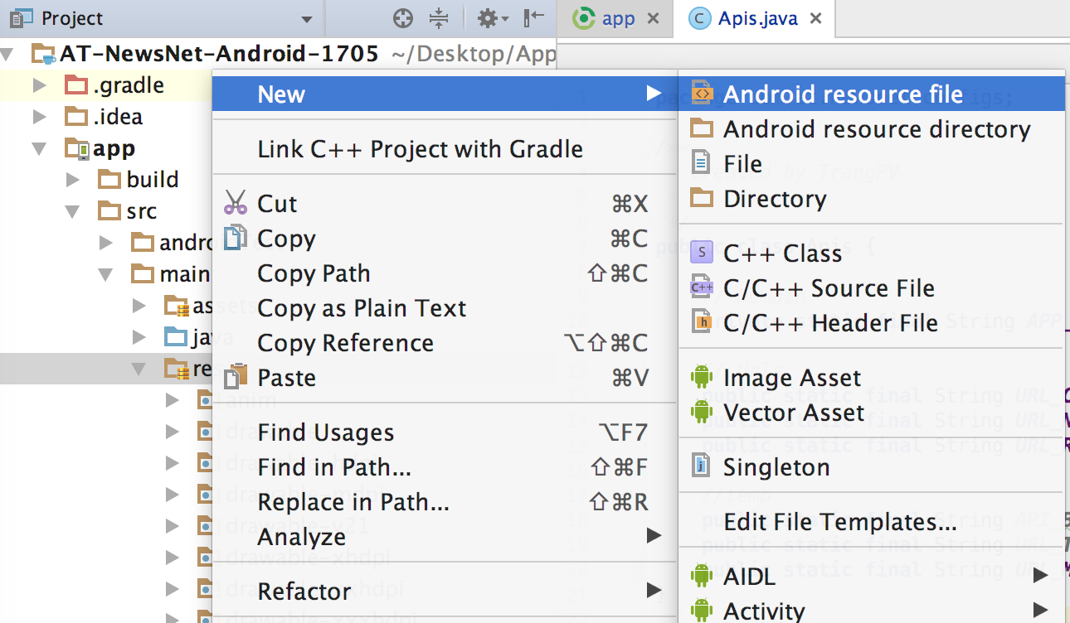

* **Step 2:**

Select locale 🡪 click next

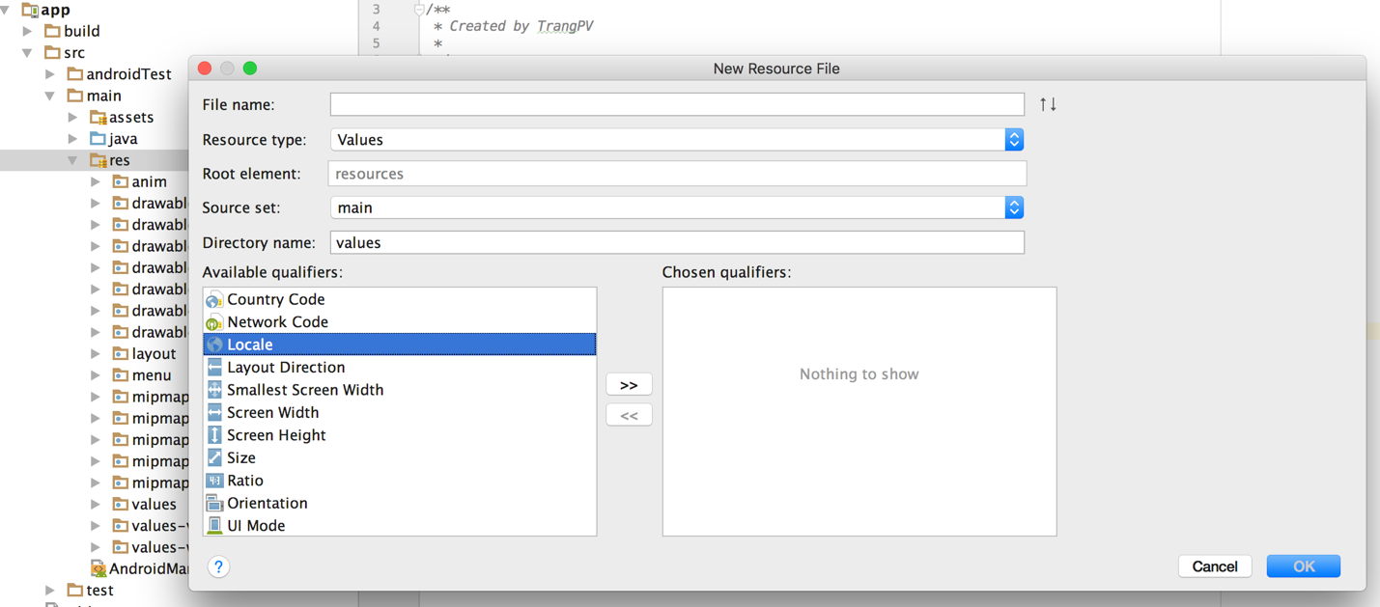

After select locale it will be as below. Now you can choose your country 🡪 Put a file name is “strings” and click OK. It will be generated a foler with name “values-countrycode” in res folder

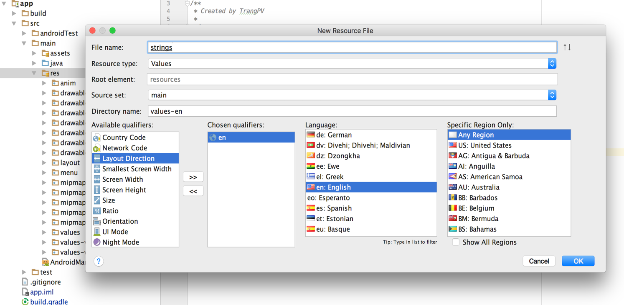

* **Step 3**: Now open strings.xml file in “values” folder 🡪 copy all content in this 🡪 paste to file that you have created.
* **Step 4:** Finally, we can translate text

**B. Configure for app**

Go to “main_config.xml” file as screenshot below.



**Now we see the keys. Please look at description below**

**+** The “*app_name*” : Change for your app name

**+** The “*URL_API*”: After you install the backend successfully, please get your backend link and put it here. Note: Copy right link same as our format.

Congratulation!!!

You have configured successfully.

Now Let’s try building and run it

Customer support & customization

We have full team of developers that will help you to fix issues related to development, deployment.

Please contact with us via:

# General support:

1. Skype: suusoft
2. Email : [suusoft@gmail.com](mailto:support@suusoft.com)
3. Whatsapp: