Hallmark Assessment Task: Analysis of Organizational Diversity of Lockheed Martin

Jennifer L. Hankins
College of Education and Human Development, University of Louisville
LEAD 314-51: Diversity in the Workplace
Dr. Randy Whetstone
August 8, 2024

Hallmark Assessment Task: Analysis of Organizational Diversity of Lockheed Martin
The purpose of this assignment is to analyze the diversity practices of an organization, its history, assessment (of current realities and efforts), acceptance (developing support for change), action (moving forward), accountability (shared ownership), achievement (measuring progress), and more action (to sustain momentum). I chose Lockheed Martin, an American industry leader in aerospace and defense manufacturing. My research included interviews with three employees, Lockheed’s extensive website, other internet sources, and critical thinking from guided by our course materials.
History
Lockheed Martin was founded in 1995, following a merger of Lockheed Corporation and Martin Marietta Corporation – both companies founded during aviation history in the United States where great aviators like Harriet Quimby and the Wright brothers, and a few years decades later, Amelia Earhart. Like these great pioneering aviators, Lockheed's original founding fathers, Glen Martin and brothers Allan and Malcolm Lockheed had vision, ingenuity, courage, and persistence as they pressed on building, manufacturing, and refurbishing aircraft from commercial to military.
Lockheed's C-141 project, as one of the South's largest employers, played a significant role in the desegregation from claims that Lockheed had discriminated against its Black employees - conforming to segregated assembly lines, restrooms, water fountains, and breakrooms. The National Association for the Advancement of Colored People (NAACP) filed complaints against the Equal Job Opportunities office and, in May 1961, met with President Kennedy. The outcome was that Lockheed agreed to integrate assembly lines and recruit and train Black employees, including those in roles as managers and pilots (Scott, 2020).
A few years later, Lockheed suffered a financial loss due to contract negotiations with the Pentagon for the C-5 Galaxy (double the size of the C-141 and the largest transport plane), followed by a drastic loss in the workforce after Rolls-Royce, the engine manufacturer of the L-1011 Tri-Star, filed for bankruptcy. With the help of President Nixon's Emergency Loan Guarantee Act, Lockheed had to take out a loan to stay afloat but was eventually able to pay its debt in full. President Bush reduced defense spending during the Cold War, forcing Lockheed to consolidate and close one of its California plants. Another California plant, with newly acquired General Dynamics, teamed with Boeing to develop the F-22 Raptor (Scott, 2020).
Presently, Lockheed Martin is one of the world's largest defense and aerospace contractors, with contacts totaling $68.5 million, and is the world's largest military aircraft manufacturer. Lockheed's largest defense contract ($250 billion) is the F-35 Joint Strike Fighter program. Lockheed has four business areas: Aeronautics, Missiles and Fire Control, Rotary and Mission Systems, and Space (Lockheed Martin Corporation, 2024).
Lockheed has over 122,000 employees - 65,000 of which are engineers, scientists, and technologists – present in all 50 U.S. states and territories; 93% of its employees and suppliers are U.S.-based, and they have 345 facilities in 54 countries. Lockheed prides itself on "helping the future arrive" and promotes its culture with the statement, "We value our employees' unique backgrounds, their desire for career growth, and an urge to solve some of the world's most complex problems" (Lockheed Martin Corporation, 2024). Fostering innovation is part of their sustainability priorities of advancing resource stewardship, elevating digital responsibility, fostering workplace resiliency, and modeling business integrity, as evidenced by their financial performance and economic and social impact.
As shown (Figure 1), Lockheed's core values include "Do What's Right, Respect Others, and Perform with Excellence" as fundamental to who they are and what they do (Lockheed Martin Corporation, 2024). Their values send a lead-with-integrity message for zero tolerance on harassment, discrimination, and retaliation, encouraging employees to be upstanders in areas like privacy, information and asset protection, compliance with trade laws, corporate citizenship, and human rights, to name a few.
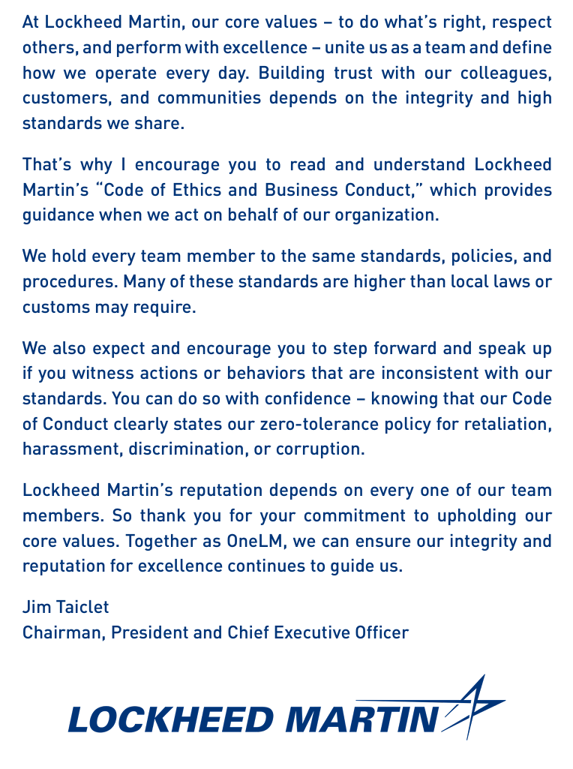
Figure 1: Lockheed's Code of Conduct - Setting the Standard Message from its CEO.
Lockheed's diversity message is about promoting diversity and inclusion throughout the corporation from the top down. It has established a OneLM approach, which calls for transformation to facilitate togetherness and where inclusion is necessary to propel innovation and realize its collective power. The emphasis is on a workplace where all employees can thrive and contribute to its mission. Figure 2 shows a statement from Lockheed's Chief Diversity Officer. Each business is a team proficient in the specific business areas to lead its members in diversity and inclusion efforts. Also, as part of that mission, it encourages self-identification that includes gender identification, military service, and sexual orientation (not part of their annual government demographic submissions) and allows employees to see themselves as represented and more comfortable doing so.
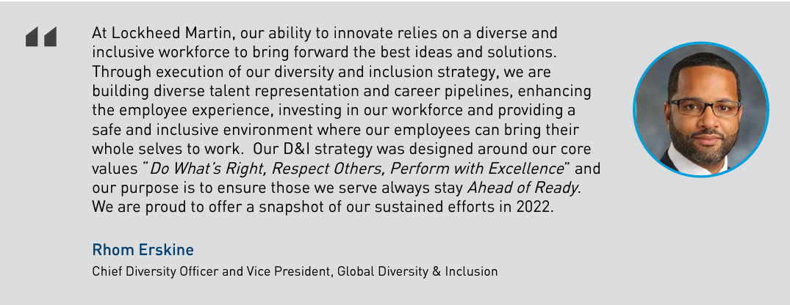
Figure 2: Chief Diversity Officer & VP, Global Diversity & Inclusion
Lockheed, as a federal contractor, is required by the U.S. government to report workforce data known as the Employer Information Report (EEO-1 Report), which includes data based on gender, ethnicity, and race by job categories, based on the U.S. Department of Labor's classification guide and the Standard Occupational (SOC) Classification and Census Job Codes and Titles without regard to industry. The EEO-1 Report is one step towards transparency and awareness. Figure 3 shows Lockheed's 2022; of the 116K employees, 61 K are engineers, scientists, and technologists. The reporting includes four categories: women, people of color, veterans, and people with disabilities, with 23.3% of employees are women, 24.7% are women as executives and 30.8% are women on the board of directors; 30.4% are employees are people of color, 16% are people of color as executives and 7.7% are people of color as the board of directors; 21.2% of employees are veterans, 20.6% are veterans as executives and 38.5% are veterans as board of directors; and 10.8% of employees are disabled and 11.1% of disabled veterans as executives. Other categories include generational and education, highlighting that most employees are millennials or Generation X. Most have a bachelor's degree or high school, coming in second ranking, and graduate/PhD are close behind. Lockheed is aware of diversity.
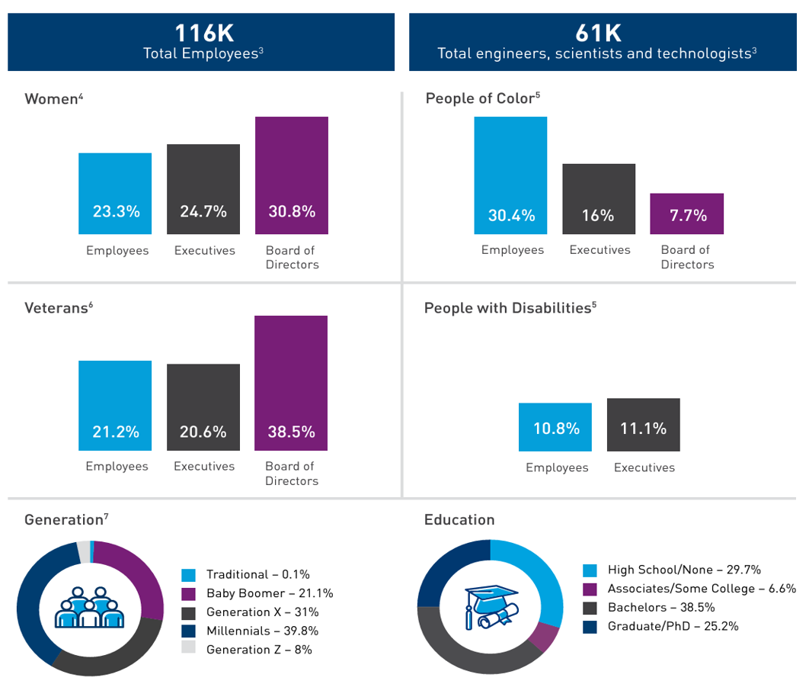
Figure 3: Lockheed's 2022 Global Diversity and Inclusion Annual Report on Demographics
and its presence and value within its workforce. While federally mandated, collecting and reporting the data above keeps Lockheed mindful of its diversity.
Assessment
I interviewed three employees of Lockheed Martin, all working in California as F-35 Contract Instructor Pilots, all former retired military officers, and all White males. I conducted two survey interviews by email (Interviewee # 1 and # 3) and the third (Interviewee # 2) by phone (See Tables 1 and 2). All three interviewees wished to remain anonymous and provided detailed answers.
As shown in Table 1, Interviewee # 1, explains the rating he provided in the Organizational Snapshot (Appendix A). He explains that, while rating leadership as a seven, pay issues do not align with leadership claims and industry pay (CIP stands for Contract Instructor Pilot). His circumstances are different because his current position requires him to belong to a union with higher pay and demands. However, subcontractors can charge less, leaving a lack of pay transparency between union Lockheed employees, the non-unionized leadership, and the non-unionized subcontractors. Aside from a pay disparity, he feels that open discourse is encouraged, and individual voices heard to include those on his team with disabilities and family needs, providing flexibility and accommodations.
When asked about diversity and inclusion in his team, he ranked both as "Somewhat Diverse" and "Somewhat Inclusive," explaining that he considers his team to be fairly diverse – different ages, military (enlisted and officers groups), civilian (non-military), varying socio-economic status, male and females, multiple ethnicities, ages ranging from 20s to 50s, varying disabilities, left and right learning, and geographic disparity with team members from all over the United States. He went on to explain questions he asked during the hiring phase (race, disability status, veteran status, and gender) and views differing opinions as welcomed. Leadership is not top-down; instead, leadership is receptive to differences in perspectives and ideas, especially from younger individuals, allowing all individuals to be experts in their unique fields (minimum experience required is ten years) and highlighting skill level.
Table 1 – Interviewee # 1 – Former U.S. Navy Fighter Pilot & Officer
Rating | Area of Influence | Reason for Rating
7 | Leadership | - slightly lower rating due to the union issues  - fights over industry standard pay  - some feelings of LM leadership’s actions are not aligned with what they claim
8 | Culture | - culture is flexible, supports change, is inclusive, and supports diversity.
6 | Involvement | - some individual involvement is somewhat low  - we are replaceable and don't influence any big-picture changes.
5 | Business | - Lockheed is having a hard time filling all the CIP roles at all its locations due to pay issues  - most locations have gone on strike and unionized  - possibly suggesting the need for Lockheed to address individual concerns versus the bottom line
8 | Strategy & Measures | - Lockheed strives to comply with all government regulations and bureaucracy  - training is constant  - big picture strategy does not involve individuals at my level
9 | Staffing & Development | - only qualified individuals are hired  - quality decreases during strikes  - training is done well  - no ability to promote higher than the current level  - would lower the rating from a 9 to a 5
8 | Ownership | - high-performance requirements and standards that are held qualifications are tied to more pay and a tendency to withhold from those most qualified to receive them

Interviewee # 2 (interview conducted by phone), a 20-year retired officer, pilot, and flight instructor in the U.S. Airforce who has worked for Lockheed for just shy of one year, presented a different picture of leadership in the Organizational Snapshot (Appendix B). He explained that in his current role as a flight instructor, he supervises 15 pilots (all White males) in a highly technical field, with the only diversity being age and experience, ranging from 30 – 50 year-olds with anywhere from 10 to 30 years of experience. He went on to describe that receive support from two groups that are more diverse – schedulers and IT. The diversity of those groups consists of both males and females, people of color, and varying ages. This is his observation only and does not consider learning differences, sexual orientation, gender identity, or disability. On occasion, there will be group planning meetings, but otherwise, the teams’ function independently of one another in their primary work functions.
He went on to explain why he ranked leadership as a five and culture as a four, which is that his team works in a "silo" without too much knowledge of who the boss' boss is and not a lot of information sharing beyond the technical realm of his team's work duties and missions. He further explained that he is aware of DEI-type emails and postings in the breakrooms. He agrees with this and gives a seven rating for involvement, culture, business, staffing and development, and ownership, explaining that Lockheed values its employees and provides support but expects and hires excellence. He said his team will have varying perspectives and styles on a specific function or method, and while the training mission is shared vision, they will come together and appreciate and learn from one another, often adopting different approaches.
Interviewee # 3, also a former U.S. Navy fighter pilot, has worked at Lockheed for three years. He completed the Organizational Snapshot (Appendix C) and describes leadership as not listening and micro-managing, resulting stagnation and little room or opportunity for training and mentorship. My view of this is that given the highly technical field and the experience required, these are the best of the best, and leadership may overlook opportunities for individuals who are highly proficient to reach even higher levels of expert skills. His ratings in culture, involvement, and staffing and development support this view – employees who receive recognition, even slight, are motivated and have a greater sense of satisfaction.
When asked about diversity and inclusion in his team, he ranked both as "Somewhat," explaining that his team lacks cohesion. He contributes to the lack of diversity and inclusion on his team as the result of an industry (fighter pilots and tactical aviation) predominantly male and White males; and while his team lacks diversity, other teams at Lockheed are – by race, gender, socio-economic status, and age. He explained that there are DEI email notifications sent to Lockheed (non-subcontract employees), but he is not privy to these; however, he does see DEI postings in workplace shared areas. He mentioned that corporate leadership is diverse based on what he gleans in emails.
Table 2 – Interviewee # 3 – Former U.S. Navy F/A-18F Super Hornet Pilot & Officer
Rating | Area of Influence | Reason for Rating
5 | Leadership | - some employees do not feel heard and feel micro-managed  - sometimes stifled when trying to create a better site, leading to stagnation and resentment
6 | Culture | - site is fairly diverse  - we are surely value-based  - some degree of lacking people focused or supporting change
4 | Involvement | - site morale and team cohesion can be low - people looking for ways to get out of their roles/pass to others
7 | Business | - nature of our business requires readiness to shift perspective and focus at a moment’s notice to meet the current global demand  - we must be ready for any change
10 | Strategy & Measures | - largest defense contractor in the world is doing something right to have that title
6 | Staffing & Development | - little recognition, no mentoring, low efforts in development and training  - there is a slow plan for us to improve  - sometimes less productive in development  - some degree of more work being done by those who are most tenured
5 | Ownership | - yes, to professional ownership of our actions and ability to properly execute the latest tactics and training guidelines  - unable to take ownership and find opportunities to improve the site as a whole

An analysis of Lockheed’s website revealed that over 36K of Lockheed’s employees are involved in Business Resource Groups such as Able & Allies, Black Excellence Council, Hispanic Organization for Leadership & Awareness, PRIDE, Women Impact Network, Professional Asian American Network, and Military Veterans. The Lockheed Martin Social Impact supports STEM through charitable contributions supporting student readiness, vocational scholarship programs, and postsecondary for adult learners through programs such as Girls Inc., Project Lead the Way, NPower, CodePath, and Hacking for Defense. Lockheed also invests in its current workforce through fellowships, especially to the military community. Lockheed has received recognition from Best of the 2024 Best Top Diverse Employer in DiversityCOMM Magazine, DEI 2024 Best Place to Work for Disability Inclusion, 2021 Best Places to Work for LGBTQ Equality, 2022 U.S. Department of Labor HIRE Vets Gold Award, and 2024 Readers’ Choice – A Top 50 Employer Woman Engineer Magazine.
The vast number of individuals employed or who perform contract work for Lockheed suggests that a more thorough analysis and snapshot would include several individuals in each of the four business areas who are representative of entry-level, mid-range, and upper-level management.
Acceptance
The benefits of implementing diversity are many. In Putting our differences to work: The fastest way to innovation, leadership, and high performance (Kennedy, 2008) describes her participation in “The Habitat Jam” – a 72-hour, online global dialogue, engaging people from all walks of life from business and government leaders to the poor from all over the world, including Kenya. (p. 23). Its purpose was a call to action on societal issues, and the sheer diversity presented an opportunity to engage in new thinking, evolve ideas and perspectives to create trust, and take risks together for sustainability in communities. There have been other forums like “The Habitat Jam” and those examples ring the same truth – we are stronger, and we grow as a collective by forming a community of diverse perspectives. However, mindset is the key to leading and implementing diversity efforts. Educating in our homes and communities about what diversity means and its value.
The workplace presents more challenges like education disparities and training, lack of awareness and policies, limited resources put towards recruitment, and unfair hiring practices, which are a few examples of barriers; however, one of the most significant barriers is a lack of leadership buy-in. A company will always have barriers if the leadership (board of directors and C-suite executives) does not support diversity. Leadership needs to be educated to lead in today’s global economy, which includes reaching new stages of growth, “visionary leaders… recognize people are the number one source of new ideas for innovation” (Kenndy, 2008, p. 31). It all comes down to an earnest mindset seeking improvements through change.
Action
Lockheed has made great strides in progress toward diversity, particularly in youth programs like STEM and young adult programs like Girls Inc. and NPower. These programs have missions that focus on underprivileged communities, which is one reason for the disparity in education and training. My first recommendation for Lockheed is to engage its contract workers, like my interviewees, in outreach in these areas, such as allowing a partial workday to speak at an outreach program or offering an incentive for participation. Young people need inspirational visions that are present to engage in a dialogue, ask questions, or make a connection, and these experiences can be life-changing to a young person.
Another goal would be to create YouTube videos, in lieu of guest appearances, that directly speak to the youth or young adult – offering advice, making a connection, and suggestions for resources. A third goal for Lockheed would be to offer incentives to donate to the cause of outreach, like sponsoring tuition. The sponsorship could also include a mentorship to either meet in person or correspond. Our youth are the future, and the time and money invested in them will guarantee a more robust and brighter future.
A fourth but relevant goal specific to Lockheed's contract employees is to begin annual surveys, like the organizational snapshot, to gain valuable feedback on the "silo" environment and culture. This would allow for leadership to see areas of improvement – recruitment, creating a more inclusive atmosphere, and accepting suggestions for improvements.
Accountability
Accountability starts with thinking about the value of the organizational snapshot. “All leaders hold a responsibility to think” (Kennedy, 2018, p.51). By examining the areas of leadership, culture, involvement, business, strategy and measures, staffing and development, and ownership, a leader will get a glimpse of current realities to action to share ownership of the change and progress ahead.
My contribution towards diversity in my workplace and community is volunteering to mentor. Mentorship is valuable and mutually beneficial to the mentor as well as the mentee. So often, young people lack guidance at home, and because it truly takes a village, they need community. In my workplace, I can seek individuals who are novices and offer to assist in their skill development. I can network within my workplace and seek to include members in teams to be inclusive and open to diverse perspectives. Networking is a powerful tool and starts with stepping out of our routines and comfort zones to start a dialogue. When we discourse with one another, we make connections and better understand planting and watering the seeds of change.
Achievement
Measuring achievement is not how we reach the goal of diversity. As I mentioned earlier, actual change in diversity efforts is a change in mindset and attitude, and “Change is our willingness to be inclusive of everyone – to see each of us as a whole person made up of many dimensions of diversity” (Kennedy, 2008, p. 137). However, we can measure progress goals of efforts, as in the action goals I suggested; Lockheed's pilot instructors could keep litter boards of money donated and/or hours spent volunteering in mentorship programs. Healthy competition in this area is putting into practice good citizenship habits towards a change in mindset.
Lockheed at the corporate level, could implement surveys to capture metrics such as the categories in the organizational snapshot and use towards efforts in better recruitment processes that include women and people of color and include scholarships to underrepresented groups.
More Action
Momentum is how we persist and persevere into more action. “More action is the step that breathes life into new action” (Kennedy, 2008, p. 139). Change is constant, and no one arrives at the end or finish line; in other words, the work is not finished even though progress is achieved, but rather, there is maintenance and more work to be done. Kenned (2008) discusses remaining attentive to change and keeping the momentum by continuing and cultivating. Lockheed did not begin from innovation that stopped at the first achievement but instead through persistence towards goal after goal, which is how they remained steadfast and adapted to the evolution of aviation. Likewise, Lockheed and other companies should continue to have powerful visions and hire individuals who are educated in diversity to promote change not only in achieving but also in changing mindsets to transform workplaces where all are treated with respect, equality, and inclusion. Change always starts with one.

References
Kennedy, D. (2008). Putting our differences to work: The fastest way to innovation, leadership, and high performance. Berrett-Koehler Publishers.
Lockheed Martin Corporation. (2024). [Website]. https://www.lockheedmartin.com/.
Lockheed Martin Corporation. (2024). [Website]. https://www.lockheedmartin.com/en-us/who-we-are/leadership-governance/board-of-directors.html.
Lockheed Martin Corporation. (2024). [Website]. https://www.lockheedmartin.com/en-us/who-we-are/leadership-governance.html.
Lockheed Martin Corporation. (2020, July 2). Lockheed Martin CEO Jim Taiclet on Leadership [Video]. YouTube. https://youtu.be/RIeL7TbdJ1s.
Scott, T. A. (2020, August 11). Lockheed Martin. New Georgia Encyclopedia. https://www.georgiaencyclopedia.org/articles/business-economy/lockheed-martin/

Appendix A

The University of Louisville
College of Education and Human Development
Educational Leadership, Foundations, and Human Resource Education
Organizational Leadership and Learning Program (OLL)
LEAD 314 - Diversity in the Workplace
Dr. Randy Whetstone Jr., Clinical Assistant Professor
Organizational Snapshot Table
(As adapted from Kennedy, 2008)

You can utilize this “Organizational Snapshot Table” for your Analysis of Organizational Diversity (HAT Project). As you interview the three (3) Career Professionals that work for your selected Organization – you can refer to the following Areas of Influence, including: Leadership, Culture, Involvement, Business, Strategy & Measures, Staffing & Development, and Ownership (all listed at the bottom of your table).
On the left side of the table is a numerical ranking from 1 (lowest) – to 10 (highest) – of how the Career Professionals rank/perceive the “current readiness and/or effectiveness” of each of the Areas of Influence within their Organization. Please ask the Career Professional to rank each Area of Influence from 1 (lowest) to 10 (highest), and they can draw a dot on the table where they believe their Organization “stands.” You can also use the supplementary information on page 50 in our Kennedy (2008) text that offers additional “considerations” in each of the Areas of Influence.

Organizational Snapshot Table
LEAD 314 – Diversity in the Workplace
10
9 |  |  |  |  |  | X
8 |  | X |  |  | X |  | X
7 | X |  |  | 
6 |  |  | X
5 |  |  |  | X
4
3
2
1
↕ ↕ ↕ ↕ ↕ ↕ ↕
Leadership Culture Involvement Business Strategy & Staffing & Ownership
Measures Development

Career Professional’s Name _Brian O’Toole (Interviewee #1)
Organization __Lockheed Martin______________________________________________
Date ___July 24, 2024_______________________________________________________
Student’s Name __Jen Hankins________________________________________________
Appendix B

The University of Louisville
College of Education and Human Development
Educational Leadership, Foundations, and Human Resource Education
Organizational Leadership and Learning Program (OLL)
LEAD 314 - Diversity in the Workplace
Dr. Randy Whetstone Jr., Clinical Assistant Professor
Organizational Snapshot Table
(As adapted from Kennedy, 2008)

You can utilize this “Organizational Snapshot Table” for your Analysis of Organizational Diversity (HAT Project). As you interview the three (3) Career Professionals that work for your selected Organization – you can refer to the following Areas of Influence, including: Leadership, Culture, Involvement, Business, Strategy & Measures, Staffing & Development, and Ownership (all listed at the bottom of your table).

On the left side of the table is a numerical ranking from 1 (lowest) – to 10 (highest) – of how the Career Professionals rank/perceive the “current readiness and/or effectiveness” of each of the Areas of Influence within their Organization. Please ask the Career Professional to rank each Area of Influence from 1 (lowest) to 10 (highest), and they can draw a dot on the table where they believe their Organization “stands.” You can also use the supplementary information on page 50 in our Kennedy (2008) text that offers additional “considerations” in each of the Areas of Influence.

Organizational Snapshot Table
LEAD 314 – Diversity in the Workplace
10
9
8
7 |  |  | x | x |  | x | x
6 |  |  |  |  | x
5 | x
4 |  | x
3
2
1
↕ ↕ ↕ ↕ ↕ ↕ ↕
Leadership Culture Involvement Business Strategy & Staffing & Ownership
Measures Development
Career Professional’s Name: Duncan French (Interviewee #2)
Organization: __Lockheed Martin______________________________________________
Date: July 25, 2024 Student’s Name: Jen Hankins

Appendix C

The University of Louisville
College of Education and Human Development
Educational Leadership, Foundations, and Human Resource Education
Organizational Leadership and Learning Program (OLL)
LEAD 314 - Diversity in the Workplace
Dr. Randy Whetstone Jr., Clinical Assistant Professor
Organizational Snapshot Table
(As adapted from Kennedy, 2008)

You can utilize this “Organizational Snapshot Table” for your Analysis of Organizational Diversity (HAT Project). As you interview the three (3) Career Professionals that work for your selected Organization – you can refer to the following Areas of Influence, including: Leadership, Culture, Involvement, Business, Strategy & Measures, Staffing & Development, and Ownership (all listed at the bottom of your table).
On the left side of the table is a numerical ranking from 1 (lowest) – to 10 (highest) – of how the Career Professionals rank/perceive the “current readiness and/or effectiveness” of each of the Areas of Influence within their Organization. Please ask the Career Professional to rank each Area of Influence from 1 (lowest) to 10 (highest), and they can draw a dot on the table where they believe their Organization “stands.” You can also use the supplementary information on page 50 in our Kennedy (2008) text that offers additional “considerations” in each of the Areas of Influence.

Organizational Snapshot Table
LEAD 314 – Diversity in the Workplace
10 |  |  |  |  | X
9
8
7 |  |  |  | X
6 |  | X |  |  |  |   X
5 | X |  |  |  |  |  | X
4 |  |  | X
3
2
1
↕ ↕ ↕ ↕ ↕ ↕ ↕
Leadership Culture Involvement Business Strategy & Staffing & Ownership
Measures Development
Career Professional’s Name Johnny Cushing (Interviewee # 3)
Organization Lockheed Martin
Date 04August2024
Student’s Name Jen Hankins

