Hallmark Assessment Task: Professional Licensing Updates and Management System for CLG Engineering, LLC

Jennifer L. Hankins
College of Education and Human Development, University of Louisville
LEAD 341-50: Manage Projects in the Workplace
Dr. Hardy MacKenzie
October 6, 2024
Table of Contents

Main Page 1
Scope Statement 2
Stakeholder Analysis 3
Business Case 4
Exhibit A 6
SWOT Analysis 7
Work Breakdown Structure 8
Ghantt Chart 9
Critical Path 10
Communication Plan 11
Risk Management 12

Main Page
Project Description:
This project aim is updating professional licenses for a recently acquired engineering firm, ensuring compliance across the various jurisdictions, and streamline the credentialing management within the company’s existing framework. The engineering firm is registered in 26 states with active projects in the majority those states. Compliance is crucial to avoid delays and loss of revenue. The budget is $30,000 with a deadline of three months.

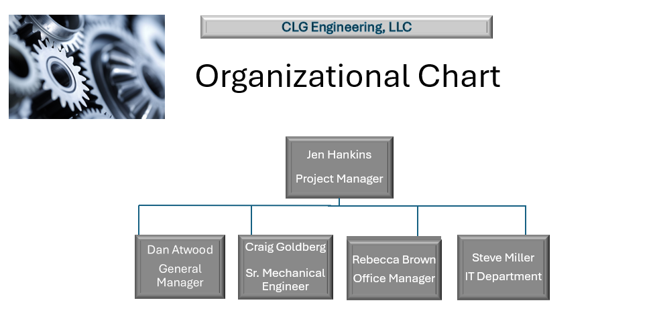

Scope Statement

Project Title: Professional Licensing Updates and Management System for CLG Engineering, LLC
Date: October 6, 2024 Prepared by: Jen Hankins
Project Justification:

Updating the professional licensing for CLG Engineering, LLC (“CLG”) and streamlining the tracking and management process is crucial for regulatory compliance, operational efficiencies, risk management, continuity and growth, and employee development and retention. This project will position CLG for success in the engineering industry.
Product Characteristics and Requirements:

- Regular meeting times – Project Manager (Jen Hankins) operates out of Anchorage & others out of Georgia
- Increasing single purchase and credit limit of corporate credit card for Jen Hankins
- Notary and FedEx services
- Training for tracking system
- IT Department
Product User Acceptance Criteria:

1. Attend meetings
2. Respond to request for action items (e.g., emails, forms, signatures, notary, and mail)
3. Attend training
Summary of Project Deliverables:

Project management-related deliverables: scope statement, stakeholder analysis, business case, SWOT analysis, work breakdown structure, cost breakdown, critical path, communication plan, and risk management assessment.

Product-related deliverables: research reports, design documents, software code, hardware, etc.
- Updated professional licenses
- Centralized tracking system for renewables

Stakeholder Analysis
October 6, 2024

Project Name: Professional Licensing Updates and Management System for CLG Engineering, LLC

KEY STAKEHOLDERS
Organization: Internal (All)
Name | Role on Project | Level of Interest | Level of Influence | Potential Management Strategies
Adam Smith | CEO of Parent Company | High | High | Communicate at regular meetings for status updates.
Dan Atwood | General Manager | High | High | Reports to executive leadership and oversees day-to-day operations at the Georgia headquarters.
Craig Goldberg | Sr. Mechanical Engineers | High | High | Reports to General Manager and oversees engineering projects and is key point of contact for licensing updates.
Rebecca Brown | Office Manager | High | Medium | Liaison between Georgia headquarters and Project Manager at the Anchorage corporate office of parent company.
Steve Miller | IT Department | High | High | Communicate at regular meeting how to best mitigates risks and implement system infrastructure and training.

Business Case
October 6, 2024

Project Name: Professional Licensing Updates and Management System for CLG Engineering, LLC
- Introduction/ Background
The project management team has been assigned the task of updating the professional licensing of CLG Engineering, LLC, an engineering recently acquired by a corporation located in Anchorage, Alaska. The project has an additional task of developing a licensing tracking system for efficiency of compliance and risk management.
  - Business Objective
The objective is to update the professional engineering licenses and establish best practices for tracking credentialing renewables.
3.0 Current Situation and Problem/Opportunity Statement
Current Situation: CLG needs to update its professional licensing in various states to continue active engineering projects in several states across the United States.
Problem Statement: The lack of making time-sensitive licensure updates will result in cease and desist orders from regulatory boards, resulting in tarnishing CLG’s professional reputation with its clients and a loss of revenue.
4.0 Critical Assumption and Constraints
Budget: Capped at $30,000 and based on the combined and current licensing cost across the various states with funds set aside for license tracking software. It is assumed this will cover the entire cost of the project.
Deadlines: That each phase of the project is based on realistic timeframe, assuming each will proceed without significant delays.
Geographical/Time Zones: Constraints of a four-hour time zone difference can lead to delays, so careful coordination and decision-making is crucial.
Software: It is assumed that technology will be available when needed.
Compliance and Regulatory Approvals: It is assumed that all necessary regulatory approvals and compliance measures will be obtained on schedule. Delays in this area could push back deadlines.
Stakeholder Engagement: Timely feedback and decision-making from stakeholders and key decision-makers are assumed. Delays in approvals or feedback could impact project deadlines.

5.0 Analysis of Options and Recommendation
Planning research to map out requirements of the regulatory agencies in each state. IT will begin selection of license tracking software and has begun testing. The project will continue efficiently with each team member giving time and focus to this project as priority one.
6.0 Preliminary Project Requirements
Preliminary requirements will include a schedule of project, regulatory research and compliance analysis, compilation of required documents, risk management plan, communication plan, implementation plan, and technology tools.
7.0 Budget Estimate and Financial Analysis
The allocated funds of $30,000 is based on costs of licensing in each state as well as the cost of licensing tracking software. Additional funds will be available as compliance and licensing are non-negotiables for CLG’s active and future engineering projects.
The project must be completed within three months to ensure compliance requirement time frame for each state.
8.0 Schedule Estimate for Objectives
Three months is the estimated schedule to complete the project objectives. There is little flexibility for time constraints.
Month 1: Initial Set-up, Planning & Execution Tasks
- Duties and responsibilities assigned
- Outline active project states as top priority
- Develop timeline
- Begin regulatory research
- File first round of applications
- IT Department to purchase software

Month 2: Execution Tasks Continue & Training
- IT to begin software installation and implementation
- File second round of application medium priority states
- Begin software training for data entry of licensing information

Month 3: Finalize & Review
- File third round of application low priority states
- Cross-train all staff on licensing tracking software
- Check status of applications in remaining states
- Feeback surveys and after-action review
9.0 Potential Risks
Incliment weather causing closure of regulatory agencies, illness of any team members, unexpected issues with vendors, mail delays or system outages for applications.
10.0 Cost Breakdown – Exhibit A

Exhibit A

- Company Licensing Fees (26 states)
Application & Renewal Fees: Average Cost: $450 each state
- Total Company Licensing Cost: $11,700

- Senior Engineer Licensing Fees (26 states)
State PE License Renewal Fees: Average Cost: $200 each state
Miscellaneous Costs: Average Cost: $300 each state (Background checks, document verification, and administrative fees)
- Total Senior Engineer Licensing Cost: $13,000

- License Tracking Software
Basic Package: $3,300
Advanced Features: $ 500 (e.g., automated renewal alerts, multi-user access)
Setup and Implementation Fees: $1,000 (one-time setup and configuration costs)
Annual Subscription: $500
- Total Software Cost: $5,300

SWOT Analysis

 | Positives | Negatives
Internal Factors | Strengths | Weaknesses
 | - Experienced team members that possess organizational skills and are effective communicators  - Company standards are excellence and accuracy  - Availability of funds without prior approval  - Office manager is also a notary public which saves money and time for applications  - FedEx account allows ease of labels and mail pick up without time delays | - No formal system for tracking licensing and credentialing renewables  - Lack of knowledge sharing system for industry best practices  - Time constraints  - Geographic diversity  - Learning curve for employees with less experience with technology
External Factors | Opportunities | Threats
 | - Develop a more efficient tracking system for licensing  - Cross-training administrative staff and licensed professionals for a more efficient tracking process and to build institutional knowledge  - Increase professional reputation  - Increase in revenue | - Incliment weather causing delays and office closures at the company headquarters and/or state agencies  - Mail delays for applications  - Unexpected illness of team member  - Vendor issues from active projects or suppliers

Work Breakdown Structure
October 6, 2024
Project Name: Updates and Management System for Professional Licensing
1.0 Project Management and Planning
  - Duties and responsibilities assigned Identify specific licensing requirements for each jurisdiction.
  - Outline active project states as top priority
  - Develop timeline
  - Begin regulatory research and requirements
  - File first round of applications
  - IT Department to purchase software
2.0 Execution Tasks Continue & Training
2.1 IT to begin software installation and implementation
2.2 File second round of application medium priority states
2.3 Begin software training for data entry of licensing information
3.0 Finalize
3.1 File third round of application low priority states
3.2 Cross-train all staff on licensing tracking software
3.3 Check status of applications in remaining states
4.0 Review
4.1 Feeback surveys
4.2 After-action review

Ghantt Chart
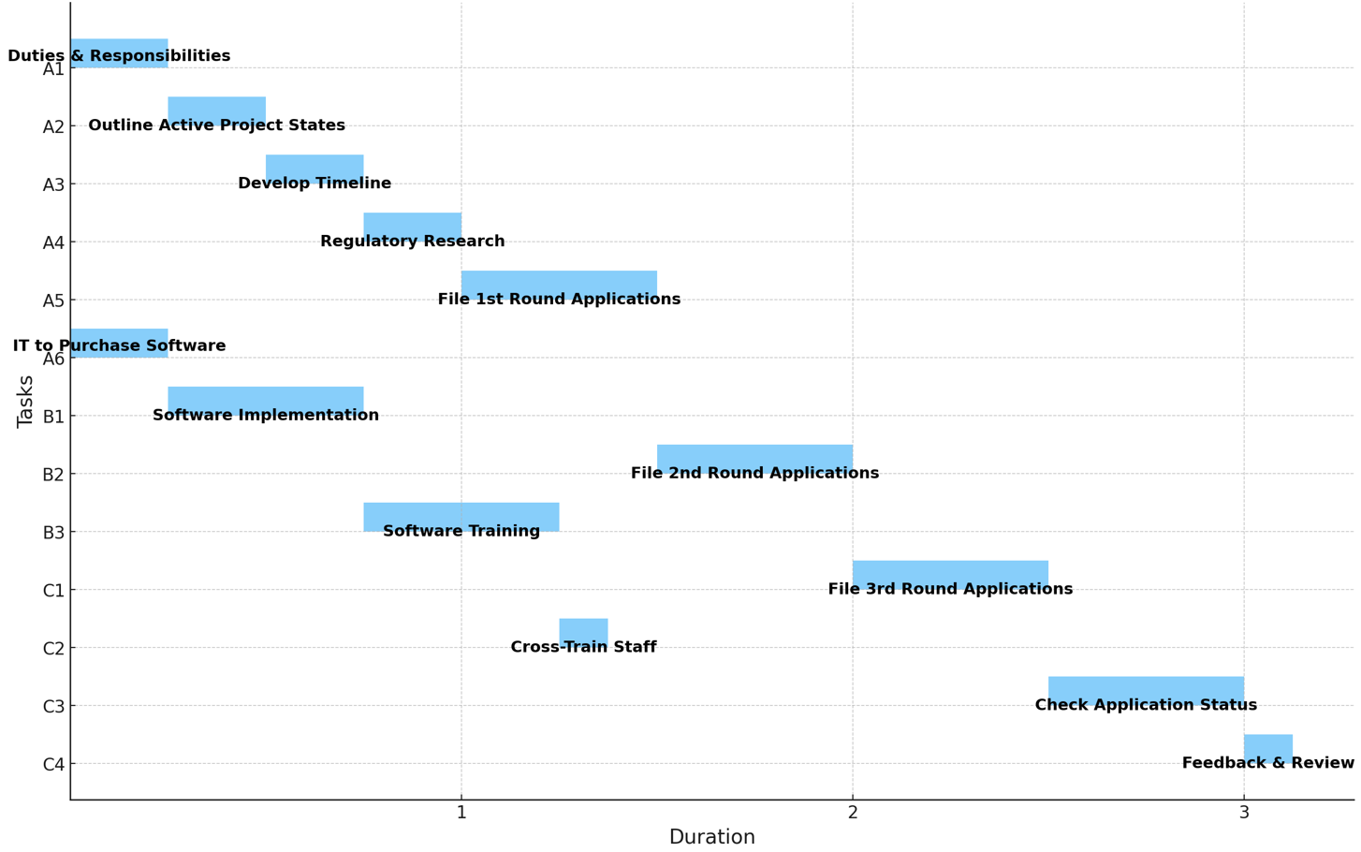

Critical Path
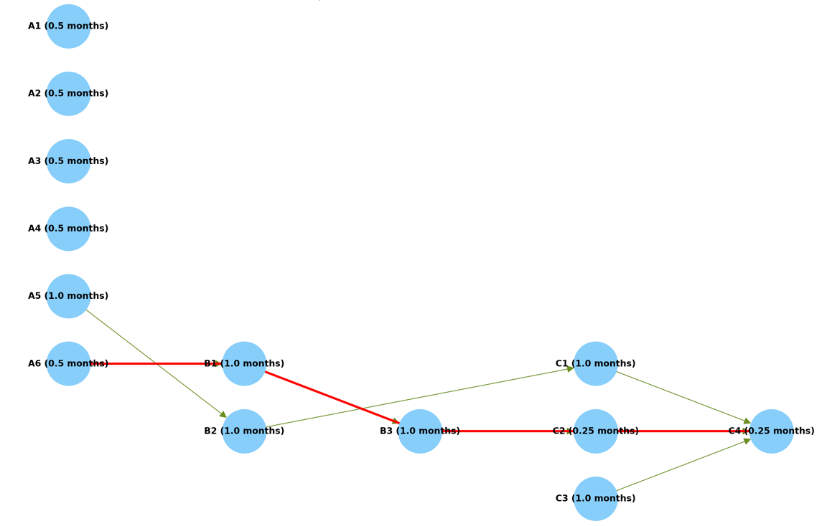
Longest Path: A6 (0.5 months) → B1 (1.0 month) → B3 (1.0 month) → C2 (0.25 months) → C4 (0.25 months)

Communication Plan
Project Name: Professional Licensing Updates and Management System for CLG Engineering, LLC
- Stakeholder communications requirements:
- Weekly meetings with status reports covering each area of the project. Attendance and participation during the meetings required.
- MS Teams and emails will be interim and additional communication.
- It’s crucial team members come prepared to participate in the meetings.
- Everyone will need to be respectful towards all participants in the project and work as a team.
- Communicate often and right away for issues or delays. Do not wait for the weekly meeting to address. Be proactive to problem-solving.

- Communications summary:
- See schedule chart below for expectations and due dates. Contact the project manager for any questions or exceptions.

Stakeholders | Communications Name | Delivery Method/Format | Producer | Due/Frequency
Adam Smith | Weekly status report and weekly meetings | Hard copy and in person meeting | All team members | Thursday at 10:00am (1 hour)
Dan Atwood | Weekly status report and weekly meetings | Hard copy and in person meeting | All team members | Thursday at 10:00am (1 hour)
Craig Goldberg | Weekly status report and weekly meetings | Hard copy and in person meeting | All team members | Thursday at 10:00am (1 hour)
Rebecca Brown | Weekly status report and weekly meetings | Hard copy and in person meeting | All team members | Thursday at 10:00am (1 hour)
Steve Miller | Weekly status report and weekly meetings | Hard copy and in person meeting | All team members | Thursday at 10:00am (1 hour)

Risk Management

Project Name: Professional Licensing Updates and Management System for CLG Engineering, LLC
1. Methodology
- Most of the weekly work is dedicated to this project through the completion date.
- Extra computer monitors provided for efficiency.
2. Roles and Responsibilities

Jen Hankins | Adam Smith | Dan Atwood | Craig Golberg | Rebecca Brown | Steve Miller
Project Manager | CEO | General Manager | Sr. Mechanical Engineer | Office Manager | IT Department
Oversees project tasks and progress and assists in research and applications | Major decision-making authority and strategic planning with executive leadership | Oversees engineering projects and licensing compliance | Completes requirements for licensing | Application submissions, notary public services, and tracking status | System installation, development, and training lead

3. Budget and Schedule
- $30,000 budget and three (3) month schedule.
4. Risk Categories
- Office closures
- Mail delays
- Vendor or supplier issues
5. Risk Probability and Impact
  - Conduct assessment to gauge low, medium, or high probability of impact.
  - Develop strategies in the preliminary stages of the project to mitigate risks.
  - Conduct site visits for engagement with project vendors to provide clear communication and address concerns.
  - Collect information about expedited shipping methods and checking with the shipper for posted delays due to weather.

- Risk Documentation
- Our Risk Management Department will assist in documenting assessments and strategies and with archiving and retention within a centralized database.

