Change Research and Application Report:
Insights and Strategies for Acquisition Integration

Jen Hankins
University of Louisville
LEAD 442-53-4242: Supporting Organizational Change
Geneva A. Stark, Ph.D., CDP
May 18, 2024

Introduction
The purpose of this report is to analyze a scholarly research article related to organizational change and development and apply the theories and concepts learned in this article and LEAD- 442 class readings to a firsthand change experience. I am on the acquisition team for the corporation I work for and will provide firsthand information about an experience from an acquisition of an engineering firm. The article I researched can be found in The Journal of Applied Behavioral Science (2012) “Contradiction and Sensemaking in Acquisition Integration” and authors Samia Chreim and Marzieh Tafaghod researched and analyzed the acquisitions of engineering and architecture firms by a large corporation. Specifically, the aim of their research was to examine how the acquired managers experience makes sense of the changes, how those frames contrast with the acquiring managers, and how the relationship between the two influence that adjustment.
Review of the Article
Article Selection Spotlight
The article was of particular interest to me because I assisted in an acquisition of on an engineering firm last summer. For the sake of anonymity, I’ll call the company CET Consulting, Inc. (“CET”). CET was formed in 2002, the three owners were senior engineers and as part of the stock-purchase agreement, would become employees of the firm post-acquisition. Most of the due diligence was performed by an outside company – investigating legal, economic, fiscal, and financial stability or vulnerabilities. Our in-house counsel worked with CET’s attorney on the particulars of the stock-purchase agreement. There were many meetings to collaboration and compile documents and information which I participated in; and I conducted extensive research for the professional licensing requirements. Post-acquisition, I converted CET to an LLC – a tax and financial strategy mapped out in the pre-acquisition phase. This was a new experience for me but one that provided much insight into the world of business mergers and acquisitions.
Article Purpose and Keywords
An acquisition is not only a change of ownership but a change of and to the roles – the acquired managers are now “newcomers”, and that role involves acclimating which triggers “sensemaking”. There are three elements to sensemaking: (Weick, 1995 as cited in Chreim and Tafaghod, 2012).
[Sensemaking] [t]he combination of past moment + connection + present moment of experience creates a meaningful definition of the present situation. Frames …tend to be the past moments of socialization and cues tend to be present moment of experience. … a relation between these two moments, meaning is created. [C]ontent …of sensemaking is to be found in the frames and categories that summarize past experience, in the cues and labels that snare specifics of present experience, and in the ways these two settings of experience are connected (p. 7).
Experiences with acquiring members frame the sensemaking of the newcomers and adjustment to the new role frame – perceived and actual – construct the meanings of relationships to the new firm and its acquiring managers. Relationships can support or hinder experiences of the acquired manager and contribute to employee retention or loss which is the focus of authors Chreim’s and Tafaghod’s research.

Methods
The authors used qualitative case research of three acquisitions – two engineering firms and one architecture firm – using purposeful sampling and the “snowball” sampling technique, as discussed in Anderson (2020, p. 151), the interviewer asks the interviewee to suggest who else they would recommend interviewing. The authors interviewed members from both the acquiring and acquired firm post-acquisition that included senior management, corporate staff, human resources, and regional/division leaders. Interview topics included: acquisition motives, individual roles and responsibilities before and after, similarities and differences of the acquiring and acquired firms, major steps in the integration, enablers and obstacles to the integration, how the interviewee experienced the transition, relationships between acquiring and acquired members, and evaluation of the acquisition outcomes (Chreim and Tafaghod, p. 11).
The initial data was coded and shared to senior members and managers of the acquiring and acquired firms who meet weekly to discuss and come to agreement. Following, advanced data analysis was collected that focused on roles and relationships and compared to the frames held by both. Additional data collection involved unobtrusive measures (Anderson, pp. 162-163) that included agreements, communication, and documents related to the acquisition. The importance of good data gathering techniques, “generates information about organizational functioning, effectiveness and health…[that] can be a force that can spark interest in change” (Nadler, 1977 as cited in Anderson, p. 147). The mixed methods approach is a way to look at the information and validate conclusions (p. 167).

Results and Conclusions
The three firms examined: Firm 1 – a specialized field of engineering, the acquiring firm had no experience and the motive of the acquisition was to add as a new field of practice;
Firm 2 – engineering field that the acquiring firm already had experience in and geographical expansion as the motive; Firm 3 – an architecture firm in an area that the acquiring firm already had experience and a motive of achieving depth and geographical expansion. Each acquisition taking place in different years and the length of time post-acquisition ranged from three years, eighteen months, and fifteen months, respectively, to the authors’ research. Of the three firms, Firm 1 had the least success with more than fifty percent loss of employees and revenue drops; Firm 2 had a small percentage of employee loss and acceptable revenue in one division and higher employee and revenue loss in another division. Firm 3 was the most successful with zero employee or revenue loss.
Figure 1 (Chreim and Tafaghod, p. 15) is a visual of the summary of the authors’ analysis – showing acquired managers frames of past to present experiences as newcomers. Dominate and reoccurring themes of loss of autonomy resulting in diminished authority to make even small, everyday type decision to strategic ones; customization versus standardization – convert to the acquiring manager’s way; compliance with corporate policies – led to inefficiencies; relationship information – guidance on how, who, and where to get information; and radical versus - incremental – form over function type issues.
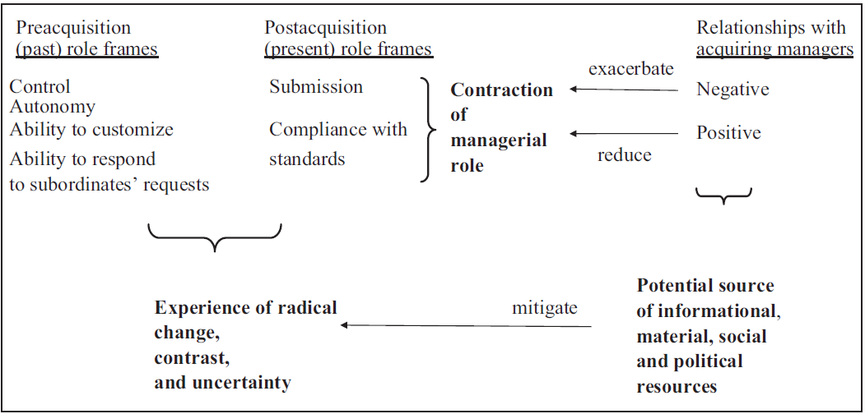
Figure 1: Acquired manager sensemaking and adjustment experience during integration. Implications and Recommendations
In reading the data and direct quotes in interview notes, it was easy for me to identify the common thread in the unsuccessful integrations post-acquisitions, and that is the relationship with acquiring managers and acquired managers. There was a direct correlation to acquired managers who experienced a positive relationship with acquiring managers to those that didn’t. Acquiring managers who viewed the acquisition as a routine process often treated acquired managers as
a means to an end and gave no concern for their change experience. Positive relationships included interactions framed by past socialization experiences with acquiring managers pre-acquisition which continued post-acquisition when acquiring managers provided support, helpful guidance and information that eased the radical change into a process towards successful integration, a greater sense of empowerment, and increase in job satisfaction and retention.
Application to Case Example: Acquisition of CET Consulting – Insights and Strategies for Acquisition Integration
Situation Described
The acquisition of CET Consulting, Inc. in the initial stages, seemed to be a successful one – three senior engineers, with combined 50 plus years of experience, were retained as employees who not only had expertise but a professional reputation for quality work, with many contracts throughout roughly twenty-six states with revenue in the millions. Considering the many aspects of post-acquisition integration, which my part involved a lot of time devoted over the course of nearly a year, many of other departments spent devoted time.
The senior engineers were hoping to focus their time, talent, and skills on projects and remove themselves from the stresses of business ownership. All three profited from the sale of their company, had generous employment contracts that also included compensation for projects not yet paid out prior the acquisition. All should be good, right? Wrong!
Diagnosing the Situation: Sensemaking, Frames and Cues Missed
Seven months post-acquisition all three senior engineers walked out without notice. My own interpretation is the root causes as similar issues to those in Chreim’s and Tafaghod’s Firms 1 and 2 case studies. It was in the integration to corporate’s systems and the disconnect to meaningful experiences with the acquirer where the failure occurred. So much time was spent on Teams calls, rather than actual one-on-one, in-person interactions integrating to solve transitioning payroll and time-keeping systems, how things are done, resources, and who to contact. Also, there was the information I needed to update the company’s many licenses, a processed prolonged due to the engineers’ lack of availability and the four hour time zone difference between corporate and CET’s principal office. There were other departmental issues that I was not involved with nor privy to that likely contributed.
I remember Teams calls where I could sense a lack of enthusiasm and a negative outlook from one of the senior engineers in particular whom I’d met and spent professional time with collaborating during a work conference a few months following the acquisition. It seemed to contradict his usual demeanor. One of the other senior engineers started to refuse flat out to participate in meetings. I’ve grown to trust my gut instincts and mentioned my observations to more senior corporate staff, but our corporation is stretched thin with supporting over 7,700 employees and close to 100 companies.
As learned in Anderson “When two organizations come together, culture clashes can occur on a variety of dimensions… and successfully integrating… requires significant work”
(p. 311). Anderson goes on to explain common problem areas: individual integration – too much time spent finding information, employees lack motivation/engagement and results in turnover and a return to old ways; team integration – lack of understanding of team goals, purposes, and processes; cross-team department integration – work duplicates and missed handoffs, confusion about task assignments; organization-wide integration – failure to make changes and inability to realize competitive opportunities (p. 314).
Prescription for Improvement
Chreim and Tafaghod make recommendations for successful integration that begin prior to the acquisition, and in my analysis, could be categorized as emotional intelligence and leveraging human capital and are as follows:
- provide attention and recognition in the early stages, attempting to forge relationships prior to the acquisition allowing managers from both firms to gauge the level of fit and use to decide whether or not to proceed; and
- provide training in integration and set specific integration targets that become part of the performance evaluation of the integration managers; and
- understanding that an acquisition involves a sense of loss, creates uncertainty about relationships and routines, contributing to anxiety, significant sensemaking demands and implications for work-life dynamics (p. 28).
In the context of the acquisition of my case example, and understanding the motivation and business strategy of our corporation, we still would have acquired CET. However, I see the value in forming pre-acquisition relationships. From the Anderson readings, the concepts of organizational development that I would use include a combination approach to incompatibility of organizational cultures targeting challenges that compete against integration (p. 315).
These interventions would include CTE’s acquiring managers and our corporate staff having an in-person meet and greet, followed by a dinner event seeking to find common ground outside of the change, allowing a discourse to begin and relationships to form. I’ve seen how networking can be a powerful tool – one of our strategic business units hosts an annual “university” and it’s an excellent venue to learn from others and expand your network, gaining a different perspective while strengthening skills and efforts.
Following the acquisition of CTE, I would utilize intervention methods to integrate individual, teams, departments, and organization – focusing on onboarding in-person sessions and orientations, team-start up and manager development, strategic planning and goal-setting, leadership development to align missions and goals, and ultimately organizational design that removes gridlock and promotes growth (Anderson, p. 320). The key motivating factors by Hertzberg (1993) explain people are satisfied by the intrinsics of what they do. This aligns with Influencer (2013, p. 218) that vital behaviors must connect to intrinsic satisfaction and social support to effect change. Using these theories would demonstrate that our corporation has management values of “high concern for production and a high concern for people” (Anderson, p. 32).
CTE Consulting has survived the post-acquisition despite the situation and has since hired equally as talented senior engineers to fill the void which the flipside, has paved the way for a fresh culture that is better aligned with the overall vision and mission of the owning corporation.

References
Anderson, D. L. (2020). Organization development: The process of leading organizational Change (5th ed.). SAGE Publications.
Chreim, S., & Tafaghod, M. (2012). Contradiction and sensemaking in acquisition integration. The Journal of Applied Behavioral Science. 48, 5-32. https://doi.org/10.1177/0021886311403311
Grenny, J., Patterson, K., Maxfield, D., McMillan, R., & Switzler, A. (2013). Influencer: The new science of leading change, Second Edition. New York: McGraw Hill.

