Walnut Designs

George Chesney, Jen Hankins, Jeremy Norman

Organizational Learning & Leadership Program, University of Louisville

LEAD 311: Needs Assessment

Dr. Rodney Merkley

April 20, 2024

Table of Contents
Part 1 – Assessment Introduction and Plan 2
Needs Assessment Overview and Introduction 3
Charter - Problem Statement/ Business Case 3
Kick-Off Meeting Agenda 5
Needs Assessment Scheduling 5
Part 1 Grading Rubric 7
Part 2 – Methodology: Data Collection Plan 7
Methodology Section Introduction 8
Data Collection Plan Introduction 8
Data Collection Plan Table 8
Part 2 Grading Rubric 9
Part 3 – Methodology: Quantitative Data Collection & Analysis 10
Quantitative Data Collection - Overview 11
Quantitative Data Collection – Tool/Instrument 11
Quantitative Data Collection – Analysis 12
Part 3 Grading Rubric 13
Part 4 – Methodology: Qualitative Data Collection & Analysis 13
Qualitative Data Collection - Overview 14
Qualitative Data Collection – Tool/Instrument 14
Qualitative Data Collection – Analysis 15
Part 4 Grading Rubric 16
Part 5 – Conclusion/Reflection 16
Part 5 Grading Rubric 17

Part 1 – Assessment Introduction and Plan

Needs Assessment Overview and Introduction
Name of the project: Walnut Designs Needs Assessment
Organization overview
Walnut Designs is a custom-made furniture store specializing in unique, made-to-order furniture. Originally founded in 1980 by Jack Smith, the company was founded in response to dissatisfaction with mass-produce furniture made from wood byproducts. The company has gone through significant growth, specifically in the early 2000’s. This growth resulted in expansion of the company by creating two locations, one in North Carolina and the other in Indiana. Both locations employ approximately 50 individuals and share HR/IT resources. The main product of the company is custom “slab” walnut dining room and conference room tables, which command high prices due to uniqueness and craftsmanship.
The company is using existing equipment and processes to make this furniture, but they are not designed for this operation. Additionally, the company faces challenges related to its workforce. These challenges include an aging workforce that has all the experience and expertise to make furniture, and a younger workforce that does not have the necessary skillset.
Assessment description
The assessment will focus on the impending loss of expertise due to the retirement of many experienced employees at the company. Additionally, the assessment will include what is needed to properly train the younger workforce and a training plan to sustain the knowledge long-term. Additionally, the assessment will address the inefficiencies and limitations coming from the use of existing equipment and process issues, with a focus on the determination of the proper equipment and what are industry best practices to use that equipment efficiently.
Business Case
The business case for these problems will ensure long-term sustainability and growth of the company in face of impending workforce challenges and operational/equipment inefficiencies.

Charter - Problem Statement/ Business Case
Project Name: Walnut Designs
1. Introduction/Background to the Problem:
An aging workforce that contains the required knowledge approaching retirement age with no plan in place to replace that knowledge in the next generation. Improper equipment and processes to make the required product.
2. Specific Problem Statement:
Twenty-three (23) employees are reaching retirement age and there is no mechanism in place to ensure the proper transfer of skill and knowledge to the next generation of workers in the company. The use of improper machinery and processes to manufacture “slab” tables is resulting in reduced profits, $2000, compared to what would be possible if using more efficient processes and correct equipment.
3. Current Situation and Importance of the Problem/Issue:
The scope of the assessment will focus on what equipment is needed and industry best practices for the process to use that equipment. Additionally, the assessment will look at methods to address training the younger workforce for them to have the requisite skills to manufacture products.
4. Analysis of Options and Recommendations:
A robust training program based on senior workforce input and other industry practices will help junior personnel get up to speed faster and create an atmosphere of learning and improved performance. Additionally, training in new equipment and processes will be the effective way to get rid of poor work practices and inefficiencies that currently exist.
5. Estimates of Organization Benefits (Financial & non-Financial:
Legal – Compliance with employment laws and regulations. Ensuring proper compliance with various employment laws and regulations regarding hiring, training, and termination. Additionally, product liability is a concern. Using improper equipment to make a product could result in the company being liable for product defects or poor quality resulting in injury or damage.
Operational – Use of existing equipment is resulting in inefficiencies that delay production, therefore resulting in loss of profits for the company.
Customer Service – Reduced inefficiency in making the product results in delays for customers receiving their orders. Additionally, potential issues will be generated if the younger workforce is not properly trained, which could result in lowered product quality and further delays for customers.
Strategic – Reduced the company's sustainable growth by using inefficient processes and the next generation of workers having a reduced level of knowledge of the assembly and manufacturing process.
6. Schedule Estimate:
Expect this assessment to take approximately five months to identify issues and come up with solutions fully with course of actions available to implement.
7. Project Team:
George Chesney, Jen Hankins, and Jeremy Norman

Kick-Off Meeting Agenda

Project Name: | Walnut Design Needs Assessment | Date: | 17 March 2024

Meeting Objective: Profit Optimizing Session
Agenda:
- Welcome and Introduction
- Resource Allocation (SME)
- Growth and Development
- Training Programs
- New Equipment Procurement
- Knowledge Retention Concerns
- Closing Remarks

Action Item(s) | Assigned Individual | Deadline
SME Scheduling (Training) | Jeremy Norman | 20 Mar 24
New Equipment Cost | Jen Hankins | 20 Mar 24
Performance | George Chesney | 20 Mar 24
Quarterly Finances | Jeremy Norman | 1 Apr 2024 (Qtr. end)

Date/time of next meeting: 20 Mar 24

Needs Assessment Scheduling
Prepared by: | George Chesney & Jen Hankins | Date: | 17 March 2024

# | Activity | Owner |  | Time | Month 1 | Month 2 | Month 3 | Month 4 | Month 5 | Month 6
1 | Pre-Assessment Prep | Team Lead |  | 3 weeks
1a | Define Objectives and scope for gaps in employee skills | Project Lead |  | 1 day
1b | Identify key stakeholders | Project Lead |  | 1 day
1c | Determine path of questionnaire or survey. Development of decision | Project Lead |  | 1-1.5 weeks
1d | Review current training plan/employee turnover rates | Project Lead |  | 1 week
2 | Survey Staff Members | Dept. Manager #1 |  | 1 month
2a | Survey Distribution | Survey Coordinator |  | 2 weeks
2b | Employee Return of Surveys | Dept. Managers |  | 1 week
2c | Send reminders | Survey Coordinator |  | 2 days
2d | Put survey results in database | Survey Coordinator |  | 1 week
3 | Data Analysis |  | Team Lead | 1 month
3a | Analyze survey responses and data analysis for turnover process |  | Team Lead | 2 weeks
3b | Identify skills that are missing from high demand areas |  | Team Lead | 3 days
3c | Compare survey results against current practices |  | Team Lead | 1 week
3d | Generate findings and recommendations for action |  | Team Lead | 1 week

# | Activity | Owner | Time | Month 1 | Month 2 | Month 3 | Month 4 | Month 5 | Month 6
4 | Prepare & Present TNA Report | Project Lead | 2 weeks
4a | Stakeholder engagement | Project Lead/ Dept. Managers/HR | 3 days
4b | Present findings and recommendations | Project Team | 3 days
4c | Gather stakeholder feedback and implement necessary information into COA | Department Managers | 1 week
5 | Final COA development | Project Team | 2 weeks
5a | Based on findings and feedback, finalize COA | Project Lead | 2 days
5b | Define training objectives, target audience, and delivery methods for training | Project Team | 1 week
5c | Develop final timeline for COA implementation and follow up evaluation | Project Lead | 3 days
6 | Final Report and Presentation | Project Lead | 1 week
6a | Develop presentation for final report | Project Team | 2 days
6b | Present findings to organization leadership | Project Lead | 1 day

Part 2 – Methodology: Data Collection Plan

Methodology Section Introduction
Data Collection Plan: Combining the use of employee surveys, interviews/focus groups, and feedback from stakeholders to generate information and data from stakeholders to generate information and data that can therefore be analyzed to determine the best course forward.
Quantitative Data Collection and Analysis: Employee surveys that will collect data on employee demographics, job roles, proficiency levels in specific skills, training experiences, and preferences for training formats.
Qualitative Data Collection and Analysis: Performance of interviews with stakeholders/managers/selected employees to determine their perspectives on training needs. Combining this feedback with focus group usage to determine internal thoughts on training needs and challenges.
Findings: Using the findings from both the survey and the interviews, the information will be aggregated to determine the best course of action going forward. Expected results from the data will include what kind of training would be best suited for the company, who will provide that training, and how often the training will occur.

Data Collection Plan Introduction
The data collection plan will aim to gather information about the organization’s workforce, training needs, and existing resources to inform the development of an effective training plan. Using the data gained, the needs assessment will determine the full breadth of the training gap, who would benefit most from the training, and who would be best suited to provide it.
The assessment team will use a mixed methods approach to gather quantitative and qualitative information from different perspectives to gain descriptive information for validity. The key data collection areas will consider three areas:
1) participants – the required prerequisites, intended audience, preferred methods of learning, existing competencies, and audience characteristics to establish a learner profile.
2) organization – management and supervisors’ behaviors, demands and pressures, and physical surroundings, assessing work setting to determine culture.
3) performance – job, content, and task analyses, to identify training content.
The data collection plan will serve as a gauge of operational efficiency, sales and revenue, and employee performance. The information from the data collection plan will allow us to support areas of operation lacking and implement processes for moving forward. This is a collaborative process that is only possible with your dedicated efforts and cooperation. You have our word that our training professionals will maintain a positive environment that is respectful of your time and one that is transparent each step of the way. Please reach out if you should have additional concerns or accommodation needs. Data collection is vital for gaining an invaluable understanding that ensures broadening, innovation, and strategic advantage for your company and its mission.
While we strive for across-the-board data collection, it’s vital to acknowledge potential limitations such as response bias in surveys, external factors that can contribute influenced training outcomes, and constricted self-reported data accuracy. We understand that we must fully invest in both data collection and training concurrently to give ourselves the best opportunity to be successful. In the face of said challenges, we are confident that our data collection plan will produce valuable insights to advise sustainable improvement of our training and development ingenuity.
In closing, this data collection plan signifies our devotion to evidence-based decision making and continued improvement in and through training and development. Our goal is to optimize the impact of our training programs while simultaneously driving the professional growth and advancement of our employees. We appreciate the continued cooperation and support of all stakeholders in this venture to higher excellence.

Data Collection Plan Table

Data Collection Tool | Metric | Description | Intended Use | Collectors | Storage | Frequency
Interviews/Focus Groups | Training required | Description of what training will be necessary based on survey results | Inquire from stakeholders/employees about what needs exist and what training plan would solve those | Jenny, Sandra, and Jimmy | Paper log of interview results | Everyday for 3 days
Survey | Current skill proficiency | Self-evaluation and assessment of where employee proficiency currently lies | Determine the skill level of different employees to determine how large the gap is and what areas require improvement | Mike and Bobby | Electronic Survey | Weekly

Part 2 Grading Rubric
Part 2 | Requirements | Draft Pts. | Final Pts.
Introduction  (400 words) | Provides a brief overview of the Data Collection and Analysis section, describing what readers will expect/see in section, mentioning:  - Data Collection Plan; Quantitative and Qualitative methods  - That the data was analyzed, and findings identified  - That each will be discussed in detail in subsequent sections. | 1 | 2
Data Collection Plan | The schedule demonstrates a methodical plan to collect data. | 1 | 1
 | All rows are fully developed/created using TNA template document | 1 | 2
 | Total: | 3 | 5

Part 3 – Methodology: Quantitative Data Collection & Analysis

Quantitative Data Collection - Overview
Rationale/Justification
Using a survey will be the most useful tool in data collection for a few reasons, as listed below:
- Standardization: Surveys offer standardized questions and response options, ensuring consistency in data collection. Making it easier to analyze responses quantitatively and compare results over different employees or time periods.
- Flexibility: Surveys allow us to customize questions and response options based on our specific objectives. We will use closed-ended and open-ended questions to provide quantitative and qualitative insights.
- Cost-Effectiveness: Compared to other methods of data collection, like observations and experiments, surveys can be more cost-effective. They require fewer resources and can reach a larger audience or group of employees through online web without significant financial investment.
- Versatility: Collecting data on various topics, including attitudes, behaviors, opinions, and training preferences.
Recipients
Employees will be our target audience for this survey. As we hope to gather feedback on various aspects of the workplace, such as job satisfaction, training and development, overall employee experience, and organizational culture.
Process
The objective of this survey is to gauge and gather data to assess training effectiveness and identify areas for improvement. The data collection will be administered as a survey and distributed through an anonymous online platform. The survey will be returned through a website once submitted anonymously. Reminders will be sent every other day to those that haven’t submitted. Additionally, the survey will be accompanied by a statement on the purpose of the survey and a statement about what the results will be used to accomplish.
Ethical/Inclusion Considerations
We have decided with our human resource team, the best way to handle confidentiality is anonymity. We will accomplish this by using a singular code for all employees to log in and take surveys. This will eliminate the fear of reprisal.

Quantitative Data Collection – Tool/Instrument
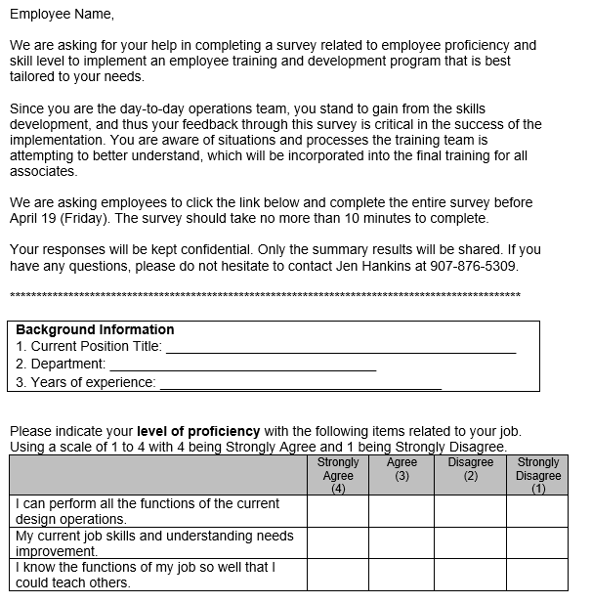
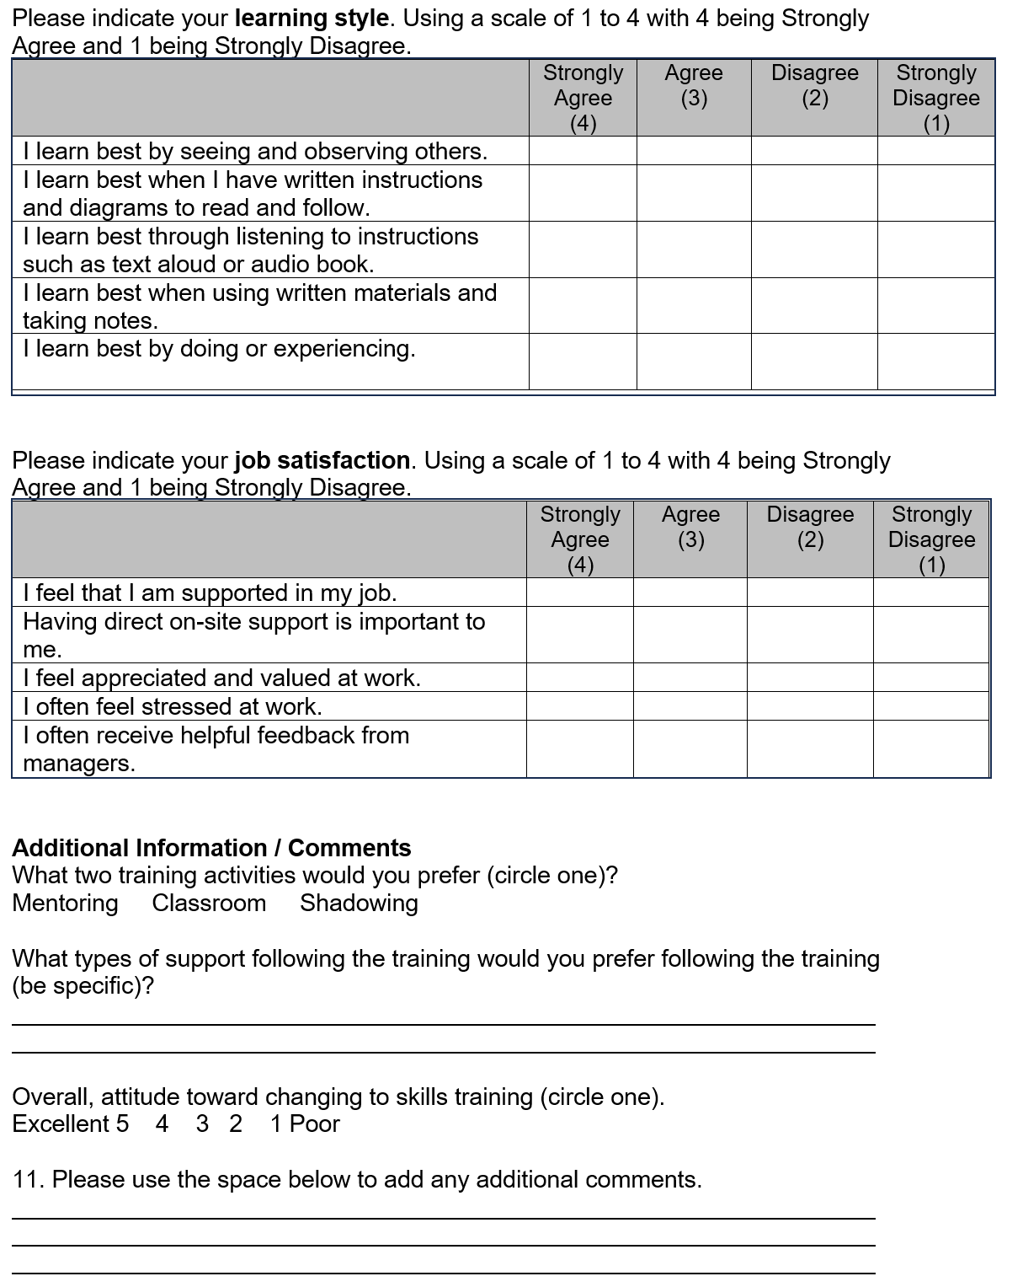

Quantitative Data Collection – Analysis
Analysis Process
Data was collected using a survey that focused on three areas: performance of duties, Learning style, and Job Satisfaction. Additionally, information was collected on the preferred method of training activity to learn from and the overall attitude toward creating a skill training program. These areas were selected to inform the team on the best course of action to close the necessary gaps and determine the best training method to maximize retention and improve skill sets.
A small cross-section of data is included below that covers the responses of 16 personnel. The sections are broken up at the top and have personal information that includes the participant's position title, department, and years of experience. This data is useful for breaking down the information gathered by departments, determining if a single department is having an issue, or using the years of experience to determine if there is a larger culture issue of senior vs. junior personnel, as previously disclosed.
The different sections are then broken up into codes (P for performance, LS for learning style, JS for job satisfaction, ACT for desired activity, and ATT for attitude towards skills training) to determine the options for how the data is sorted. The responses for P/LS/JS were scored on a 1-4 range, with one being strongly disagree and four being highly agree, with no neutral answer being offered. This removes any bias or apathy towards the survey; the participant needs to decide actively whether they agree or disagree with the statement. With ACT only having three options, data must be entered on the primary choice of the respondent. The data is calculated in the average row to show the response with the highest count. Lastly, ATT is graded on a scale of 1-5, with one being poor and five being excellent, to determine the respondents' outlook on their attitude towards the potential change in skills training.
There are two fill-in spots on the survey for respondents to add in their own responses. This data is not on the spreadsheet but will require the information to be populated manually and evaluated separately. This is because it is not controlled data; no integrity rules cover what could appear. This will be difficult to aggregate in a spreadsheet but will provide insight into the overall thoughts of the workforce and will be useful to guide discussions in later focus groups/interviews.
All this information is populated in a spreadsheet, with an overall average assigned to each column for the responses provided. The spreadsheet can be filtered further based on the identifying characteristics provided using pivot tables or sorting functions in the table itself.
Summary of Findings from Data Analysis
Initial findings from the sample show many responses from the manufacturing department, with a couple of other departments also responding at this point. The average experience in the sample group is relatively senior, but there is a good spread of both the senior and junior personnel in the company. This is a good spread of knowledge of the company, and therefore, the data being analyzed is most likely to be a fair representation of the company at large. All three questions about performance have averages showing a lean toward disagreement with the questions being asked. Of most concern during the initial review was the low average for P1, which shows that most people do not agree with their ability to fully operate the equipment they are responsible for. Further analysis of the data shows that most respondents responded with a 3, meaning the number is being driven lower by only a couple of responses while also not being floated by enough people who would consider themselves “experts.” This will require more data to determine the impact of this response further.
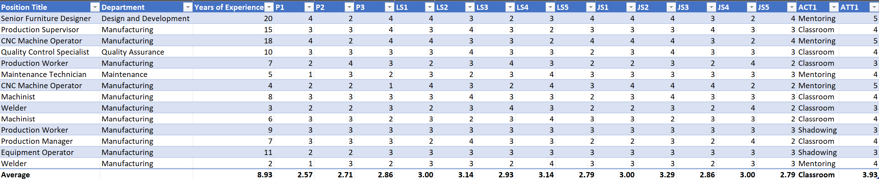
We see all the other responses coming in with averages right around three, meaning general agreement with the statements. The five questions regarding learning style all have relatively the same averages, showing that no one dominant learning style exists in the workforce. This must be considered when developing training plans to ensure that all learning styles are being addressed appropriately. Additionally, the dominating choice of training method is in the classroom. This is useful as we can tailor training towards most of the learning styles more easily in the classroom. Further analysis of more data will show the spread of desire of the group if it changes. Lastly, the respondents provided data showing high acceptance and attitude towards a change in skills training. This is encouraging as it shows there will be less resistance to the training assessment findings, and managing change in the organization will be slightly less challenging if handled appropriately.

Part 4 – Methodology: Qualitative Data Collection & Analysis

Qualitative Data Collection - Overview
Rationale/Justification
We’ve decided that a focus group is the most appropriate tool for our company, as it has many variables, such as a diverse age range. Because it allows for studying different perspectives, experiences, and preferences among younger and older participants. By bringing together individuals from different age groups, the company can gain valuable insights into the training needs, preferences, and learning styles of various demographic sections. This all-inclusive understanding can inform the development of training programs that are effective and engaging for employees of all ages and, in time, contribute to the company’s growth and success. Which is our ultimate goal.

Recipients
Our focus group will consist of a cross-section of employees from different experience levels and roles within the warehouse. This will include junior apprentices with less experience and seasoned craftsmen with a wealth of knowledge and experience. By bringing together individuals with varied backgrounds and perspectives, the focus group aims to gather insights on training needs, process improvements, and workplace dynamics that provide to the entire workforce.

Process
The focus group will be conducted in a hotel conference room (Charlotte Marriot City Center) five minutes from our facility. This will be done after regular work hours to provide a neutral and comfortable environment for participants to express their thoughts and opinions freely. Holding the sessions outside of regular work hours ensures minimal distractions and allows employees to fully engage in the discussion without the pressures of their daily tasks. This will be held from 6-8 pm on Wednesday and Thursday. The incentive for employees is they will be paid their hourly wage for the focus group's duration, plus an extra hour to compensate for the inconvenience. Reminders will be sent through multiple channels to ensure maximum visibility and participation. These channels will include email, Microsoft Teams, flyers, and personal invitations through company leadership. We will include specific details such as the focus group's date, time, location, and purpose to help employees plan accordingly and prioritize attendance.

Ethical/Inclusion Considerations
When discussing confidentiality with focus group participants, we will emphasize the importance of respecting everyone’s privacy and ensuring a safe space for open dialogue. We will start by stating that all information shared during the focus group will be treated with strict confidentiality and will only be used to improve training programs and workplace processes. This will be outlined in the initial invitation. We will encourage participants to share their thoughts openly, reassuring them that their anonymity and privacy will be protected. We will provide a drop box for participants to raise any concerns they may have about confidentiality during or after the focus group session, ensuring that everyone feels comfortable and respected throughout the process.

Qualitative Data Collection – Tool/Instrument

Figure 1: Focus Group Introduction Letter
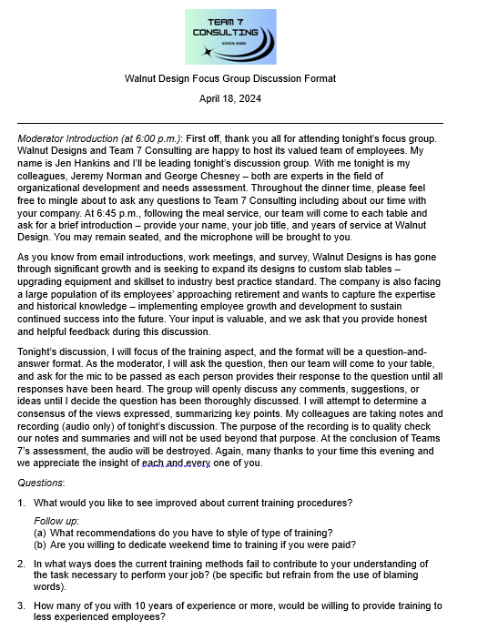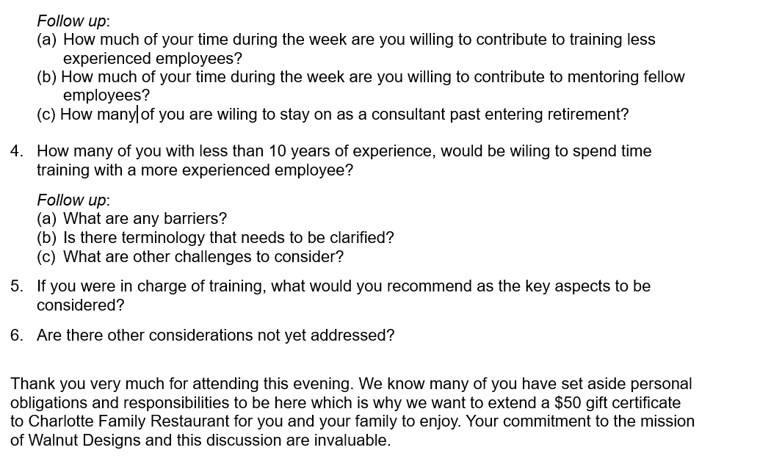
Figure 2: Focus Group Discussion Format

Qualitative Data Collection – Analysis
Analysis Process
Data was documented by a couple of interns trained to document all answers to all questions. This was important to ensure accurate data collection, and no answers were to be deemed inconsequential. These interns, who had no vested interest in the information being inputted, entered this data into spreadsheets and were provided instructions to put in all answers that were provided during the focus group meeting. With the aid of AI, the answers to the questions being asked were sorted for keywords or phrases that were repeated in each question. These keywords were tracked on a different spreadsheet that showed the count of repetition of those words cross-referenced with the question being asked. Each keyword was assigned a code to allow for easier tracking in the spreadsheet. Additionally, these keywords were assigned to each interviewee to allow the information reviewer to go back to see each interviewee's comments.
The code for each keyword was the first number of the question being asked, and the second number being the numerical value provided to the keyword. For example, the first question keyword would be Q11, and the second keyword of the first question is labeled Q12. This would continue for each question and unique keyword identified. Additionally with the code, is the keyword itself. This can be seen in the top row of the sample data provided below.
This method was decided upon as it allowed for a quick and efficient manner to see the commonality of the answers being provided and to key in on common threads. Additionally, with the ability to then go back and see what each interviewee said in its entirety, both a vertical and horizontal audit of the answers could be conducted to ensure maximum data validation.

Summary of Findings from Data Analysis
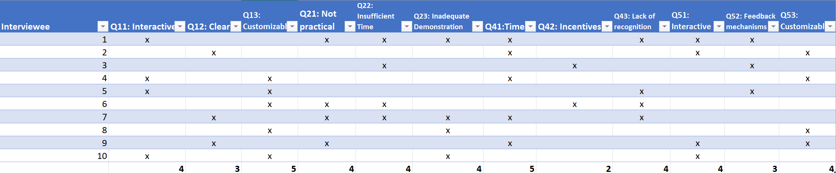
With the data collection from 10 interviews documented in the sample table above, some baseline analysis of the results can be conducted. The bottom row of each column shows the tabulation of entries of the keyword, with each keyword being marked by an x in the associated cell of the interviewee. With question 1 being about what the group would like to see improved about the training program, there was a strong desire to see the program contain customization and be interactive. This also aligns with the results of question 5, which asked if the participants were in charge of the training program and what they would incorporate into it. There was a strong correlation of results between the two questions shows this data to be very true and representative of the larger group so far since the same results were provided for two questions with similar basis. The evaluation of this part will need to be tracked, but initial analysis would suggest that these two portions will need to be accounted for in any training program that would be developed.
Another data point to be observed is the responses for why senior personnel fail to train or mentor juniors. Time was a result of 50% of the answers of the focus group, with some of those also mentioning a lack of recognition as a concern. This will require addressing as those personnel responding demonstrate the need for a program that will address these concerns, and the executives and managers of the company will need to institute a program that will show recognition and create a separate time to entice the senior personnel to train newer personnel to increase performance of the company.
Lastly, there is an equal distribution of responses to why current training plans fail to perform. Further data being populated will hopefully flesh out a dominant area, but current data shows there are many reasons to be believed for the failure, and therefore, shows an overall failure of the program and not an easy fix to repair one dominant section. This would indicate that a full rollout of a training program from the ground up is necessary instead of just patching the current program.

Part 5 – Conclusion/Reflection
Recommendations
- Create a new training program: A training program is needed based on the workers' needs in both the context of learning preferences and desires. The data provided from surveys and focus groups show that the learning styles are evenly distributed throughout the workforce. Therefore, we recommend creating a training program catering to all visual, audio, and hands-on aspects to maximize the retention of knowledge and skills being taught. We recommend that this training program be contracted out to professionals with experience in manufacturing processes based on the information gathered, which shows that the current training program is inadequate and insufficient. The use of outside contractors will ensure experts are used to create the training program and will be able to meet the budget requirements of the company.
- Incentivize trainers: While the company has a large set of senior members in their workforce, it fails to recognize their accomplishments. Therefore, those personnel have no desire to train the junior personnel and pass along their skills. We recommend a program that will provide recognition based on the time that they dedicate to mentorship and training. This recognition would be in the form of praise from management and leadership of the company in public forums. This could be company-wide email distribution, meeting calls, or personal praise from key leadership. Additionally, a major concern of the company personnel was the lack of dedicated time to provide training for others. We recommend identifying the personnel that would be best suited for training and creating a specific training department that those personnel will then man up with. They will focus their time on training others and create dedicated training blocks based on creating the new training program.
- Leverage technology: Ensure any training program being developed can be customized for future adaptation and worker needs. While the current junior workforce has a low level of knowledge of skills and abilities, that will quickly be changed as training becomes a larger part of the work routine. This will require the ability to change the training needs as more advanced skills will need to be worked on. Leveraging proper technology will help with future-proofing the training program to ensure another needs assessment is not required to reach the next level.
- Provide customized training: Ensure the new training program has the ability to be customized to the individual needs of the worker being trained. By creating a new dedicated training department, tailored plans can be created for each subset of workers, therefore not wasting time teaching already known skills. Ensure the program can support the creation of tailored plans to maximize training returns.
Alignment with TNA Charter, Problem Statement, and Business Case
The TNA charter, problem statement, and business case described: 1) impending loss of expertise due to the retirement of many experienced employees, 2) a training plan needed to build and grow the knowledge of the junior workforce by capturing the institutional and historical knowledge of the senior workforce, and 3) best processes and training needed to address existing equipment inefficiencies and limitations.
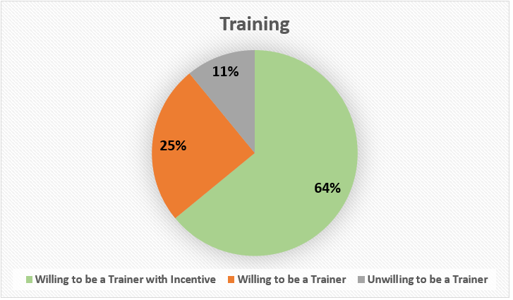
Figure 1: Willingness of Senior Employees to Train Junior Employees
[As a presentation to Walnut Design’s stakeholders]
As shown in Figure 1, Team 7 Consulting’s recommendations highlight training which captures the human capital of your business, your senior workforce. As shown, 64% of your senior workforce are willing to train the junior workforce with a caveat of an incentive - recognition for both existing and future accomplishments while another 25% are willing to train absent an incentive. This equates to capturing 89% of the institutional knowledge in your experienced workforce The associated cost savings, will allow you to allocate funds to new equipment purchases. Hiring a professional team with expertise in manufacturing and production to train employees will ensure compliance with regulations and laws.
This plan ensures organizational financial and non-financial benefits, which aligns with our TNA Charter, Problem Statement, and Business Case presented at introduction. Our findings and recommendations ensure long-term sustainability and growth of Walnut Design’s human capital, legal compliance with laws and regulations for new equipment, an increase to operations and product quality, timely customer service, and an increase in overall sustainability of growth for many years to come. Further, this aligns with Walnut Designs’ mission to provide unique furniture to its customers.
If you’re ready to take the next steps towards this strategic advantage, our design team is here to help with the setup training plan and implementation. Those individuals are highly skilled, and two members of that team is here with us today, to answer any questions you may have. The recommendation is a role out presentation of the training department at the monthly staff meeting, approximately a month from now. We wish you all the best, it’s been a pleasure working with all of you and it is now, with great pleasure that I introduce to you, Dr. Smith and design team members, Stacey, and Peter.

Collective Lessons Learned
Chesney – Learned what the format of a properly designed needs assessment looks like and how to convey the information garnered from the data analysis in a way that can be understood clearly. While I have experience performing these tasks on a routine basis, I have never had to document my findings, and now I have experience using a template that is easily repeatable and lays out the information neatly.

Hankins – I learned how a large part of the organizational scan and data collection gathering involves emotional intelligence and good intuition on the part of the assessor – “listening” for what isn’t being said or stated but otherwise conveyed nonverbally. Also, how to control bias while collecting data and best practices and tools. I had little experience with the statistical analysis of quantitative data, so I gained a better understanding of how to infuse data with meaning and present the relationship. Qualitative data comes easier to me but learning about the Data Analysis Spiral gave me a better perspective in how to unpack the meaning of the “how” and “why”.

Norman- I learned the importance of a needs assessment in relation to a business strategy standpoint. Understanding the intricate steps in data collection as well as how to clearly articulate was a practice I will use militarily. I have a few years of logistical management experience, but not to this extent of specificity. Now I feel well equipped on planning and executing a Needs Assessment.

