Hallmark Assessment Task: Bridging Generational Differences - Lifespan Development Perspective

Jen Hankins
LEAD 460-51: Adult Learning and Diversity
Dr. Geneva Stark
December 2, 2024

Bridging Generational Differences - Lifespan Development Perspective
The purpose of this research assignment is to examine how to bridge the generational differences in the workplace and how to refine organizational practices, training, and research that challenge how generation is defined while encompassing the related impact theories of generation (age, cohort, and period), and shared consciousness to shift organizational thinking from categorical generational differences to lifespan dynamics. The lifespan development framework considers historical and sociocultural influences and how organizations can support life-long learning for their employees, bringing the work-life experience into balance and increasing satisfaction and productivity.
Literature Review
The articles provided a comprehensive view of the vast adult learner needs in the workforce. They emphasize the vastness of workplace diversity related to generational differences and highlight the importance of integrative lifespan metrics to inform and integrate best practices in human development that consider continuous development at the individual level.
Article One: “Considering Generations from a Lifespan Developmental Perspective” in Work Aging and Retirement by authors Cort W. Rudolph and Hannes Zacher and combined with The Whys and Hows of Generations Research by Pew Research Center.; and
Article Two: “Lifespan Learning and Development and its Implications for Workplace Training” in Current Directions in Psychological Science by author Margaret E. Beier
Article Three: “Diversity, Inclusion, and Human Resource Management: A Call for More Belongingness and Intersectionality Research" by authors Oluremi B. Ayoko and Yuka Fujimoto.
Article One - Generations from a Lifespan Developmental Perspective
Authors Curt Rudolph and Hannes Zacher provide a technical and comprehensive view addressing critical elements of lifespan development from a technical perspective of research and methodologies, defining generations and tracing historical concepts, examining and contextualizing the lifespan development framework, and proposing theoretical guidelines for future research that focus on individual-level versus the generational black box arbitrary age-bracketing. Key terms: Age - (biological/chronological age (years since birth) and age effect refer to differences due to positions in the life cycle (younger and older); Cohort - one's birth year and cohort effect one's year of birth and the differences due to the generation one belongs to and where one is at in the process of forming opinions; and Period - the current year (contemporaneous time), and period effect is when events (wars, COVID pandemic, or significant social forces like the visibility of LGBTQ) simultaneously impact everyone regardless of age.
Another key term is generations, which refers to "a group of people born during the same time span, who by virtue of their chronological age proximity have shared similar life experiences" (Rudoph & Zacher, 2017, p. 113). Pew Research Center (2015) defines a generation as "a group of people born over a 15-20 year span [and the analysis of is] informed by demographics, historical events, attitudes, popular culture, and prevailing consensus among researchers" (para. 4 and 5). Questioning the definition of generations and what power it may have on social change has been the subject of arguments by many sociologists who viewed generations as historical units and birth year as one circumstance of shared and similar behaviors (common mental framework) and others like Karl Mannheim, who view generations as age cohorts united by historical and social events in their formative years, forming generational consciousness driving worldviews (Rudolph and Zacher, 2017). Defining generations and what impacts generations is crucial to alleviate stereotypes and capture the appropriate metrics for human resources development.
In lifespan development, researchers consider the influences and interdependencies of age, cohort, and period and how they impact generations. Figure 1 illustrates broad ideological divides between generations and how views and attitudes can differ between generations but also shift over time (Pew Research, 2015).
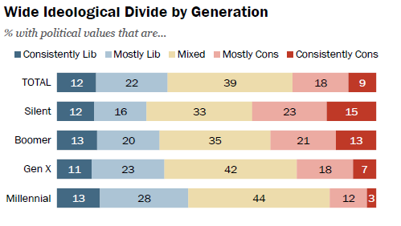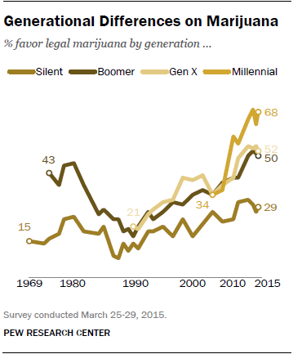
Figure 1: Examples of Key Differences in Generations
Figure 2 show examples of how period effects influence work-related outcomes (Rudolph & Zacher, 2017, p. 116).
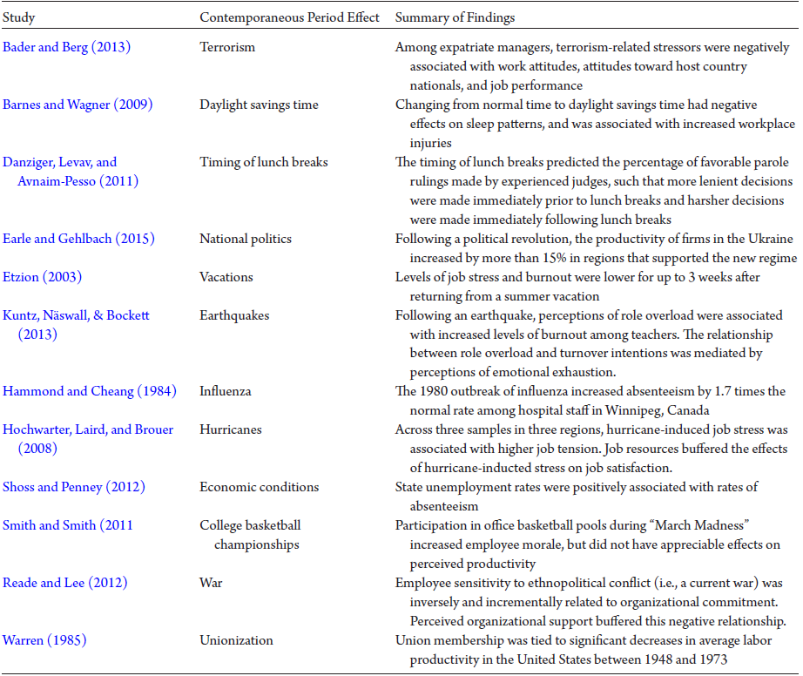
Figure 2:Examples of Empirical Evidence of Contemporary Period Effects
Shared experience is another influence consideration. "Adults grow as learners because of their life experiences" further explains how these experiences shape the adult learner's growth (Knowles, 2017, p. 191). Examples of how societal or historical events affect individuals in the workplace shape experiences, create shared experiences, and emphasize the importance of capturing metrics for workplace development that adjusts to the necessary flexibility. Rudolph and Zacher further discuss cohort effects that impact lifespan development, as well as biological (genetics), sociocultural factors (economy, education, and medical care), and intergenerational exchanges (families - parenting and grandparenting).
As shown in Figure 3, Rudolph and Zacher propose alternative views of experimental methodologies for integrating development principles and propose more meaningful and measurable variables that address lifespan dynamics that influence outweigh categorical differences, providing depth to the age, period, and cohort impacts (Rudolph & Zacher, 2017, p. 124) — from a life-transitions perspective, recognizing shared experience and collecting measures that reflect a person's response, attitudes, or opinions surrounding cohort and period events.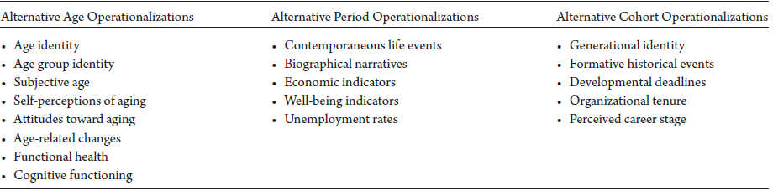
Figure 3: Alternative Age, Period, and Cohort Operationalizations
Rudolph and Zacher conclude by discussing the various current methodologies for studying and measuring generations, from an individual's generational identity to generational group pairing characteristics, the latter they see as a driver of age-related stereotypes, assumptions, and overall well-being of individuals. The highlight of their research proposes a differentiated lifespan approach that emphasizes individual-level processes to unmask ageism and the need for continuous developmental influences to understand better implications of aging and life stages that address attitudes, values, and behaviors.
Article Two – Life-Span Learning and Development and its Implications for Workplace
The article begins with the author, Margaret Beier, highlighting keywords - lifespan development, lifelong learning, training, and aging. She explains, "The majority of the employed people are between the ages of 25 and 54, and the age groups with the fastest-growing percentage of workers are even older (Beier, 2022, p. 56). Beier takes the lifespan development approach as she discusses aging and its implications for lifelong learning in the workplace. The author recognizes aging as a continuous process influenced by personality, interests, ability, motivation, contextual factors (education and training), and decline and growth characterizations (Baltes et al., 1980, as cited by Beier, 2022). Despite declines, the older adult employee/learner is capable of learning and is driven by abilities, motivation, and how existing knowledge can support new learning.
Beier acknowledges that while age-related decline contributes to "self-fulfilling prophecies" (their internal stereotypes) by reducing interests, adjusting strategies like self-paced learning and tapping into their internal motivations can fuel the learner's effort-utility. This approach leads to organizations developing programs that support the variety of differences in the aging adult learner/employee and alleviate stereotypes.
The growth aspect of abilities and motivation of lifelong learning places importance on socioeconomic goals, whether the learning is worth it, and whether it aligns with their expertise. An example is MOOCs (massive open online courses), which provide opportunities to examine learner behavior over a brief period and perceptions on assorted topics—through a more recent 2018 MOOC, Torres and Beier examined learners' course engagement, prior knowledge, and performance. Their findings revealed no effects of age on learning performance between young and old learners. However, they found that age positively related to engagement with older learners, watching more videos, and spending more time with course materials (Beier, 2022).
Beier (2022) concludes with three focus areas for organizational training and design learning: 1) reskilling can be cognitively and motivationally challenging to older learners, 2) little is known about job knowledge transfer and assessing real-world skills and knowledge to support retraining, and 3) the impact of technological advances presents barriers that mitigated with interactive training using artificial intelligence (p. 60). Beier acknowledges that longitudinal research is ideal, but it is taxing to resources and notes that cross-sectional research can show similar development patterns.
Article Three - Diversity, Inclusion, and Human Resource Management
The editorial piece by authors Oluremi Ayoko and Yuka Fujimoto discusses managing diversity and inclusion within the Human Resource Management role, emphasizing belongingness - the desire for social acceptance and connection and intersectionality - the interaction of multiple dimensions of diversity. The authors acknowledge that managing diverse workgroups is challenging from a human resource management perspective, and these groups tend to experience higher conflict and lower cohesion. Examples that bring such challenges are the #MeToo and #BlackLivesMatter movements and amplify differences (Ayoko and Fujimoto, 2023).
The authors highlight the need for organizations to dive deeper into beliefs on diversity and before progress for marginalized groups that support inclusion and belongingness through work engagement that presents practice-oriented HRM strategies like recruitment, training, organizational diversity learner, and performance appraisals and rewards. Additionally, the authors emphasize the need for research on intersectionality (interaction between differences and outcomes) with HR practices to form diverse workplace communities "synergiz[es] those differences to bring more meaning and collaboration at work" (Roberson, 2020, as cited by Ayoko and Fujimoto, 2023, p. 985). Such practices promote development, growth, and belongingness.
Methods and Results
Knowles discusses, "Life change is often an adult’s primary driving force for learning, and adults are most ready to learn when the learning meets an immediate life need and most motivated when it fills an internal need” (Knowles, 2020, p. 203). The andragogical process model considers the following assumptions: adults need to know the learners, their self-concept, the role of their experience, readiness to learn, orientation to learning, and motivation. In chapter 21, Knowles (2020) discusses, "mastering andragogy in practice at both the facilitator and administrator levels are learning journeys in themselves (p. 331). Principles grounded that changes can be predictable and can trigger need.
With the lifespan framework in mind to consider how the workplace bridges the generational differences and the confines of age-bracketing that often drive ageism and stereotypes, the research articles emphasize the need for individual-level metrics to develop and implement best human resource development practices toward diversity and inclusion. I adopt Rudoph and Zacher's proposal for person-level effects metrics. Simply put, how and what affects employees, and what are their attitudes, perceptions, well-being, and narratives impacted. So how is that done?
Employers must seek employees' feedback to communicate and share their past and current situation and how to improve. By creating focus groups, employees can share their insights about current events impacting all employees regardless of age. The COVID-19 pandemic is an example of an event that affected all ages. Focus groups can help tailor human resources to support current needs and respond more immediately to those needs. Focus groups foster a sense of belongingness and inclusion that crosses generational differences.
Survey questionnaires capture a more comprehensive view of long-term needs for employee development that considers past and current states. Questions such as: What is your current age? What generation do you most identify with? At what age did you begin your professional career? Has your capacity to learn modern technologies changed over time? What accurately describes your work-life balance? How has the political climate influenced your career? Do you think generational differences impact workplace dynamics and collaboration? What social movements have impacted your work or personal life? What historical events had the most impact on your life? What is your perception of technological advances? What are your career goals? Employers can use surveys to customize the work environment and experience and to pair workgroups to bridge understanding and collaboration experiences. Surveys can also capture metrics about additional training needs and career advancement goals.
Conclusion and Recommendations
Today's workforce is representative of needs that span five generations. Bridging generational differences starts with conversations to develop and unpack the diversity of generations to "shaping the age-diversity climate" (Ayoko & Fujimoto, 2023, p. 986). Figure 4 shows results from a fictitious cross-sectional survey of workplace generations in categories of age, generational identity, technology adaptation, work-life balance prioritization, the impact of historical events, and workplace cohesion with diversity demonstrating the diverse needs.
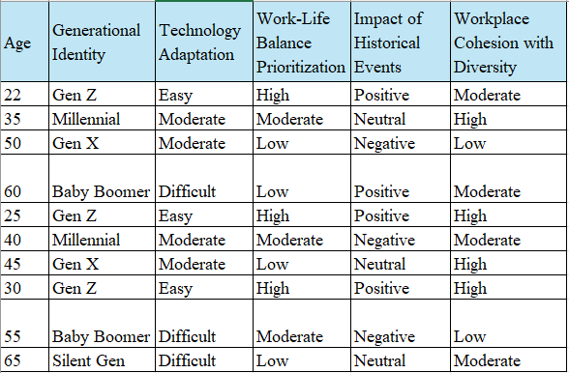
Figure 4: (Fictitious) Results from Bridging Generations Employee Survey
Assessment tools provide a window of opportunity to address these needs, which can be customized at individual and organizational levels to enhance performance experience and boost productivity.
There is no doubt of the impact of transitions in adult life, and regardless of which lifespan perspective one adheres to or adapts, the fact remains:
Adult life is a series of stages and transitions, which pushes into unfamiliar territory, each transition to a new stage creates motivation to learn, and if adult learning professionals listen closely to the motivations of their learners, they will often hear some form of life transition pushing the adults to learn (Knowles, 2020, p. 205).
The TED talk "Get Comfortable with being Uncomfortable" (Jones, 2018) stresses that we must talk about what we fear to form bridges based on truth and live our authentic selves. Brown (2016) discusses allyship from leadership to impact change and uses the Johari Window to demonstrate that the key to managing change is to under the why for change, where the pain point is, and getting allyship to sponsor the how it affects change.
As life change is constant, the need for clarification and refinement to increase learning and productivity outcomes in today's workplace is ever-present. The lifespan development framework can serve to bridge generational differences in the workplace, impacting change for adult learning, diversity, and inclusion.

References
Ayoko, O. B., & Fujimoto, Y. (2023). Diversity, inclusion, and human resource management: A call for more belongingness and intersectionality research. Journal of Management & Organization, 29(6), 983–990. doi:10.1017/jmo.2023.72
Beier, M. E. (2022). Life-Span learning and development and its implications for workplace training. Current Directions in Psychological Science, 31(1), 56-61. https://doi.org/10.1177/09637214211003891
Brown, J. (2016). Inclusion: Diversity, the new workplace & the will to change. (2nd ed.). Publish Your Purpose Press.
Knowles, M., Holton, E., Swanson, R. & Robinson, P. (2020). The adult learner: The definitive classic in adult education and human resource development (9th ed.). Routledge: Taylor and Francis.
Pew Research Center. (2015, September 3). The Whys and Hows of Generations Research. https://www.pewresearch.org/politics/2015/09/03/the-whys-and-hows-of-generations-research/
Rudolph, C. W., & Zacher, H. (2017). Considering generations from a lifespan developmental perspective. Work Aging and Retirement, 3(2), 113–129. https://doi.org/10.1093/workar/waw019
TED. (2018, January 2). Get comfortable with being uncomfortable. Luvvie Ajayi Jones [Video]. YouTube. https://www.youtube.com/watch?v=QijH4UAqGD8

