Advanced ReactJS

Advanced React Labs and Challenges


Contents
1. Quick Lab 1 – useReducer and useRef 1
1.1. Objectives 1
1.2. Activity 1
2. Quick Lab 2 – useMemo and useCallback 3
2.1. Objectives 3
2.2. Activity 3
2.3. Objectives 4
2.4. Activity 4
3. Quick Lab 4 – Redux 7
3.1. Objectives 7
3.2. Activity 7

Quick Lab 1 – useReducer and useRef

Objectives
- To be able to create a managed form in React using useReducer and useRef

Activity
- Open the lab 1 starter in VSCode.
- Install dependencies.
- Create an inputRef using useRef and add it to the addTask input
- In TaskManager.jsx initialise a new reducer with useReducer
- Update the reducer function with three action types: ADD_TASK, TOGGLE_TASK AND CLEAR_COMPLETED. At the moment these can just return a blank object and remember to add a default case to the switch statement that just returns the state object as-is.
- In the handleTask function use the inputRef to grab the value of the addTask field then dispatch an event with type: “ADD_TASK” and payload:value
- Clear the input.
- Focus the input again.
- Update the ADD_Task case:
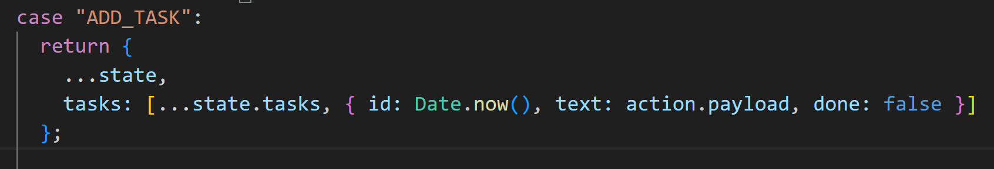
- Add the handleTask function as the onSubmit for the form
- Update the TOGGLE_Task case: 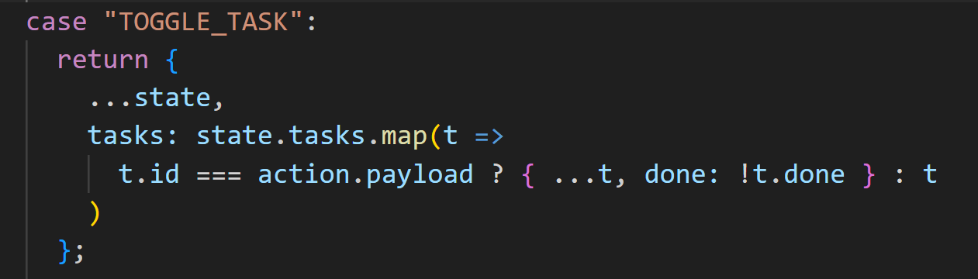
- call dispatch from the onClick of the li with type: “TOGGLE_TASK” and payload: task.id
- Update the CLEAR_COMPLETED case: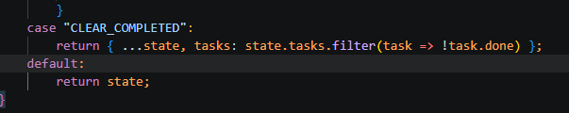
- Call dispatch from the onClick of the clear button with type: “CLEAR_COMPLETED”

Quick Lab 2 – useMemo and useCallback

Objectives
- To be able to use useMemo and useCallbck to make a React app more efficient

Activity
1. Open the lab 1 starter in VSCode.
2. Open SearchList.jsx
3. Use useCallback to memoise the handleSelect function to prevent unnecessary re-renders
4. Use useMemo to memoise the item filtering (makng sure to add a query dependency) this will ensure the filtering operation doesn’t slow down the application by being run unnecessarily.
Quick Lab 3 – useActionState, useOptimistic and useFormStatus

Objectives
- To be able to use useActionState, useOptimistic and useFormStatus in a React app

Activity
1. Open the lab 1 starter in VSCode.
2. Open TodoApp.jsx
3. Add the optimistic state to ToDoApp 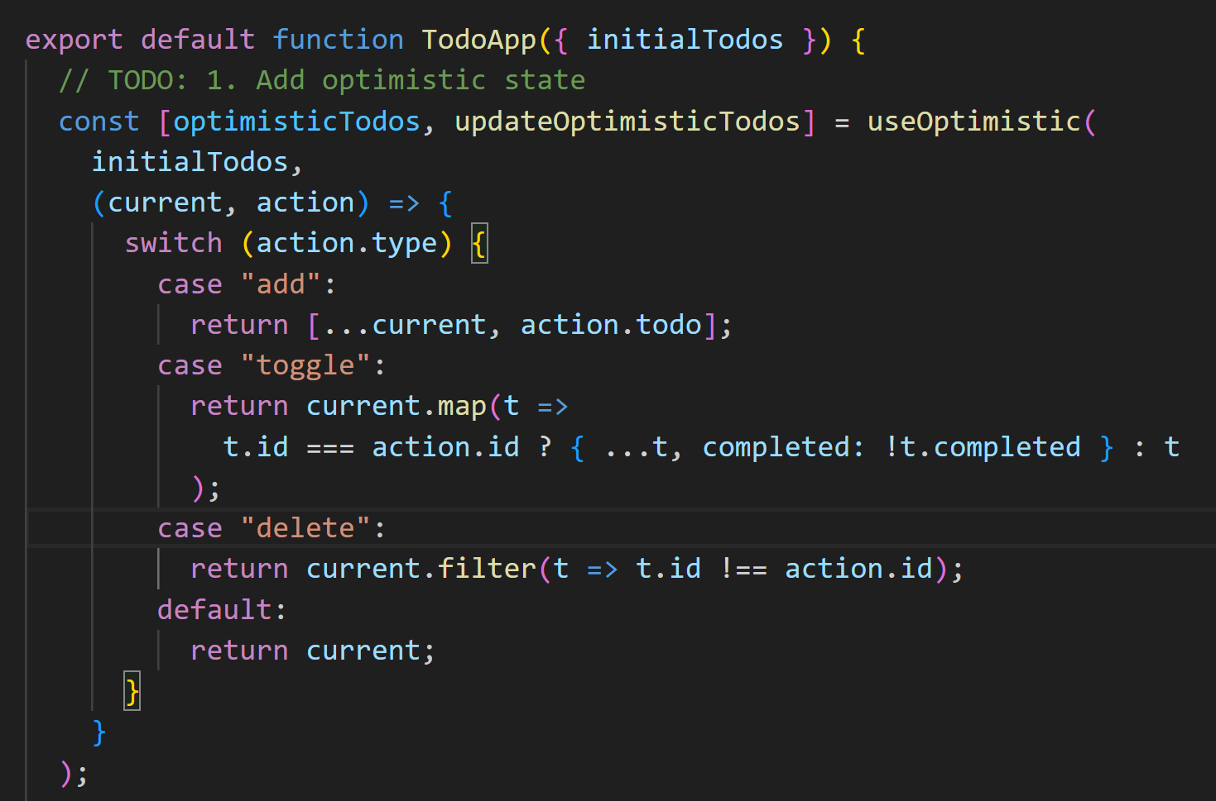
4. Add the useActionState for addTodo 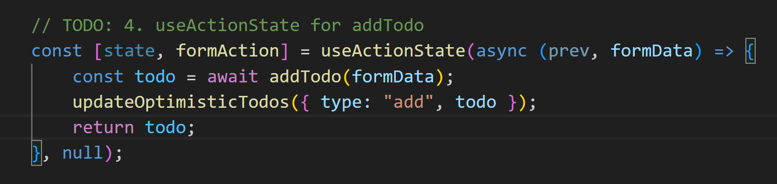
- Add the formAction to the AddTodoForm via the action prop 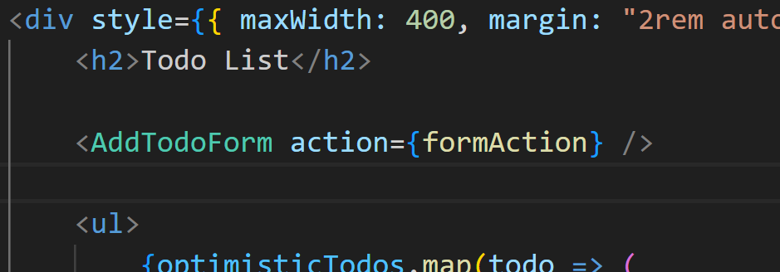
- Add the formActions to toggle and delete todos 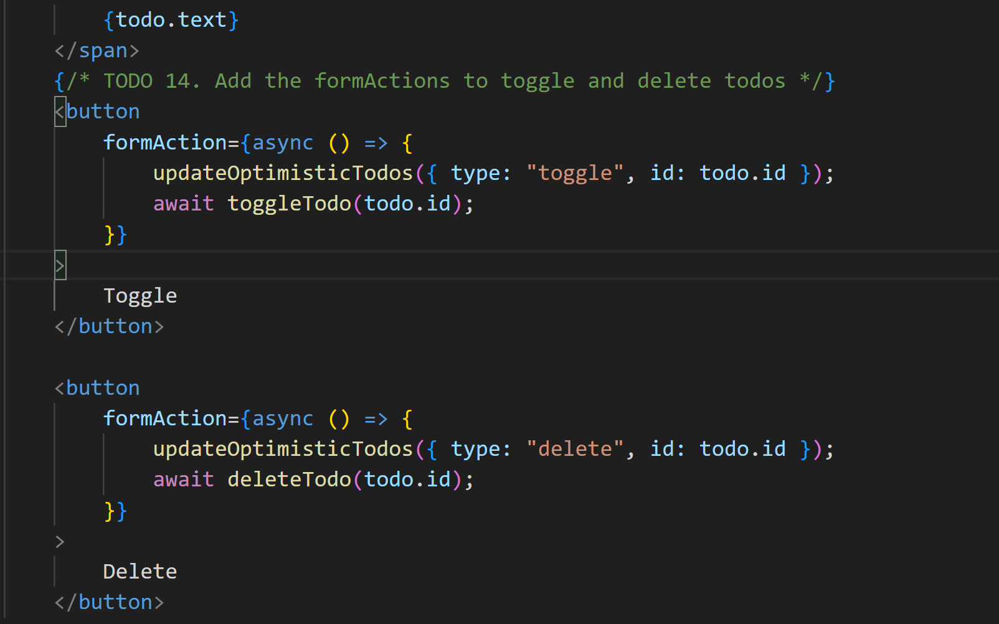
- Add useFormStatus to SubmitButton – this will allow the submit button to be disabled whilst the submit is in progress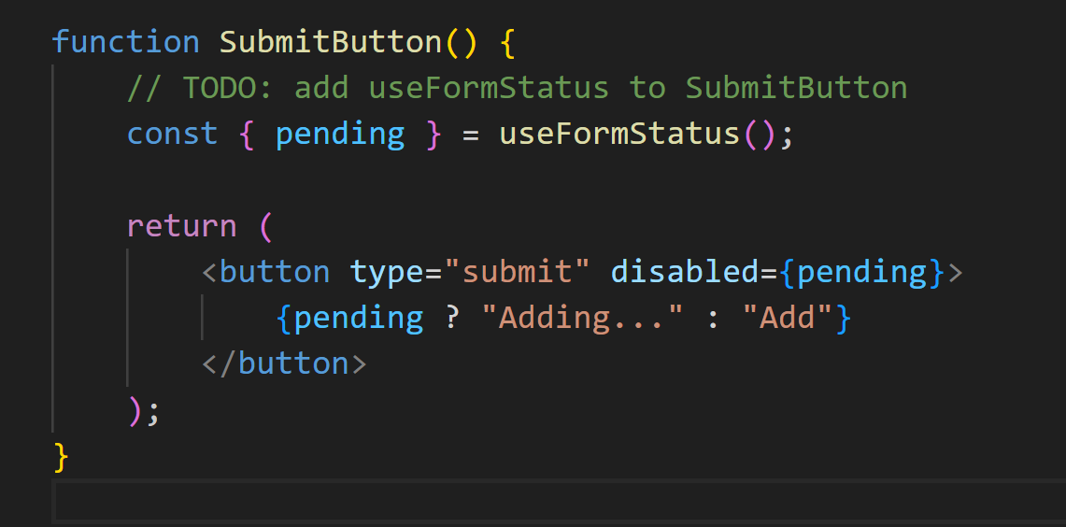

Quick Lab 4 – Redux

Objectives
- To implement React Redux to manage state in a simple application.

Activity
- Open the starter 02-redux in VSCode
- Install dependencies
- Open store.js; this is where we will be creating the store for this React app. Start by creating a slice called booksSlice with name: “books”, an initialState: { items: [], filter: “all” and reducers: {}
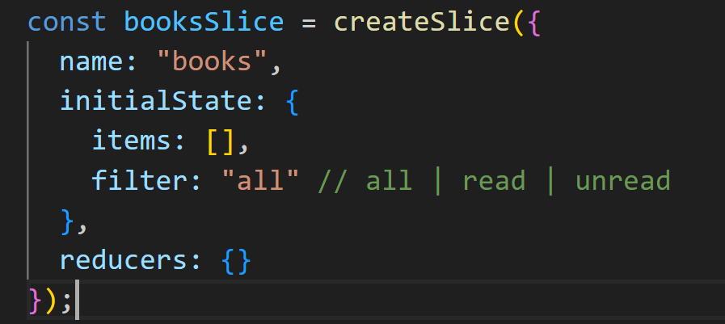
- Add reducers addBook, removeBook, toggleRead and setFilter
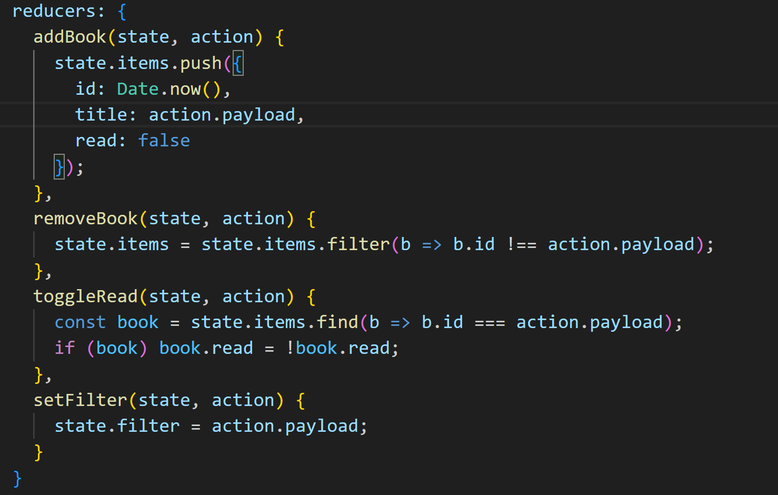
- Export the actions from bookSlice
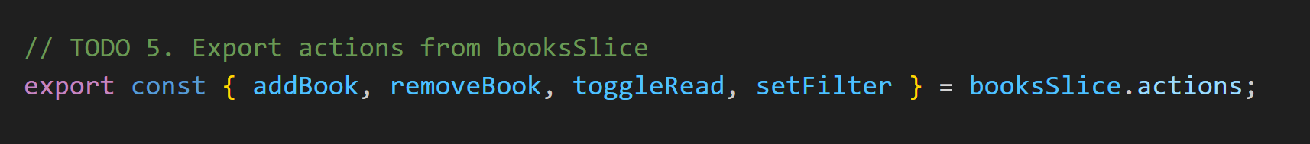
- Configure and export the store
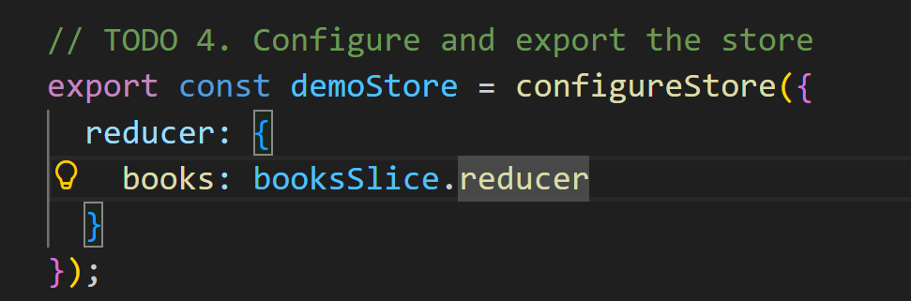
- In order to access the store in App it must be provided so next add a provider wrapped around <App/> in main.jsx, making sure to import the demoStore you just created.
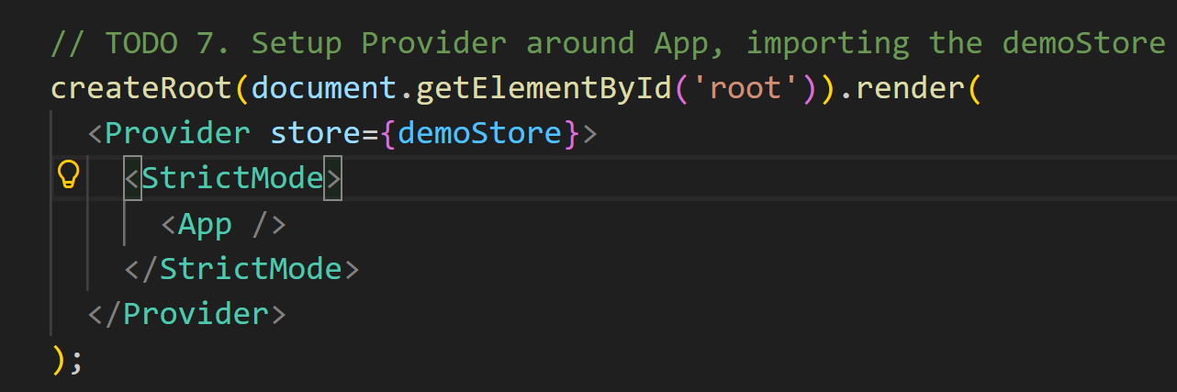
- Fetch dispatch function from the store in App.js
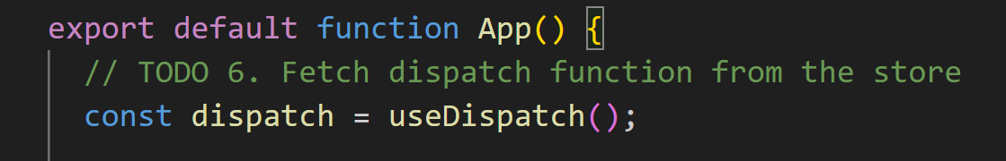
- Fetch items and filter from the store
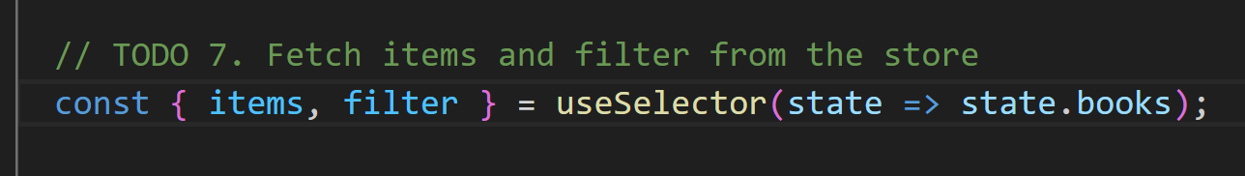
- Filter the items array using the filter you just extracted from the store
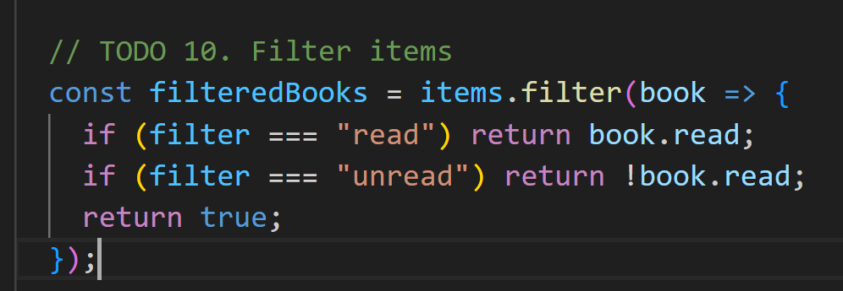
- Use dispatch to update the filter value when the corresponding button is clicked
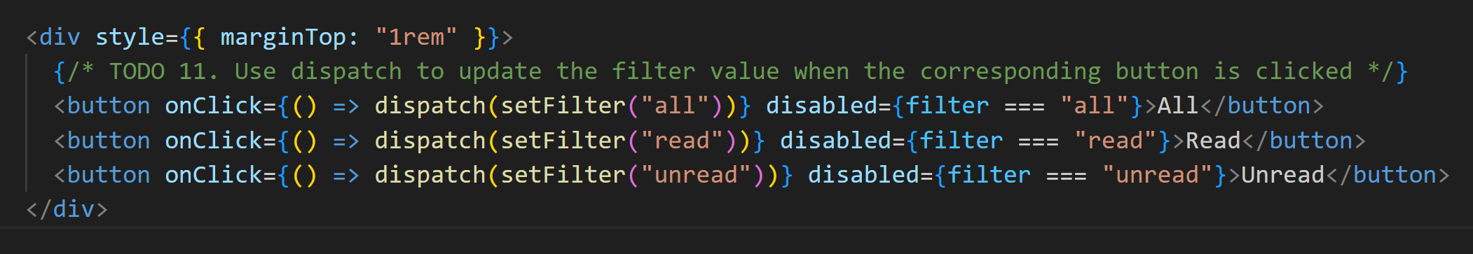
- Use dispatch to toggle and remove books
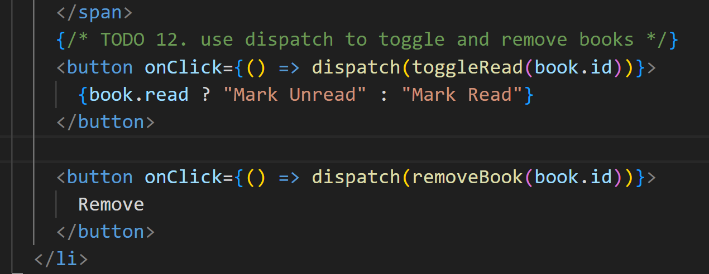
- Update the handleSubmit function to add a book using dispatch – remember to blank the title afterwards.
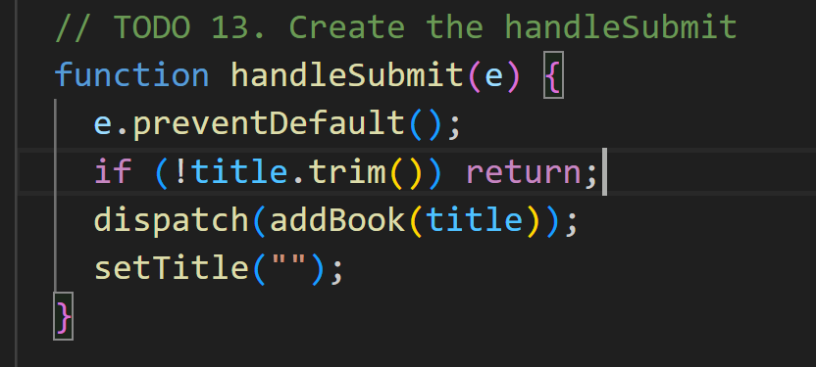
- Test your App in the browser

- Update the CLEAR_COMPLETED case: 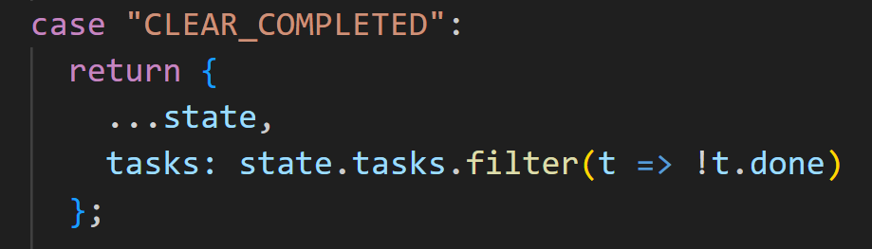
- call dispatch from the onClick of the clear button with type: “CLEAR_COMPLETED
- Test your TaskManager in the browserby running it using vite

This is the end of Quick Lab 1


