**a6report6**

For this report, the Rossler Attractor system was analyzed with initial conditions of {X,Y,Z}(0) = {0.001, 0.001, 0.001}, a = 0.25, b = 1, and a variable c. As c is increased in the from 5.5 t0 10, it appears that the maximum deflection in the z direction increases, as is shown in *Figures 1-4*. Additionally, it can be seen that the trend seems to be that as c increases, the periodic paths within the system seem to collapse to fewer individual paths. This can be seen with four distinct bundles in the arc of *Figure 2* compared to the two bundles of *Figure 4*.

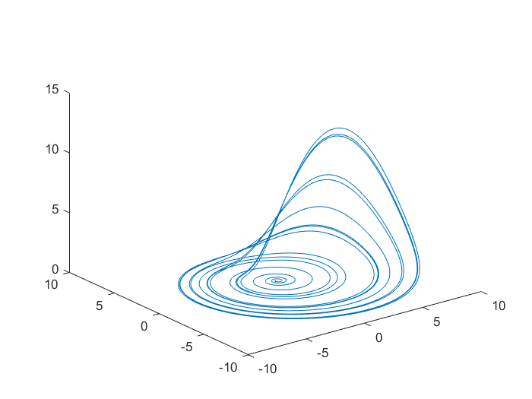

**Figure 1.** Rossler Attractor where a = 0.25, b = 1, and c = 5.5

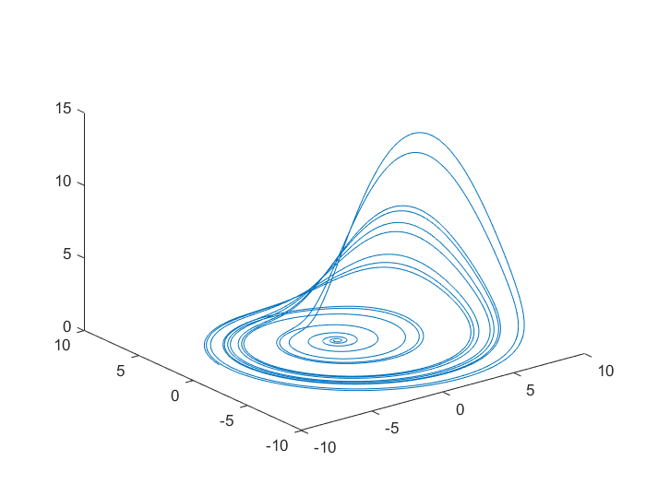

**Figure 2.** Rossler Attractor where a = 0.25, b = 1, and c = 6

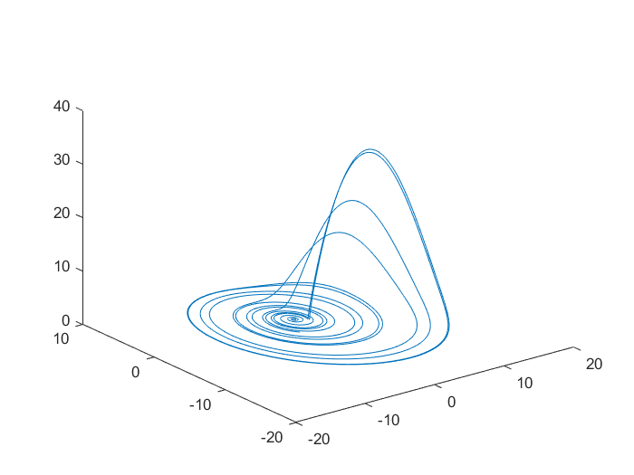

**Figure 3.** Rossler Attractor where a = 0.25, b = 1, and c = 8

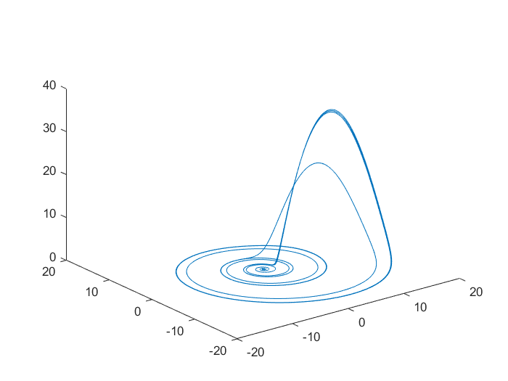

**Figure 4.** Rossler Attractor where a = 0.25, b = 1, and c = 10