**JD Haynes Unit 3 Homework**

**Terminal Homework – A High Stakes Investigation**

## Step 1 Investigation Prep – Create Directories

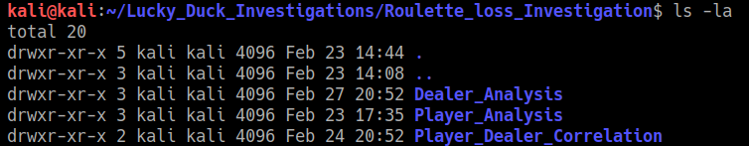

## Step 2 Gathering Evidence

Move files and directories for win/loss player data and employee schedules to specified directories

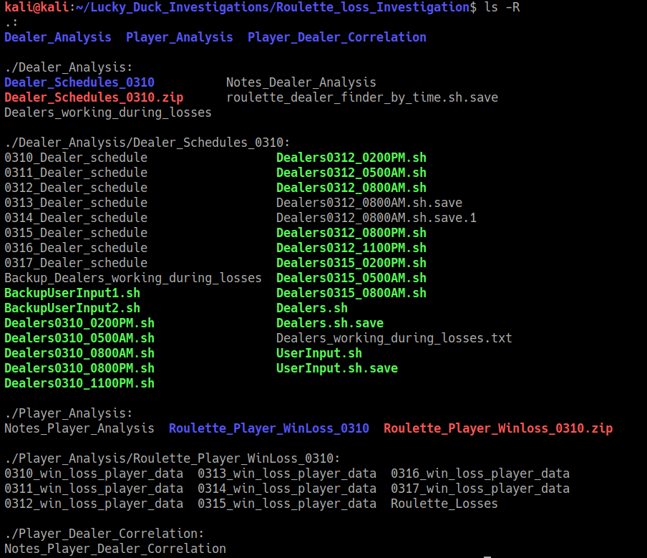

## Step 3 Correlating the Evidence

**Player Analysis**

*cat 0310_win_loss_player_data | grep "-" | grep '[A-Za-z0-9]' | awk '{print$0}' > Roulette_Losses*

*cat 0312_win_loss_player_data | grep "-" | grep '[A-Za-z0-9]' | awk '{print$0}' >> Roulette_Losses*

*cat 0315_win_loss_player_data | grep "-" | grep '[A-Za-z0-9]' | awk '{print$0}' >> Roulette_Losses*

*cat Roulette_Losses*

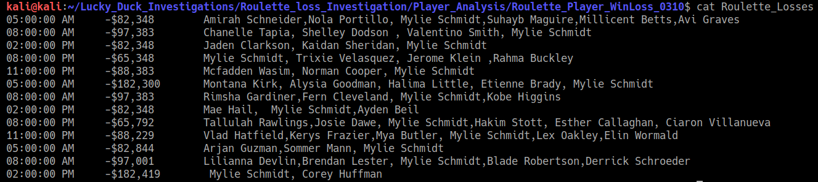

Observed that Mylie Schmidt’s name appears frequently. There are 13 recorded loss times.

Per this command, Mylie’s name appeared 13 times:

*grep -o -i Mylie Roulette_Losses | wc -l*

Add notes/conclusions to “*Notes_Player_Analysis*”

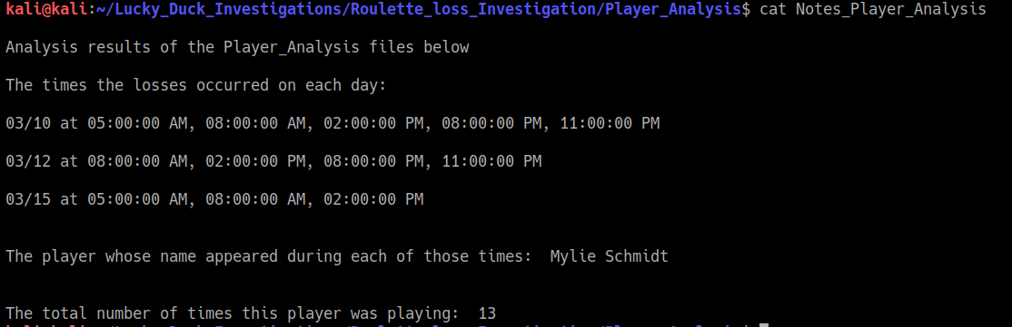

**Dealer Analysis**

Tried a bunch of variations until I came up with this syntax that added the spaces and made it more readable:

*cat 0310_Dealer_schedule | grep '05:00:00 AM\|08:00:00 AM\|02:00:00 PM\|08:00:00 PM\|11:00:00 PM' | awk {'print $1" "$2" "$5" "$6'}*

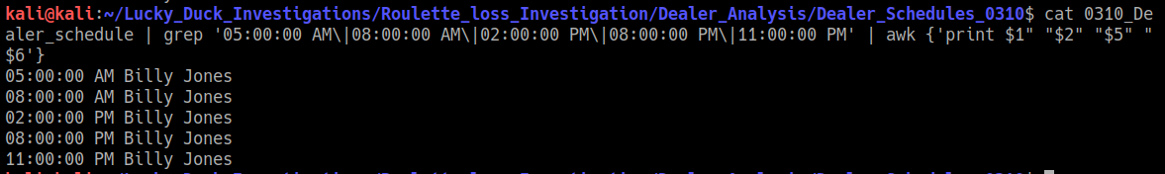

**Then created individual command lines for a single date and time, by just changing out the date and/or time on each command line. Three examples below:**

*cat 0310_Dealer_schedule | grep '05:00:00 AM' | awk {'print $1" "$2" "$5" "$6'}*

*cat 0310_Dealer_schedule | grep '08:00:00 AM' | awk {'print $1" "$2" "$5" "$6'}*

*cat 0312_Dealer_schedule | grep '05:00:00 AM' | awk {'print $1" "$2" "$5" "$6'}*

Next I created the scripts for each command line. An example script, “*Dealers0310_0500AM.sh*” is below:

*#Script finds dealer for roulette game at date and time specified in script*

*#!bin/bash  
cat 0310_Dealer_schedule | grep '05:00:00 AM' | awk {'print $1" "$2" "$5" "$6'}*

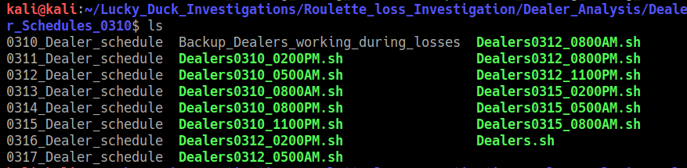

Next I created a script that combined all the individual command lines into a single script called “*Dealers.sh*” and then puts the output into a file called “*Dealers_working_during_losses.txt*”

The script looks like this:

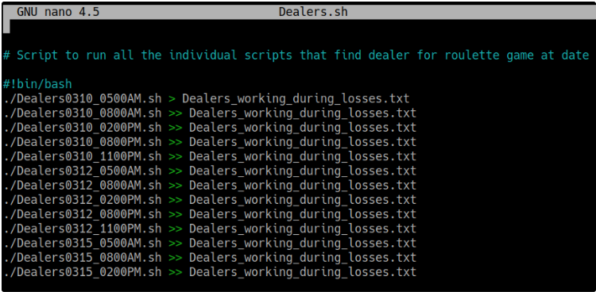

The output looks like this:

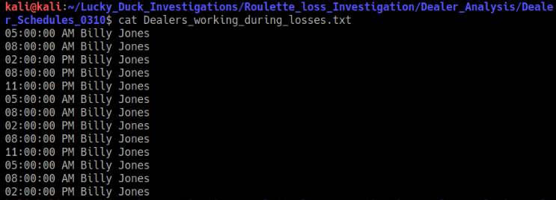

Updated the notes in “*Notes_Dealer_Analysis*”

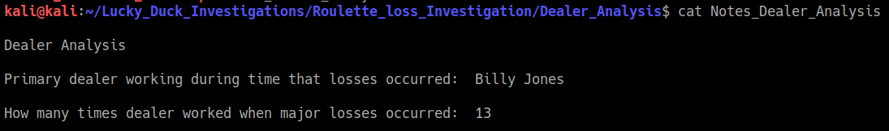

**Player/Employee Correlation**

Updated the notes in “*Notes_Player_Dealer_Correlation*”

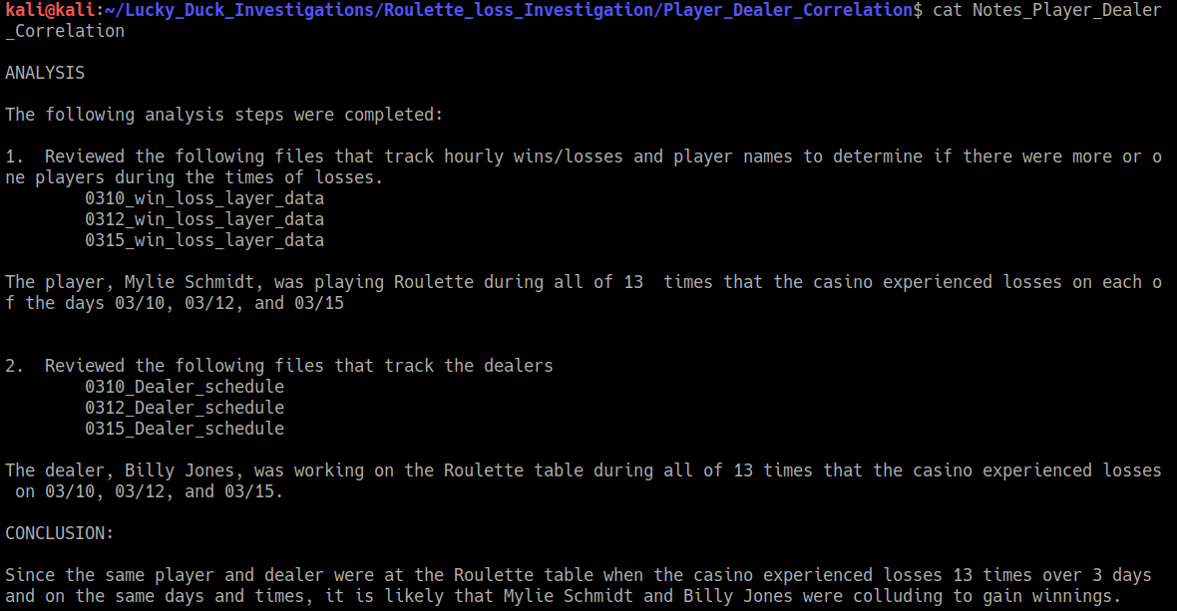

Step 4 Scripting Your Tasks

Created a script to find the roulette dealer based on date and time:

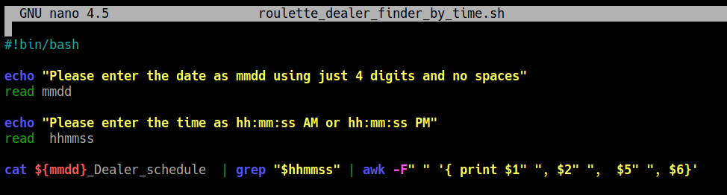

Bonus

