CSC 3101 – Winter 2020

Lab Assignment 2

1. Design a circuit on Logicly for this 8-3 Multiplexer, shown in your textbook. (40 points)

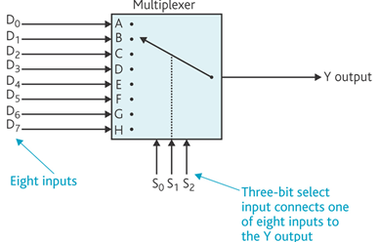

**Output (Y)**

|  |  |  |
| --- | --- | --- |
| **S0**  **X** | **S1**  **Y** | **S2**  **Z** |
| **A** | **B** | **C** | **D** | **E** | **F** | **G** | **H** | **Expression** |
| **0** | **0** | **0** | **1** |  |  |  |  |  |  |  |  |
| **0** | **0** | **1** |  | **1** |  |  |  |  |  |  | **Z** |
| **0** | **1** | **0** |  |  | **1** |  |  |  |  |  | **Y** |
| **0** | **1** | **1** |  |  |  | **1** |  |  |  |  | **Y Z** |
| **1** | **0** | **0** |  |  |  |  | **1** |  |  |  | **X** |
| **1** | **0** | **1** |  |  |  |  |  | **1** |  |  | **XZ** |
| **1** | **1** | **0** |  |  |  |  |  |  | **1** |  | **X Y** |
| **1** | **1** | **1** |  |  |  |  |  |  |  | **1** | **X Y Z** |

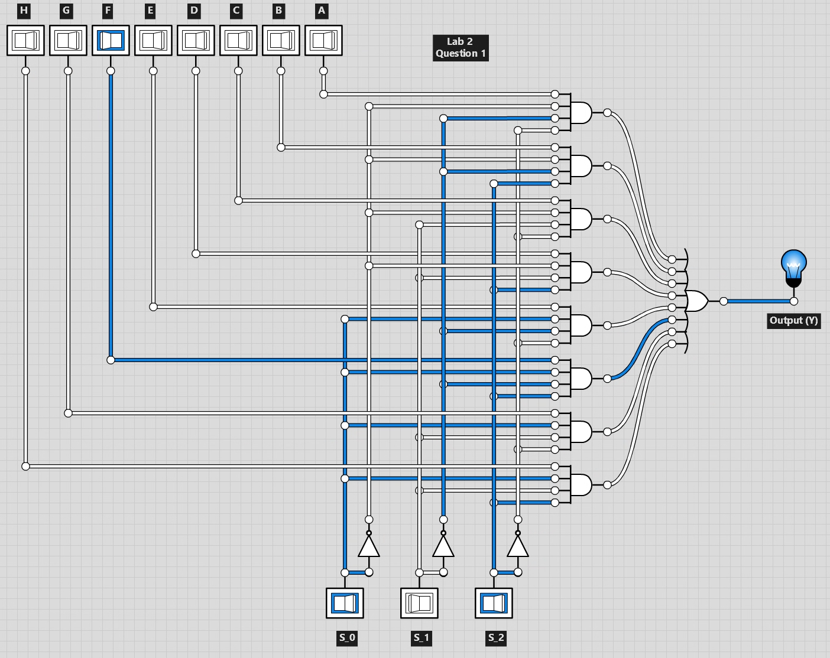

1. Design a circuit that accepts a 4-bit input and determines if the accepted input is a number from the Fibonacci series or not. If the accepted number is a number in the Fibonacci series, then the light bulb should be “ON” and the 4-bit digit display should show the number. If the accepted number is not a part of the Fibonacci series, then the light bulb should be “OFF” and the digit display should show 0. (60 points)

**4-Bit Fibonacci Numbers**

|  |  |  |  |
| --- | --- | --- | --- |
| **S0**  **A** | **S1**  **B** | **S3**  **C** | **S4**  **D** |
| **0** | **1** | **2** | **3** | **5** | **8** | **13** | **Expression** |
| **0** | **0** | **0** | **0** | **1** |  |  |  |  |  |  |  |
| **0** | **0** | **0** | **1** |  | **1** |  |  |  |  |  | **D** |
| **0** | **0** | **1** | **0** |  |  | **1** |  |  |  |  | **C** |
| **0** | **0** | **1** | **1** |  |  |  | **1** |  |  |  | **C D** |
| **0** | **1** | **0** | **0** |  |  |  |  |  |  |  |  |
| **0** | **1** | **0** | **1** |  |  |  |  | **1** |  |  | **BD** |
| **0** | **1** | **1** | **0** |  |  |  |  |  |  |  |  |
| **0** | **1** | **1** | **1** |  |  |  |  |  |  |  |  |
| **1** | **0** | **0** | **0** |  |  |  |  |  | **1** |  | **A** |
| **1** | **0** | **0** | **1** |  |  |  |  |  |  |  |  |
| **1** | **0** | **1** | **0** |  |  |  |  |  |  |  |  |
| **1** | **0** | **1** | **1** |  |  |  |  |  |  |  |  |
| **1** | **1** | **0** | **0** |  |  |  |  |  |  |  |  |
| **1** | **1** | **0** | **1** |  |  |  |  |  |  | **1** | **C** |
| **1** | **1** | **1** | **0** |  |  |  |  |  |  |  |  |
| **1** | **1** | **1** | **1** |  |  |  |  |  |  |  |  |

**Equation:**

F = !A !B !C !D + !A !B !C D + !A !B C !D + !A !B C D + !A B !C D + A !B !C !D + A B !C D + A B C D

**Simplified:**

F = !A !B + B !C D + !B !C !D

