20CS6033/Fall 2022

Instructor: Anca Ralescu

**Homework Assignment #5**

**Assigned on 11/22/2022**

**Due on Canvas on 11/30/2022**

**NO LATER THAN 11:59PM**

**HARD DEADLINE**

**50 points**

**Dieudonne Muhirwa M14185704**

**Allen Detmer M15216736**

**JiaBin Chang M13782945**

**Joseph Matawaran M15228497**

This is a “pencil and paper” assignment, that is, it requires no programming. **Please type**. You must show all your work, but do not write more than strictly necessary for each answer. In other words, show that you know what it is needed to answer for each question.

**Problem 1 (30 points)**. Two astronomers in different parts of the world make measurements M1 and M2 of the number of stars N in some small region of the sky, using their telescopes. There is a small possibility *e* of error by up to one star in each direction. Each telescope can also (with a much smaller probability *f*) be badly out of focus (events F1 and F2), in which case the scientist will undercount by three or more stars (or if N is less than 3, fail to detect any stars at all). Consider the three networks shown below:

1. Which of these Bayesian networks are correct (but not necessarily efficient) representations of the preceding information?

The correct networks are network (ii) and network (iii). The network (ii) is the correct representation of the preceding information because it is built directly from the physical network, same as well to the network (iii) because it is similar to network (ii) with just different direction of arrows assigned to the variables. Since F and N cannot be conditionally independent to the provided M, the network (i) is not the correct representation.

1. Which is the best network? Explain.

Network (ii) is the best network because it is simple to understand, intuitive, and has fewer links. Therefore, the conditional probability table entry's value can be assigned more easily.

1. Write out a **conditional distribution** for $P(M1 |N),$ for the case where $N ∈\{1, 2, 3\}$ and $M1 ∈\{0, 1, 2, 3, 4\}$. Each entry in the conditional distribution should be expressed as a function of the parameters *e* and/or *f*. That is, you will obtain **symbolic CPTs**.

|  |  |  |  |  |  |
| --- | --- | --- | --- | --- | --- |
| N|M1 | 0 | 1 | 2 | 3 | 4 |
| 1 | $$\frac{e}{2}+f$$ | $$1-e-f$$ | $$\frac{e}{2}$$ | $$0$$ | $$0$$ |
| 2 | $$f$$ | $$\frac{e}{2}$$ | $$1-e-f$$ | $$\frac{e}{2}$$ | $$0$$ |
| 3 | $$f$$ | $$0$$ | $$\frac{e}{2}$$ | $$1-e-f$$ | $$\frac{e}{2}$$ |

1. Suppose $M1 =1$ and $M2 =3$. What are the possible numbers of stars if you assume no prior constraint on the values of N?

Since M1 and M2 are identically distributed, both M1 and M2 should have non zero probability.

$N=2$ is possible, if both M1 and M2 made small error.

$N=4$ is possible, if M2 made small error and M1 made smaller error.

$N≥6$ is possible, if both M1 and M2 made smaller error.

|  |  |  |  |  |  |  |  |  |
| --- | --- | --- | --- | --- | --- | --- | --- | --- |
| N|M1 | 0 | 1 | 2 | 3 | 4 | 5 | 6 | 7 |
| 1 | $$\frac{e}{2}+f$$ | $$1-e-f$$ | $$\frac{e}{2}$$ | $$0$$ | $$0$$ | 0 | 0 | 0 |
| 2 | $$f$$ | $$\frac{e}{2}$$ | $$1-e-f$$ | $$\frac{e}{2}$$ | $$0$$ | 0 | 0 | 0 |
| 3 | $$f$$ | $$0$$ | $$\frac{e}{2}$$ | $$1-e-f$$ | $$\frac{e}{2}$$ | 0 | 0 | 0 |
| 4 | ? | ? | 0 | e/2 | 1-f-e | e/2 | 0 | 0 |
| 5 | ? | ? | ? | 0 | e/2 | 1-f-e | e/2 | 0 |
| 6 | ? | ? | ? | ? | 0 | e/2 | 1-f-e | e/2 |

1. What is the most likely number of stars, given these observations? Explain how to compute this, or if it is not possible to compute, explain what additional information is needed and how it would affect the result.

We need to find the maximum value of $P(N, M1=1, M2=3)$.

We have $P\left(N=2, M1=1, M2=3\right)=P\left(N=2\right){(\frac{e}{2})}^{2}$

And we know $P\left(N=4, M1=1, M2=3\right)≤P\left(N=4\right)f(\frac{e}{2})$

We don’t know the exactly the number, but we know $P\left(M1=1\right| N=4)≤f$

So, if $P\left(N=2\right)(\frac{e}{2})>P(N=4)f$, N=2 is the most probable value.

If P $\left(N=2\right)\left(\frac{e}{2}\right)<P(N=4)f$, then it depends on the way that “undercount by three or more” distributed among the various values.

If f is really small value, then $P\left(N=2\right)(\frac{e}{2})>P(N=4)f$, N=2 will be the most probable value.

1. Considering the network shown in (ii), and that the two telescopes work identically, $N ∈\{1, 2, 3\}$ and $M1,M2 ∈\{0, 1, 2, 3, 4\}$, with the **symbolic CPTs** obtained above, and using the enumeration algorithm calculate the **probability distribution $P(N |M1 =2,M2 =2)$** . Show all your work.

According to enumeration method

$$P\left(N | M1,M2\right)=αP\left(N\right)\sum_{F1}{P\left(F1\right)P(M1|N,F1)\sum_{F2}{P\left(F2\right)P(M2|N,F2)}}$$

In the case M1=2, M2=2, F1 and F2 cannot happen,

$$P\left(N | M1,M2\right)∝P\left(M1 | N\right)P\left(M2 | N\right)=\frac{P(N∩M1)}{P(N)}×\frac{P(N∩M2)}{P(N)}$$

$$P\left(N\right)=\sum_{N=1}^{3}{P\left(N\right)=}{(\frac{e}{2})}^{2}+{(1-e-f)}^{2}+{(\frac{e}{2})}^{2}={(1-e-f)}^{2}+\frac{e^{2}}{2}$$

$$P\left(N=1 | M1=2,M2=2\right)=\frac{\frac{e^{2}}{4}}{{(1-e-f)}^{2}+\frac{e^{2}}{2}}$$

$$P\left(N=2 | M1=2,M2=2\right)=\frac{{(1-e-f)}^{2}}{{(1-e-f)}^{2}+\frac{e^{2}}{2}}$$

$$P\left(N=3 | M1=2,M2=2\right)=\frac{\frac{e^{2}}{4}}{{(1-e-f)}^{2}+\frac{e^{2}}{2}}$$

**Problem 2(20 points**) Consider the Bayes net shown below:

In the diagram above, the nodes have the following meanings:

B =BrokeElectionLaw,

I =Indicted,

M =PoliticallyMotivatedProsecutor ,

G=FoundGuilty,

J =Jailed.

1. Which of the following equations describe the network structure?
 $P(B, I,M) = P(B)P(I)P(M).$

 $P(J |G) = P(J | G, I)$ 1. .

$P(M | G,B, I) = P(M | G,B, I, J).$

The equation b describes the network structure because J and I are independent conditions on G.

This equation c describes the network structure because M and J are independent conditions on G, B, I, and J.

1. Calculate the value of $P(b, I, ¬m, g, j)$.
$$P\left(b,i,\sim m,g,j\right)=P\left(i,b,\sim m\right)P\left(g | i,b,m\right)P(j|g)$$

$$=P\left(b\right)P\left(\sim m\right)P\left(i | b,\sim m\right)P\left(g | i,b,\sim m\right)P\left(j | g\right)$$

$$=0.9×0.9×0.5×0.8×0.9=0.2916$$

2. Calculate the probability that someone goes to jail given that they broke the law, have been indicted, and face a politically motivated prosecutor.

B, I, M are all fixed true, this makes $P\left(G\right)=0.9$

$$P\left(J | b,i,m\right)=α\sum{P\left(J,g\right)}$$

$$=α\left[P\left(J,g\right)+P\left(J,\sim g\right)\right]$$

$$=α[<P\left(j,g\right), P\left(\sim j,g\right)>+<P\left(j,\sim g\right)+P\left(\sim j,\sim g\right)>]$$

$$=α\left[<0.81,0.9>+<0,0.1>\right]$$

$$=<0.81,0.19>$$

Probability of going to jail is 0.81

1. Suppose we want to add the variable $P =PresidentialPardon$ to the network; draw the new network and briefly explain any links that you added.

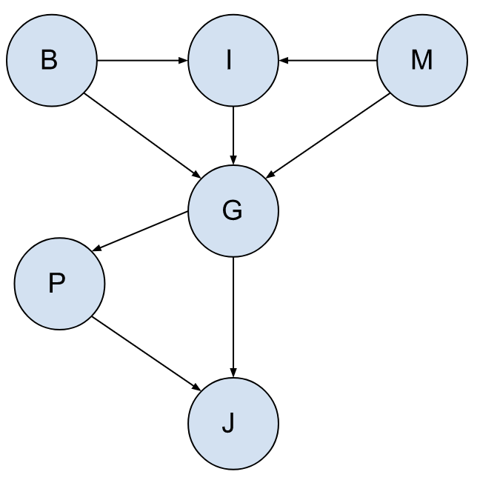

Added link (G, P) and link (P, J)

Link (G, P) - After a person is found Guilty they have a chance of getting P(PresidentialPardon). Presidential Pardons are rare thus assume P(p | g) = 0.01. Thus, to get a PresidentialPardon you must first be found Guilty. Thus, P(p | ~g) = 0.

|  |  |
| --- | --- |
| G | P(P) |
| T | 0.01 |
| F | 0 |

Link (P,J) - Shows the probability that the person will still go to J (Jail) and NOT get a PresidentialPardon. The table below shows it is hard to get P (PresidentialPardon).

|  |  |  |
| --- | --- | --- |
| G | P | P(J|G,P) |
| T | T | 0 |
| T | F | 0.99 |
| F | T | 0 |
| F | F | 0 |