The Following image is the screenshot of the IR1A.py and the result.

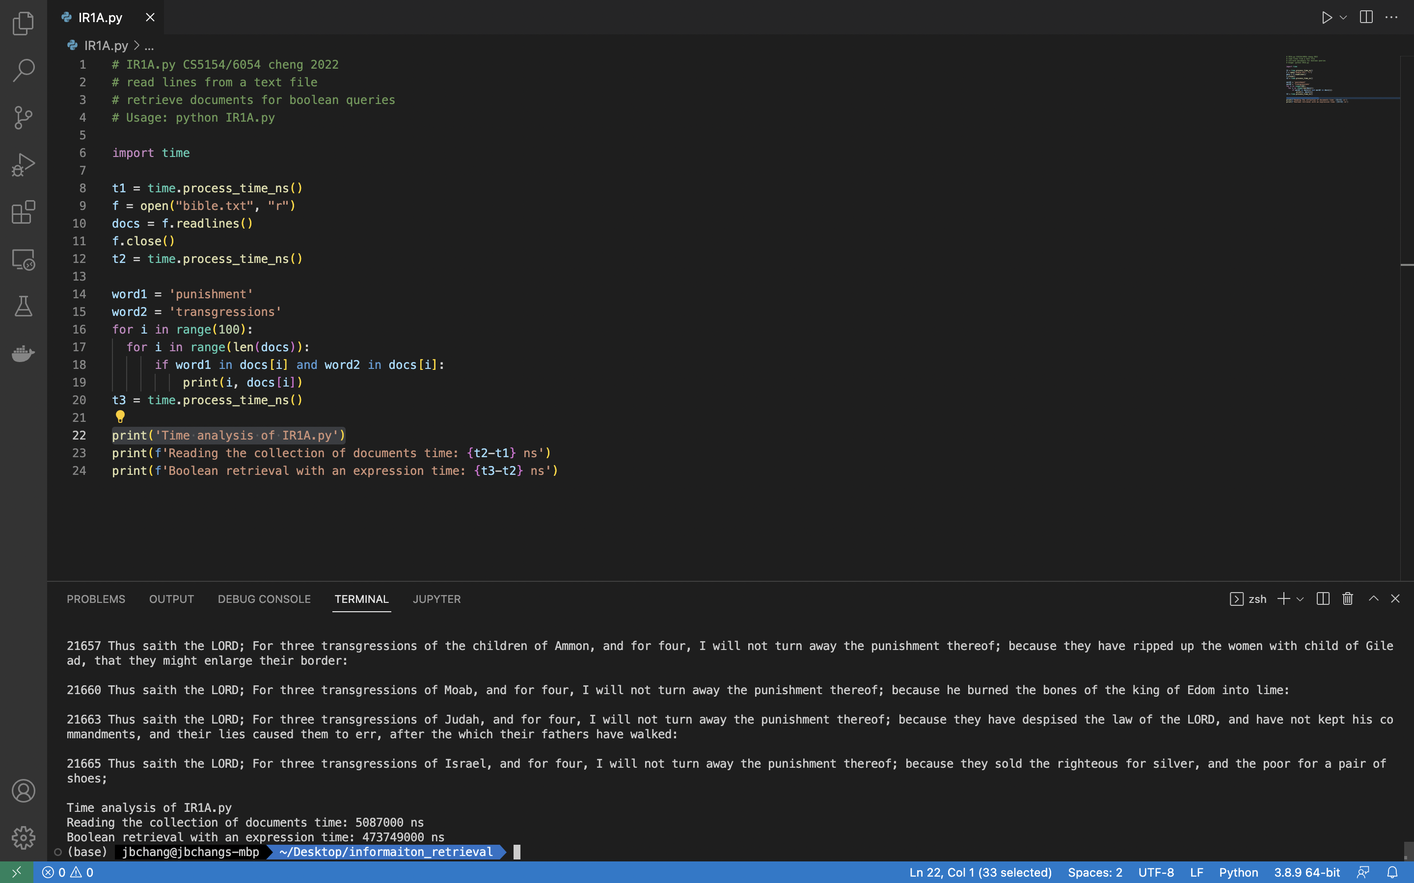

The Following image is the screenshot of the IR1B.py and the result.

