IR13A.py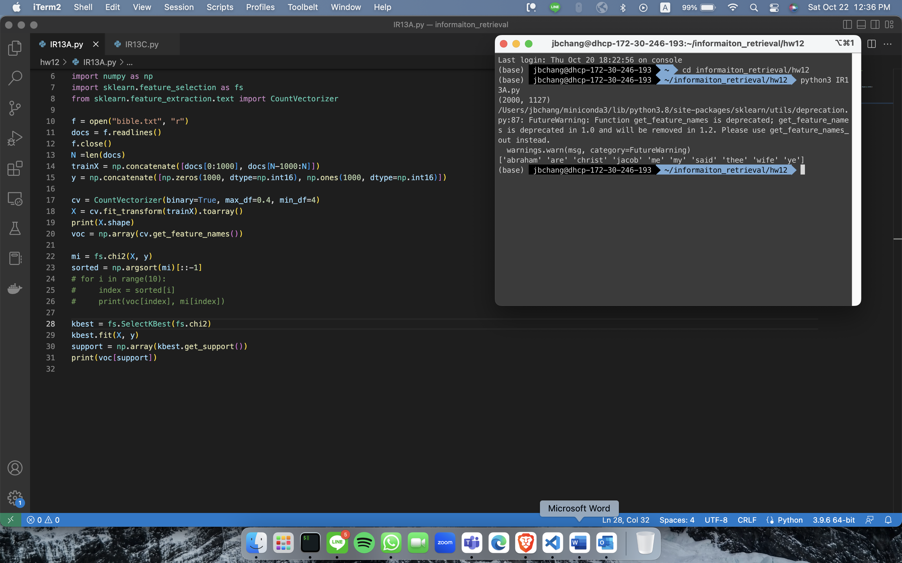

IR13C.py

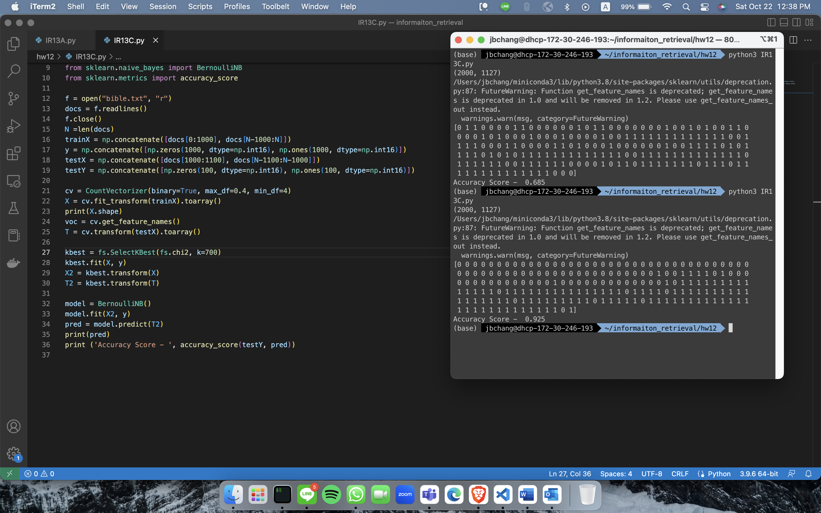

Mutual_info_classif, k=100 🡪 accuracy = 0.685

Chi2, k=700 🡪 accuracy = 0.925