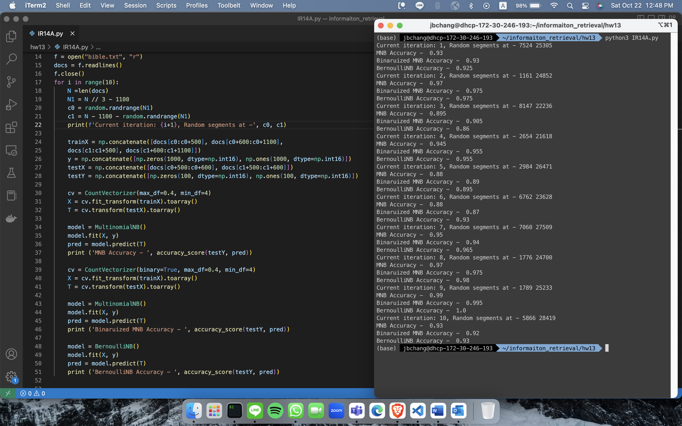

MNB (MultinomialNB): 9 times is the best

binarized MNB (tf binary): 9 times is the best

BernoulliNB:9 times is the best

