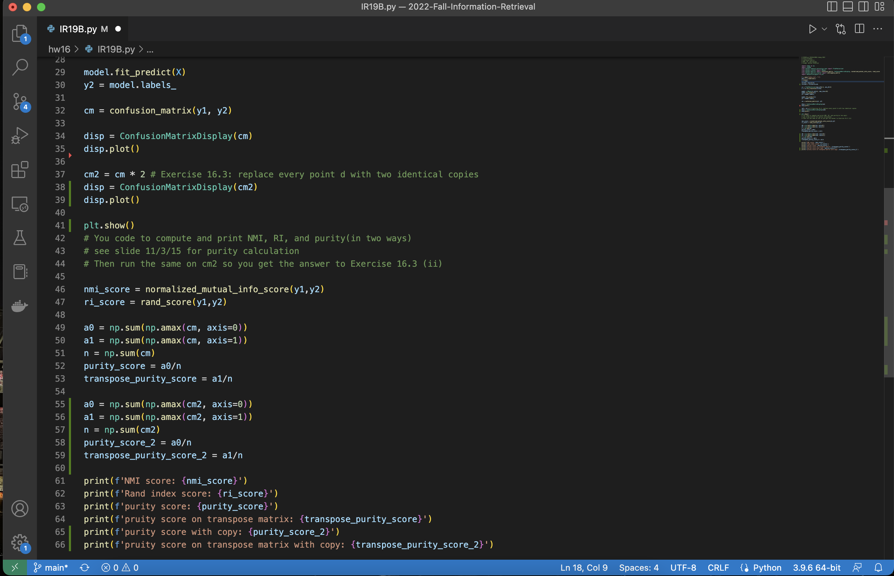

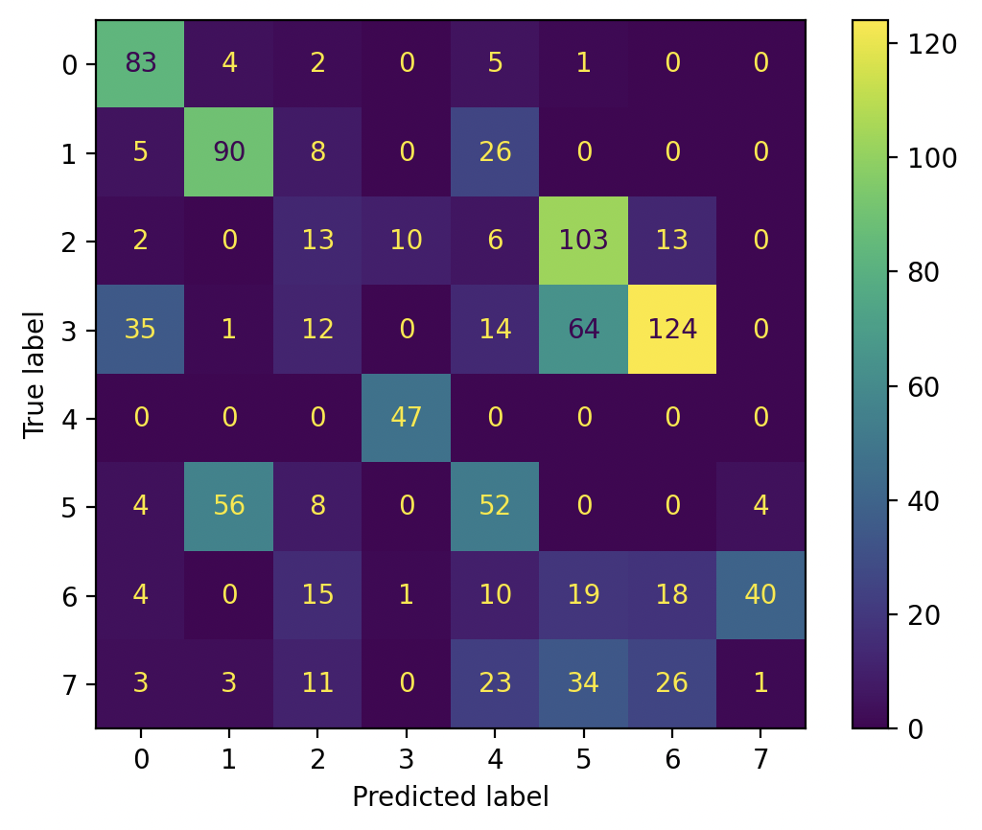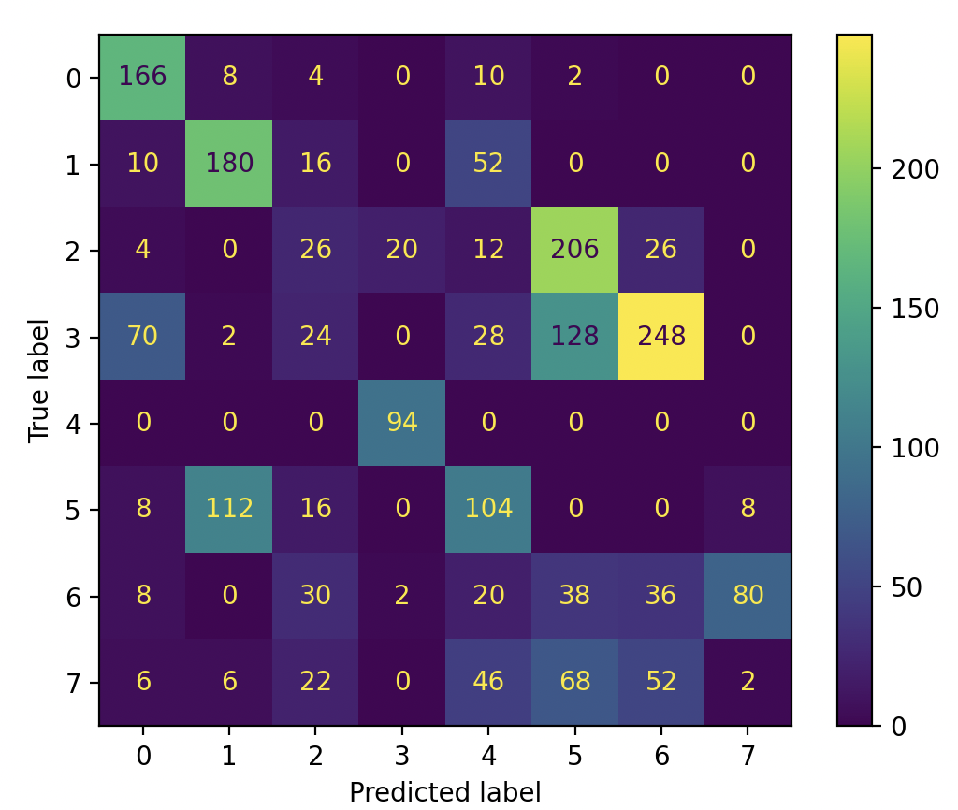

NMI score: 0.4296450441416745

Random index score: 0.8207467467467467

purity score: 0.554

pruity score on transpose matrix: 0.577

purity score with doubling: 0.554

pruity score on transpose matrix with doubling: 0.577

Pruity is invariant to doubling

Random index score is invariant to swap