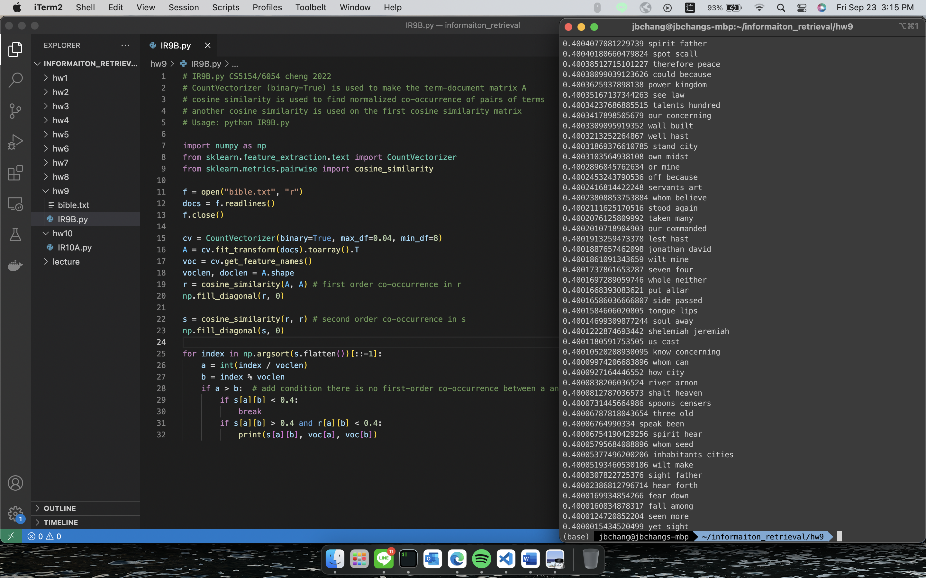

Before adding condition the results have the amount of 9117, after adding the condition the results reduce to 9064.